ENME 485/691 Industrial AI | Homework 03 Report
Health Assessment of a Rotor Shaft with Unbalance Defects Using a Support Vector Machine
Group members: You Jung Jun, Rahul Ravi Vk, Merrick Carlisle Summers, Arinze Submitted: October 5th 2026

1. Introduction

1.1 Background and problem
The rotor-bearing testbed of Homework 02 is used again. A disk on the shaft accepts screws that create a controlled mass unbalance: one screw is unbalance level 1 and two screws are unbalance level 2. An accelerometer on the bearing block records vibration at 2560 Hz; the nominal shaft speed is 20 Hz and the measured speed is about 21 Hz. Unbalance produces a force that rotates with the shaft, so its signature is a rise of the vibration at the shaft frequency (1X).
Compared with Homework 02 the task has two changes. The problem is now three-class (healthy, unbalance level 1, unbalance level 2), and the classifier is a support vector machine (SVM). The assignment also suggests extracting more time-domain features from the raw signal, such as RMS, peak-to-peak and standard deviation, which this report evaluates explicitly.

1.2 Raw data
Table 1. Data sets used (each record: 38,400 samples = 15 s at 2560 Hz).
Data set | Condition | Records | Use
Training, healthy | Normal shaft | 20 | class 0
Training, unbalance level 1 | One screw on the disk | 20 | class 1
Training, unbalance level 2 | Two screws on the disk | 20 | class 2
Testing | Labels given in the appendix (10 per class) | 30 | to be assessed

Figure 1 shows one raw waveform per class. The three conditions are visually indistinguishable in the time domain, and the overall vibration level even decreases slightly with unbalance (RMS of 0.079, 0.072 and 0.063 g for the three classes). Figure 2 shows the class-averaged spectra. The broadband content between 400 and 800 Hz, which sets the overall level, is the same in all classes, while the line at the shaft frequency grows from 0.0014 g (healthy) to 0.0055 g (level 1) and 0.0257 g (level 2). The information is confined to a narrow band around 21 Hz.
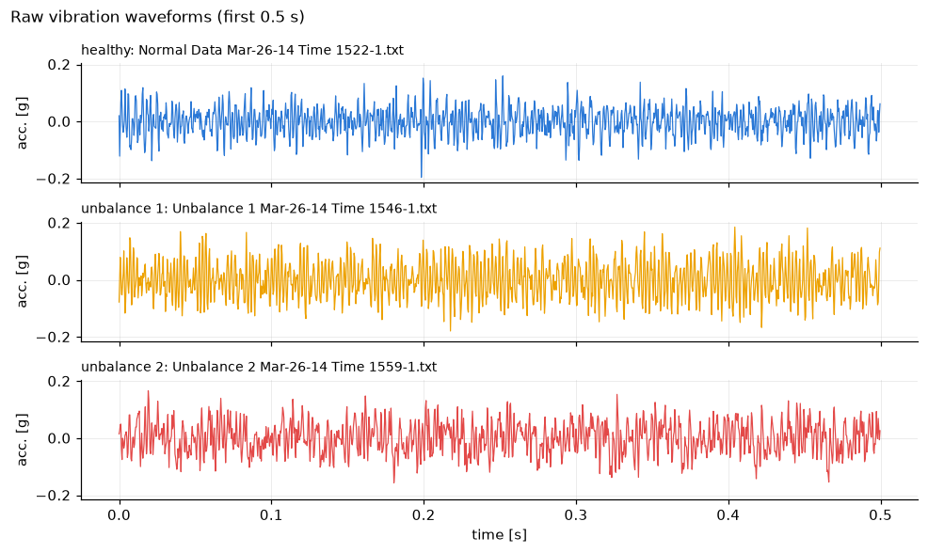
Figure 1. Raw vibration waveforms of the three classes (time domain).
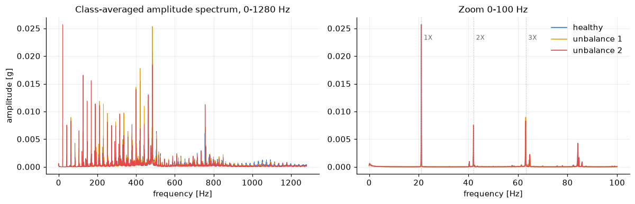
Figure 2. Class-averaged amplitude spectra (frequency domain).

2. Implemented Solution

2.1 Analytics process
Sample preparation. Each file is parsed into a 38,400-sample vector. Training records are labelled 0, 1, 2 by folder. Test records are ordered chronologically and numbered 1 to 30; their true labels follow the appendix table (file names starting with "Data" are healthy, records from 15:49 to 15:52 are level 1, records from 16:06 on are level 2).
Feature extraction. Three feature groups, 23 features in total, are computed for every record. (a) Raw time-domain statistics, as suggested by the assignment: RMS, peak-to-peak, standard deviation, peak, crest factor, kurtosis, skewness, shape factor and impulse factor. (b) Frequency-domain features from a Hann-windowed FFT: amplitudes of the 1X, 2X and 3X harmonics, with the 1X peak searched within 17 to 23 Hz so the true shaft speed is tracked, the 0 to 100 Hz band RMS and the 1X to RMS ratio. (c) The same nine time-domain statistics computed on a 15 to 30 Hz zero-phase band-pass filtered signal, which Homework 02 showed is what makes time-domain statistics informative.
Feature selection. Figures 3 to 5 show the class distributions of the three groups with the one-way ANOVA F-statistic in each panel title (between-class over within-class variance, the three-class form of the Fisher ratio). The raw statistics do not separate the classes: the best of them, RMS, has F = 5.7 and most have p > 0.1. The frequency-domain features separate the classes strongly, led by the 1X amplitude with F = 1120; the 2X harmonic separates level 2 only, and 3X carries nothing. On the band-pass filtered signal the suggested statistics become the strongest features of all: peak-to-peak, peak, RMS and standard deviation reach F = 1260 to 1300. For a sinusoid these statistics are direct estimates of its amplitude, so they measure the same 1X component as the FFT.
Table 2. Class mean ± standard deviation of key features on the training records (mg = 10⁻³ g).
Feature | Healthy | Unbalance 1 | Unbalance 2
1X amplitude (FFT) | 1.45 ± 0.59 | 5.55 ± 0.28 | 25.72 ± 2.94
2X amplitude (FFT) | 2.08 ± 1.04 | 2.24 ± 1.02 | 7.56 ± 1.47
RMS, band-pass 15–30 Hz | 1.14 ± 0.39 | 4.40 ± 0.21 | 20.28 ± 2.19
Peak-to-peak, band-pass 15–30 Hz | 4.75 ± 1.18 | 14.08 ± 0.59 | 60.46 ± 6.29
RMS, raw signal | 78.5 ± 19.7 | 71.8 ± 13.0 | 62.9 ± 9.0
Peak-to-peak, raw signal | 771 ± 360 | 686 ± 142 | 613 ± 166

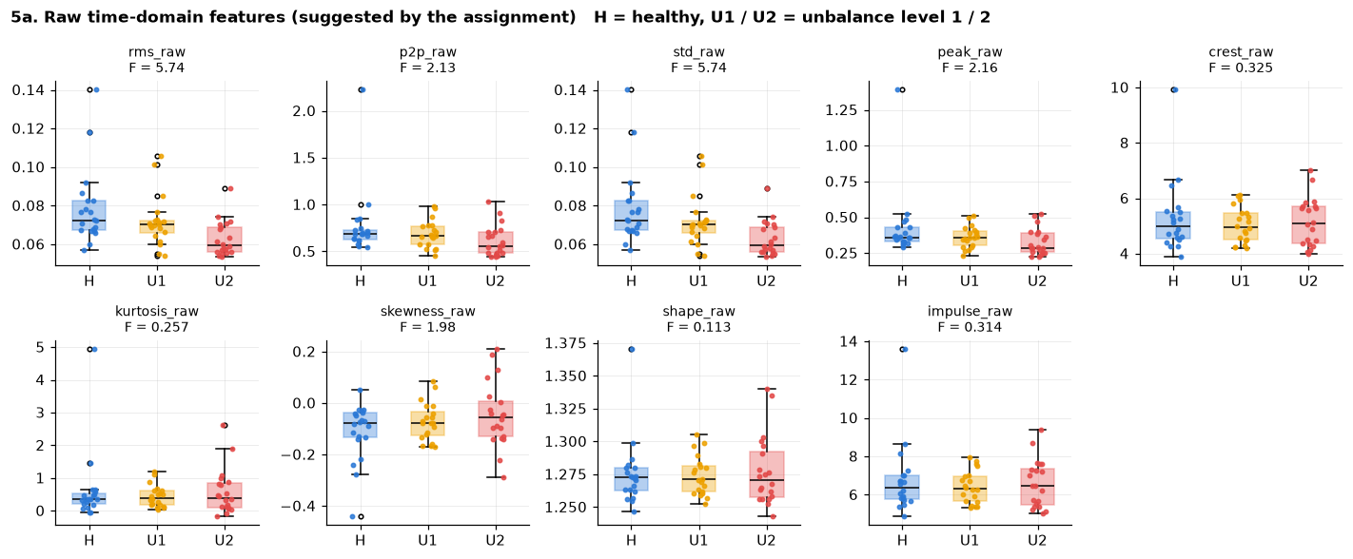
Figure 3. Raw time-domain features by class.
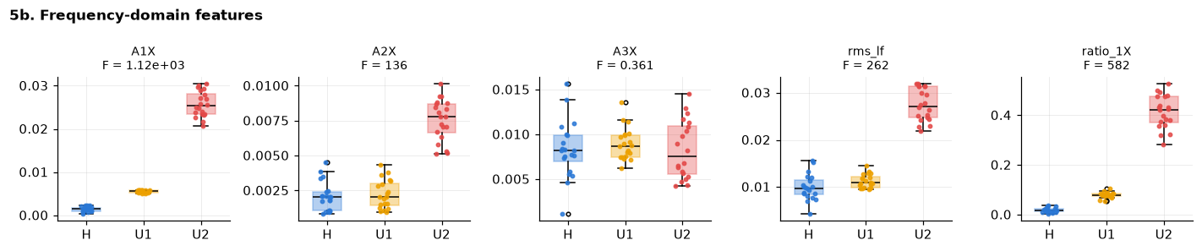
Figure 4. Frequency-domain features by class.
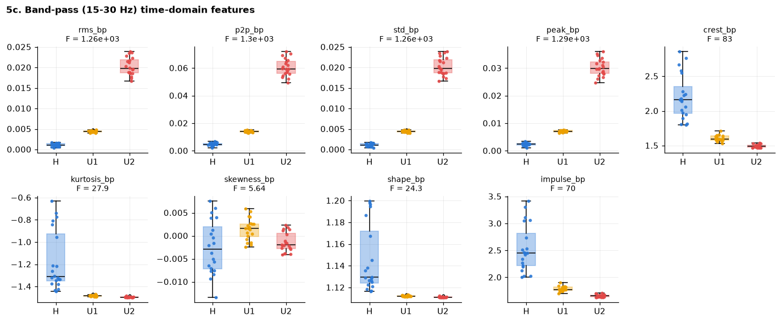
Figure 5. Band-pass filtered time-domain features by class.
ANOVA is a filter method: it scores each feature alone and cannot see redundancy or interactions. One representative of the two other families was therefore added (Figure 6). As embedded methods, the weights of a linear SVM trained on all 23 standardized features, and an L1-penalized linear SVM whose penalty drives useless weights to zero. As wrapper method, recursive feature elimination with 5-fold cross-validation (RFECV), which removes the smallest-weight feature step by step and tracks the accuracy. Mutual information was added as a second filter. The four rankings agree (Spearman correlation 0.78 to 0.97): band-pass amplitude statistics and the 1X amplitude first, raw statistics last. RFECV reaches 100 % cross-validation accuracy with a single feature, the band-pass peak. The L1-SVM keeps two features at the smallest penalty that preserves 100 % accuracy, the band-pass peak-to-peak and the band-pass crest factor, and discards the other amplitude features as redundant copies of the same 1X information, which is the redundancy a univariate filter cannot show.
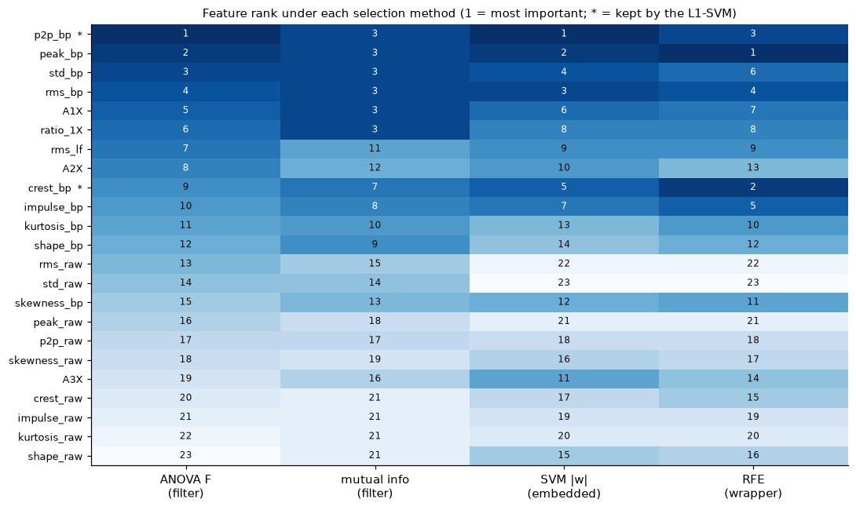
Figure 6. Feature rank under the filter, embedded and wrapper methods.
Support vector machine. A soft-margin SVM finds the hyperplane with the largest margin between classes while penalizing margin violations with the parameter C; kernels map the features to a space where a linear boundary suffices. A linear SVM was first implemented from scratch with the Pegasos sub-gradient algorithm and checked against scikit-learn on the binary problem healthy versus faulty: the two weight vectors have a direction cosine of 0.9999 and identical training accuracy. The three-class problem is then solved with scikit-learn's SVC (one-vs-one voting). For each of four feature sets, A raw time-domain (9 features), B frequency-domain (5), C band-pass time-domain (9) and D all features (23), a pipeline of standardization and SVC is tuned by grid search over the kernel (linear, RBF, polynomial), C and the RBF width, with stratified 5-fold cross-validation on the 60 training records.

2.2 Solution flow chart
Figure 7 summarizes the process from top to bottom. The 90 records are loaded and labelled; each record follows three signal paths (FFT spectrum, raw waveform, band-pass filtered waveform) that yield the frequency-domain and time-domain features. Feature selection with filter, embedded and wrapper methods ranks the features and defines the four feature sets. For each set an SVM is tuned by cross-validated grid search, the tuned models label the 30 test records, and the labels are scored against the appendix with a confusion matrix, accuracy, precision and recall.
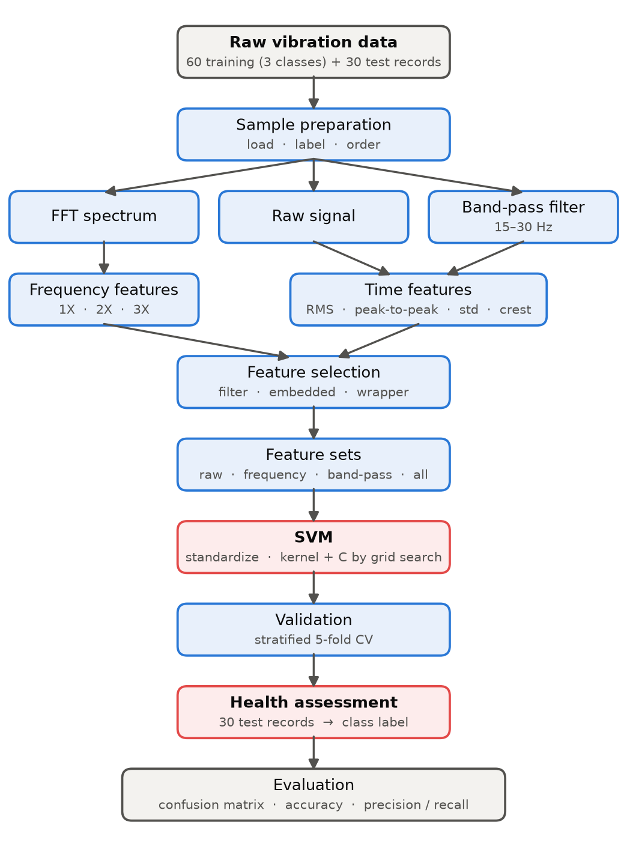
Figure 7. Flow chart of the solution process.

3. Results
Table 3. Tuned SVM per feature set: cross-validation accuracy on the 60 training records and accuracy on the 30 labelled test records.
Feature set | Features | Best kernel | CV accuracy | Test accuracy | Test errors
A: raw time-domain | 9 | linear | 0.48 | 0.33 | 20 / 30
B: frequency-domain | 5 | linear | 1.00 | 1.00 | 0 / 30
C: band-pass time-domain | 9 | linear | 1.00 | 1.00 | 0 / 30
D: all features | 23 | linear | 1.00 | 1.00 | 0 / 30

Table 3 gives the main result. The SVM trained on the assignment's raw time-domain features performs at chance level on the test set (10 of 30 correct for three classes), and no kernel helps (Figure 8). The frequency-domain, band-pass and combined feature sets all reach 100 % cross-validation accuracy and classify all 30 test records correctly. In every case the linear kernel with C = 1 is selected; RBF and polynomial kernels reach the same accuracy, so the simplest kernel is kept. Feature set B (five frequency-domain features) is used as the primary model because it is the smallest set with a perfect score.
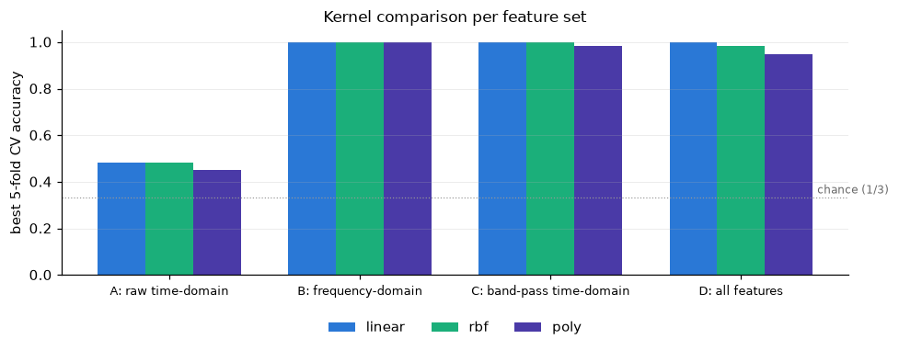
Figure 8. Best cross-validation accuracy per kernel and feature set.
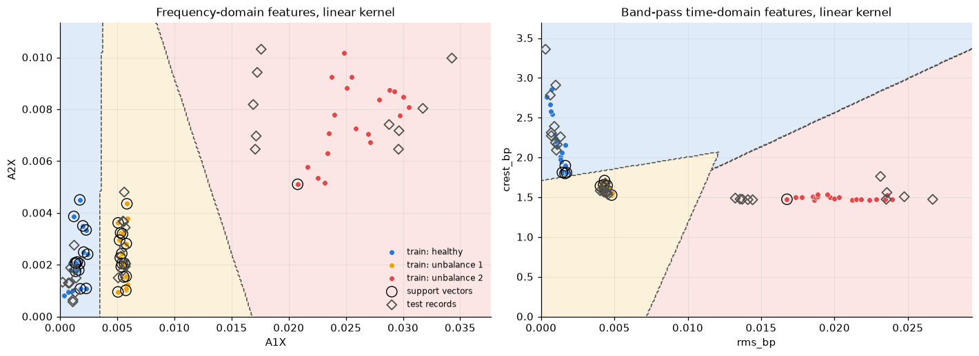
Figure 9. SVM decision regions, support vectors and test records for two feature pairs.
Figure 9 shows the decision regions of the linear SVM for two feature pairs: the three classes form well separated clusters, the support vectors (circled) are the few training records nearest to the boundaries, and all test records (diamonds) fall in the region of their true class. Figure 10 shows the test confusion matrices of the four feature sets; the primary model gives a diagonal 10/10/10 matrix with precision and recall of 1.000 for every class. Figure 11 gives the health label of each of the 30 test records: records 1 to 10 are healthy, 11 to 20 unbalance level 1 and 21 to 30 unbalance level 2, all matching the appendix.
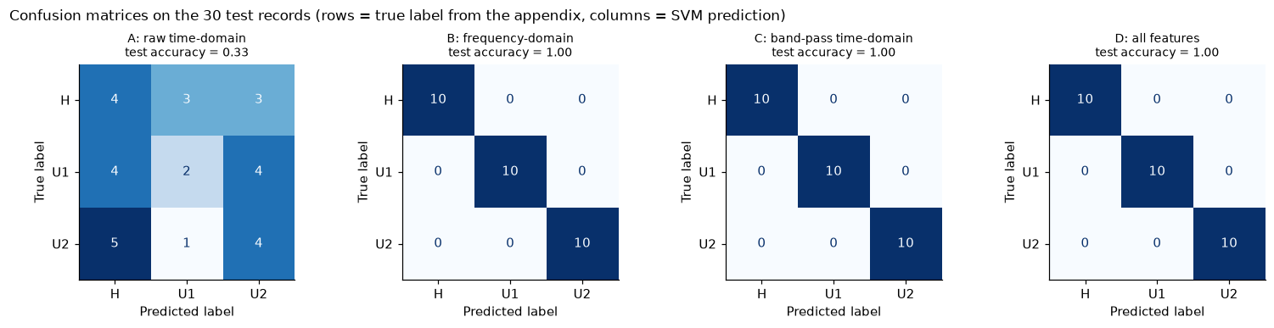
Figure 10. Confusion matrices on the 30 test records for the four feature sets.
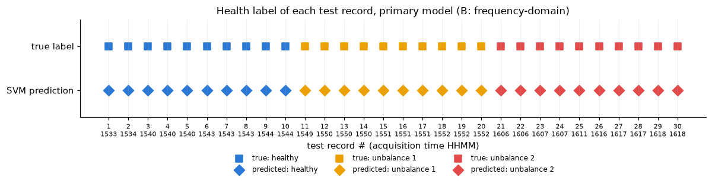
Figure 11. Health label of each test record: true label and SVM prediction.
Figure 12 places the test records on the 1X amplitude axis next to the training clusters. Records 21 to 25 lie inside or slightly above the level-2 training cluster, while records 26 to 30 (1X about 0.017 g) lie between the level-1 (0.0055 g) and level-2 (0.0257 g) clusters. The linear SVM puts its boundary between those clusters just below 0.017 g, so the five records are assigned to level 2 in agreement with the appendix, but they are the records with the smallest margin.
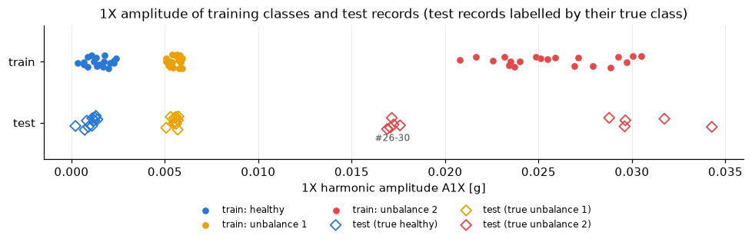
Figure 12. 1X amplitude of training classes and test records.

4. Discussion
Extracted features. The suggested raw time-domain statistics are nearly useless on this testbed, because mass unbalance adds a synchronous force at 21 Hz while the overall vibration level is set by 400 to 800 Hz structural content that is identical in all three conditions. Two routes reach the useful band: the FFT (1X and 2X amplitudes) or a band-pass filter followed by exactly the statistics the assignment suggests. The suggested features therefore do work, but only after the signal is filtered around the shaft frequency. Speed tracking of the 1X peak is essential; reading the spectrum at the nominal 20 Hz would destroy the feature.
Feature selection. Filter, embedded and wrapper methods give the same ranking, so the conclusion does not depend on the criterion. Each family adds something: the ANOVA filter orders the features by margin, mutual information saturates once a feature separates the classes perfectly, the SVM weights rank the shape features (crest, impulse factor) higher because the classifier uses them together with an amplitude feature, and the L1 penalty and RFE show that one amplitude feature is sufficient and that the five amplitude features are redundant.
Modelling technique. The classes are linearly separable in the standardized feature space, so the linear kernel is selected and the penalty C has no visible effect; the SVM optimizes the margin rather than the number of errors, and the support vectors are the records closest to the boundaries. Compared with the logistic regression of Homework 02, the SVM gives the same hard labels but no probability; the distance to the boundary plays the role of a confidence measure. With 20 records per class, cross-validation accuracy saturates at 100 % and cannot discriminate between kernels or feature sets, so parsimony and physical interpretability decide.
Results. All 30 test records are classified correctly by the frequency-domain, band-pass and combined models. Records 26 to 30 are correctly labelled level 2 but sit between the two unbalance training clusters, which suggests a smaller effective unbalance than the training level 2 (for example a different screw position); in Homework 02 the same five records had the lowest fault probability. A three-level classifier only resolves the levels it was trained on; a continuous severity indicator such as the 1X amplitude or the band-pass RMS is more informative when the unbalance can take intermediate values.
Limitations. The test set is small (10 per class) and was recorded on the same day as the training data, so the perfect score is not a guarantee for other speeds, loads or sensors. The perfect separability also means that the hyper-parameter search and the wrapper selection have nothing to trade off.

5. Conclusion
- The raw time-domain features suggested by the assignment (RMS, peak-to-peak, standard deviation) cannot separate healthy, level-1 and level-2 unbalance; an SVM trained on them performs at chance level (33 %) on the test set.
- The same statistics on a 15 to 30 Hz band-pass filtered signal, or the 1X and 2X FFT amplitudes, separate the three classes perfectly (ANOVA F above 1000). Filter, embedded and wrapper selection methods agree; one band-pass amplitude feature is already sufficient.
- A linear-kernel SVM (C = 1) chosen by stratified 5-fold cross-validation reaches 100 % cross-validation accuracy with frequency-domain, band-pass or combined features; RBF and polynomial kernels add nothing because the classes are linearly separable.
- On the 30 labelled test records the primary model predicts every record correctly: records 1 to 10 healthy, 11 to 20 unbalance level 1, 21 to 30 unbalance level 2, a diagonal 10/10/10 confusion matrix with precision and recall of 1.0 for every class. Records 26 to 30 lie between the two unbalance clusters, which a continuous severity indicator reveals and a class label hides.

6. Appendix – Codes
All results were produced by the Jupyter notebook hw3_rotor_bearing_svm.ipynb (Python 3.13; numpy, scipy, pandas, scikit-learn, matplotlib). The code cells are reproduced in execution order, grouped by notebook section; printed outputs are omitted.

1. Setup
# Imports, constants, and a consistent plotting style used throughout the notebook.
import re
from pathlib import Path

import numpy as np
import pandas as pd
import matplotlib.pyplot as plt
from matplotlib.patches import Patch
from scipy import signal, stats
from sklearn.svm import SVC
from sklearn.pipeline import make_pipeline
from sklearn.preprocessing import StandardScaler
from sklearn.model_selection import GridSearchCV, StratifiedKFold, cross_val_score, cross_val_predict
from sklearn.feature_selection import f_classif, mutual_info_classif, RFECV
from sklearn.svm import LinearSVC
from sklearn.metrics import confusion_matrix, accuracy_score, classification_report, ConfusionMatrixDisplay

FS = 2560.0 # sampling rate [Hz]
F_ROT = 20.0 # nominal shaft speed [Hz] (1X)

DATA_DIR = next(p for p in (Path("../data/rotor-bearing-hw3"), Path("data/rotor-bearing-hw3")) if p.exists()).resolve()
OUT_DIR = Path("results"); OUT_DIR.mkdir(exist_ok=True)

CLASSES = ["healthy", "unbalance 1", "unbalance 2"] # class index 0, 1, 2
COLORS = {"healthy": "#2a78d6", "unbalance 1": "#eda100", "unbalance 2": "#e34948"}
C_TEST = "#52514e"
CMAP = plt.matplotlib.colors.ListedColormap([COLORS[c] for c in CLASSES])
plt.rcParams.update({
"figure.dpi": 110, "axes.spines.top": False, "axes.spines.right": False,
"axes.grid": True, "grid.alpha": 0.25, "grid.linewidth": 0.6,
"lines.linewidth": 1.2, "font.size": 9.5, "legend.frameon": False,
})
pd.set_option("display.precision", 4)
print("Data folder:", DATA_DIR)

2. Data loading
# Read one record and parse the acquisition time / record index from the file name.
def load_record(path: Path) -> np.ndarray:
lines = path.read_text().splitlines()
start = next(i for i, l in enumerate(lines) if l.strip().lower() == "acceleration") + 1
return np.array([float(v) for v in lines[start:] if v.strip()])

def parse_name(path: Path):
m = re.search(r"Time (\d{4})-(\d+)", path.name)
return m.group(1), int(m.group(2))

def load_folder(folder: Path, label):
recs = []
for p in sorted(folder.glob("*.txt")):
t, idx = parse_name(p)
recs.append({"file": p.name, "time": t, "idx": idx, "label": label, "x": load_record(p)})
return recs

# True label of a test record, following the appendix table of the assignment.
def test_label(path: Path):
t, _ = parse_name(path)
if path.name.startswith("Data"):
return 0 # healthy
return 1 if int(t) < 1600 else 2 # 15:49-15:52 -> level 1, 16:06-16:18 -> level 2

healthy = load_folder(DATA_DIR / "Training" / "Healthy", 0)
unbal1 = load_folder(DATA_DIR / "Training" / "Faulty" / "Unbalance 1", 1)
unbal2 = load_folder(DATA_DIR / "Training" / "Faulty" / "Unbalance 2", 2)
testing = sorted([dict(r, label=test_label(DATA_DIR / "Testing" / r["file"])) for r in load_folder(DATA_DIR / "Testing", None)],
key=lambda r: (r["time"], r["idx"]))
training = healthy + unbal1 + unbal2

print(f"training: {len(healthy)} healthy, {len(unbal1)} unbalance 1, {len(unbal2)} unbalance 2 | testing: {len(testing)} records")
print("test labels (from appendix):", np.bincount([r["label"] for r in testing]), "= healthy, unbalance 1, unbalance 2")
print("samples per record:", {len(r["x"]) for r in training + testing}, "->", len(healthy[0]["x"]) / FS, "s each")

3. Raw data description
# Per-class summary statistics of the raw acceleration signals.
def raw_stats(recs, name):
x = np.concatenate([r["x"] for r in recs])
return pd.Series({"records": len(recs), "mean [g]": x.mean(), "std [g]": x.std(), "min [g]": x.min(), "max [g]": x.max()}, name=name)

pd.DataFrame([raw_stats(healthy, "healthy"), raw_stats(unbal1, "unbalance 1"), raw_stats(unbal2, "unbalance 2"), raw_stats(testing, "testing")])

# Time waveforms of one record per class (first 0.5 s, about 10 shaft revolutions).
t = np.arange(len(healthy[0]["x"])) / FS
n_show = int(0.5 * FS)
fig, axes = plt.subplots(3, 1, figsize=(9, 5.4), sharex=True, sharey=True)
for ax, rec, cls in zip(axes, (healthy[0], unbal1[0], unbal2[0]), CLASSES):
ax.plot(t[:n_show], rec["x"][:n_show], color=COLORS[cls], lw=0.8)
ax.set_title(f"{cls}: {rec['file']}", loc="left", fontsize=9); ax.set_ylabel("acc. [g]")
axes[-1].set_xlabel("time [s]")
fig.suptitle("Raw vibration waveforms (first 0.5 s)", x=0.01, ha="left", fontsize=11)
fig.tight_layout(); plt.show()

# Hann-windowed single-sided amplitude spectrum, and class-averaged spectra in the 0-100 Hz band.
def amplitude_spectrum(x: np.ndarray):
x = x - x.mean(); w = np.hanning(len(x))
return np.fft.rfftfreq(len(x), d=1 / FS), 2.0 * np.abs(np.fft.rfft(x * w)) / w.sum()

def mean_spectrum(recs):
f = amplitude_spectrum(recs[0]["x"])[0]
return f, np.mean([amplitude_spectrum(r["x"])[1] for r in recs], axis=0)

fig, axes = plt.subplots(1, 2, figsize=(11, 3.6))
for recs, cls in zip((healthy, unbal1, unbal2), CLASSES):
f, A = mean_spectrum(recs)
axes[0].plot(f, A, color=COLORS[cls], lw=0.7, label=cls)
m = f <= 100
axes[1].plot(f[m], A[m], color=COLORS[cls], lw=1.1, label=cls)
axes[0].set(title="Class-averaged amplitude spectrum, 0-1280 Hz", xlabel="frequency [Hz]", ylabel="amplitude [g]")
axes[1].set(title="Zoom 0-100 Hz", xlabel="frequency [Hz]")
for k in (1, 2, 3):
axes[1].axvline(k * 21.05, color="0.7", ls=":", lw=0.8)
axes[1].text(k * 21.05 + 1, axes[1].get_ylim()[1] * 0.85, f"{k}X", color="0.4", fontsize=8)
axes[1].legend(); fig.tight_layout(); plt.show()

4. Feature extraction
# Time-domain statistics of a signal, suffixed with the signal they come from.
TD_STATS = ["rms", "p2p", "std", "peak", "crest", "kurtosis", "skewness", "shape", "impulse"]

def time_domain_features(x: np.ndarray, tag: str) -> dict:
rms = np.sqrt(np.mean(x ** 2)); peak = np.max(np.abs(x)); mean_abs = np.mean(np.abs(x))
return {f"rms_{tag}": rms, f"p2p_{tag}": np.ptp(x), f"std_{tag}": x.std(), f"peak_{tag}": peak,
f"crest_{tag}": peak / rms, f"kurtosis_{tag}": stats.kurtosis(x), f"skewness_{tag}": stats.skew(x),
f"shape_{tag}": rms / mean_abs, f"impulse_{tag}": peak / mean_abs}

# Zero-phase band-pass filter around 1X (4th-order Butterworth, forward-backward), with edge trimming.
SOS_BP = signal.butter(4, [15.0, 30.0], btype="band", fs=FS, output="sos")
TRIM = int(1.0 * FS)
def bandpass(x): return signal.sosfiltfilt(SOS_BP, x)[TRIM:-TRIM]

def band_peak(f, A, f_center, half_width):
m = (f >= f_center - half_width) & (f <= f_center + half_width)
i = np.argmax(A[m]); return A[m][i], f[m][i]

# Full feature vector for one record.
def extract_features(x: np.ndarray) -> dict:
f, A = amplitude_spectrum(x)
a1, f1 = band_peak(f, A, F_ROT, 0.15 * F_ROT)
a2, _ = band_peak(f, A, 2 * f1, 1.0)
a3, _ = band_peak(f, A, 3 * f1, 1.0)
lf = (f > 0) & (f <= 100)
d = {"A1X": a1, "A2X": a2, "A3X": a3, "f1X": f1,
"rms_lf": np.sqrt(np.sum((A[lf] / np.sqrt(2)) ** 2)), "ratio_1X": a1 / np.sqrt(np.mean(x ** 2))}
d |= time_domain_features(x[TRIM:-TRIM], "raw")
d |= time_domain_features(bandpass(x), "bp")
return d

def feature_table(recs):
rows = []
for r in recs:
d = extract_features(r["x"]); d.update(file=r["file"], time=r["time"], label=r["label"]); rows.append(d)
return pd.DataFrame(rows)

train = feature_table(training)
test = feature_table(testing)
FEAT_RAW = [f"{s}_raw" for s in TD_STATS]
FEAT_SPEC = ["A1X", "A2X", "A3X", "rms_lf", "ratio_1X"]
FEAT_BP = [f"{s}_bp" for s in TD_STATS]
FEATURES = FEAT_RAW + FEAT_SPEC + FEAT_BP
y_train, y_test = train.label.values, test.label.values
train.to_csv(OUT_DIR / "train_features.csv", index=False); test.to_csv(OUT_DIR / "test_features.csv", index=False)
print(f"{len(FEATURES)} features per record: {len(FEAT_RAW)} raw time-domain, {len(FEAT_SPEC)} frequency-domain, {len(FEAT_BP)} band-pass time-domain")
train.groupby("label")[FEATURES].mean().T.rename(columns=dict(enumerate(CLASSES)))

5. Feature exploration and selection
# Box plot helper: one panel per feature, three classes.
rng = np.random.default_rng(0)
def box_panel(ax, feat, title):
data = [train.loc[train.label == k, feat] for k in range(3)]
bp = ax.boxplot(data, widths=0.5, patch_artist=True, medianprops=dict(color="black", lw=1),
flierprops=dict(marker="o", markersize=3, markerfacecolor="none"))
for patch, cls in zip(bp["boxes"], CLASSES):
patch.set(facecolor=COLORS[cls], alpha=0.35, edgecolor=COLORS[cls])
for i, (d, cls) in enumerate(zip(data, CLASSES), start=1):
ax.scatter(i + rng.uniform(-0.12, 0.12, len(d)), d, s=8, color=COLORS[cls], alpha=0.85, zorder=3)
ax.set_xticks([1, 2, 3]); ax.set_xticklabels(["H", "U1", "U2"]); ax.set_title(title, fontsize=9)

def box_grid(feats, suptitle, ncol=5):
nrow = int(np.ceil(len(feats) / ncol))
fig, axes = plt.subplots(nrow, ncol, figsize=(2.6 * ncol, 2.7 * nrow))
for ax, feat in zip(np.ravel(axes), feats):
F = f_classif(train[[feat]].values, y_train)[0][0]
box_panel(ax, feat, f"{feat}\nF = {F:.3g}")
for ax in np.ravel(axes)[len(feats):]:
ax.axis("off")
fig.suptitle(suptitle, x=0.01, ha="left", fontsize=11, fontweight="bold"); fig.tight_layout(); plt.show()

box_grid(FEAT_RAW, "5a. Raw time-domain features (suggested by the assignment) H = healthy, U1 / U2 = unbalance level 1 / 2")
box_grid(FEAT_SPEC, "5b. Frequency-domain features")
box_grid(FEAT_BP, "5c. Band-pass (15-30 Hz) time-domain features")

# Three-class separability ranking: ANOVA F-statistic and p-value for every feature.
F, p = f_classif(train[FEATURES].values, y_train)
ranking = pd.DataFrame({"feature": FEATURES, "F": F, "p-value": p,
"group": ["raw time-domain"] * len(FEAT_RAW) + ["frequency-domain"] * len(FEAT_SPEC) + ["band-pass time-domain"] * len(FEAT_BP)})
ranking = ranking.sort_values("F", ascending=False).reset_index(drop=True)

group_color = {"raw time-domain": "#86b6ef", "frequency-domain": "#eb6834", "band-pass time-domain": "#1c5cab"}
fig, ax = plt.subplots(figsize=(8.5, 6))
rk = ranking[::-1]
ax.barh(rk.feature, rk.F.clip(lower=1e-2), color=[group_color[g] for g in rk.group], height=0.65)
ax.set(xscale="log", xlabel="ANOVA F-statistic (log scale)", title="Three-class feature separability")
ax.grid(axis="y", visible=False)
ax.legend(handles=[Patch(color=c, label=g) for g, c in group_color.items()], loc="lower right")
fig.tight_layout(); plt.show()
ranking.style.format({"F": "{:.3g}", "p-value": "{:.2e}"}).hide(axis="index")

5.2 Wrapper and embedded methods
# Standardized training matrix shared by the selection methods below.
scaler_all = StandardScaler().fit(train[FEATURES].values)
Z_all = scaler_all.transform(train[FEATURES].values)
CV = StratifiedKFold(n_splits=5, shuffle=True, random_state=0) # stratified 5-fold splitter, reused in section 6

# Filter 2: mutual information between each feature and the class label.
mi = mutual_info_classif(Z_all, y_train, random_state=0)

# Embedded 1: weights of the tuned linear SVM on all features (one-vs-one gives three pairwise classifiers; take the mean |w|).
svm_lin = SVC(kernel="linear", C=1).fit(Z_all, y_train)
w_abs = np.abs(svm_lin.coef_).mean(axis=0)

# Embedded 2: L1-penalized linear SVM. Sweep the penalty and count the surviving (non-zero) features.
l1_path = []
for C in [0.01, 0.02, 0.05, 0.1, 0.2, 0.5, 1.0]:
l1 = LinearSVC(penalty="l1", dual=False, C=C, max_iter=20000).fit(Z_all, y_train)
alive = np.any(np.abs(l1.coef_) > 1e-6, axis=0)
cv_acc = cross_val_score(make_pipeline(StandardScaler(), LinearSVC(penalty="l1", dual=False, C=C, max_iter=20000)), train[FEATURES].values, y_train, cv=CV).mean()
l1_path.append({"C": C, "features kept": int(alive.sum()), "CV accuracy": cv_acc, "kept": [f for f, a in zip(FEATURES, alive) if a]})
l1_tab = pd.DataFrame(l1_path)
# smallest penalty that still gives perfect cross-validation accuracy
C_L1 = l1_tab.loc[l1_tab["CV accuracy"] >= l1_tab["CV accuracy"].max() - 1e-9, "C"].min()
l1_keep = l1_tab.loc[l1_tab.C == C_L1, "kept"].iloc[0]
print(f"L1-SVM: smallest C with the best CV accuracy = {C_L1} -> keeps {len(l1_keep)} feature(s): {l1_keep}")
l1_tab[["C", "features kept", "CV accuracy"]].style.format({"CV accuracy": "{:.3f}"}).hide(axis="index")

# Wrapper: recursive feature elimination with 5-fold cross-validation, using the linear SVM as the estimator.
rfecv = RFECV(SVC(kernel="linear", C=1), step=1, min_features_to_select=1, cv=CV, scoring="accuracy").fit(Z_all, y_train)
n_feat = np.arange(1, len(FEATURES) + 1)
mean_acc, std_acc = rfecv.cv_results_["mean_test_score"], rfecv.cv_results_["std_test_score"]
rfe_selected = [f for f, keep in zip(FEATURES, rfecv.support_) if keep]
print(f"RFECV: smallest subset reaching the best CV accuracy = {rfecv.n_features_} feature(s): {rfe_selected}")

fig, ax = plt.subplots(figsize=(8, 3.2))
ax.fill_between(n_feat, mean_acc - std_acc, mean_acc + std_acc, color="#86b6ef", alpha=0.4, label="±1 std over folds")
ax.plot(n_feat, mean_acc, marker="o", ms=4, color="#1c5cab", label="mean CV accuracy")
ax.axvline(rfecv.n_features_, color=COLORS["unbalance 2"], ls="--", lw=1, label=f"selected: {rfecv.n_features_} feature(s)")
ax.set(xlabel="number of features kept (RFE eliminates the smallest-weight feature at each step)", ylabel="5-fold CV accuracy",
ylim=(0.3, 1.03), title="Wrapper method: recursive feature elimination with cross-validation")
ax.legend(loc="lower right"); fig.tight_layout(); plt.show()

# Side-by-side comparison of the four criteria: rank of every feature under each method (1 = most important).
comp = pd.DataFrame({"feature": FEATURES, "ANOVA F": F, "mutual info": mi, "linear SVM |w|": w_abs,
"RFE order": rfecv.ranking_, # 1 = kept to the end, larger = eliminated earlier
"L1-SVM kept": [f in l1_keep for f in FEATURES]})
for col in ["ANOVA F", "mutual info", "linear SVM |w|"]:
comp[f"rank {col}"] = comp[col].rank(ascending=False).astype(int)
comp["rank RFE"] = comp["RFE order"].rank(method="min").astype(int)
comp = comp.sort_values("rank ANOVA F").reset_index(drop=True)

rank_cols = ["rank ANOVA F", "rank mutual info", "rank linear SVM |w|", "rank RFE"]
print("Spearman correlation between rankings (1 = identical order):")
print(comp[rank_cols].corr(method="spearman").round(2).to_string())

fig, ax = plt.subplots(figsize=(10, 6))
mat = comp[rank_cols].values
im = ax.imshow(mat, cmap="Blues_r", aspect="auto", vmin=1, vmax=len(FEATURES))
ax.set_xticks(range(len(rank_cols))); ax.set_xticklabels(["ANOVA F\n(filter)", "mutual info\n(filter)", "SVM |w|\n(embedded)", "RFE\n(wrapper)"])
ax.set_yticks(range(len(comp))); ax.set_yticklabels([f + (" *" if k else "") for f, k in zip(comp.feature, comp["L1-SVM kept"])], fontsize=8.5)
for i in range(mat.shape[0]):
for j in range(mat.shape[1]):
ax.text(j, i, mat[i, j], ha="center", va="center", fontsize=8, color="white" if mat[i, j] <= 8 else "#0b0b0b")
ax.set_title("Feature rank under each selection method (1 = most important; * = kept by the L1-SVM)", fontsize=10); ax.grid(False)
fig.tight_layout(); plt.show()
comp[["feature"] + rank_cols + ["L1-SVM kept"]].style.hide(axis="index")

6. Support vector machine
# Minimal linear soft-margin SVM trained with Pegasos (stochastic sub-gradient descent on the hinge loss).
class LinearSVMScratch:
def __init__(self, lam=0.01, n_epochs=2000, seed=0):
self.lam, self.n_epochs, self.seed = lam, n_epochs, seed

def fit(self, X, y):
X = np.asarray(X, float); y = np.where(np.asarray(y) > 0, 1.0, -1.0)
n, d = X.shape; rng = np.random.default_rng(self.seed)
w, b, t = np.zeros(d), 0.0, 0
w_sum, b_sum = np.zeros(d), 0.0
for _ in range(self.n_epochs):
for i in rng.permutation(n):
t += 1; eta = 1.0 / (self.lam * t)
if y[i] * (X[i] @ w + b) < 1: # margin violated: hinge sub-gradient active
w = (1 - eta * self.lam) * w + eta * y[i] * X[i]; b += eta * y[i]
else:
w = (1 - eta * self.lam) * w
w_sum += w; b_sum += b
self.coef_, self.intercept_ = w_sum / t, b_sum / t # averaged iterate (more stable)
self.hinge_ = np.mean(np.maximum(0, 1 - y * (X @ self.coef_ + self.intercept_)))
return self

def decision_function(self, X): return np.asarray(X, float) @ self.coef_ + self.intercept_
def predict(self, X): return (self.decision_function(X) >= 0).astype(int)

# Binary check (healthy = 0 vs faulty = 1) on two standardized features.
Xb = train[["A1X", "A2X"]].values; yb = (y_train > 0).astype(int)
scaler_b = StandardScaler().fit(Xb); Zb = scaler_b.transform(Xb)
lam = 0.01; C_equiv = 1.0 / (lam * len(Zb)) # Pegasos lambda <-> sklearn C = 1 / (lambda n)
scratch = LinearSVMScratch(lam=lam).fit(Zb, yb)
sk = SVC(kernel="linear", C=C_equiv).fit(Zb, yb)
print(f"scratch : w = {scratch.coef_.round(3)}, b = {scratch.intercept_:.3f}, mean hinge loss = {scratch.hinge_:.4f}")
print(f"sklearn : w = {sk.coef_[0].round(3)}, b = {sk.intercept_[0]:.3f} (C = {C_equiv:.3g})")
print("training accuracy scratch / sklearn:", accuracy_score(yb, scratch.predict(Zb)), "/", accuracy_score(yb, sk.predict(Zb)))
print("direction cosine between the two weight vectors:", np.dot(scratch.coef_, sk.coef_[0]) / np.linalg.norm(scratch.coef_) / np.linalg.norm(sk.coef_[0]))

# Visual check: both hyperplanes (and sklearn's margin / support vectors) on the standardized A1X-A2X plane.
fig, ax = plt.subplots(figsize=(7.5, 4.5))
for k, cls in enumerate(CLASSES):
m = y_train == k
ax.scatter(Zb[m, 0], Zb[m, 1], s=26, color=COLORS[cls], label=cls, zorder=3)
ax.scatter(Zb[sk.support_, 0], Zb[sk.support_, 1], s=110, facecolor="none", edgecolor="black", lw=1.0, label="support vectors (sklearn)", zorder=4)
xx = np.linspace(Zb[:, 0].min() - 0.3, Zb[:, 0].max() + 0.3, 200)
for mdl, c, name, ls in [(scratch, "0.2", "from scratch", "-"), (sk, "#4a3aa7", "sklearn", "--")]:
w, b = (mdl.coef_, mdl.intercept_) if mdl is scratch else (mdl.coef_[0], mdl.intercept_[0])
for off, lw in [(0, 1.6), (1, 0.7), (-1, 0.7)]:
ax.plot(xx, (off - b - w[0] * xx) / w[1], color=c, ls=ls, lw=lw, label=f"{name}: w·x + b = 0" if off == 0 else None)
ax.set(xlabel="A1X (standardized)", ylabel="A2X (standardized)", ylim=(Zb[:, 1].min() - 0.6, Zb[:, 1].max() + 0.6),
title="Linear SVM, healthy vs faulty: scratch vs scikit-learn (thin lines: margins)")
ax.legend(loc="upper right", fontsize=8); fig.tight_layout(); plt.show()

6.2 Multi-class SVM: kernel and hyper-parameter selection
# Feature sets and the hyper-parameter grid.
FEATURE_SETS = {
"A: raw time-domain": FEAT_RAW,
"B: frequency-domain": FEAT_SPEC,
"C: band-pass time-domain": FEAT_BP,
"D: all features": FEATURES,
}
GRID = [
{"svc__kernel": ["linear"], "svc__C": [0.01, 0.1, 1, 10, 100]},
{"svc__kernel": ["rbf"], "svc__C": [0.1, 1, 10, 100], "svc__gamma": ["scale", 0.01, 0.1, 1]},
{"svc__kernel": ["poly"], "svc__C": [0.1, 1, 10], "svc__degree": [2, 3], "svc__gamma": ["scale"]},
]
CV = StratifiedKFold(n_splits=5, shuffle=True, random_state=0)

searches, rows = {}, []
for name, feats in FEATURE_SETS.items():
pipe = make_pipeline(StandardScaler(), SVC())
gs = GridSearchCV(pipe, GRID, cv=CV, scoring="accuracy").fit(train[feats].values, y_train)
searches[name] = gs
best = gs.best_params_
rows.append({"feature set": name, "n features": len(feats), "best kernel": best["svc__kernel"], "C": best["svc__C"],
"gamma / degree": best.get("svc__gamma", best.get("svc__degree", "-")),
"CV accuracy": gs.best_score_, "CV std": gs.cv_results_["std_test_score"][gs.best_index_],
"train accuracy": gs.best_estimator_.score(train[feats].values, y_train)})
cv_table = pd.DataFrame(rows).set_index("feature set")
cv_table.style.format({"CV accuracy": "{:.3f}", "CV std": "{:.3f}", "train accuracy": "{:.3f}"})

# How the kernels compare within each feature set (best C / gamma per kernel).
fig, ax = plt.subplots(figsize=(9, 3.6))
width = 0.25; kernels = ["linear", "rbf", "poly"]; kcol = {"linear": "#2a78d6", "rbf": "#1baf7a", "poly": "#4a3aa7"}
for j, k in enumerate(kernels):
vals = []
for name, gs in searches.items():
res = pd.DataFrame(gs.cv_results_); vals.append(res.loc[res["param_svc__kernel"] == k, "mean_test_score"].max())
ax.bar(np.arange(len(searches)) + (j - 1) * width, vals, width, color=kcol[k], label=k)
ax.set_xticks(np.arange(len(searches))); ax.set_xticklabels([n.split(":")[0] + ":" + n.split(":")[1][:22] for n in searches], fontsize=8.5)
ax.axhline(1 / 3, color="0.6", ls=":", lw=0.8); ax.text(len(searches) - 0.6, 0.35, "chance (1/3)", color="0.4", fontsize=8)
ax.set(ylim=(0, 1.05), ylabel="best 5-fold CV accuracy", title="Kernel comparison per feature set")
ax.grid(axis="x", visible=False); ax.legend(loc="upper center", bbox_to_anchor=(0.5, -0.14), ncol=3); fig.tight_layout(); plt.show()

# Cross-validated confusion matrices on the training data (out-of-fold predictions of the tuned models).
fig, axes = plt.subplots(1, 4, figsize=(14, 3.4))
for ax, (name, gs) in zip(axes, searches.items()):
feats = FEATURE_SETS[name]
y_oof = cross_val_predict(gs.best_estimator_, train[feats].values, y_train, cv=CV)
ConfusionMatrixDisplay(confusion_matrix(y_train, y_oof), display_labels=["H", "U1", "U2"]).plot(ax=ax, colorbar=False, cmap="Blues")
ax.set_title(f"{name}\nCV accuracy = {accuracy_score(y_train, y_oof):.2f}", fontsize=9); ax.grid(False)
fig.suptitle("Out-of-fold confusion matrices on the 60 training records", x=0.01, ha="left", fontsize=11)
fig.tight_layout(); plt.show()

6.3 Decision regions of the tuned SVM
# Decision-region plot for a two-feature SVM, with support vectors and the test records overlaid.
def plot_regions(ax, feats, params, title):
pipe = make_pipeline(StandardScaler(), SVC(**{k.replace("svc__", ""): v for k, v in params.items()}))
pipe.fit(train[feats].values, y_train)
x0 = np.concatenate([train[feats[0]], test[feats[0]]]); x1 = np.concatenate([train[feats[1]], test[feats[1]]])
g0 = np.linspace(0, x0.max() * 1.1, 300); g1 = np.linspace(0, x1.max() * 1.1, 300)
G0, G1 = np.meshgrid(g0, g1)
Z = pipe.predict(np.c_[G0.ravel(), G1.ravel()]).reshape(G0.shape)
ax.contourf(G0, G1, Z, levels=[-0.5, 0.5, 1.5, 2.5], colors=[COLORS[c] for c in CLASSES], alpha=0.14)
ax.contour(G0, G1, Z, levels=[0.5, 1.5], colors="0.3", linewidths=1.0, linestyles="--")
for k, cls in enumerate(CLASSES):
m = y_train == k
ax.scatter(train.loc[m, feats[0]], train.loc[m, feats[1]], s=26, color=COLORS[cls], edgecolor="white", lw=0.4, label=f"train: {cls}", zorder=3)
sv = pipe[-1].support_
ax.scatter(train.iloc[sv][feats[0]], train.iloc[sv][feats[1]], s=100, facecolor="none", edgecolor="black", lw=0.9, label="support vectors", zorder=4)
ax.scatter(test[feats[0]], test[feats[1]], s=42, marker="D", facecolor="none", edgecolor=C_TEST, lw=1.2, label="test records", zorder=5)
ax.set(xlabel=feats[0], ylabel=feats[1], title=title, xlim=(g0[0], g0[-1]), ylim=(g1[0], g1[-1]))
return pipe

fig, axes = plt.subplots(1, 2, figsize=(13, 4.8))
pB = searches["B: frequency-domain"].best_params_
pC = searches["C: band-pass time-domain"].best_params_
plot_regions(axes[0], ["A1X", "A2X"], pB, f"Frequency-domain features, {pB['svc__kernel']} kernel")
plot_regions(axes[1], ["rms_bp", "crest_bp"], pC, f"Band-pass time-domain features, {pC['svc__kernel']} kernel")
axes[0].legend(loc="lower right", fontsize=8); fig.tight_layout(); plt.show()

7. Health assessment of the test data
# Predict the test records with every tuned model and score against the appendix labels.
res = test[["file", "time", "A1X", "A2X", "rms_bp", "rms_raw"]].copy()
res.insert(0, "#", np.arange(1, len(res) + 1))
res["true"] = [CLASSES[k] for k in y_test]
acc_rows = []
for name, gs in searches.items():
key = name.split(":")[0]
pred = gs.best_estimator_.predict(test[FEATURE_SETS[name]].values)
res[f"pred_{key}"] = [CLASSES[k] for k in pred]
acc_rows.append({"feature set": name, "CV accuracy": gs.best_score_, "test accuracy": accuracy_score(y_test, pred),
"test errors": int((pred != y_test).sum())})
acc_table = pd.DataFrame(acc_rows).set_index("feature set")

# Primary model: best CV accuracy, fewer features on ties.
order = sorted(searches, key=lambda n: (-searches[n].best_score_, len(FEATURE_SETS[n])))
BEST = order[0]; best_key = BEST.split(":")[0]
res["predicted"] = res[f"pred_{best_key}"]; res["correct"] = res.predicted == res.true
res.to_csv(OUT_DIR / "test_health_assessment.csv", index=False)
print("primary model:", BEST, "|", searches[BEST].best_params_)
acc_table.style.format({"CV accuracy": "{:.3f}", "test accuracy": "{:.3f}"})

# Confusion matrices on the 30 test records for all four feature sets.
fig, axes = plt.subplots(1, 4, figsize=(14, 3.4))
for ax, name in zip(axes, searches):
key = name.split(":")[0]
cm = confusion_matrix(res.true.map(CLASSES.index), res[f"pred_{key}"].map(CLASSES.index), labels=[0, 1, 2])
ConfusionMatrixDisplay(cm, display_labels=["H", "U1", "U2"]).plot(ax=ax, colorbar=False, cmap="Blues")
ax.set_title(f"{name}\ntest accuracy = {acc_table.loc[name, 'test accuracy']:.2f}", fontsize=9); ax.grid(False)
fig.suptitle("Confusion matrices on the 30 test records (rows = true label from the appendix, columns = SVM prediction)", x=0.01, ha="left", fontsize=11)
fig.tight_layout(); plt.show()

# Primary model: confusion matrix and per-class precision / recall.
y_pred_best = res.predicted.map(CLASSES.index).values
fig, ax = plt.subplots(figsize=(4.2, 3.8))
ConfusionMatrixDisplay(confusion_matrix(y_test, y_pred_best, labels=[0, 1, 2]), display_labels=CLASSES).plot(ax=ax, colorbar=False, cmap="Blues")
ax.set_title(f"Primary model ({BEST}): test accuracy = {accuracy_score(y_test, y_pred_best):.3f}", fontsize=9.5); ax.grid(False)
plt.setp(ax.get_xticklabels(), rotation=20, ha="right"); fig.tight_layout(); plt.show()
print(classification_report(y_test, y_pred_best, target_names=CLASSES, digits=3))

# Health label of every test record: true label vs predicted label, in chronological order.
fig, ax = plt.subplots(figsize=(11, 3.2))
for k, cls in enumerate(CLASSES):
m = res.true == cls
ax.scatter(res["#"][m], np.full(m.sum(), 1), s=70, marker="s", color=COLORS[cls], label=f"true: {cls}")
m = res.predicted == cls
ax.scatter(res["#"][m], np.full(m.sum(), 0), s=70, marker="D", color=COLORS[cls], label=f"predicted: {cls}")
for n, ok in zip(res["#"], res.correct):
if not ok: ax.annotate("x", (n, 0.5), ha="center", va="center", color="black", fontsize=11, fontweight="bold")
ax.set_yticks([0, 1]); ax.set_yticklabels(["SVM prediction", "true label"]); ax.set_ylim(-0.6, 1.6)
ax.set_xticks(res["#"]); ax.set_xticklabels([f"{n}\n{t}" for n, t in zip(res["#"], res.time)], fontsize=7)
ax.set(xlabel="test record # (acquisition time HHMM)", title=f"Health label of each test record, primary model ({BEST})")
ax.grid(axis="y", visible=False); ax.legend(loc="upper center", bbox_to_anchor=(0.5, -0.32), ncol=3, fontsize=8)
fig.tight_layout(); plt.show()

# Per-record results table (true label from the appendix, prediction of every feature set, primary prediction).
show = res[["#", "file", "A1X", "rms_bp", "true"] + [f"pred_{n.split(':')[0]}" for n in searches] + ["predicted", "correct"]]
def color_cls(v):
return f"color: {COLORS[v]}; font-weight: bold" if v in COLORS else ""
show.style.format({"A1X": "{:.4f}", "rms_bp": "{:.4f}"}).map(color_cls, subset=["true", "predicted"] + [c for c in show.columns if c.startswith("pred_")]).hide(axis="index")

# Where the test records sit relative to the training classes on the two strongest features.
fig, ax = plt.subplots(figsize=(9, 3.2))
rng = np.random.default_rng(1)
for k, cls in enumerate(CLASSES):
v = train.loc[train.label == k, "A1X"]
ax.scatter(v, np.full(len(v), 1) + rng.uniform(-0.12, 0.12, len(v)), s=22, color=COLORS[cls], label=f"train: {cls}")
for k, cls in enumerate(CLASSES):
m = res.true == cls
ax.scatter(res.A1X[m], np.zeros(m.sum()) + rng.uniform(-0.12, 0.12, m.sum()), s=40, marker="D", facecolor="none", edgecolor=COLORS[cls], lw=1.2, label=f"test (true {cls})")
mid = res.A1X[(res.A1X > 0.015) & (res.A1X < 0.02)]
ax.annotate(f"#{res['#'][mid.index].min()}-{res['#'][mid.index].max()}", (mid.mean(), -0.3), ha="center", fontsize=8, color="0.3")
ax.set_yticks([0, 1]); ax.set_yticklabels(["test", "train"]); ax.set_ylim(-0.6, 1.6)
ax.set(xlabel="1X harmonic amplitude A1X [g]", title="1X amplitude of training classes and test records (test records labelled by their true class)")
ax.grid(axis="y", visible=False); ax.legend(loc="upper center", bbox_to_anchor=(0.5, -0.28), ncol=3, fontsize=8); fig.tight_layout(); plt.show()

