Environmental Data Analysis
Data Wrangling Report
Created by Moataz Kamal & Yousef Sherif
Year: 2022
Tools: Python (Pandas) + Tableau

1. Project context
This report documents the full workflow used to clean, prepare, analyze, and visualize environmental indicators with a focus on Carbon Monoxide (CO) and Temperature (TEMP) for the year 2022. The final deliverable is a Tableau dashboard that combines global distribution maps with a monthly trend view.

2. Data sources and structure
Two CSV files were used as the final analysis-ready inputs for Tableau:
File | Grain | Rows | Columns | Main use in Tableau
01_air_clean.csv | Daily city records (2022) | 10,000 | 21 | Country/city averages + map layers
07_city_month_trends.csv | City-month aggregates (12 months) | 240 | 14 | Monthly trend (seasonality) + comparisons

Coverage: 20 cities across 19 countries. Date range: 2022-01-01 to 2022-12-28.

3. Data wrangling process (Python)
The wrangling steps below were applied before building Tableau visuals.

3.1 Ingestion and profiling
• Loaded both CSV files using Pandas.
• Checked dataset size, column names, and data types.
• Verified missing values and duplicates.

3.2 Data type standardization
• Converted the Date column to datetime.
• Ensured pollutant and weather fields are numeric (float).
• Ensured boolean flags are stored as True/False.

3.3 Quality rules and validation flags
To make data quality visible and auditable, simple validation columns were added:
• Flag_Humidity_Range: marks humidity values outside 0-100.
• Flag_Wind_Negative: marks wind speed values below 0.
In the provided dataset, these flags are always False, which supports that the exported data is already consistent.

3.4 Feature engineering for time analysis
Time fields were derived from Date to simplify Tableau work:
• Year (int)
• Month (1-12)
• MonthName (January to December)
• Day (1-31)

3.5 City-level spike logic (PM2.5)
A spike indicator was created to highlight extreme PM2.5 days per city:
• PM25_P90_City: the 90th percentile PM2.5 threshold computed per city.
• PM25_Spike: True when PM2.5 is higher than that city’s PM25_P90_City.
In this dataset, PM25_Spike is True for 10.04% of daily records.

3.6 Monthly aggregation for trends
The monthly trends dataset (07_city_month_trends.csv) was built to support seasonality charts:
• Grouped daily records by City and Month.
• Calculated monthly averages for CO, Temperature, PM2.5, PM10, NO2, SO2, O3, Humidity, and Wind Speed.
• Summed PM25_Spike per city-month into PM25_SpikeCount.

3.7 Export for Tableau
After cleaning and feature engineering, the outputs were saved as CSV and used directly in Tableau. This avoids doing heavy calculations inside Tableau and makes the pipeline reproducible.

4. Analysis approach
The analysis was designed to answer two questions:
1) Where are CO and Temperature higher or lower across the world?
2) How do CO and Temperature change across the months of 2022?

4.1 Core descriptive statistics (daily records)
Key metrics from 01_air_clean.csv are shown below (daily granularity).
Metric | Mean | Min | Max
CO | 5.048 | 0.1 | 10.0
Temperature | 14.897 | -10.0 | 40.0
PM2.5 | 77.448 | 5.02 | 149.98
PM10 | 104.438 | 10.0 | 200.0
NO2 | 52.199 | 5.01 | 100.0
SO2 | 25.344 | 1.0 | 49.99
O3 | 106.032 | 10.04 | 200.0
Humidity | 55.079 | 10.01 | 99.99
Wind Speed | 10.232 | 0.5 | 20.0

4.2 Monthly behavior (city-month averages)
Using 07_city_month_trends.csv, we computed overall monthly averages across all cities. Average CO ranges from 4.963 (December) to 5.173 (April), a range of 0.210. Average Temperature ranges from 14.228 (November) to 15.770 (June).
Monthly averages across all cities (CO and Temperature):
Month | Avg CO | Avg Temperature
January | 5.008 | 14.241
February | 5.063 | 14.721
March | 5.079 | 14.651
April | 5.173 | 14.850
May | 5.029 | 14.993
June | 5.020 | 15.770
July | 5.064 | 15.306
August | 5.026 | 15.043
September | 5.071 | 14.703
October | 5.084 | 14.608
November | 5.061 | 14.228
December | 4.963 | 15.426

4.3 CO vs Temperature relationship
To test whether CO and Temperature move together in this dataset, Pearson correlation was calculated:
• Daily record correlation (01_air_clean.csv): r = -0.009
• City-month correlation (07_city_month_trends.csv): r = 0.099
These values indicate a very weak relationship in this dataset.

4.4 PM2.5 spike behavior (extra insight)
Even though the dashboard focus is CO and Temperature, PM2.5 spikes help explain extreme pollution periods.
• Highest total PM2.5 spikes across cities: August (106 spikes)
• Lowest total PM2.5 spikes across cities: September (66 spikes)
This can be added later as a bar chart or KPI in Tableau.

5. Insights
Insights were taken directly from the cleaned data and the dashboard views.

5.1 Countries with higher average CO (2022)
Top 5 countries by average CO (daily records):
Rank | Country | Avg CO | Avg Temperature
1 | Thailand | 5.264 | 14.73
2 | Mexico | 5.141 | 15.41
3 | Egypt | 5.127 | 14.67
4 | Turkey | 5.123 | 15.20
5 | USA | 5.122 | 14.69

Bottom 5 countries by average CO (daily records):
Rank | Country | Avg CO | Avg Temperature
1 | Spain | 4.886 | 15.38
2 | South Korea | 4.890 | 15.27
3 | Brazil | 4.907 | 16.19
4 | France | 4.941 | 14.62
5 | Canada | 4.947 | 15.15

5.2 Cities with higher average CO (2022)
Top 5 cities by average CO (daily records):
Rank | City | Country | Avg CO | Avg Temperature
1 | Bangkok | Thailand | 5.264 | 14.73
2 | Los Angeles | USA | 5.247 | 14.61
3 | Mexico City | Mexico | 5.141 | 15.41
4 | Cairo | Egypt | 5.127 | 14.67
5 | Istanbul | Turkey | 5.123 | 15.20

6. Tableau dashboard implementation
The final dashboard was built using the two prepared CSV files as separate data sources (no joins required):
• Maps: built from country-level averages (using Country_join for consistent geocoding).
• Trend chart: built from 07_city_month_trends.csv using MonthName for the x-axis.
Recommended Tableau calculations:
• AVG(CO) and AVG(Temperature) as measures.
• MonthName ordered from January to December to avoid alphabetical sorting.

7. Dashboard screenshots
Screenshots below show the global maps (TEMP and CO) and the monthly trend view used in the final story.
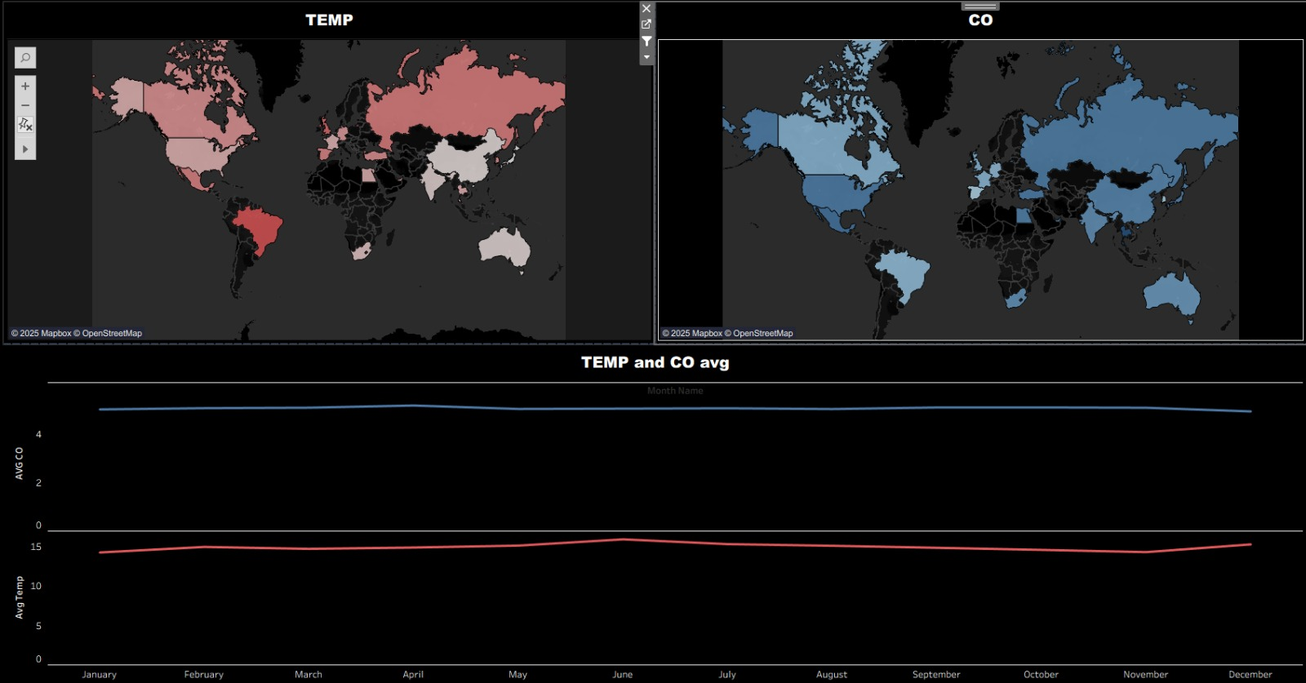
Figure 1: Global maps for Temperature and CO + monthly averages.
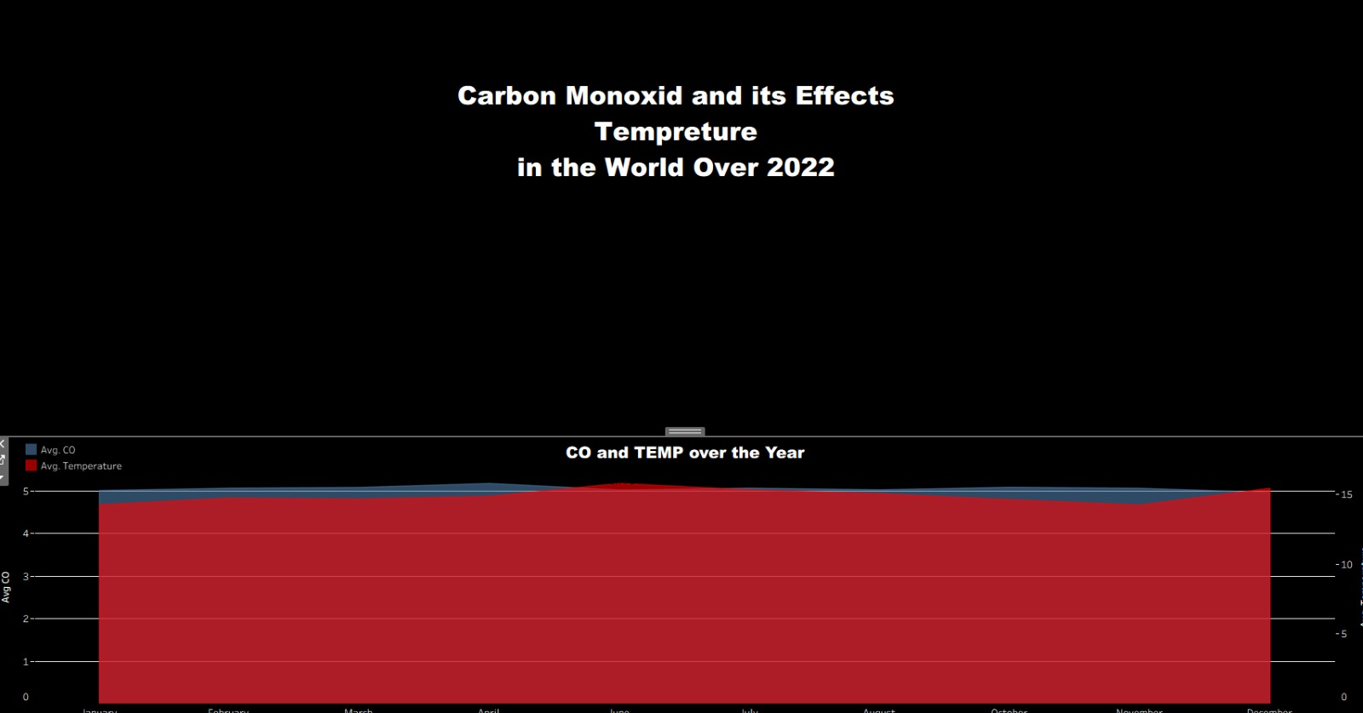
Figure 2: Final dashboard title and combined CO/TEMP yearly trend.

8. Limitations and next steps
Limitations:
• Country averages can hide big differences between cities.
• Correlation does not prove causation; more variables are needed to explain drivers.
• The dataset covers a limited number of cities, so results represent the sample provided.
Next steps:
• Add extra charts: top/bottom rankings, scatter plot (CO vs Temperature), and PM2.5 spike KPI.
• Add filters in Tableau: Country, City, Month, Pollutant.
• Add external context (industry, fires, traffic) if more datasets are available.

Appendix A: Data dictionary (key fields)
01_air_clean.csv:
• City, Country: location fields.
• Date: daily record date in 2022.
• PM2.5, PM10, NO2, SO2, CO, O3: pollutant measures.
• Temperature, Humidity, Wind Speed: weather measures.
• Year, Month, MonthName, Day: derived time fields.
• PM25_P90_City: 90th percentile threshold of PM2.5 per city.
• PM25_Spike: True when PM2.5 exceeds PM25_P90_City.
• Country_join: standardized country name used for joining/geocoding.
07_city_month_trends.csv:
• City, Country_join, Month, MonthName: dimensions for monthly analysis.
• Pollutant and weather columns: monthly averages per city.
• PM25_SpikeCount: number of spike days in that city-month.

