
Cairo University
Faculty of Computers and Information

CS251
Software Engineering I
Educational games
Project Team
Youmna Ashraf Mohamed 20140314
Yomna Mansour Mohmaed 20140316
Sara Tarek Farid 20140135
Hadeer Mohamed Awad 20140303

November 2016

Contents
Team 3
Document Purpose and Audience 3
Introduction 3
Software Purpose 3
Software Scope 3
Definitions, acronyms, and abbreviations 3
Requirements 3
Functional Requirements 3
Non Functional Requirements 3
System Models 3
Use Case Model 3
Use Case Tables 3

Team
ID | Name | Email | Mobile
20140135 | Sara Tarek Farid | Saratarek224@hotmail.com | 011118639266
20140314 | Youmna Ashraf Mohamed | youmnaashraf968662@gmail.com | 01125322537
20140316 | Yomna Mansour Mohamed | Youmnamansour15@gmail.com | 01123914441
20140303 | Hadeer Mohamed Awad | hadeer.awad212@gmail.com | 01144431554

Document Purpose and Audience:
Purpose:
The purpose of this document is to describe a web application system. It will describe the main purpose of this application's software and a detailed description for its scope and how different actors will interact this system and how this system is work. It also includes functional requirements and Non-functional requirements.
Audience:
This document target the Client, Designers, System analysts and the Developers.

Introduction
Software Purpose:
The purpose of this software is to enhance the educational process based on games to make the students eager to learn and encourage them to learn and understand basic educational concepts.
This will make the students benefit from the internet instead of wasting their times on social media.
It will allow the teachers to interact with their students and see their performance and improve them.
Software Scope:
This software is a web application system of a game-based educational platform. This application will contain four main categories Science, Math, Coding and Technology. Games may be "Match Pictures", "Multiple Choice Game", "Run Code Game".
Games will be played by one student and will be created by teacher. Each game should belong to one category.
Students and teachers must have accounts on this application to access it. The teachers have the ability to try any game, also can create any new game, also should be able to edit or remove and game he/she created it before, can make replies to student's comments for games created by him/her and see the achievements of student in any game. The students will use this application to play the games, rate it, comment on it, see their scores in any game the played and see their performance in each category.
This software will make the educational process easier.

Requirements

Functional Requirements
The System should:
-Allow actors to create account.
-Send confirmation mail to users
-Allow users to login.
-Check validation of logged information
-Allow user to choose category
-Allow user to choose game
-Allow users playing the game.
-Allow user to choose to save the game
-Calculate the score of the game to students
-Allow student and teacher to choose to rate game or not
-Allow student to choose if comment or not and teacher to choose to reply or niot
-Allow students to check their games achievement.
-Allow teacher to see students achievement of a specific game.
-Allow teachers to edit games by adding or removing some features on it.

--Create account: when the user opens the system he must create an account, he must enters his name, password, email, phone number, date of his birth and if he is student or teacher and submit information then the system check if the information is valid or not and then it is valid it sends a confirmation mail to the user and the account is created and if it is not valid the system displayed the non valid information for the user to rewrite it.
--login: after receiving confirmation mail and accept it the user will be able to login to the system by entering email and password and the system checks if both of them are valid.
--Display categories to the user : the system display categories to the user and the user is able to choose one category and then choose a game from this category and play or try the game and the system displays the game description to the user before playing it.
--Play game: both teacher and students are able to play the games and after finishing the students choose to save the game and the system display his score and the teacher didn’t have a score then the system display rate to both teacher and student and they can rate or skip rating if the student rating the game he become able to write a comment and the teacher is always able to reply to the student comments.
--Check achievements: student able to see his score of each game separately and also to see his performance in each category, he can see his achievements through his profile as each profile contains student information and his achievements , also the teacher can see students score at a specific game by choose the games score.
--Teacher edits games: system allows teacher to add or remove some features to the game according to options available on the system.

Non Functional Requirements
1-Usability: The system is easy to use as each component is separated and displayed clearly. Each game has a description to play it.
2-Performance: System respond is quick. For example: registration confirmation mail is send to the user within 20 seconds.
3-Supportability: System team will keep track of its failure to solve it and to add more features and games to it according to users comments on Facebook page and complains.
4-Different categories: System contains 4 categories to help students learn more fields efficiently.
5-Secuirty: Users must accept confirmation mail so that they can log in with valid account and then start playing and creating games.
6-Web based product: This system has no memory requirement but it needs network to be accessed.
7-Compitability: This system a desktop application that fit only windows operating systems.
8-Legal: The system follow legal issues involving the privacy of the information, intellectual property right, exports of restricted technologies.

System Models

Use Case Model
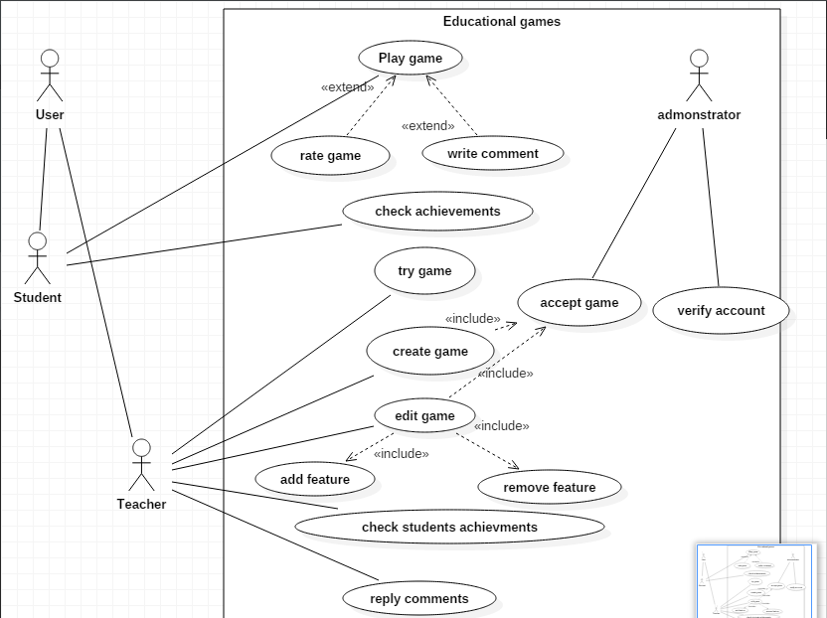

Use Case Tables

Use Case ID: | 1
Use Case Name: | Play game
Actors: | Student
Pre-conditions: | Log-in with valid account
Post-conditions: | Ending the game and get score
Flow of events: | User Action | System Action
Flow of events: | 1-Student chooses a category that he or she want to learn concept about
Flow of events: |  | 2- System will display games in this category
Flow of events: | 3- Student chooses game
Flow of events: |  | 4- System will display description for the chosen game
Flow of events: | 5-Student choose play to start the game
Flow of events: |  | 6-System open the game
Flow of events: | 7-Student play the game and finish the game
Flow of events: |  | 8-System display the student score,add the score to student achievements and ask if the student want to rate the game or to write comment
Flow of events: | 9-Student rate the game and write comment if he or she want or choose to rate and comment later
Exceptions: | User Action | System Action
Exceptions: | 1-Student exit the game or internet connection is lost
Exceptions: |  | 2- System will not save the score
Includes:
Notes and Issues:

Use Case ID: | 2
Use Case Name: | Check achievements
Actors: | Student
Pre-conditions: | Student log-in with valid account
Post-conditions: | System display student achievements
Flow of events: | User Action | System Action
Flow of events: | 1- Student go to his or her profile
Flow of events: |  | 2- System display the content of the student profile
Flow of events: | 3- Student choose achievements from the profile
Flow of events: |  | 4- System display games played by student and the student score in each game
Exceptions: | User Action | System Action
Includes:
Notes and Issues:

Use Case ID: | 3
Use Case Name: | Try game
Actors: | Teacher who want to try a game
Pre-conditions: | Teacher should log-in with valid account
Post-conditions: | The game end
Flow of events: | User Action | System Action
Flow of events: | 1- Teacher select the game he or she want to try
Flow of events: |  | 2- System display description for this game
Flow of events: | 3- Teacher choose play
Flow of events: |  | 4- System open the game
Flow of events: | 4-teacher play the game until the game end
Exceptions: | User Action | System Action
Includes:
Notes and Issues: | When teachers try games they just play it they will not get score or be able to rate it

Use Case ID: | 4
Use Case Name: | View student's achievements
Actors: | Teacher who want to view students' scores in a game created by this teacher
Pre-conditions: | Teacher Log-in with valid account
Post-conditions: | System display students score in the chosen game
Flow of events: | User Action | System Action
Flow of events: | 1- Teacher chooses to view the options of game he or she want to view students score in it
Flow of events: |  | 2- System display options of the game to the teacher
Flow of events: | 3-Teacher choose to view students achievements
Flow of events: |  | 4- System will display students names and its scores in the chosen game
Exceptions: | User Action | System Action
Includes:
Notes and Issues:

Use Case ID: | 5
Use Case Name: | Reply comments
Actors: | Students and teachers
Pre-conditions: | Teacher or student login-with valid account
Post-conditions: | System add the reply to the comment
Flow of events: | User Action | System Action
Flow of events: | 1- Teacher or student choose to view the options of game
Flow of events: |  | 2- System display options of the game
Flow of events: | 3-Teacher or student choose to view comments
Flow of events: |  | 4- System display comments and repliesof this game
Flow of events: | 4-teacher or student choose the comment they want to reply on
Flow of events: |  | 5-System allow the user to write a reply
Flow of events: | 6-Teacher or student write the reply and submit it
Flow of events: |  | 7-System will confirm the user that the reply has been submitted and display the reply below the comment or at the end of previousreplies on this comment
Exceptions: | User Action | System Action
Includes:
Notes and Issues:

Use Case ID: | 6
Use Case Name: | Edit game
Actors: | Teacher
Pre-conditions: | Teacher should log-in with valid account
Post-conditions: | Game will be available to be played with it is new features
Flow of events: | User Action | System Action
Flow of events: | 1- Teacher chooses to view the options of game he or she want to edit
Flow of events: |  | 2- System display options of the game
Flow of events: | 3-Teacher choose to edit the game
Flow of events: |  | 4-System show features that can be added and allow teacher to select features to be removed
Flow of events: | 5-Teacher add new features or remove features or both and then submit the game after making the desired changes
Flow of events: |  | 6-System will add this game with its new features after the administrator accept this game to be added
Exceptions: | User Action | System Action
Includes: | This use case include accept use case that performed by the administrator, add feature, remove feature
Notes and Issues: | Administrator may refuse this game and give the teacher the reason

Use Case ID: | 7
Use Case Name: | Rate game
Actors: | Student
Pre-conditions: | Student have played the game and get his or her score
Post-conditions: | Student submit the rate and system save it
Flow of events: | User Action | System Action
Flow of events: | 1- Student get his or her score after playing the game
Flow of events: |  | 2- System ask the student to rate the game by choosing interesting, normal or boring
Flow of events: | 3- Student choose one choice to rate the game
Flow of events: |  | 4- System save the student choice
Exceptions: | User Action | System Action
Exceptions: | 1-Student can skip this option and dose not rate the game
Exceptions: |  | 2-System allow the student skip this option if student dose not want to rate the game
Includes:
Notes and Issues:

Use Case ID: | 8
Use Case Name: | Write comment
Actors: | Student
Pre-conditions: | Student log-in with valid account
Post-conditions: | System confirm student that the comment submitted
Flow of events: | User Action | System Action
Flow of events: | 1- Student chooses to view the options of game he or she want to comment on
Flow of events: |  | 2- System display options of the game
Flow of events: | 3- student choose to write comment
Flow of events: |  | 5-System allow the user to write a comment
Flow of events: | 3-Student write the comment and submit it
Flow of events: |  | 4- System add the comment to the comments of this game and confirm the user that the comment has been submitted
Exceptions: | User Action | System Action
Includes:
Notes and Issues:

Use Case ID: | 9
Use Case Name: | Create game
Actors: | Teacher
Pre-conditions: | Teacher log-in with valid account
Post-conditions: | New game create and added to the system
Flow of events: | User Action | System Action
Flow of events: | 1- Teacher choose create game
Flow of events: |  | 2- System display the available templates for the game
Flow of events: | 3- Teacher choose a desired template for its new game
Flow of events: |  | 4- System display the available features that teacher can use to create the game
Flow of events: | 5-Teacher add features to the game templates , name new game and submit it
Flow of events: |  | 6-System ask the user to choose category to add this game in
Flow of events: | 6-Teacher choose the category
Flow of events: |  | 7-System will add the game to the chosen category and confirm the teacher that the new game added to the system after administrator accept this game to be added
Exceptions: | User Action | System Action
Includes: | This use case include accept use case that performed by the administrator
Notes and Issues:

Use Case ID: | 10
Use Case Name: | Remove game
Actors: | Teacher who want to remove a game that he or she created before
Pre-conditions: | Teacher log-in with valid account
Post-conditions: | The game removed
Flow of events: | User Action | System Action
Flow of events: | 1- Teacher chooses to view the options of game he or she want to remove
Flow of events: |  | 2- System display options of the game
Flow of events: | 3-Teacher choose remove
Flow of events: |  | 4- System ask the teacher if he or she sure that they want to remove this game or they will cancel
Flow of events: | 5-Teacher confirm to remove the game
Flow of events: |  | 6-System remove this game
Exceptions: | User Action | System Action
Includes:
Notes and Issues:

Use Case ID: | 11
Use Case Name: | Add feature
Actors: | Teacher who want to add new feature to game that teacher created before
Pre-conditions: | Teacher should log-in with valid account
Post-conditions: | New feature added to the game
Flow of events: | User Action | System Action
Flow of events: | 1- Teacher select to view options of the game
Flow of events: |  | 2- System display options of this game
Flow of events: | 3- Teacher choose to edit
Flow of events: |  | 4- System display the available features that can be added to the game
Flow of events: | 5-Teacher choose the desired feature
Flow of events: |  | 6-System add the chosen feature to the game
Exceptions: | User Action | System Action
Includes:
Notes and Issues:

Use Case ID: | 12
Use Case Name: | Remove feature
Actors: | Teacher who want to remove feature from game that teacher created before
Pre-conditions: | Teacher should log-in with valid account
Post-conditions: | Old feature deleted from the game
Flow of events: | User Action | System Action
Flow of events: | 1- Teacher select to view options of the game
Flow of events: |  | 2- System display options of this game
Flow of events: | 3- Teacher choose to edit
Flow of events: |  | 4- System allow the user to select feature to be removed
Flow of events: | 5-Teacher choose feature to be removed
Flow of events: |  | 6-System remove the chosen feature from the game
Exceptions: | User Action | System Action
Includes:
Notes and Issues:

Use Case ID: | 13
Use Case Name: | Accept game
Actors: | Administrator
Pre-conditions: | Administrator notified that a new game need to be added or an old game need to be added after edit
Post-conditions: | A game became available to be played
Flow of events: | User Action | System Action
Flow of events: | 1- Administrator try this game and find if it is suitable to be added to the system and if it related to its category and then accept this game
Flow of events: |  | 2- System add this game to the available games
Exceptions: | User Action | System Action
Includes:

Use Case ID: | 14
Use Case Name: | Verify account
Actors: | Administrator
Pre-conditions: | Administrator notified that someone send identity to make teacher account
Post-conditions: | Teacher account became available to be used by the teacher
Flow of events: | User Action | System Action
Flow of events: | 1- Administrator check the identity and accept the teacher
Flow of events: |  | 2- System allow the teacher to log-in with the verified account
Exceptions: | User Action | System Action
Includes:

