
Schedule of Development Milestones
Resource Schedule
Producer: Young Gou
MS | Deliverables | Date
0 | 0 - Execution / Pre-Production  Deliverables:  Documentation & Process  - Core GDD / creative vision doc  - QA plan / test strategy doc - scope, bug taxonomy, workflow, test-case templates, exit criteria, QA ramp plan  - Production Plan / greenlight approval package - consolidates all deliverables below into one approval submission, plus a risk register  Legal & Operations  - Facility + personnel contracts, signed  - Facility/software procurement and licensing  Engineering  - System framework / tech architecture, initial build - incl. version control/branching strategy and target platform/device range decision  - Backend / online scaffolding  - Automated test tooling, initial setup  Art & Narrative Direction  - Visual style bible + directional sketches  - Story tone + outline  Validation  - Playable prototype - Tutorial Level “The Summoner” vertical slice (movement, folding mechanics, camera, level geometry, collectibles, tutorial assembly, case fragment, comic panel presentation) | Oct-30-2026
1 | 1 - Feature Complete  Deliverables:  Narrative & Content Production  - Narrative outline detail + case content for levels 1-4  - 2 levels (white box + scene concept + character concept); 2 more levels in white box  Art & Animation  - Base materials + VFX  - Main character rig + animation  Gameplay & Engineering  - Cockroach and dinosaur enemy systems  - Engineering structure - version control/branching strategy, code architecture module boundaries (gameplay / backend-online / content-pipeline-tools / UI), code review process, basic event-tracking/analytics hooks  - Backend performance optimization, ongoing  - Internal level toolset  - Main feature UI, with multi-device UI adaptation  - Automated build pipeline, initial version  QA  - Detail requirements refinement, automated tooling expansion, narrative/level testing, ongoing  Validation  - Integrated Alpha build - narrative + gameplay + level + concept art across levels 1-4, reviewed against GDD | Apr-30-2027
2 | 2 - Alpha  Deliverables:  Content Production  - Levels 1-4 at Alpha-stage completeness - narrative/level/gameplay/characters/environment/materials/VFX end-to-end playable; not yet audio/voiceover  - First live-service version's 2 post-launch levels, white box  - One new cosmetic character design  Engineering  - Monetization/store UI - product display, pricing, purchase entry point  - UI / backend / build-pipeline / QA-automation optimization, ongoing; engineering structure: technical debt backlog established and triaged  QA  - Functional + device compatibility testing on levels 1-4, against the MS0 device matrix  Validation  - Content Complete build - missing audio/voiceover, reviewed | Jul-30-2027
3 | 3 - Beta  Deliverables:  Content Production  - Levels 1-4 at true Shippable quality - final polish and bug cleanup  - Levels 5-8 at Alpha-stage  Audio & Voiceover  - Audio - tutorial + levels 1-4 + first 3 months' post-launch content (4 more levels) + in-client music  - Voiceover - tutorial + levels 1-4 + first 3 months' post-launch content  LiveOps & Economy  - LiveOps V1 event - first event built from scratch  - Economy system - the underlying mechanism/capability for 5 monetization product categories: Battle Pass, Monthly Card, direct currency purchase bundles, direct skin purchase, Starter Pack  - Monetization content - the actual character, costume, and decoration assets for the first 3 months' (2 versions) worth of sellable items, distinct from the system above  - IAP policy self-check - design-stage review against Apple/Google IAP policies, ahead of the formal MS4 submission  QA  - Limited closed beta / playtest  Marketing  - Marketing materials | Oct-29-2027
4 | 4 - Certification & Release (RC)  Deliverables:  Store Submission & Legal  - App review submission package - compliance checklist, build, and required documentation for App Store / Google Play  - Store listing marketing assets - screenshots, description, icon; distinct from the review submission package above  - Legal docs - Privacy Policy (incl. minors'/children's data privacy), Terms of Service / EULA, age/content rating, local/regional regulatory approval  - Commercial ops - IAP products configured and live in App Store Connect / Google Play Console  Content Production  - Levels 5-8, at Shippable  Marketing  - Marketing campaign  Build & QA  - Gold Master / RTM build, final and locked  - QA full-system final regression pass - levels, monetization, account, UI  Live Operations Readiness  - Analytics/telemetry dashboards, live and validated; hotfix process ready | Dec-30-2027
5 | 5 - Archive  Deliverables:  Source Code & Build Archive  - Final GDD, staffing plan, schedule, all style bibles, RTM code - archived as a fully version-tagged source repository  - Automated tooling - archived (build pipeline config/scripts, QA automation scripts)  - Complete build package - archived (iOS + Android builds and debug symbol files)  Process & Documentation Archive  - Core content-production pipelines - documented (reusable workflows for level, character/skin, event, and battle-pass-season creation); feeds MS6  - QA documentation - archived (QA plan, test case library, known-issues/bug database)  - Post-mortem / retrospective document - feeds MS6's template design  Legal & Vendor Archive  - Review/cert materials, vendor contracts, and legal docs - archived  Creative Asset Archive  - Art assets - archived in two layers (MS0 directional materials vs. final production assets), organized by Feature ID  - Narrative source materials - archived (story bible, full scripts/dialogue)  - Audio/VO source files - archived | Jan-14-2028
6 | 6 - Live-Service Version Template  Staggered/rolling pipeline: 2-3 versions' content in flight simultaneously at different stages, not strictly serial.  Deliverables:  Content Production (per cycle)  - 2 levels per cycle - days 1-15 greybox, 15-30 Alpha-stage, 30-45 Shippable  - Narrative - case script/dialogue for the 2 levels  - 1 new character per cycle - modeling/rig/animation  - 1 new cosmetic skin per cycle - content for the store, distinct from the storefront capability below  - Audio/VO - batched every other cycle (~90 days) rather than every cycle  LiveOps & Monetization  - Monetization storefront - Battle Pass, Monthly Card, direct currency bundles, and direct skin purchase remain available for sale each cycle  - 1 event per cycle - designed and implemented  - Data analysis - prior cycle's retention/monetization data reviewed to inform next cycle's event and economy tuning  - A/B testing capability - closes the data-analysis feedback loop  QA & Release  - QA - regression/certification-style testing pass each cycle  - Build/release - packaging and deployment each cycle  - Hotfix window - post-release response process each cycle | Template - first cycle begins Jan-2028, repeating every 45 days thereafter

Resource Schedule
Team size across the development phases, aligned to the milestone gates above. Headcount is expressed in full-time equivalents (FTE); the team ramps to a pre-launch peak in Beta, then settles into a sustained live-service crew.
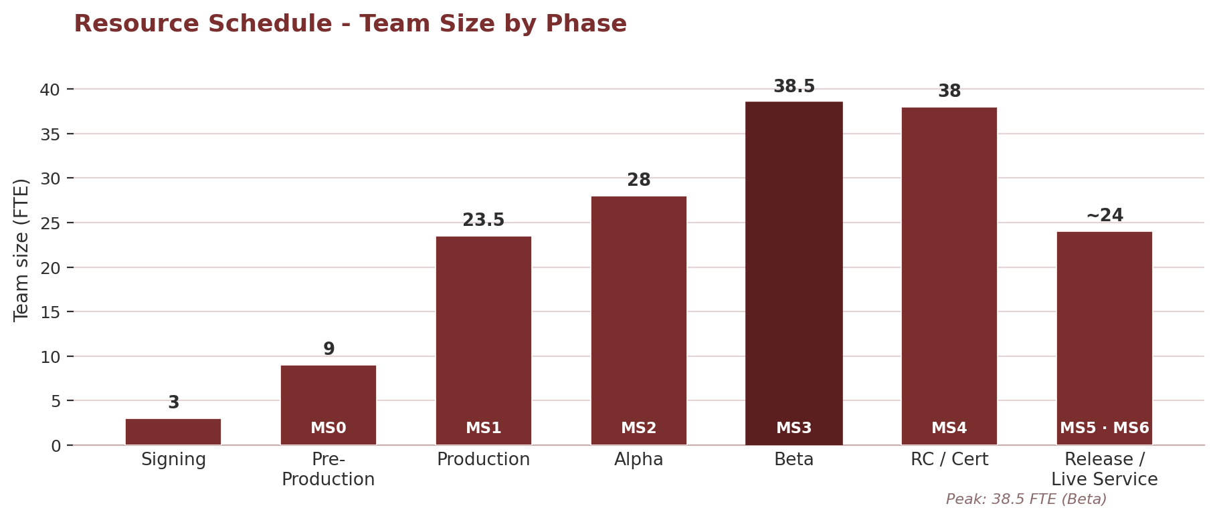
Phase | Timeline | Milestone Gate | Team Size (FTE)
Signing | Jul 2026 | - | 3
Pre-Production | Aug – Oct 2026 | MS0 · Oct 30, 2026 | 9
Production | Nov 2026 – Apr 2027 | MS1 · Apr 30, 2027 | 23.5
Alpha | May – Jul 2027 | MS2 · Jul 30, 2027 | 28
Beta | Aug – Oct 2027 | MS3 · Oct 29, 2027 | 38.5 (peak)
RC / Certification | Nov – Dec 2027 | MS4 · Dec 30, 2027 | 38
Release / Live Service | Jan 2028 onward | MS5 · Jan 14, 2028 / MS6 template | 22 – 27 (steady-state)
 End of Milestone Schedule

