***Documentation***

***Project description in details:***

***1-Login or Registration Controller:***

* Registration action: a new user types all their information and clicks submit, data is then validated to make sure there is not an existing user with those credentials.
* login action: allows registered users to login to the site and access all the features that the site gives them. If they type in their username and password and click submit, user credentials are validated and if correct they are logged in.

***2-Post Controller:***

* CreatePost: Allows user to choose a picture and a caption to post then uploads it as a new post.

***3-ProfileController:***

* ViewProfile: view logged in user Profile With Bro (profile details ) and all his posts.
* EditProfile:allows user to edit his own profile info (eg.:Profile picture,Bio).

***4-SearchController:***

* Search: allows user to search for particular user using his username.
* ViewOtherProfile: allows user to view specific profile he wants to see.
* AddFriend: allows user to send follow request to other users only if it is not already sent.

***5-Friends Controller:***

* ViewRequests: allows logged in user to see who wants to follow him.
* Accept: allows user to accept follow request.
* Reject: allows user to reject follow request.

***6-Home Controller:***

* ViewAllPosts: allows user to see all posts with their likes and comments only from the people who he/she follow.
* Like :allow user to like any post he wants.
* Undo: Removes user's last action (eg: like or dislike).
* Dislike: allow user to dislike any post he wants.
* makeComment: allow user to make a comment in any post he wants.

***Class Diagram:***

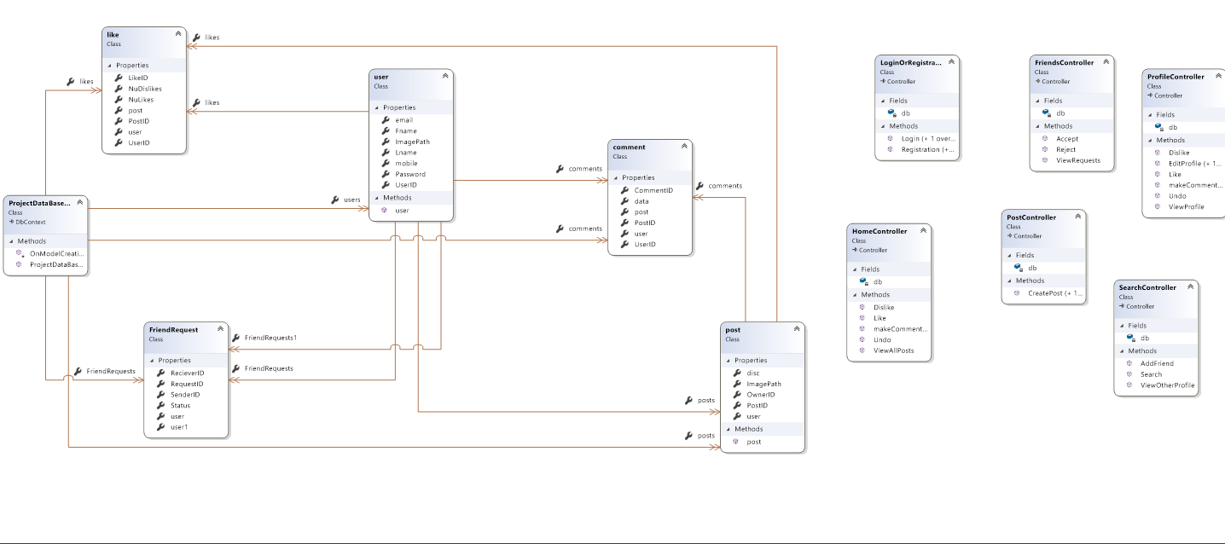

***DataBase Schema:***

