This is a simple document to test my word to pdf converter.
.
.
.
INSERT CAT IMAGE
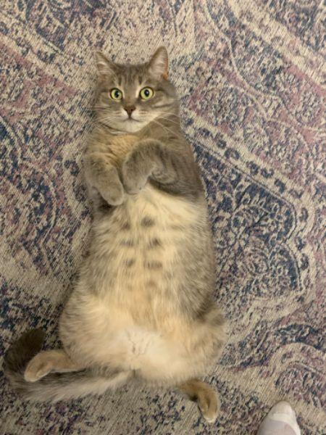

GOOD BOY

