1. **Laravel Application – Official Api**   
     
   List of Error / Update / Modification  
   Application Login Details    
   <https://application.globalgymsoftware.online/>Id: [super@admin.com](mailto:super@admin.com)Password : password  
     
   <https://application.globalgymsoftware.online/contacts>  
   <https://application.globalgymsoftware.online/report>

<https://application.globalgymsoftware.online/show-report/1>

- Add Serial Number Option in Contact Book  
- Date filter need to make working and add from date to to date filter

- Report Details The Report shows our Old Number as the Sender Number but actually not

- Delete / Edit  / Update  Group Option Need to Add

- Contact Book Bulk Select and Delete Not Working Need to Fix

- Select Contact between Serial Number and

**Refer Below Details with Screenshot**

* 1. <https://application.globalgymsoftware.online/contacts>  
       
      Contact Book Bulk Select and Delete Not Working Need to Fix

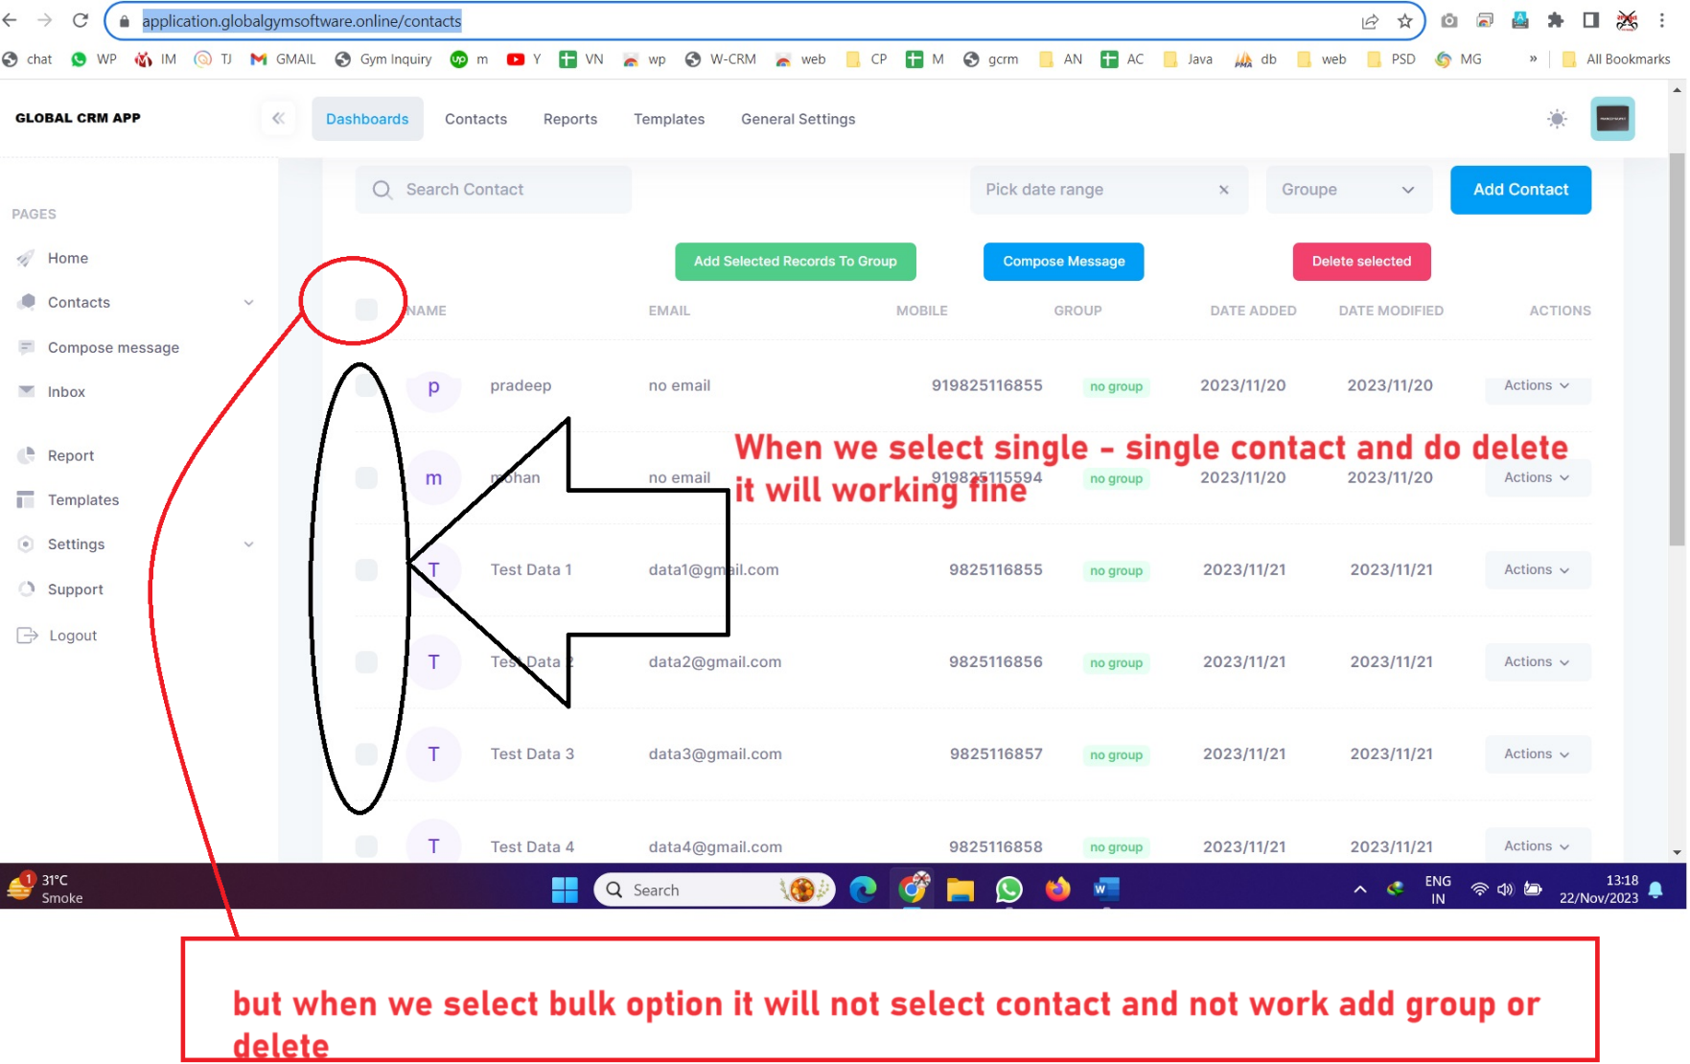

* 1. <https://application.globalgymsoftware.online/contacts>  
       
     Date filter need to make working and add from date to to date filter

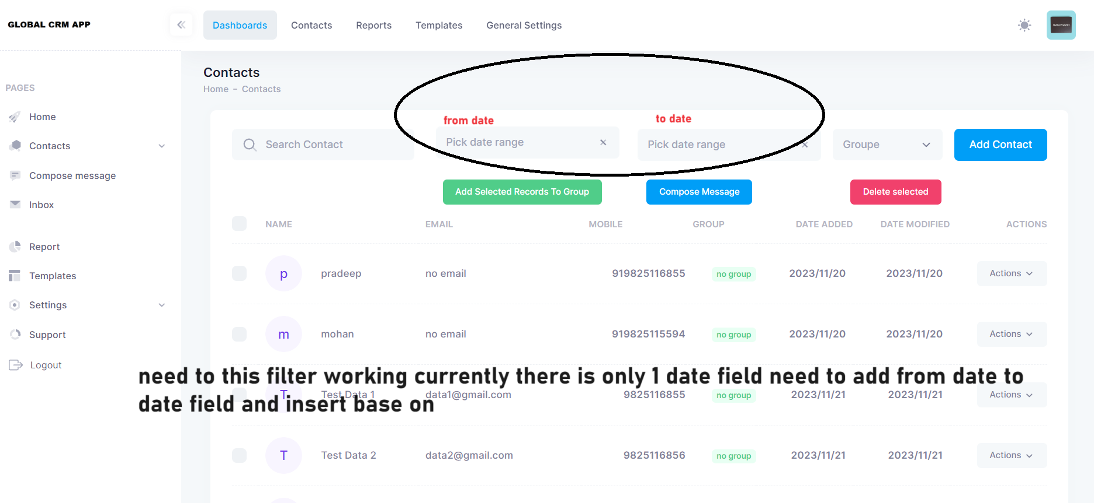

* 1. Report Page   
       
     Problem: Report Details The Report shows our Old Number as the Sender Number but actually not  
     <https://application.globalgymsoftware.online/report>  
       
     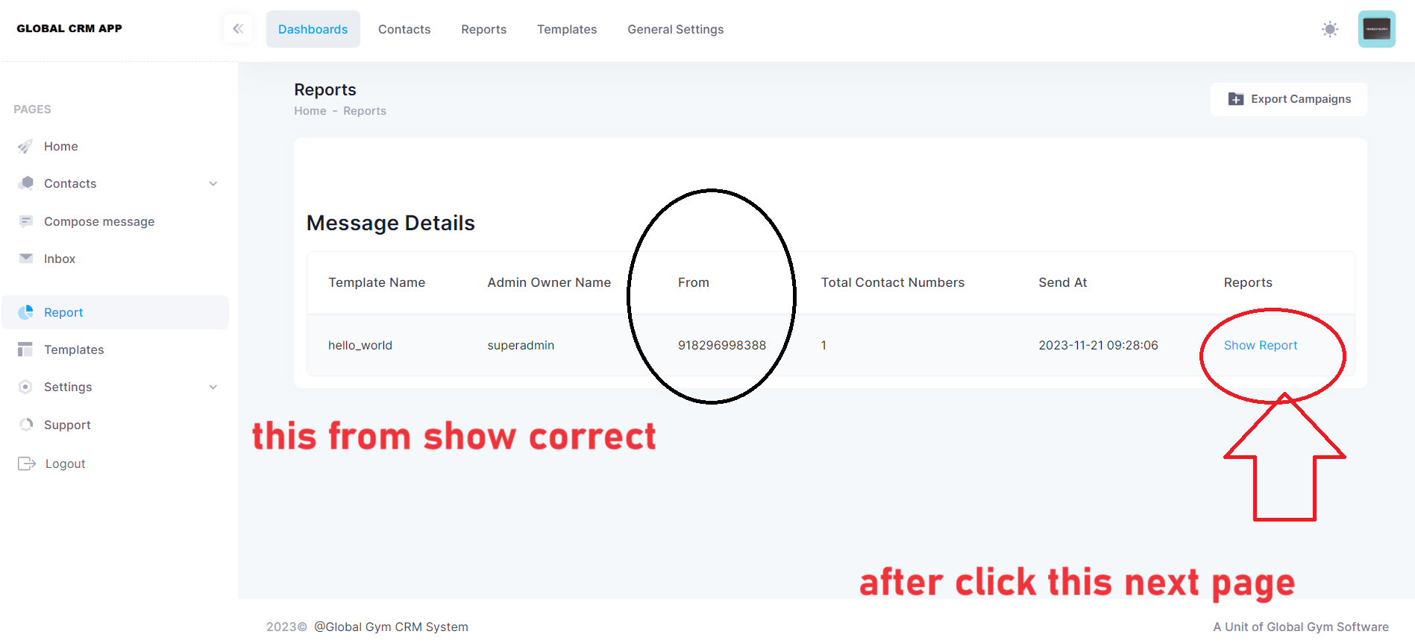

<https://application.globalgymsoftware.online/show-report/1>  
  
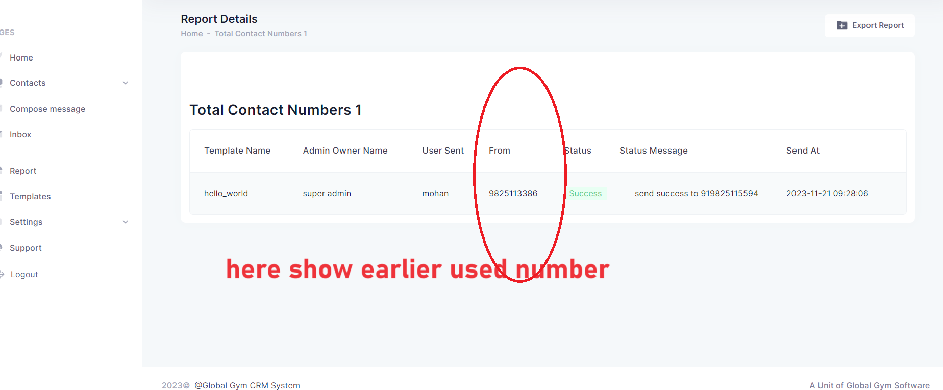

* 1. Add Serial Number column in Contact Page

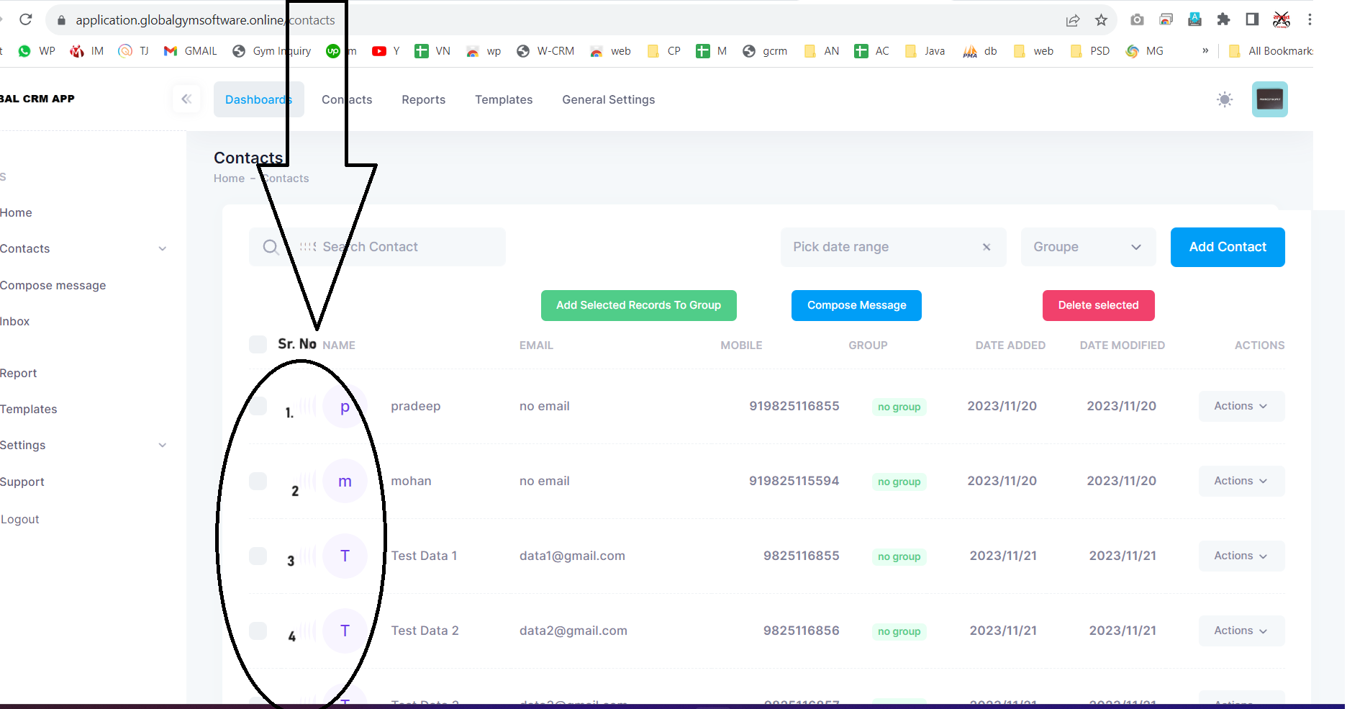

* 1. <https://application.globalgymsoftware.online/contacts/groups>  
       
     Require to Add Option for Edit / Delete Group
  2. Data Loading Take time in loading page