Assignment Deliverables Documentation

1. StackTest and the screen shot failures

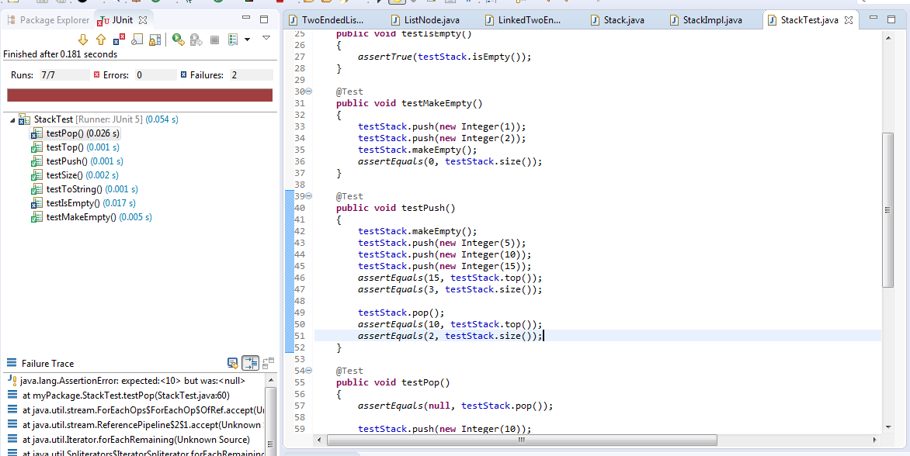

1. The three bugs before fixing
2. The condition should be <= 0 because in order to take care of when the stack is empty
3. Old and new arrays are not placed appropriately
4. It should be –size instead of size—

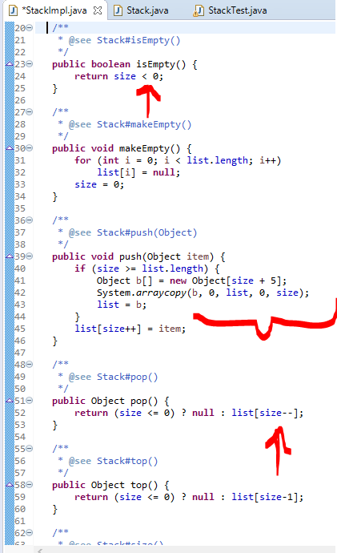

1. After fixing the bugs:

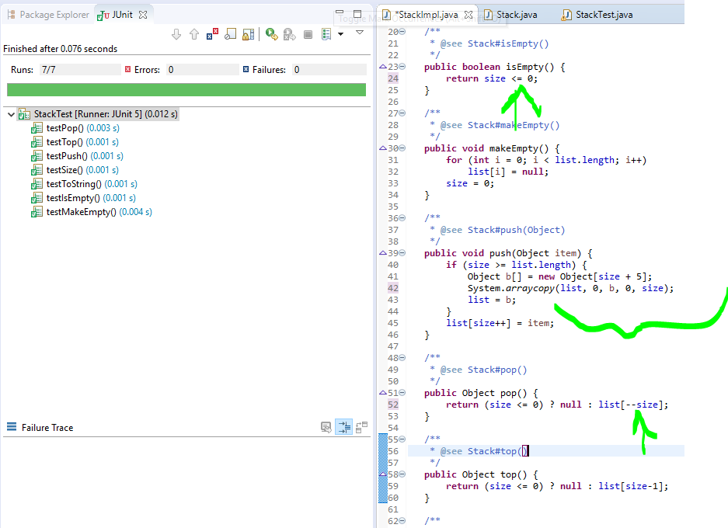

1. All test passing:

