|  |  |  |
| --- | --- | --- |
| **WORLD IMPACT CAPITAL LTD.**  **(“WIC”)** | **BUSINESS**  **OPERATIONS SYSTEM (BOS)** | **Website Case Study** |
|  | **Standard Practice Instruction (SPI)**  **Revision Number** | **BOS SPI 2001-1**  **Rev 2** |
|  | **Date** | **March 5, 2018** |
|  | **Author** | **AIA** |
|  | **Date Last Updated** | **March 14, 2018** |

Website Case Study

By Abdullah-Isa Amole BA MSc CFA Level 2 candidate

This document assess the contents and key elements of comparable private equity websites and determine the most relevant elements to include in the World Impact Capital website. Elements that seem particularly useful are highlighted and code provided as well as suggested tweaks. In conclusion the content and elements most relevant to World Impact Capital are listed and suggestion made as to the priority or feasibility of inclusion.

# Contents

Introduction

Aqua-Spark

Arborview Capital

The Blackstone Group

The Carlyle Group

CityBlue Hotels

References

# Introduction

This document describes WIC’s original website, and the websites of 5 reference websites. These websites are:

* The Carlyle Group
* CityBlue Hotels
* The Blackstone Group
* AquaSpark
* Arborview Capital

Current website

Constants: Background image on evrey page is a picture of an African sunset, silhouetting a tree on the tundra. Contact information in the bottom right hand corner and the WIC logo in the top left. The placeholder WIC logo; a "dura", is in the header. The navigation links are to the Homepage, Fund description, Key facts and Management team.

Homepage - is functional with the "fund introduction", "geographic focus" and "impact objective". Beside the fund introduction is what can be assumed to a placeholder; image of a woman with a "dura".

Fund description - has brief description of the fund. Key facts - "Investee criteria" and "fees" paragraphs accompanied by the image of an African couple in the doorway of their hut and contact information in the bottom left.

Management team - Comprehensive backgrounds for both Nyasha Gwatidzo and Matthew Powell.

# Aqua-Spark

# Arborview Capital

# Blackstone

# The Carlyle Group

We work for our investors

The Carlyle Group is global alternative asset manager with $195 billion in assets under management, established in 1987 and now boasting a 1,600-person team working together as a network, leveraging the varied expertise data to create value for their 1,750 investors.

Key aspects to the Carlyle website would firstly be the bold colours; blue, white and grey, two of which are colours of the company logo. The Header is predominantly blue with a green bottom border and is not fixed. The header contains links to; “Public Investors”, “LP Login”, “Chinese Investor Portal”, “Japanese Investor Portal”, “About Carlyle”, “Our Business”, “Illuminate”, “Citizenship”, “Media Room” and “Creating Value”. The header also contains social media links; Facebook, twitter, LinkedIn and Instagram. The header also contains a news update regarding 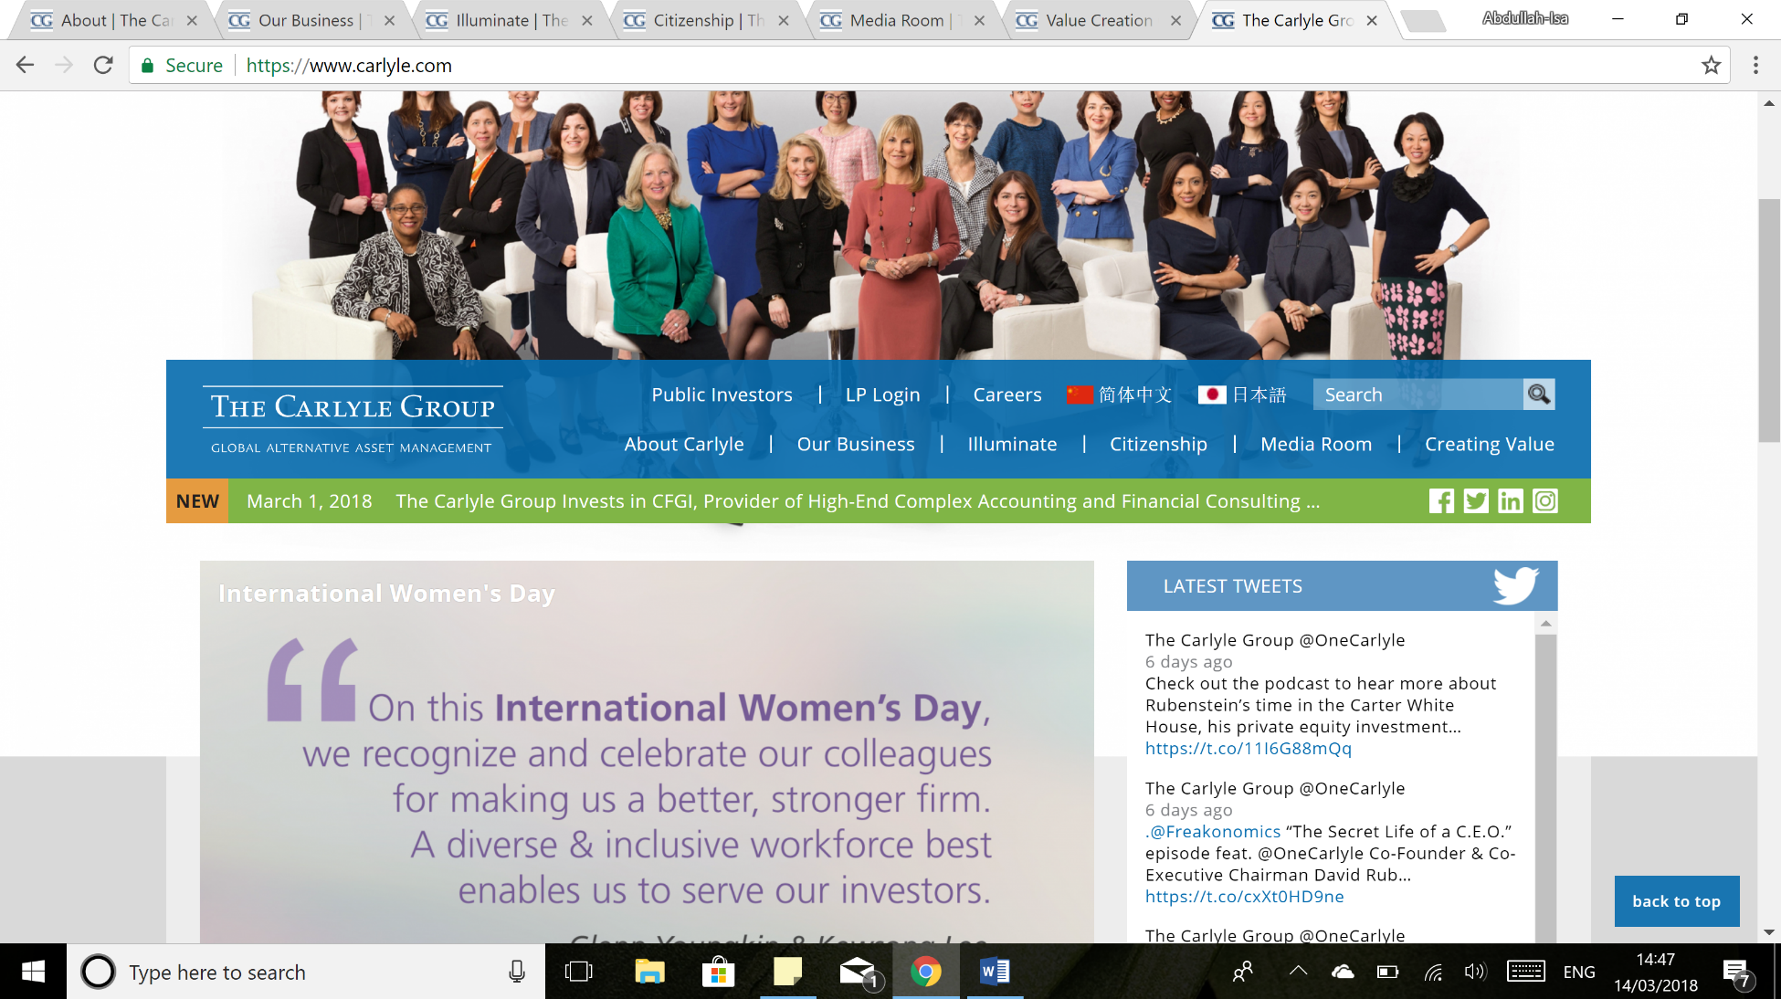the Group or its dealings.

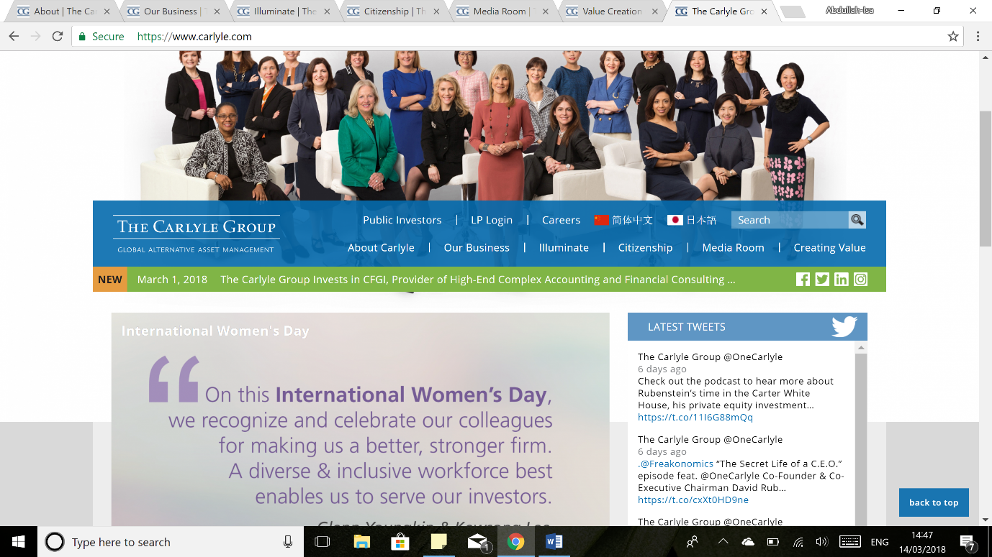It doesn’t seem like a live feed, it is instead drawing from a databank of documents most likely and picking the most recent article.

<div class="views-row">

<div class="views-field views-field-title"><span class="field-content"><time datetime="00Z" class="datetime">March 1, 2018</time>

<a href="/media-room/news-release-archive/carlyle-group-invests-cfgi-provider-high-end-complex-accounting-and" hreflang="en">The Carlyle Group Invests in CFGI, Provider of High-End Complex Accounting and Financial Consulting to Corporate CFOs, CAOs and Controllers</a></span></div>

</div>

Public investors hyperlink links to a page detailing investment information available to the general public (e.g. the Nasdaq quote, Carlyle Group 10-K and Analyst Coverage) because the Carlyle Group are a publicly listed company. LP login as would be assumed is a limited partner portal, with the requisite password protected login prompts.

<form class="form-signin" action="login.do" method="post">

<input id="login" name="j_username" type="text" class="input-block-level" placeholder="Username or Email"><br>

<input id="password" name="j_password" type="password" class="input-block-level" placeholder="Password"><br>

<button id="login-btn" class="btn btn-large btn-sign-in" type="submit">Sign In</button>

<p id="message" class="warning-message">

The “Careers” page maintains the palette (white, blue and grey), as well as the elements in the header. However there is a clear aesthetic being pushed regarding the personable nature of the company, with numerous smiling portraits as the background at the very head of the page. The page makes prominent all the social media platforms, provides reasons why a career at Carlyle is to be coveted, as well as conspicuously placed advertisements regarding Carlyle’s attitudes to diversity.

The Corporate Overview is provides links to important information regarding the fund, such as theory of value creation, industry awards, the team, corporate videos (i.e. One Carlyle), an interactive map and graphs of varying key statistics (i.e. Assets under Management).

<map name="employeeMap" id="employeeMap">

<area alt="East Asia and Pacific" title="East Asia and Pacific" ref="eastasiaandpacific" href="#" shape="poly" coords="385,110,398,52,397,45,404,46,412,52,418,56,422,55,423,60,425,63,429,61,437,58,444,62,440,66,441,67,444,74,444,77,435,82,433,85,428,82,422,78,420,74,417,70,413,70,415,73,415,77,417,81,420,87,420,91,422,97,422,101,422,106,425,109,425,112,426,114,430,119,433,125,433,130,437,138,444,142,453,144,463,148,467,151,476,148,476,151,471,153,468,154,472,161,467,160,464,154,461,157,459,160,460,… >

**truncated for convenience**

Our Business is a page dedicated to detailing the business segments The Group is invested in as well as key partners, such as McDonalds, solasto and Vogue International.

<div class="slick-track" style="opacity: 1; height: 3133px; top: -1205px;" role="listbox"><div class="field__item slick-slide slick-cloned" data-slick-index="-4" aria-hidden="true" tabindex="-1" style="width: 192px;"><div id="" class="default component component--image component--id-4891">

<a class="link-wrapper" href="/media-room/news-release-archive/mcdonald’s-announces-growth-plan-china-following-completion" tabindex="-1">

<div class="field field--name-field-image field--type-image field--label-hidden field__item"> <picture>

<!--[if IE 9]><video style="display: none;"><![endif]-->

<source srcset="/sites/default/files/styles/image_component_large_1x/public/McDonald_PortCo-updated_676x378.jpg?itok=KsWl8NFT 1x, /sites/default/files/styles/image_component_large_1_5x/public/McDonald_PortCo-updated_676x378.jpg?itok=j8HbFe3X 1.5x, /sites/default/files/styles/image_component_large_2x/public/McDonald_PortCo-updated_676x378.jpg?itok=VnVPrjbO 2x" media="all and (min-width: 1041px)" type="image/jpeg">

**truncated for convenience**

The Illuminate is the page where The Group offers insight regarding various topics through a number of mediums, such as case studies, commentaries and mini-podcasts by top individuals in the firm. The Citizenship page is dedicated to outlining the company’s corporate citizenship; the events being hosted in support of local communities and causes. The Media Room provides access to media and media contacts. Lastly the Value Creation page is a list of case studies detailing how The Group affected positive change with an investee company, such as consulting on the splitting off of Booz Allen Hamilton’s commercial consulting business segment.

A prominent element on the homepage is the “Valucast”, the Carlyle Group’s version of a podcast. They provide a short snippet of audio that covers a range of topics such as cybersecurity, diversity and corporate citizernship. It must be noted that a prominent disclaimer is posted below the links, that remove any liability on the part of the Carlyle Group regarding the opinions expressed by the podcaster.

<audio controls="" controlslist="nodownload">

<source src="https://www.carlyle.com/sites/default/files/mp3/ValuCast_Episode_063.mp3" type="audio/mpeg">

Your browser does not support the audio element.

</audio>

# CityBlue Hotels

*“Rise with Africa. Rise with CityBlue”*

CityBlue is a relatively new and aggressively growing[1] hotel franchise, established in 2013 to provide mid-scale international quality across Sub-Saharan Africa. The hotel business is coupled with “Urban by CityBlue”; the boutique subsidiary.

Whilst not a fund, the website is particularly stylish and clean. With its high-quality images, sleek box elements (i.e. “Weekend Getaway”, “Meetings”, “Where to Eat” and “Where to Stay”) and blue hue to all of the backgrounds. The hue is no surprise as it has been chosen with the name of the company in mind.

Constants exist in the headers and footers. The header consists of the “Home”, “Hotels”, “Restaurants”, “Meetings & Events”, “Careers”, “About Us”, “Contact Us” and “Book Now” hyperlinks.

The “Book Now” hyperlink has been made prominent in the navigation bar, and for good reason as bookings are the lifeblood of CityBlue’s business. The homepage doubles down on bookings by having a button to book and also a queries field to search for booking dates on the homepage. For ease of use there are drop-down lists in the header as some of the hyperlinks have several subcategories; Restaurants has the option of 10 restaurants in the drop-down list. The header is an expanding fixed (to the top of the page) element that is ~95% of the screens width but expands to 100% at the bottom of the page.

<header class="sticky-header">

<div class="logo"><a title="CityBlue" href="https://www.citybluehotels.com"><img alt="CityBlue" src="https://www.citybluehotels.com/wp-content/themes/cityblue/img/logo.png"></a></div>

<nav class="mainmenu">

<div class="menu-main-menu-container"><ul id="menu-main-menu" class="menu"><li id="menu-item-9" class="menu-item menu-item-type-post_type menu-item-object-page menu-item-home current-menu-item page_item page-item-2 current_page_item menu-item-9"><a href="https://www.citybluehotels.com/">Home</a></li>

<li id="menu-item-576" class="sub menu-item menu-item-type-post_type menu-item-object-page menu-item-has-children menu-item-576"><a href="https://www.citybluehotels.com/hotels/">Hotels</a>

<ul class="sub-menu">

<li id="menu-item-571" class="menu-item menu-item-type-custom menu-item-object-custom menu-item-has-children menu-item-571"><a href="#">Rwanda</a>

<ul class="sub-menu">

<li id="menu-item-1167" class="menu-item menu-item-type-post_type menu-item-object-post menu-item-1167"><a href="https://www.citybluehotels.com/hotels/cityblue-epic-hotel-suites-nyagatare-rwanda-3/">CityBlue EPIC Hotel &amp; Suites, Nyagatare, Rwanda</a></li>

<li id="menu-item-494" class="menu-item menu-item-type-post_type menu-item-object-post menu-item-494"><a href="https://www.citybluehotels.com/hotels/cityblue-hotel-suites-embassy-row-kigali/">CityBlue Embassy Row Hotel &amp; Suites, Kigali, Rwanda</a></li>

<li id="menu-item-490" class="menu-item menu-item-type-post_type menu-item-object-post menu-item-490"><a href="https://www.citybluehotels.com/hotels/urban-by-cityblue-kigali/">Urban by CityBlue, Kigali</a></li>

</ul>

</li>

<li id="menu-item-572" class="menu-item menu-item-type-custom menu-item-object-custom menu-item-has-children menu-item-572"><a href="#">Uganda</a>

<ul class="sub-menu">

<li id="menu-item-489" class="menu-item menu-item-type-post_type menu-item-object-post menu-item-489"><a href="https://www.citybluehotels.com/hotels/urban-by-cityblue-kampala/">Urban by CityBlue, Kampala</a></li>

</ul>

</li>

<li id="menu-item-645" class="menu-item menu-item-type-custom menu-item-object-custom menu-item-has-children menu-item-645"><a href="#">Kenya</a>

<ul class="sub-menu">

<li id="menu-item-1161" class="menu-item menu-item-type-post_type menu-item-object-post menu-item-1161"><a href="https://www.citybluehotels.com/hotels/cityblue-creekside-hotel-suites-mombasa-kenya-2/">CityBlue Creekside Hotel &amp; Suites, Mombasa, Kenya</a></li>

</ul>

</li>

</ul>

</li>

<li id="menu-item-577" class="sub menu-item menu-item-type-post_type menu-item-object-page menu-item-has-children menu-item-577"><a href="https://www.citybluehotels.com/restaurants/">Restaurants</a>

<ul class="sub-menu">

<li id="menu-item-1181" class="menu-item menu-item-type-post_type menu-item-object-post menu-item-1181"><a href="https://www.citybluehotels.com/restaurants/creek-ology/">Creek.ology</a></li>

<li id="menu-item-1205" class="menu-item menu-item-type-post_type menu-item-object-post menu-item-1205"><a href="https://www.citybluehotels.com/restaurants/by-the-c/">by the C</a></li>

<li id="menu-item-1206" class="menu-item menu-item-type-post_type menu-item-object-post menu-item-1206"><a href="https://www.citybluehotels.com/restaurants/atrium-lounge/">Atrium Lounge</a></li>

<li id="menu-item-1266" class="menu-item menu-item-type-post_type menu-item-object-post menu-item-1266"><a href="https://www.citybluehotels.com/restaurants/nelsons-bar/">Nelson’s Bar</a></li>

<li id="menu-item-1207" class="menu-item menu-item-type-post_type menu-item-object-post menu-item-1207"><a href="https://www.citybluehotels.com/restaurants/the-deck/">The Deck</a></li>

<li id="menu-item-1208" class="menu-item menu-item-type-post_type menu-item-object-post menu-item-1208"><a href="https://www.citybluehotels.com/restaurants/the-social/">The Social</a></li>

<li id="menu-item-233" class="menu-item menu-item-type-post_type menu-item-object-post menu-item-233"><a href="https://www.citybluehotels.com/restaurants/cafe-mamba/">Café Mamba</a></li>

<li id="menu-item-234" class="menu-item menu-item-type-post_type menu-item-object-post menu-item-234"><a href="https://www.citybluehotels.com/restaurants/harrys/">Harry’s</a></li>

<li id="menu-item-236" class="menu-item menu-item-type-post_type menu-item-object-post menu-item-236"><a href="https://www.citybluehotels.com/restaurants/sky-lounge/">Sky Lounge</a></li>

<li id="menu-item-235" class="menu-item menu-item-type-post_type menu-item-object-post menu-item-235"><a href="https://www.citybluehotels.com/restaurants/the-bistro/">The Bistro</a></li>

</ul>

</li>

<li id="menu-item-472" class="menu-item menu-item-type-post_type menu-item-object-page menu-item-472"><a href="https://www.citybluehotels.com/meetings-events/">Meetings &amp; Events</a></li>

<li id="menu-item-474" class="menu-item menu-item-type-post_type menu-item-object-page menu-item-474"><a href="https://www.citybluehotels.com/careers/">Careers</a></li>

<li id="menu-item-473" class="menu-item menu-item-type-post_type menu-item-object-page menu-item-473"><a href="https://www.citybluehotels.com/about-us/">About us</a></li>

<li id="menu-item-579" class="menu-item menu-item-type-post_type menu-item-object-page menu-item-579"><a href="https://www.citybluehotels.com/contact-us/">Contact us</a></li>

<li id="menu-item-17" class="booknow menu-item menu-item-type-custom menu-item-object-custom menu-item-has-children menu-item-17"><a target="_blank" href="http://www.citybluehotels.com/hotels/">Book Now</a>

<ul class="sub-menu">

<li id="menu-item-749" class="menu-item menu-item-type-custom menu-item-object-custom menu-item-749"><a target="_blank" href="https://bookings.ihotelier.com/bookings.jsp?hotelId=96783&amp;languageid=1">CityBlue Embassy Row Hotel &amp; Suites, Kigali, Rwanda</a></li>

<li id="menu-item-750" class="menu-item menu-item-type-custom menu-item-object-custom menu-item-750"><a target="_blank" href="https://bookings.ihotelier.com/bookings.jsp?hotelId=96758&amp;languageid=1">Urban by CityBlue, Kigali, Rwanda</a></li>

<li id="menu-item-748" class="menu-item menu-item-type-custom menu-item-object-custom menu-item-748"><a target="_blank" href="https://bookings.ihotelier.com/bookings.jsp?hotelId=99701&amp;languageid=1">Urban by CityBlue, Kampala, Uganda</a></li>

<li id="menu-item-1394" class="menu-item menu-item-type-custom menu-item-object-custom menu-item-1394"><a href="https://reservations.travelclick.com/104150?themeid=14138#/guestsandrooms">CityBlue Creekside Hotel &amp; Suites, Mombasa, Kenya</a></li>

</ul>

</li>

</ul></div></nav>

</header>

The elements advertising various services and high-traffic/priority activities (i.e. Meetings and Where to Eat) collapse when the screen is too small, likely linked to an “inherited” page width.

The footer contains a weather widget (broken currently) as well as more importantly contact information for the headquarters in each city of operation and links to the various social media (twitter, Instagram and Facebook). A more useful widget for an investment company would be related to foreign exchange rates, in the case of WIC that could be a live update for the Angolan kwanza.

Insert code for exchange rate stream here

A brief blurb is also provided on the homepage, describing the hotel chain, its place in the African hotel market and the company slogan; “Rise with Africa. Rise with CityBlue”.

# References

Aqua-Spark, 2018. Homepage. [online] Available at: <<http://www.aqua-spark.nl/>> [Accessed on 5/3/2018]

Arborview Capital, 2018. Homepage. [online] Available at: <<http://www.arborviewcapital.com/>> [Accessed on 5/3/2018]

The Blackstone Group, 2018. Homepage. [online] Available at: <<https://www.blackstone.com/>> [Accessed on 5/3/2018]

The Carlyle Group, 2018. Homepage. [online] Available at: <<https://www.carlyle.com/>> [Accessed on 5/3/2018]

The Carlyle Group, 2018. Cracking the Code: Insights on the Current Cybersecurity Climate. [online] Available at: <https://www.carlyle.com/illuminate-commentary/podcasts/cracking-code-insights-current-cybersecurity-climate> [Accessed on 14/3/2018]

The Carlyle Group, 2018.Corporate Overview. [online] Available at: <<https://www.carlyle.com/corporate-overview>> [Accessed on 14/3/2018]

The Carlyle Group, 2018. Public Investors. [online] Available at: <<http://ir.carlyle.com/>> [Accessed on 14/3/2018]

The Carlyle Group, 2018. LP Login. [online] Available at: <<https://lpconnect.carlyle.com/login.jsp;jsessionid=7399136409CF47EAB6733BAC0F5DB92D>> [Accessed on 14/3/2018]

The Carlyle Group, 2018. Careers. [online] Available at: <https://www.carlyle.com/corporate-overview/careers> [Accessed on 14/3/2018]

The Carlyle Group, 2018. Corporate Overview. [online] Available at: <<https://www.carlyle.com/corporate-overview>> [Accessed on 14/3/2018]

The Carlyle Group, 2018. Our Business. [online] Available at: <<https://www.carlyle.com/our-business>> [Accessed on 14/3/2018]

The Carlyle Group, 2018. Illuminate. [online] Available at: <<https://www.carlyle.com/illuminate-commentary>> [Accessed on 14/3/2018]

The Carlyle Group, 2018. Citizenship. [online] Available at: <<https://www.carlyle.com/citizenship>> [Accessed on 14/3/2018]

The Carlyle Group, 2018. Creating Value. [online] Available at: <<https://www.carlyle.com/value-creation-case-studies>> [Accessed on 14/3/2018]

The Carlyle Group, 2018. Media Room. [online] Available at: <<https://www.carlyle.com/media-room>> [Accessed on 14/3/2018]

CityBlue Hotels, 2018. Homepage. [online] Available at: <<https://www.citybluehotels.com/>> [Accessed on 5/3/2018]

CityBlue Hotels, 2018. About Us. [online] Available at: <https://www.citybluehotels.com/about-us/> [Accessed on 14/3/2018]

1. Currently at five hotels, with eleven deals in the pipeline across East, West and Southern Africa