第 1 次随机搜索

选择优化器: AdamW, 学习率: 0.0001

C:\Users\CMDN\anaconda3\Lib\site-packages\torchvision\models\_utils.py:208: UserWarning: The parameter 'pretrained' is deprecated since 0.13 and may be removed in the future, please use 'weights' instead.

warnings.warn(C:\Users\CMDN\anaconda3\Lib\site-packages\torchvision\models\_utils.py:223: UserWarning: Arguments other than a weight enum or `None` for 'weights' are deprecated since 0.13 and may be removed in the future. The current behavior is equivalent to passing `weights=ResNet18_Weights.IMAGENET1K_V1`. You can also use `weights=ResNet18_Weights.DEFAULT` to get the most up-to-date weights.

warnings.warn(msg)

Epoch 0/9

----------

Error displaying widget

train Loss: 0.9815 Acc: 0.5587

Error displaying widget

val Loss: 0.8699 Acc: 0.6367

Epoch 1/9

----------

Error displaying widget

train Loss: 0.8031 Acc: 0.7092

Error displaying widget

val Loss: 0.7287 Acc: 0.7549

Epoch 2/9

----------

Error displaying widget

train Loss: 0.6985 Acc: 0.7663

Error displaying widget

val Loss: 0.6409 Acc: 0.7947

Epoch 3/9

----------

Error displaying widget

train Loss: 0.6257 Acc: 0.7911

Error displaying widget

val Loss: 0.5811 Acc: 0.8117

Epoch 4/9

----------

Error displaying widget

train Loss: 0.5722 Acc: 0.8094

Error displaying widget

val Loss: 0.5374 Acc: 0.8254

Epoch 5/9

----------

Error displaying widget

train Loss: 0.5427 Acc: 0.8123

Error displaying widget

val Loss: 0.5023 Acc: 0.8345

Epoch 6/9

----------

Error displaying widget

train Loss: 0.5065 Acc: 0.8260

Error displaying widget

val Loss: 0.4776 Acc: 0.8345

Epoch 7/9

----------

Error displaying widget

train Loss: 0.4983 Acc: 0.8287

Error displaying widget

val Loss: 0.4747 Acc: 0.8424

Epoch 8/9

----------

Error displaying widget

train Loss: 0.4955 Acc: 0.8300

Error displaying widget

val Loss: 0.4719 Acc: 0.8446

Epoch 9/9

----------

Error displaying widget

train Loss: 0.4858 Acc: 0.8381

Error displaying widget

val Loss: 0.4688 Acc: 0.8469

训练完成，耗时 19m 27s

最佳验证准确率: 0.846932

第 2 次随机搜索

选择优化器: SGD, 学习率: 0.01

Epoch 0/9

----------

Error displaying widget

train Loss: 0.6441 Acc: 0.7386

Error displaying widget

val Loss: 0.4858 Acc: 0.7977

Epoch 1/9

----------

Error displaying widget

train Loss: 0.4285 Acc: 0.8417

Error displaying widget

val Loss: 0.3503 Acc: 0.8743

Epoch 2/9

----------

Error displaying widget

train Loss: 0.4043 Acc: 0.8430

Error displaying widget

val Loss: 0.3227 Acc: 0.8815

Epoch 3/9

----------

Error displaying widget

train Loss: 0.3517 Acc: 0.8668

Error displaying widget

val Loss: 0.3021 Acc: 0.8861

Epoch 4/9

----------

Error displaying widget

train Loss: 0.3316 Acc: 0.8691

Error displaying widget

val Loss: 0.2854 Acc: 0.8939

Epoch 5/9

----------

Error displaying widget

train Loss: 0.3218 Acc: 0.8779

Error displaying widget

val Loss: 0.2935 Acc: 0.8887

Epoch 6/9

----------

Error displaying widget

train Loss: 0.3082 Acc: 0.8779

Error displaying widget

val Loss: 0.2766 Acc: 0.8975

Epoch 7/9

----------

Error displaying widget

train Loss: 0.2884 Acc: 0.8923

Error displaying widget

val Loss: 0.2578 Acc: 0.9034

Epoch 8/9

----------

Error displaying widget

train Loss: 0.2914 Acc: 0.8900

Error displaying widget

val Loss: 0.2582 Acc: 0.9031

Epoch 9/9

----------

Error displaying widget

train Loss: 0.2953 Acc: 0.8871

Error displaying widget

val Loss: 0.2576 Acc: 0.9040

训练完成，耗时 19m 46s

最佳验证准确率: 0.904047

第 3 次随机搜索

选择优化器: Adam, 学习率: 0.0001

Epoch 0/9

----------

Error displaying widget

train Loss: 0.9614 Acc: 0.5509

Error displaying widget

val Loss: 0.8583 Acc: 0.6475

Epoch 1/9

----------

Error displaying widget

train Loss: 0.7949 Acc: 0.7007

Error displaying widget

val Loss: 0.7219 Acc: 0.7409

Epoch 2/9

----------

Error displaying widget

train Loss: 0.6956 Acc: 0.7575

Error displaying widget

val Loss: 0.6348 Acc: 0.7833

Epoch 3/9

----------

Error displaying widget

train Loss: 0.6328 Acc: 0.7719

Error displaying widget

val Loss: 0.5835 Acc: 0.8078

Epoch 4/9

----------

Error displaying widget

train Loss: 0.5746 Acc: 0.8035

Error displaying widget

val Loss: 0.5389 Acc: 0.8153

Epoch 5/9

----------

Error displaying widget

train Loss: 0.5455 Acc: 0.8110

Error displaying widget

val Loss: 0.5052 Acc: 0.8280

Epoch 6/9

----------

Error displaying widget

train Loss: 0.5184 Acc: 0.8130

Error displaying widget

val Loss: 0.4809 Acc: 0.8345

Epoch 7/9

----------

Error displaying widget

train Loss: 0.4988 Acc: 0.8287

Error displaying widget

val Loss: 0.4765 Acc: 0.8384

Epoch 8/9

----------

Error displaying widget

train Loss: 0.4925 Acc: 0.8300

Error displaying widget

val Loss: 0.4764 Acc: 0.8362

Epoch 9/9

----------

Error displaying widget

train Loss: 0.4909 Acc: 0.8365

Error displaying widget

val Loss: 0.4730 Acc: 0.8371

训练完成，耗时 20m 49s

最佳验证准确率: 0.838446

第 4 次随机搜索

选择优化器: SGD, 学习率: 0.0001

Epoch 0/9

----------

Error displaying widget

train Loss: 1.2575 Acc: 0.2839

Error displaying widget

val Loss: 1.1705 Acc: 0.2963

Epoch 1/9

----------

Error displaying widget

train Loss: 1.1418 Acc: 0.3326

Error displaying widget

val Loss: 1.1197 Acc: 0.3724

Epoch 2/9

----------

Error displaying widget

train Loss: 1.1037 Acc: 0.3988

Error displaying widget

val Loss: 1.0818 Acc: 0.4272

Epoch 3/9

----------

Error displaying widget

train Loss: 1.0675 Acc: 0.4533

Error displaying widget

val Loss: 1.0525 Acc: 0.4667

Epoch 4/9

----------

Error displaying widget

train Loss: 1.0379 Acc: 0.4853

Error displaying widget

val Loss: 1.0235 Acc: 0.5046

Epoch 5/9

----------

Error displaying widget

train Loss: 1.0136 Acc: 0.5199

Error displaying widget

val Loss: 0.9942 Acc: 0.5349

Epoch 6/9

----------

Error displaying widget

train Loss: 0.9851 Acc: 0.5503

Error displaying widget

val Loss: 0.9689 Acc: 0.5728

Epoch 7/9

----------

Error displaying widget

train Loss: 0.9713 Acc: 0.5653

Error displaying widget

val Loss: 0.9624 Acc: 0.5718

Epoch 8/9

----------

Error displaying widget

train Loss: 0.9668 Acc: 0.5698

Error displaying widget

val Loss: 0.9636 Acc: 0.5711

Epoch 9/9

----------

Error displaying widget

train Loss: 0.9660 Acc: 0.5689

Error displaying widget

val Loss: 0.9601 Acc: 0.5826

训练完成，耗时 20m 55s

最佳验证准确率: 0.582572

第 5 次随机搜索

选择优化器: AdamW, 学习率: 0.0001

Epoch 0/9

----------

Error displaying widget

train Loss: 1.1022 Acc: 0.4161

Error displaying widget

val Loss: 0.9668 Acc: 0.5408

Epoch 1/9

----------

Error displaying widget

train Loss: 0.8933 Acc: 0.6159

Error displaying widget

val Loss: 0.8106 Acc: 0.6854

Epoch 2/9

----------

Error displaying widget

train Loss: 0.7604 Acc: 0.7213

Error displaying widget

val Loss: 0.6963 Acc: 0.7653

Epoch 3/9

----------

Error displaying widget

train Loss: 0.6755 Acc: 0.7732

Error displaying widget

val Loss: 0.6190 Acc: 0.8120

Epoch 4/9

----------

Error displaying widget

train Loss: 0.6116 Acc: 0.7924

Error displaying widget

val Loss: 0.5671 Acc: 0.8159

Epoch 5/9

----------

Error displaying widget

train Loss: 0.5615 Acc: 0.8182

Error displaying widget

val Loss: 0.5277 Acc: 0.8365

Epoch 6/9

----------

Error displaying widget

train Loss: 0.5347 Acc: 0.8189

Error displaying widget

val Loss: 0.4948 Acc: 0.8420

Epoch 7/9

----------

Error displaying widget

train Loss: 0.5088 Acc: 0.8381

Error displaying widget

val Loss: 0.4950 Acc: 0.8420

Epoch 8/9

----------

Error displaying widget

train Loss: 0.5101 Acc: 0.8293

Error displaying widget

val Loss: 0.4898 Acc: 0.8433

Epoch 9/9

----------

Error displaying widget

train Loss: 0.5111 Acc: 0.8300

Error displaying widget

val Loss: 0.4849 Acc: 0.8460

训练完成，耗时 21m 18s

最佳验证准确率: 0.845953

第 6 次随机搜索

选择优化器: AdamW, 学习率: 0.01

Epoch 0/9

----------

Error displaying widget

train Loss: 0.7450 Acc: 0.7294

Error displaying widget

val Loss: 0.3158 Acc: 0.8825

Epoch 1/9

----------

Error displaying widget

train Loss: 0.3811 Acc: 0.8473

Error displaying widget

val Loss: 0.2499 Acc: 0.9040

Epoch 2/9

----------

Error displaying widget

train Loss: 0.3412 Acc: 0.8665

Error displaying widget

val Loss: 0.2753 Acc: 0.8913

Epoch 3/9

----------

Error displaying widget

train Loss: 0.3562 Acc: 0.8603

Error displaying widget

val Loss: 0.2809 Acc: 0.9008

Epoch 4/9

----------

Error displaying widget

train Loss: 0.3234 Acc: 0.8779

Error displaying widget

val Loss: 0.2132 Acc: 0.9194

Epoch 5/9

----------

Error displaying widget

train Loss: 0.2774 Acc: 0.8903

Error displaying widget

val Loss: 0.2967 Acc: 0.8805

Epoch 6/9

----------

Error displaying widget

train Loss: 0.3211 Acc: 0.8789

Error displaying widget

val Loss: 0.2305 Acc: 0.9142

Epoch 7/9

----------

Error displaying widget

train Loss: 0.2105 Acc: 0.9223

Error displaying widget

val Loss: 0.1652 Acc: 0.9370

Epoch 8/9

----------

Error displaying widget

train Loss: 0.1974 Acc: 0.9266

Error displaying widget

val Loss: 0.1618 Acc: 0.9406

Epoch 9/9

----------

Error displaying widget

train Loss: 0.1965 Acc: 0.9256

Error displaying widget

val Loss: 0.1540 Acc: 0.9396

训练完成，耗时 18m 35s

最佳验证准确率: 0.940601

最佳验证准确率: 0.9406

最佳优化器: AdamW

最佳学习率: 0.01

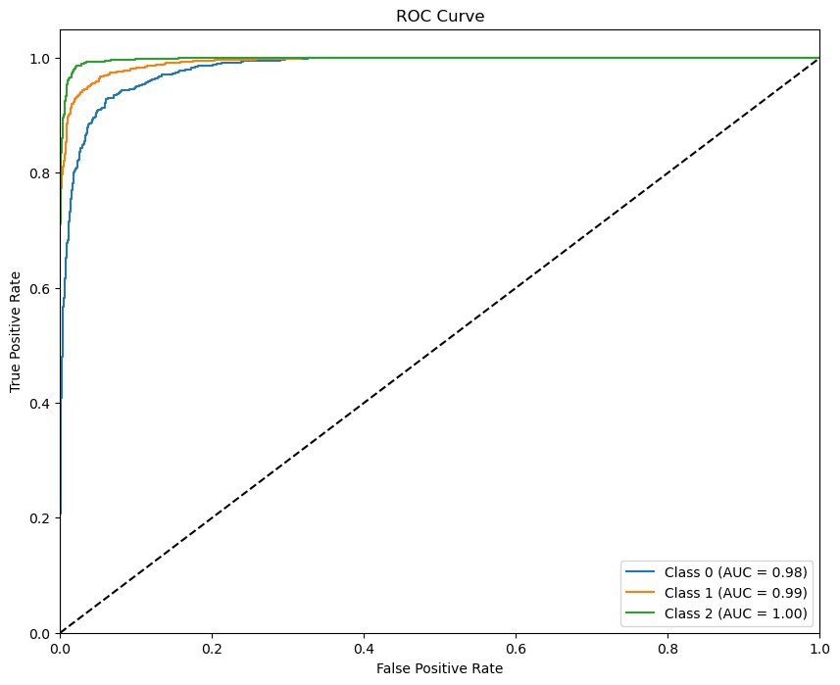

评估结果:

准确率: 0.9406

精确率: 0.9421

召回率: 0.9406

F1分数: 0.9409

