201802073 Kim Yeong Tae
OOP_03 assignment

my repository address :
https://github.com/YoungTae0406/OOP

assignment01
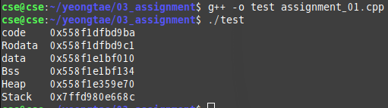

assignment02

