|  |
| --- |
| - |
| Asymmetric Reactions of Stock Market to Good and Bad News |
| ECO2510 Data Project |
|  |
| **Xin Wang, Young Wu** |
| **11/28/2013** |

|  |
| --- |
|  |

Asymmetric Reactions of Stock Market to Good and Bad News

Xin Wang and Young Wu

998162795 and 996213226

November 2013

**Introduction:**

In Kahneman and Tversky (1979)’s paper in behavioral finance, prospect theory is introduced as a way of explaining particular forms of irrational behaviors of the human investors. The paper states that “The value function is normally concave for gains, commonly convex for losses, and is generally steeper for losses than for gains.” As a result of this pattern of behavior, the reaction to good news should be different from the reaction to bad news with ex-ante similar impacts on a stock or a portfolio of stocks.

Andersen et al (2003) use a new dataset of exchange rate quotations, macroeconomic expectations, and macroeconomic realizations to explore real-time price discovery in foreign exchange. They find that exchange market reacts to news in an asymmetric way and bad news has greater impact than good news. In our project we turn to stock market rather than exchange market to see whether we can find similar asymmetric effects of good and bad news.

Another interesting paper by Mondria and Wu (2012) shows that US investors allocate the same amount of attention to bad news in any equity market, but they tend to allocate more attention to good news from familiar equity markets. The explanation in their paper is that unfavorable information has greater influence than favorable information. Actually, the title of their paper contains phrases "bad news travels like wildfire, good news travels slow", which is exactly the hypothesis we want to test in this paper. But our project differs from their paper in that we utilize high frequency trading data, while they only use aggregated yearly data.

The motivation for this project lies in our belief that with the recent extensive using of algorithmic trading, especially high frequency trading, such asymmetric pattern should be significantly reduced, because the algorithms do not use human heuristic.

This project investigates this phenomenon using trading data before and after algorithmic trading becomes popular and identifies the existence and evolution of such behavioral asymmetry. In addition, this report suggests a method to identify stock adjustment time by non-linear regression with the probit function. While most papers use the difference between macroeconomic expectations and macroeconomic announcements to proxy for good news or bad news, in our project we use data themselves to identify whether good news or bad news arrives using econometric estimation methods. We intend to use two months of trading data to provide certain insights into this topic.

**Model:**

Denote the time for the stock to adjust to equilibrium level of firm i and event j, $Δt_{ij}$, and the difference in equilibrium price before and after the event, $Δp_{ij}$. Also denote the trade volume in a 30 minute window around the event, $q_{ij}$.

Define the indicator variable for positive news to be $G_{ij}=\left\{\begin{aligned}1, &Δp_{ij}>0 \\ 0, &Δp_{ij}≤0\end{aligned}\right.$, and the indicator variable for whether the time is before or after year 2009 to be $B_{ij}=\left\{\begin{aligned}1, &t>2009 \\ 0, &t≤2009\end{aligned}\right.$.

Actually, in our data we do not observe the arrival of new information directly. We make a strong assumption that the reason why price of stock changes is market reacts to new information and we use price change to proxy for new information.

The dummy variable $G_{ij}$ is used to test whether stock market reacts faster to the arrival of bad news. The dummy variable $B_{ij}$ is used to test whether the reaction time changes with the popularity of high frequency trading. We have two months data with one month in 2006, and the other one in 2011. We guess that over these past five years, high frequency trading becomes more popular and the popularity of high frequency trading decreases the reaction time to news.

Then the regression $Δt_{ij}=β_{0}+β_{1}∙|Δp_{ij}|+β_{2}∙q_{ij}+β_{3}∙G_{ij}+β_{4}∙B_{ij}+ε_{ij}$ would identify several variables of interest.

$β_{1}, β_{2}$ should be positive and they are used as control variables. A larger change in price or a larger quantity traded should result in longer reaction time.

$β_{3}>0$ means that the reaction time for a good news is longer than that for a bad news, confirming the prospect theory.

$β_{4}<0$ means that there is a decrease in average time of adjustment for the stock before and after the extensive use of algorithmic trading.

One of the difficulty is defining and estimating $Δt_{ij}$. It should be a variable that is proportional to the time for a stock to adjust to its equilibrium level after a new piece of public information hit the market. It is also the time span of price discovery process. Two simple approaches are used in this report:

Method 1:

We could estimate $Δt_{ij}$ by the difference between the times of highest and lowest prices traded within an event window. Symbolically, let $t_{max}=\underset{t∈T}{argmax}{\{p_{t}\}}$ and $t_{min}=\underset{t∈T}{argmin}{\{p_{t}\}}$, then $Δt_{ij}=|t_{max}-t_{min}|$.

Method 2:

We could estimate $Δt_{ij}$ by a non-linear least square fitting the time series to a probit function. Write $p_{t}=α_{0}+α_{1}∙Φ\left(\frac{t-μ}{σ}\right)+ε_{t}$ where $Φ(∙)$ is the probit function, or the cumulative density function of a standard normal distribution.

We initialize parameters ${\left\{α_{0},α_{1},μ,σ\right\}}^{(0)}$ by $\{\min_{t∈T}{{\{p}_{t}\},\max_{t∈T}{{\{p}_{t}\}-\min_{t∈T}{{\{p}_{t}\}, } }}\frac{T}{2},|t_{max}-t_{min}| \}$ to increase speed of convergence. The least square procedure finds the parameters $\{α_{0},α_{1},μ,σ\}$ by minimizing $\sum_{t∈T}{ε_{t}^{2}}$, and we estimate $Δt_{ij}=\hat{σ}$.

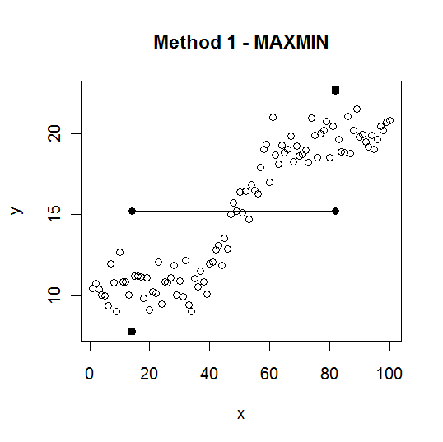 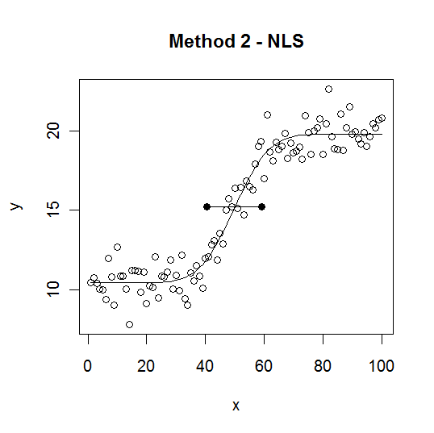

**Data:**

The data are obtained from WRDS (Wharton Research Data Services). The procedure of getting the dataset is described in the appendix. Of the 2757 companies listed in NASDAQ Stock Market, we rank them according to the size of market capitalization and pick 20 firms which lie around 250th (from highest to lowest). The market capitalization for these companies ranges from 3.5 billion to 4.1 billion. 7 out of 20 companies are in the sector of technology, but they also cover sectors of consumer service, health care, finance, capital goods, and so on. So we think it is a reasonably representative group of all companies.

As to the time dimension of our stocks, we want to have enough variation of price change in order to have large number of observations of good news and bad news within limited time. Hence we go to the website to find historical Dow Jones Industrial Average to see which month have both large price increases and decreases and find that both November 2006 and November 2011 satisfy this criterion.

**Event Identification:**

Due to large number of events are needed to have a meaningful regression, the events, and whether they are resulted from positive or negative news is identified purely through price change and trading volume.

The five largest increases and five largest decreases in prices within a window of 30 minutes are selected as events. Some of them are removed due to convergence difficulty during non-linear least squares process. The summary statistics of the remaining events are given in the table below

|  |  |  |
| --- | --- | --- |
|  | Positive | Negative |
| Total Number | 106 | 104 |
| Number in 2011 | 59 | 51 |
| Number in 2006 | 47 | 53 |
| Average Price Change | 0.6891 | 0.5574 |
| Average Volume | 284574 | 183867 |

For most of the stock, the event of November 7th US elections in both years are picked up, the following are few examples of good and bad reaction time estimates using both methods. The green (light) lines depict the estimates using the MAXMIN method, drawn as a probit function for easy comparison with the NLS method. The red (dark) lines depict the estimates using NLS method, which is more accurate in most cases:

1) Stock ALNY on 2006 (left) and 2011 (right):

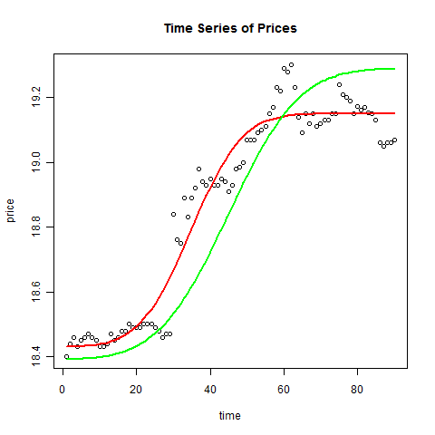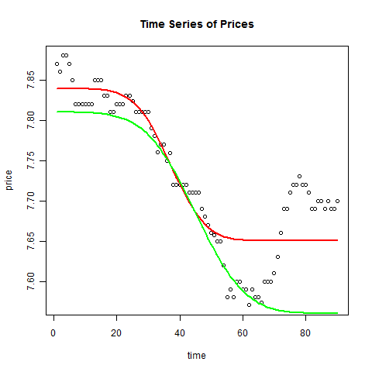

2) Stock FMER on 2006 (left) and 2011 (right):

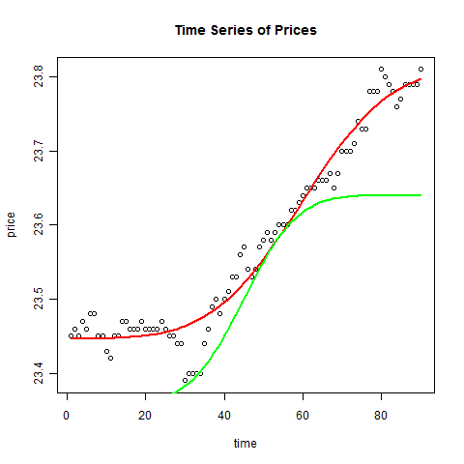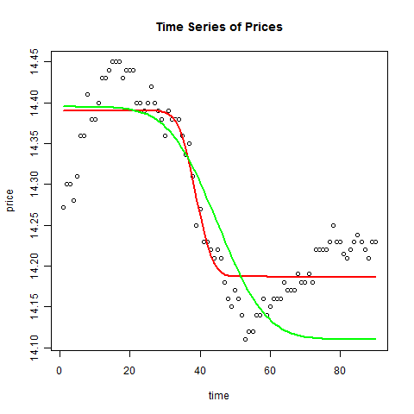

The above examples have relatively good fits with both methods. Note that NLS method is significantly better at picking up overshooting of stock prices, where the stock price increase or decrease too much at the time of events and recover a bit afterwards. Because the MAXMIN method only considers the absolute maximum and minimum, it will accommodate the overshooting too much, instead of the equilibrium price afterwards.

The following are bad examples where the methods disagree or perform in an unintended way:

Stock SPWR in mid-November in 2006 (left) and 2011 (right):

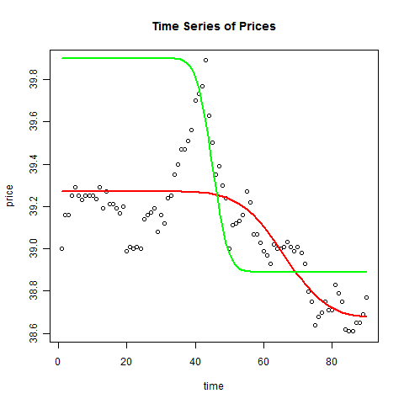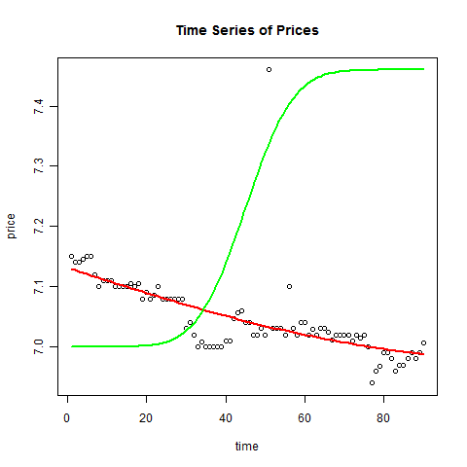

The problem with MAXMIN method is obvious in this set of examples. It picks up the absolute maximum or minimum and completely ignores the trend. NLS method does better in this case.

One significant drawback for NLS is that it does not converge in many cases due to numerical problems of singular derivative matrices. It could be fixed using better numerical method, for example, Bayesian estimation method, but it is not done for the purpose of this project.

**Analysis:**

The regression specified in the model section $Δt_{ij}=β_{0}+β_{1}∙|Δp_{ij}|+β_{2}∙q_{ij}+β_{3}∙G_{ij}+β_{4}∙B_{ij}+ε_{ij}$ is given in the following table:

Method 1:

|  |  |  |  |  |  |  |  |  |  |  |  |  |  |  |  |  |  |  |  |  |  |  |  |  |  |  |  |  |  |  |  |  |  |  |
| --- | --- | --- | --- | --- | --- | --- | --- | --- | --- | --- | --- | --- | --- | --- | --- | --- | --- | --- | --- | --- | --- | --- | --- | --- | --- | --- | --- | --- | --- | --- | --- | --- | --- | --- |
| |  |  |  |  |  | | --- | --- | --- | --- | --- | |  | Estimate | Std. Error | t value | Pr(>|t|) | | (Intercept) | 19.00829 | 1.139557 | 16.68042 | 4.92E-40 | |  | 0.295443 | 1.01738 | 0.286355 | 0.774896 | |  | 4.96E-07 | 9.06E-07 | 0.546987 | 0.584982 | |  | -0.90377 | 1.146746 | -0.78812 | 0.431537 | |  | 0.64875 | 1.145007 | 0.56659 | 0.571613 | |  |  |  |  |

Method 2:

|  |  |  |  |  |
| --- | --- | --- | --- | --- |
|  | Estimate | Std. Error | t value | Pr(>|t|) |
| (Intercept) | 9.521997 | 2.317684 | 4.10841 | 5.76E-05 |
|  | 3.066833 | 2.098396 | 1.461513 | 0.145406 |
| $$q_{ij}$$ | 2.23E-06 | 1.84E-06 | 1.209487 | 0.227869 |
| $$G_{ij}$$ | 1.159252 | 2.332305 | 0.497041 | 0.619692 |
| $$B_{ij}$$ | -3.70219 | 2.328768 | -1.58976 | 0.113429 |

The regression is reproduced for year 2006 and 2011 separately as well. It could be achieved through regression with interaction terms, and the results are reported in the appendix.

Method 2 for 2006:

|  |  |  |  |  |
| --- | --- | --- | --- | --- |
|  | Estimate | Std. Error | t value | Pr(>|t|) |
| (Intercept) | 8.369717 | 3.573155 | 2.342389 | 0.021028 |
|  | 4.627387 | 3.690333 | 1.253921 | 0.212629 |
| $$q_{ij}$$ | -8.25E-07 | 6.20E-06 | -0.13316 | 0.894318 |
| $$G_{ij}$$ | 2.479971 | 4.059506 | 0.610905 | 0.54257 |

Method 2 for 2011:

|  |  |  |  |  |
| --- | --- | --- | --- | --- |
| titles | Estimate | Std. Error | t value | Pr(>|t|) |
| (Intercept) | 7.871079 | 1.959077 | 4.017748 | 0.000117 |
|  | 1.019424 | 1.918925 | 0.531248 | 0.596474 |
| $$q_{ij}$$ | 2.65E-06 | 1.28E-06 | 2.07902 | 0.040282 |
| $$G_{ij}$$ | -0.66106 | 2.151581 | -0.30724 | 0.759323 |

The change in price and quantity has positive and insignificant impact on both measures of adjustment time, as predicted although the relationship is not strong. Also, note that both methods yield statistically insignificant results for both indicators. The results are twofold:

1) There is no statistically significant impact of whether the new information is positive or negative on the price discovery process, in particular the reaction time between equilibrium prices of stocks.

2) There is no statistically significant impact of high frequency trading on the same variable, which means high frequency traders do not shorten the reaction time.

**Conclusion:**

This project proposes two methods of estimating the reaction time of a stock after a public news event. The MAXMIN method uses the length of time between the stock’s highest and lowest prices traded during a window of 30 minutes, and the NLS method fits a probit function through the prices and uses the standard deviation parameter estimate as the reaction time. Comparing the two methods, the MAXMIN method performs better and is faster in terms of numerical computation, while the NLS provides a better fit of the prices and describes the price discovery process better.

Also, this project tries to find empirical evidence of the prospect theory. The results are statistically insignificant, showing small differences between the reaction time for positive news and negative news. Also, there are small differences between the reaction time before and after the popularity of high frequency trading. Therefore, contrary to the belief of asymmetric reaction to good and bad news, the investors seem more rational and invest in a balanced way.

One of the possibly improvement that might alter the results is to use a different functional form for NLS to incorporate overshooting more explicitly. Also, the identification of events could be handled better by using actual events from other datasets instead identified econometrically through changes in prices to reduce endogeneity problems.

**References:**

Andersen T G, Bollerslev T, Diebold F X, et al. Micro Effects of Macro Announcements: Real-Time Price Discovery in Foreign Exchange. American economic review, 2003, 93(1): 38-62.

Kahneman D, Tversky A. Prospect theory: An analysis of decision under risk. Econometrica: Journal of the Econometric Society, 1979: 263-291.

Mondria J, Hill U N C C, Wu T. Familiarity and Surprises in International Financial Markets: Bad news travels like wildfire, good news travels slow! 2012 Meeting Papers. Society for Economic Dynamics, 2012 (50).

**Appendix:**

1) Regression results with interaction terms:

Method 1:

|  |  |  |  |  |
| --- | --- | --- | --- | --- |
|  | Estimate | Std. Error | t value | Pr(>|t|) |
| (Intercept) | 15.41662 | 2.228723 | 6.917244 | 6.51E-11 |
| dps | 7.72482 | 3.954988 | 1.953184 | 0.052236 |
| qs | 1.78E-05 | 1.45E-05 | 1.229621 | 0.220328 |
| gs | 1.092656 | 2.826451 | 0.386582 | 0.699489 |
| ys | 8.238957 | 2.999658 | 2.746632 | 0.006588 |
| dps:qs | -5.90E-05 | 4.16E-05 | -1.4162 | 0.158322 |
| dps:gs | -2.42182 | 4.571902 | -0.52972 | 0.596912 |
| qs:gs | -6.25E-06 | 1.56E-05 | -0.39966 | 0.689847 |
| dps:ys | -9.40504 | 4.51486 | -2.08313 | 0.03855 |
| qs:ys | -2.36E-05 | 1.54E-05 | -1.53114 | 0.127364 |
| gs:ys | -3.97958 | 4.036309 | -0.98595 | 0.325387 |
| dps:qs:gs | 2.21E-05 | 4.53E-05 | 0.487251 | 0.62663 |
| dps:qs:ys | 5.16E-05 | 4.39E-05 | 1.173615 | 0.241988 |
| dps:gs:ys | -1.15035 | 5.672695 | -0.20279 | 0.839514 |
| qs:gs:ys | 9.93E-06 | 1.66E-05 | 0.596793 | 0.551341 |
| dps:qs:gs:ys | -2.90E-06 | 4.79E-05 | -0.0604 | 0.951897 |

Method 2:

|  |  |  |  |  |
| --- | --- | --- | --- | --- |
|  | Estimate | Std. Error | t value | Pr(>|t|) |
| (Intercept) | 4.843189 | 4.750706 | 1.019467 | 0.309251 |
| dps | 11.38091 | 8.430382 | 1.349988 | 0.178593 |
| qs | 2.58E-05 | 3.09E-05 | 0.834388 | 0.405089 |
| gs | 7.283202 | 6.024812 | 1.208868 | 0.228185 |
| ys | 2.561391 | 6.394018 | 0.400592 | 0.689161 |
| dps:qs | -6.56E-05 | 8.87E-05 | -0.73923 | 0.460662 |
| dps:gs | -8.65411 | 9.745386 | -0.88802 | 0.375629 |
| qs:gs | -3.22E-05 | 3.33E-05 | -0.9651 | 0.335696 |
| dps:ys | -8.9827 | 9.623796 | -0.93338 | 0.351782 |
| qs:ys | -1.96E-05 | 3.29E-05 | -0.59706 | 0.551161 |
| gs:ys | -6.99269 | 8.603725 | -0.81275 | 0.417357 |
| dps:qs:gs | 7.75E-05 | 9.66E-05 | 0.802813 | 0.423065 |
| dps:qs:ys | 5.19E-05 | 9.36E-05 | 0.554653 | 0.579771 |
| dps:gs:ys | 6.236903 | 12.09182 | 0.515795 | 0.606585 |
| qs:gs:ys | 2.77E-05 | 3.55E-05 | 0.780387 | 0.436114 |
| dps:qs:gs:ys | -6.00E-05 | 0.000102 | -0.58754 | 0.557523 |

2) The quote and trade data are obtained from WRDS (Wharton Research Data Services) with the list of firm: “NWS SPWR CVLT AZPN CDNS SIRO FEIC ALNY HAIN BRCD FMER PMTC MORN CAR NATI TIBX FNFG MCRS CPRT MIDD”.

The complete code, outputs, plots, and instruction for running the codes are given on the page: http://individual.utoronto.ca/youngwu/ECO2510Project.htm