10:

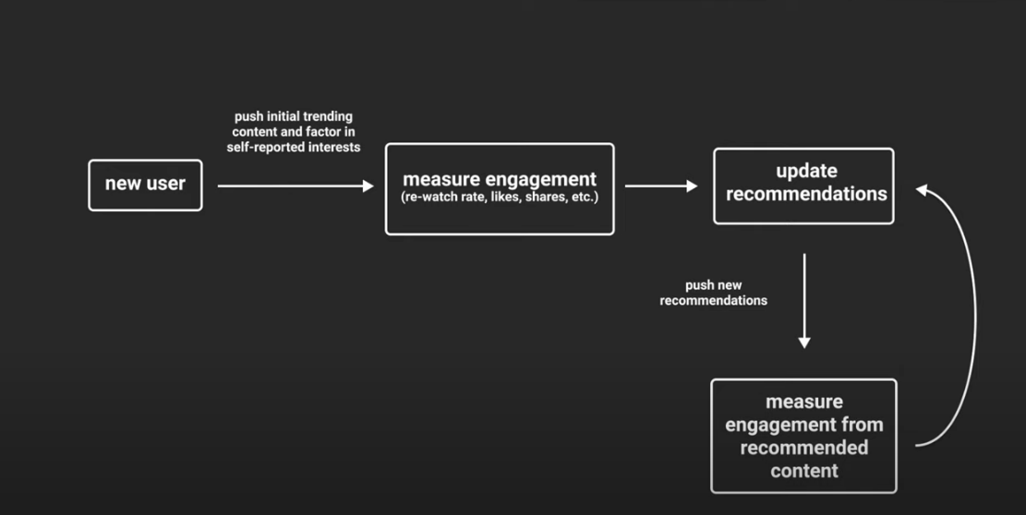

For a new user just recommend the trending content

\*) Store that to update recommendations :

1) Scroll = not interested

2) Like, share, keep on watching the post or video for long time = interested

Content based filtering -> item-item recommendations, bec u watched the movie x I recommend u to watch y and z

Collaborative filtering :

1. Preprocessing phase :

Sparse csr matrix -> user, item, ratings

We want the matrix not to be very sparse (have large non-zero elements compared to zero elements)

What is the latent features ?

1. Picking model:

Matrix factorization :  
divide user item matrix into user matrix and item matrix : (SVD,ALS,SGD)

Why use MF :  
Capturing Latent Factors

* User-user/item-item CF relies only on explicit similarity between users/items.
* MF uncovers latent factors (hidden attributes) explaining why users like certain items.
* For example, latent factors could represent abstract concepts like "fitness-related" or "social posts" without you explicitly defining these.

R - >U, S, V^t

Points :

* 1. The user put a hashtag of the place he is currently at
     1. so take this hashtag as the data being collected from his interaction
  2. if he did or did not put a hashtag I will in both cases extract some info from the photo like:
     1. objects in the photo : drinks, food, bags, etc.
     2. Analyze background/setting
  3. If I am sure about the things I extracted from the photo I will use it, if the photo is vague I will not use the info I got from it, so I will use a accuracy threshold
  4. If I got something with the accuracy threshold from the analyzing of the photo I will use the info I got

If user posts negative text on specific places, do not recommend those places to him

Positive sentiment + User dislikes post = Strong negative preference (confidence 0.7)

Positive sentiment + User likes post = Strong positive preference (confidence 0.8)