quarto

Norah Jones

2023-12-23

Table of contents

# Preface

This is a Quarto book.

To learn more about Quarto books visit <https://quarto.org/docs/books>.

# 1. Introduction

This is a book created from markdown and executable code.

See[1] for additional discussion of literate programming.

# 2. Fuel economy for suvs

ggplot(class, aes(x = displ, y = hwy)) +  
 geom_point() +  
 geom_smooth(se = FALSE)

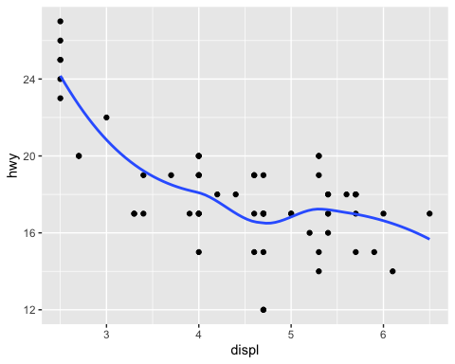

# 3. Summary

In summary, this book has no content whatsoever.

# References

1. Knuth, D. E. (1984). Literate programming. *Comput. J.*, *27*(2), 97–111. <https://doi.org/10.1093/comjnl/27.2.97>