# Introduction

This is a book created from markdown and executable code.

See[1] for additional discussion of literate programming.

library(tidyverse)

#> ── Attaching core tidyverse packages ──────────────────────── tidyverse 2.0.0 ──  
#> ✔ dplyr 1.1.4 ✔ readr 2.1.4  
#> ✔ forcats 1.0.0 ✔ stringr 1.5.1  
#> ✔ ggplot2 3.4.4 ✔ tibble 3.2.1  
#> ✔ lubridate 1.9.3 ✔ tidyr 1.3.0  
#> ✔ purrr 1.0.2   
#> ── Conflicts ────────────────────────────────────────── tidyverse_conflicts() ──  
#> ✖ dplyr::filter() masks stats::filter()  
#> ✖ dplyr::lag() masks stats::lag()  
#> ℹ Use the conflicted package (<http://conflicted.r-lib.org/>) to force all conflicts to become errors

class <- mpg |> filter(class == params$my_class)  
a <- 5  
a

#> [1] 5

# Fuel economy for suvs

ggplot(class, aes(x = displ, y = hwy)) +  
 geom_point() +  
 geom_smooth(se = FALSE)

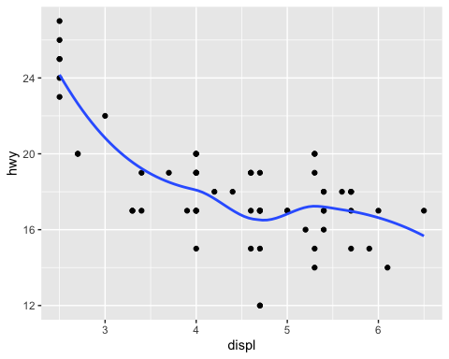

1. Knuth, D. E. (1984). Literate programming. *Comput. J.*, *27*(2), 97–111. <https://doi.org/10.1093/comjnl/27.2.97>