Task 1:

I have used VMWare and install Ubuntu on it as the spec of the machine is below:
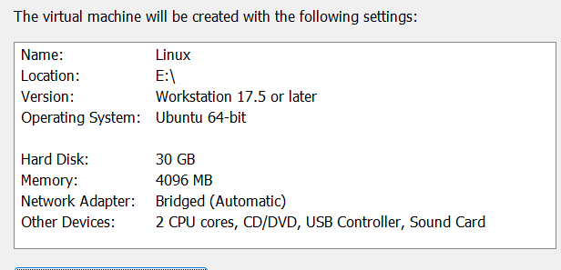

For static ip:
After configure the OS, I have assign the Static ip to the vmware, I have changed the network setting to Briged network than assign the ip.
Host machine ip is 192.168.1.2
VM Machine ip is 192.168.1.50
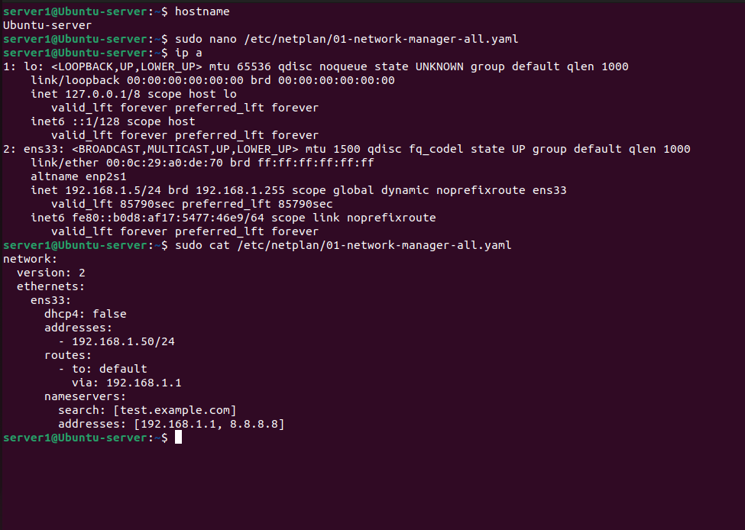
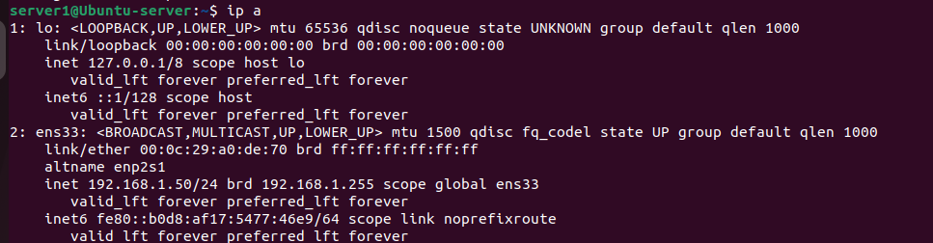

Time Sync
The time is auto sync in ubuntu, but the below command can be used to sync the ntp server.
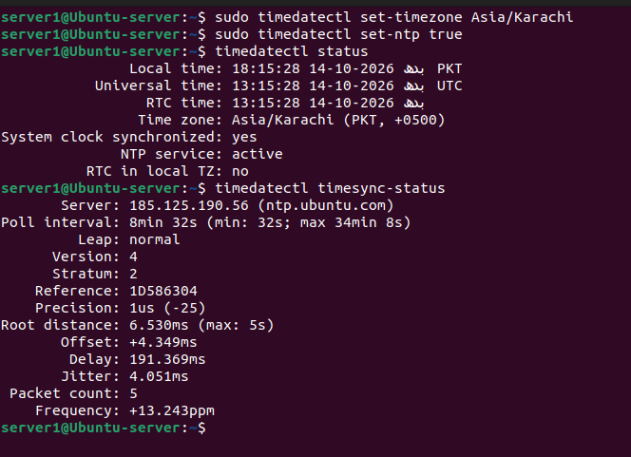

SSH:
After ntp sync, I have install the openssh-server package and allow port 22 (ssh port) on ufw and via a ufw it also reflect on iptables. The commands on iptables and ufw are below:
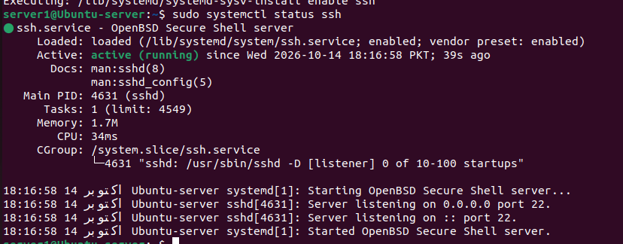
Firewall allow OpenSSH
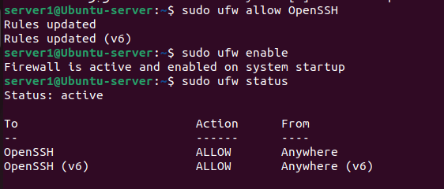

SSH Succesfully
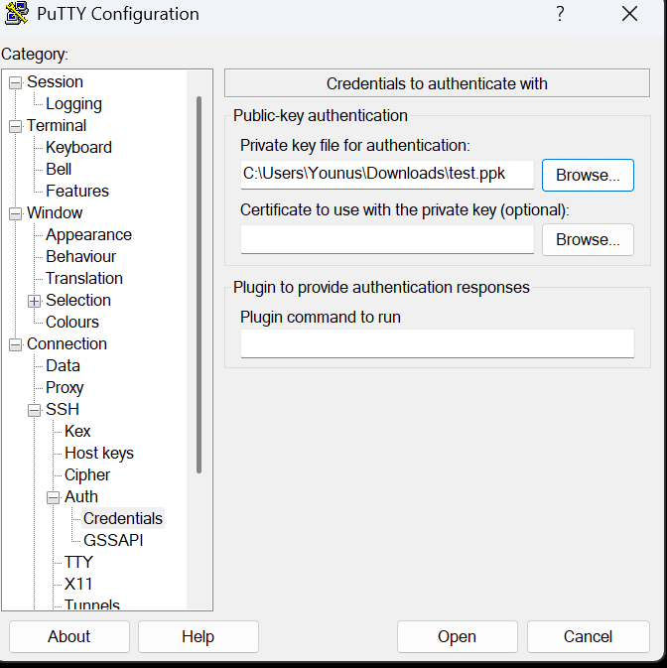
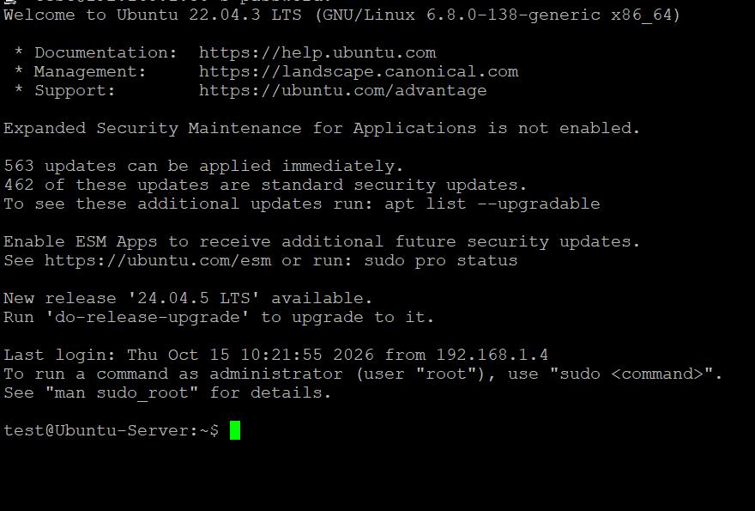

Disable Root User
After Successful SSH, I have created the user (test) non admin with sudo, and disable the root User.
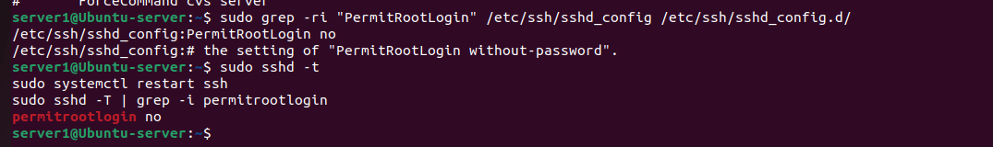

Task 2

Inventory File
For Task 2, I have install the ansible and make inventory file, as I am applying the script on local machine so on inventory I have nit added any server detail rather I have added localhost.
[Webserver]
Localhost ansible_connection=local
I have also added, how can we add the sercer ip and user.
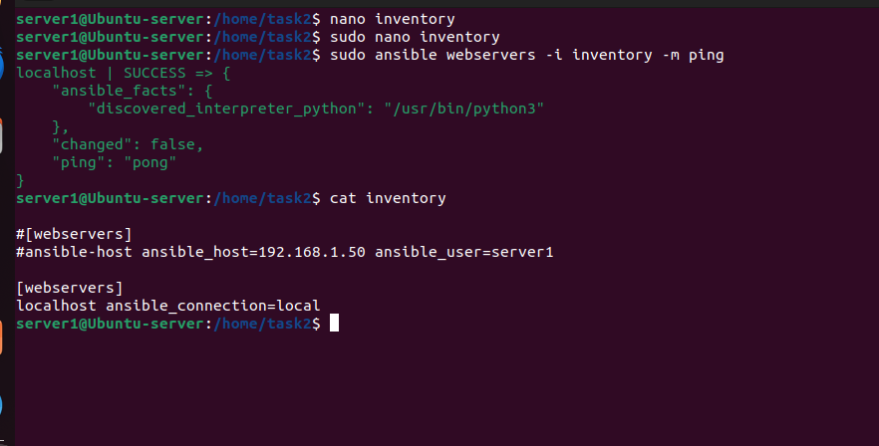
After verify the ping on inventory file that server is responding, I have created the playbook for easy understanding I have created the single file but we make the multiple files as well to easily excute the code.
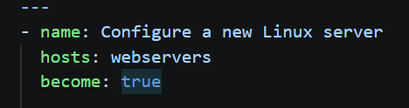
On the above block, the host is declared from inventory file and also we have mentioned to use admin privileged to install the packages.
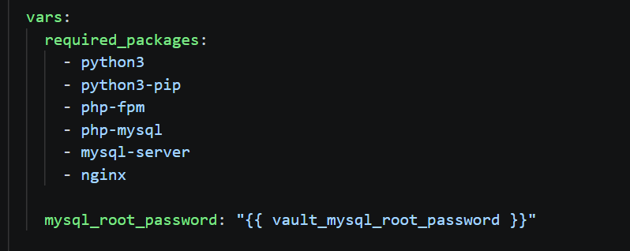
On the above block, I have declared, the variable with required_package name and valut root password of sql.
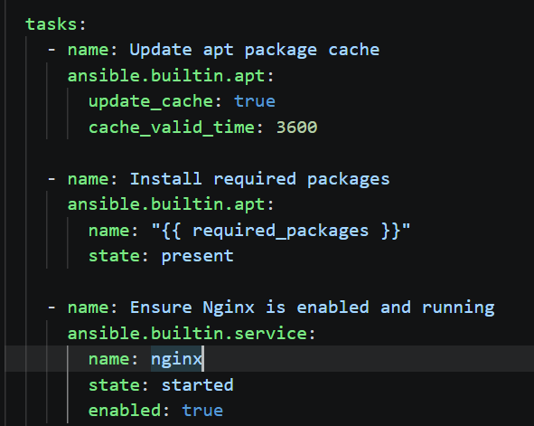
On task 1 I have command the ansible to update the cache if it is 1 hour old, if not skip this step. On second block I have installed all the package which I have declared in vars section. And at last th have ensudre the nginx should be enable and working.
- state: started starts Nginx now if it isn’t running.
- enabled: true makes it start automatically on boot.
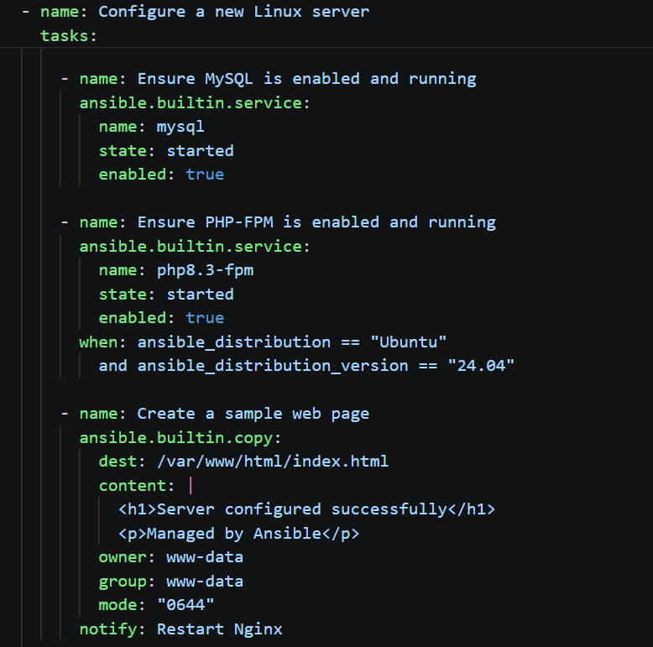
On this block, the MYSQL, PHP-FPM and nginx web page created, on MYSQL iahve have added the condition if ububtu is 24.04 so my sql is run util its disabled as MYSQL is heaily depent upon os version.
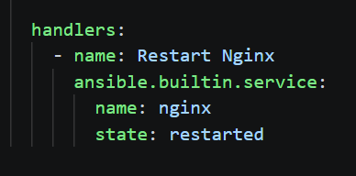
As I have changed the nginx webser so I use hanlers to restart the server.

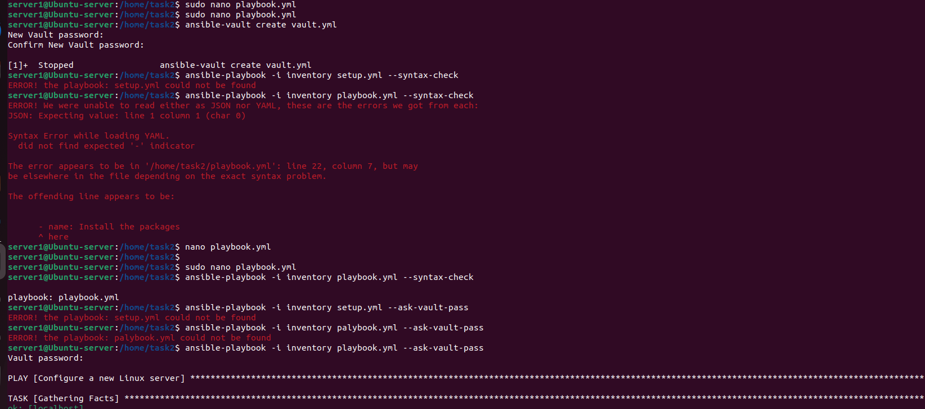
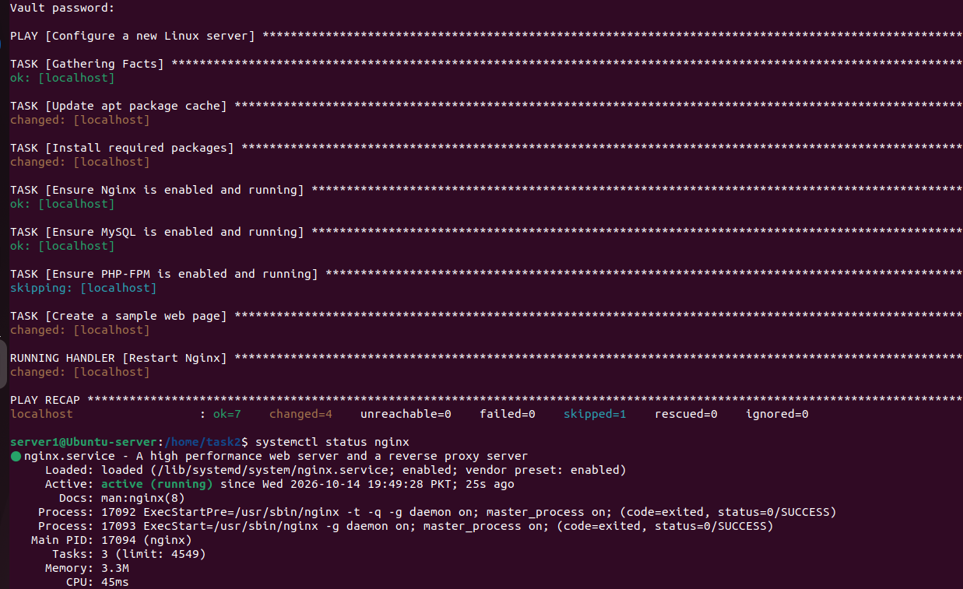
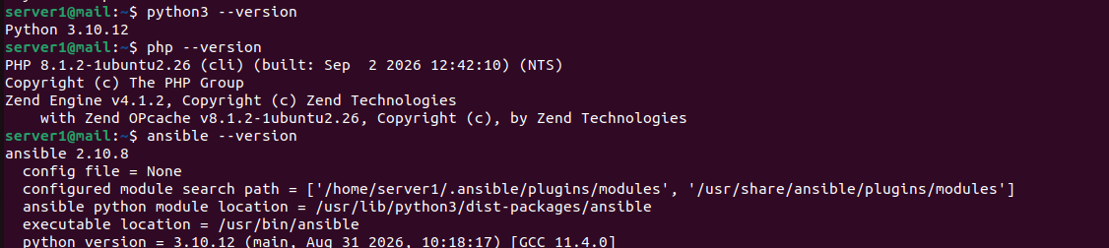

Task 4:
On below you can see the UFW status list.
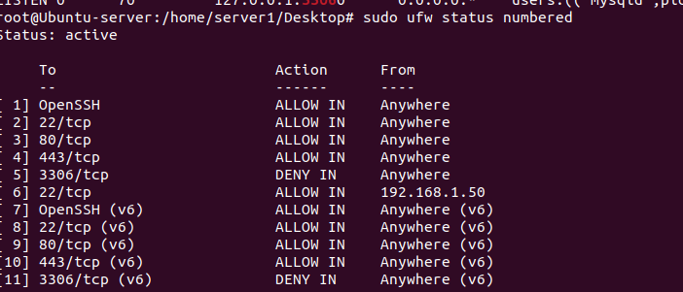
After deny all ssh connection except the specific ip:
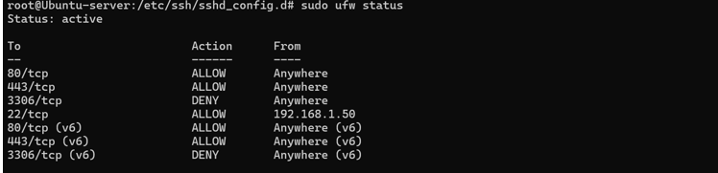
To prevent the server for brute force attack I have install the fail2ban and configure that at a tiem once 5 attempt can be done after unsuccessful attempt the console is deactivate for 5 min and session time to emter the password is also 5 min.
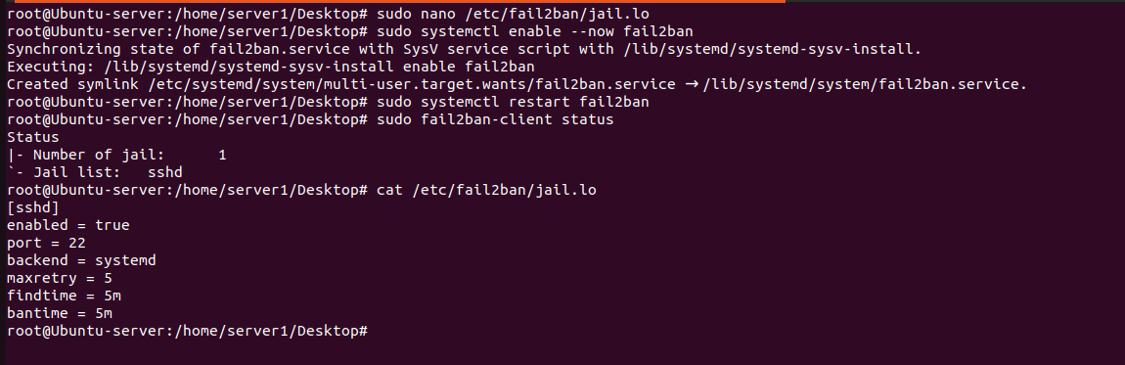
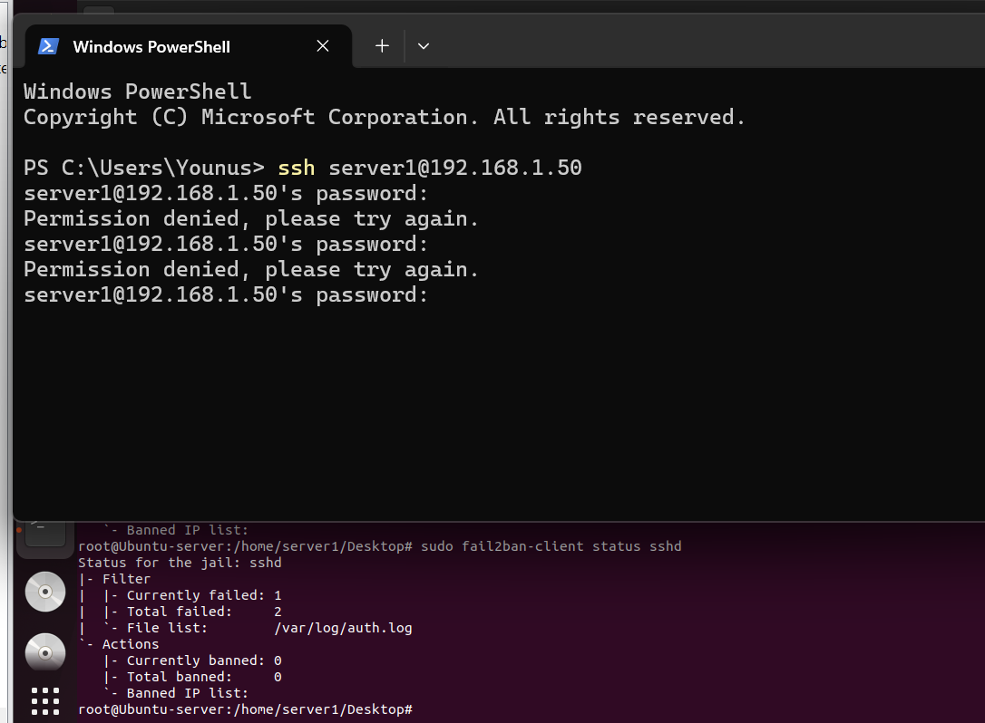
The iptables is also updated, as the iptables is read the command from top to down so to secure the ssh I have allow the loop back ip and other caoomand mean current seesion shloud allow.
After tat I have allow the port 22,80.443 and block 3306 (mysql port) and also block the inbound traffic.
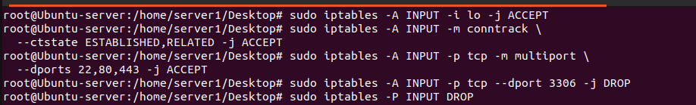
IPTable Rules:
sudo iptables -S
-P INPUT DROP
-P FORWARD DROP
-P OUTPUT ACCEPT
-N ufw-after-forward
-N ufw-after-input
-N ufw-after-logging-forward
-N ufw-after-logging-input
-N ufw-after-logging-output
-N ufw-after-output
-N ufw-before-forward
-N ufw-before-input
-N ufw-before-logging-forward
-N ufw-before-logging-input
-N ufw-before-logging-output
-N ufw-before-output
-N ufw-logging-allow
-N ufw-logging-deny
-N ufw-not-local
-N ufw-reject-forward
-N ufw-reject-input
-N ufw-reject-output
-N ufw-skip-to-policy-forward
-N ufw-skip-to-policy-input
-N ufw-skip-to-policy-output
-N ufw-track-forward
-N ufw-track-input
-N ufw-track-output
-N ufw-user-forward
-N ufw-user-input
-N ufw-user-limit
-N ufw-user-limit-accept
-N ufw-user-logging-forward
-N ufw-user-logging-input
-N ufw-user-logging-output
-N ufw-user-output
-A INPUT -j ufw-before-logging-input
-A INPUT -j ufw-before-input
-A INPUT -j ufw-after-input
-A INPUT -j ufw-after-logging-input
-A INPUT -j ufw-reject-input
-A INPUT -j ufw-track-input
-A INPUT -i lo -j ACCEPT
-A INPUT -m conntrack --ctstate RELATED,ESTABLISHED -j ACCEPT
-A INPUT -p tcp -m multiport --dports 22,80,443 -j ACCEPT
-A INPUT -p tcp -m tcp --dport 3306 -j DROP
-A FORWARD -j ufw-before-logging-forward
-A FORWARD -j ufw-before-forward
-A FORWARD -j ufw-after-forward
-A FORWARD -j ufw-after-logging-forward
-A FORWARD -j ufw-reject-forward
-A FORWARD -j ufw-track-forward
-A OUTPUT -j ufw-before-logging-output
-A OUTPUT -j ufw-before-output
-A OUTPUT -j ufw-after-output
-A OUTPUT -j ufw-after-logging-output
-A OUTPUT -j ufw-reject-output
-A OUTPUT -j ufw-track-output
-A ufw-after-input -p udp -m udp --dport 137 -j ufw-skip-to-policy-input
-A ufw-after-input -p udp -m udp --dport 138 -j ufw-skip-to-policy-input
-A ufw-after-input -p tcp -m tcp --dport 139 -j ufw-skip-to-policy-input
-A ufw-after-input -p tcp -m tcp --dport 445 -j ufw-skip-to-policy-input
-A ufw-after-input -p udp -m udp --dport 67 -j ufw-skip-to-policy-input
-A ufw-after-input -p udp -m udp --dport 68 -j ufw-skip-to-policy-input
-A ufw-after-input -m addrtype --dst-type BROADCAST -j ufw-skip-to-policy-input
-A ufw-after-logging-forward -m limit --limit 3/min --limit-burst 10 -j LOG --log-prefix "[UFW BLOCK] "
-A ufw-after-logging-input -m limit --limit 3/min --limit-burst 10 -j LOG --log-prefix "[UFW BLOCK] "
-A ufw-before-forward -m conntrack --ctstate RELATED,ESTABLISHED -j ACCEPT
-A ufw-before-forward -p icmp -m icmp --icmp-type 3 -j ACCEPT
-A ufw-before-forward -p icmp -m icmp --icmp-type 11 -j ACCEPT
-A ufw-before-forward -p icmp -m icmp --icmp-type 12 -j ACCEPT
-A ufw-before-forward -p icmp -m icmp --icmp-type 8 -j ACCEPT
-A ufw-before-forward -j ufw-user-forward
-A ufw-before-input -i lo -j ACCEPT
-A ufw-before-input -m conntrack --ctstate RELATED,ESTABLISHED -j ACCEPT
-A ufw-before-input -m conntrack --ctstate INVALID -j ufw-logging-deny
-A ufw-before-input -m conntrack --ctstate INVALID -j DROP
-A ufw-before-input -p icmp -m icmp --icmp-type 3 -j ACCEPT
-A ufw-before-input -p icmp -m icmp --icmp-type 11 -j ACCEPT
-A ufw-before-input -p icmp -m icmp --icmp-type 12 -j ACCEPT
-A ufw-before-input -p icmp -m icmp --icmp-type 8 -j ACCEPT
-A ufw-before-input -p udp -m udp --sport 67 --dport 68 -j ACCEPT
-A ufw-before-input -j ufw-not-local
-A ufw-before-input -d 224.0.0.251/32 -p udp -m udp --dport 5353 -j ACCEPT
-A ufw-before-input -d 239.255.255.250/32 -p udp -m udp --dport 1900 -j ACCEPT
-A ufw-before-input -j ufw-user-input
-A ufw-before-output -o lo -j ACCEPT
-A ufw-before-output -m conntrack --ctstate RELATED,ESTABLISHED -j ACCEPT
-A ufw-before-output -j ufw-user-output
-A ufw-logging-allow -m limit --limit 3/min --limit-burst 10 -j LOG --log-prefix "[UFW ALLOW] "
-A ufw-logging-deny -m conntrack --ctstate INVALID -m limit --limit 3/min --limit-burst 10 -j RETURN
-A ufw-logging-deny -m limit --limit 3/min --limit-burst 10 -j LOG --log-prefix "[UFW BLOCK] "
-A ufw-not-local -m addrtype --dst-type LOCAL -j RETURN
-A ufw-not-local -m addrtype --dst-type MULTICAST -j RETURN
-A ufw-not-local -m addrtype --dst-type BROADCAST -j RETURN
-A ufw-not-local -m limit --limit 3/min --limit-burst 10 -j ufw-logging-deny
-A ufw-not-local -j DROP
-A ufw-skip-to-policy-forward -j DROP
-A ufw-skip-to-policy-input -j DROP
-A ufw-skip-to-policy-output -j ACCEPT
-A ufw-track-output -p tcp -m conntrack --ctstate NEW -j ACCEPT
-A ufw-track-output -p udp -m conntrack --ctstate NEW -j ACCEPT
-A ufw-user-input -p tcp -m tcp --dport 22 -m comment --comment "\'dapp_OpenSSH\'" -j ACCEPT
-A ufw-user-input -p tcp -m tcp --dport 22 -j ACCEPT
-A ufw-user-input -p tcp -m tcp --dport 80 -j ACCEPT
-A ufw-user-input -p tcp -m tcp --dport 443 -j ACCEPT
-A ufw-user-input -p tcp -m tcp --dport 3306 -j DROP
-A ufw-user-input -s 192.168.1.50/32 -p tcp -m tcp --dport 22 -j ACCEPT
-A ufw-user-limit -m limit --limit 3/min -j LOG --log-prefix "[UFW LIMIT BLOCK] "
-A ufw-user-limit -j REJECT --reject-with icmp-port-unreachable
-A ufw-user-limit-accept -j ACCEPT

Task 5
I have disabled the root access and than disabled unwamted listing ports. (Tulpn dispale by sudo systemctl disable –now package name)
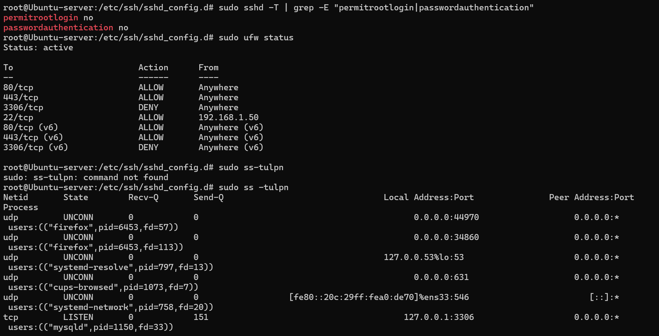
Also change the permission of the files that hold sensitive information and ssh config file,
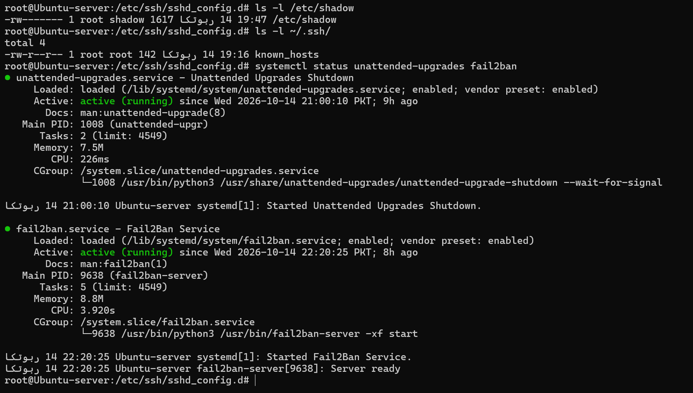

Tulpn dispale by sudo systemctl disable –now

Task 6:
The screen shot of the logs file
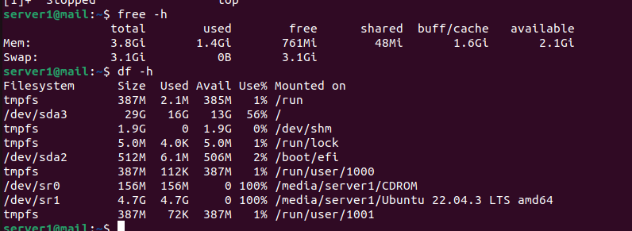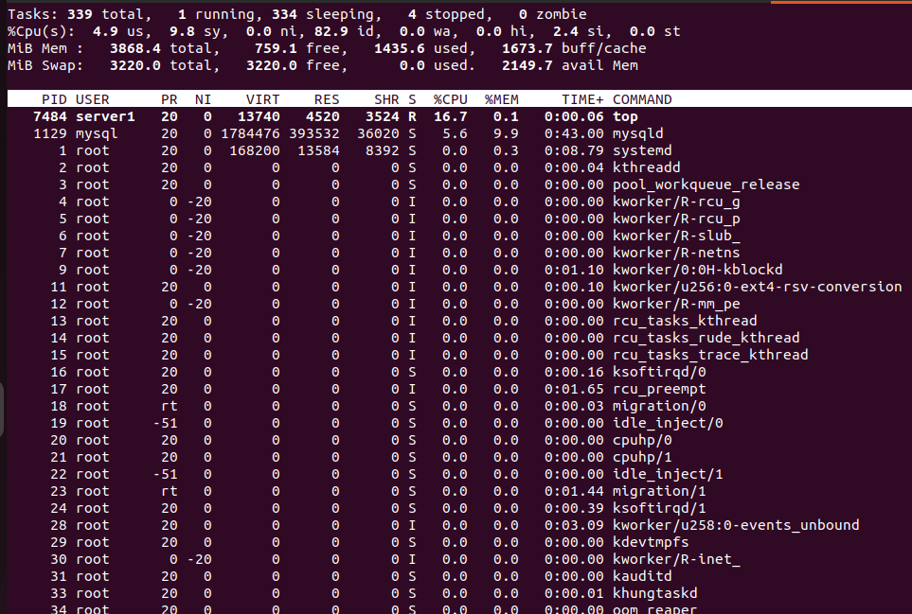
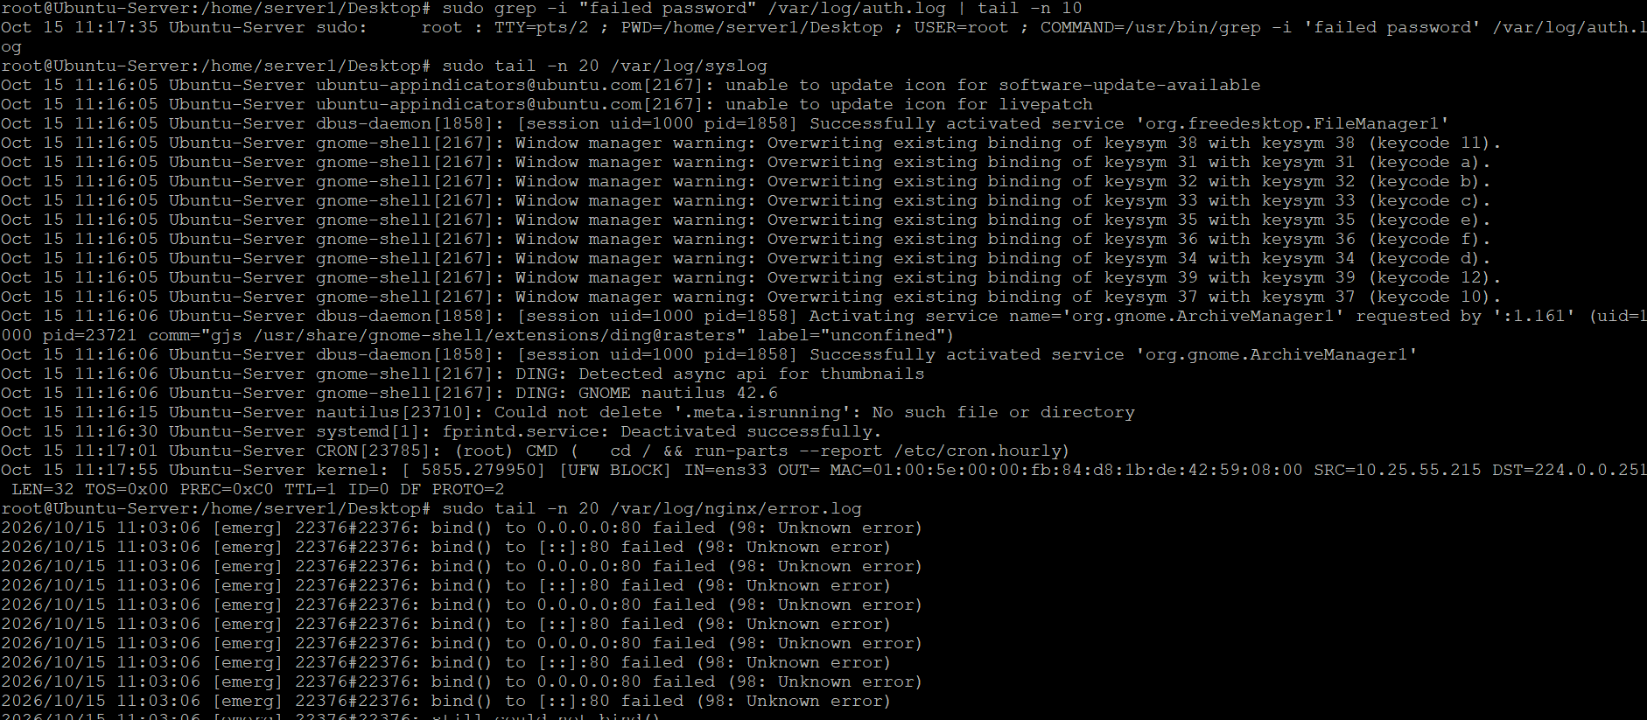

The bash file created to monitor the error
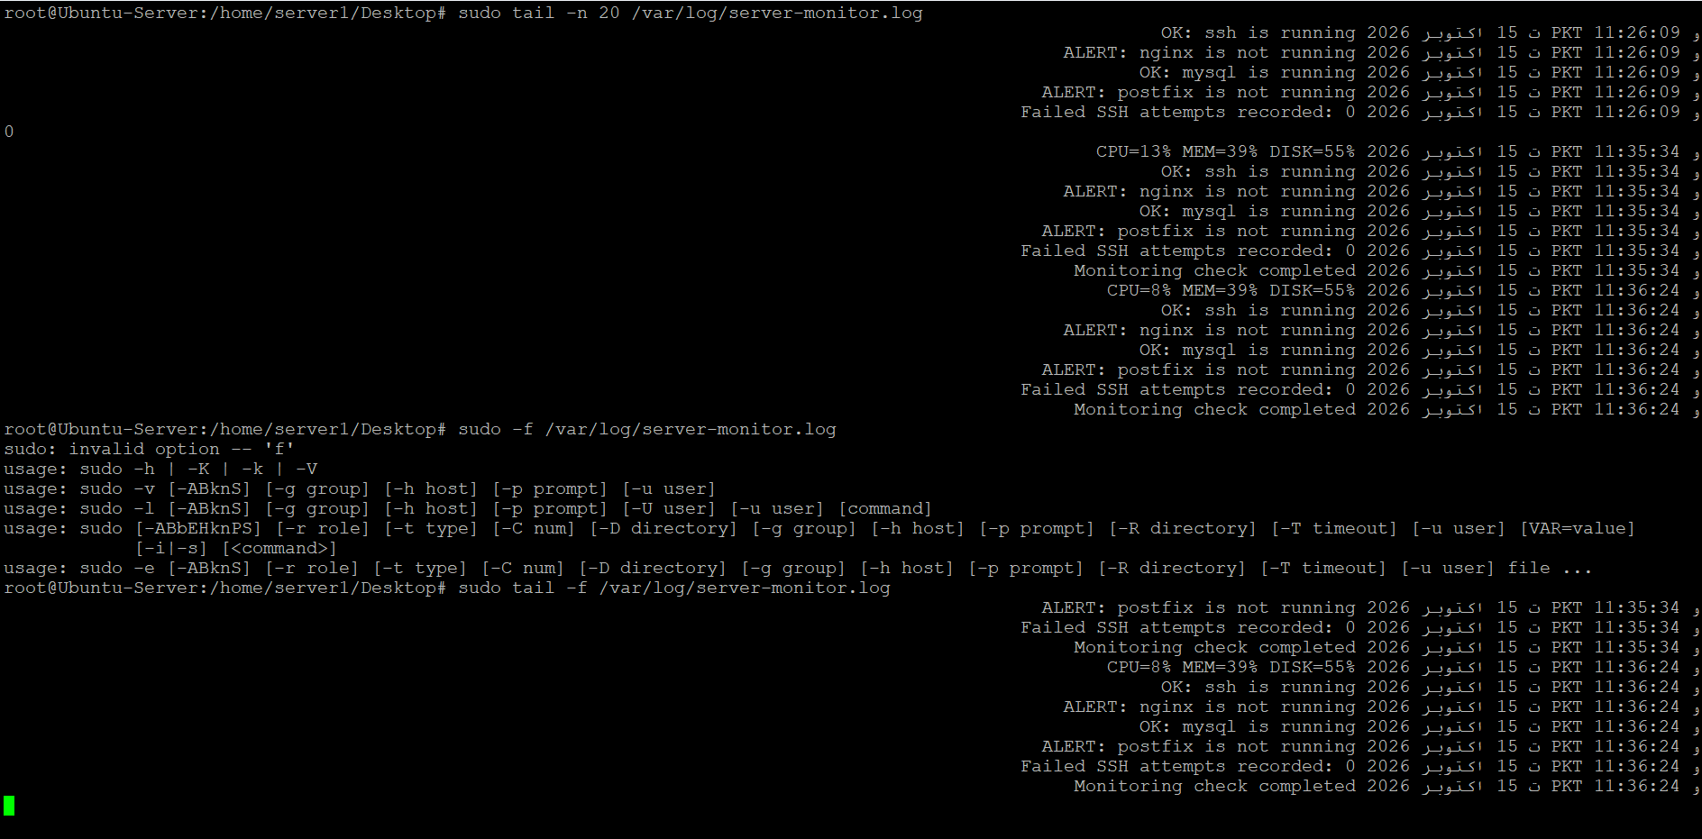

Apply cornjob to show alert after every 5 min.
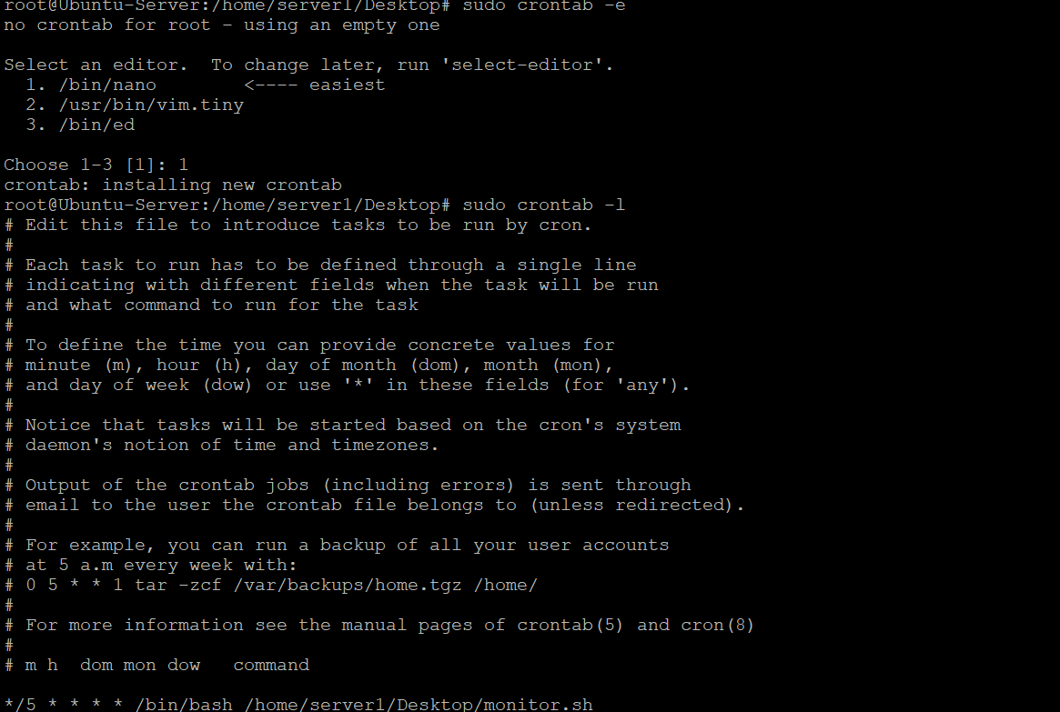

Task 7:
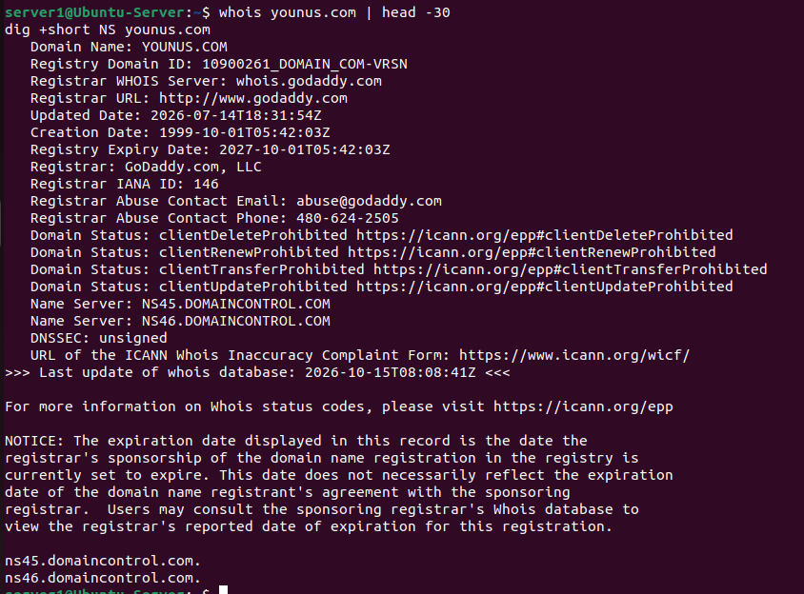
The server side work has been done, now we need to purchase the domaon (Younus.com) to set the spf, dmarc,TXT record and PTR .

Task 3:
setup.sql: Database
config.php: Database information
db.php: function to connect mysql
index.php: test page ensure the PHP is running, MYSQL is connecting and test record should be fetch

