Application of augmented reality in support of decision making for authorities

Székely, Zoltán szekely.zoltan@uni-nke.hu)
National University for Public Service, Hungary

Abstract
Augmented reality is an extension of the perception through adding virtual elements to the real environment, usually corresponding with real objects or providing additional information accessible through ubiquitous computing. A survey concluded among our students - who already have working experience in the administration - showed that during work, more than 60 per cent would welcome additional information from the client or the case displayed discretely on a smartglass for them. This paper will present aspects of possible use of augmented reality in administrational decision making especially when decision has to be made on the site.

Keywords: augmented reality, decision support, ARES

About augmented reality
Augmented reality (AR) is the extension of the perception of the user by adding virtual reality elements into the real environment (Klepper, 2007). Usually these virtual elements contain additional information related to the relevant objects in the environment, enhancing user experience, such as distance of a certain shop, owner of a real estate property, arrival time for the next bus etc. From the user perspective the virtual elements can appear overlapping the real object, hovering above or below it or on any part of the display used, as configured by the user or by the operational system (OS). These virtual elements carrying additional information are enabled by the third generation of computing, called ubiquitous computing in a user-centered design (UCD), displayed in a form to be easily understandable by any person (Hansmann, 2003).
With the augmented reality, the enhancement of the perception leads to a better cognition, adding more elements to the cognitive process already synthesizing perception through experience, learning, belief, faith, superstition etc. into an enhanced understanding of the environment and/or other circumstances. It can even deliver information not perceivable by human senses or not detectable at a given moment, such as view from another perspective (e.g. satellite view), or spectrographic display of emitted electromagnetic waves at a wavelength unable to be seen with open eyes or components of the air, exact temperature, humidity and so on. Twelve-year-old studies have already highlighted the role of augmented reality as a facilitator of information acquisition, a viable medium and strong competitor to any other source such as video or printed media (Valimont, 2002).
Better perception leads to better cognition and better cognition means more processed information, wider understanding and more effective learning, which is essential for more successful and accurate decisions. This feature of augmented reality is especially usable when only a short time is available for decision making or the environment does not allow the use of workstations or consultation with printed manuals or other sources. For example the use of augmented reality for high-precision surgery is researched since 1998 (Fuchs, 1998).

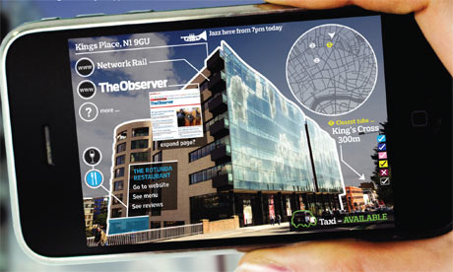
Picture 1- Example for augmented reality. Source: The Guardian

Brief history of augmented reality devices
Augmented reality appeared first in the science fiction literature: a novel of Lyman Frank Baum (author of the Wonderful Wizard of Oz as well), with the title “The Master Key”. In the novel, a boy gets an artifact from the “Demon of Electricity” which provides him the ability to see the personality of the people he meets. His eyeglasses show “C” letters above cruel, “G” letters above good persons and so on. The work was published in 1901 (Baum, 1901).
The first device trying to put this fiction to reality was the “Sensorama” built in 1957. Of course it has a size of a wardrobe and projected the virtual reality elements to a previously recorded video. The film allowed the user to wander in the outskirts of an American town while experiencing wind, smell and even 3D pictures. For this the person has to almost literally sit into the wardrobe-sized machine. Its pattern was registered in 1961 (Morton, 1961).

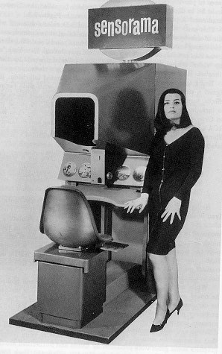  Picture 2 - Sensorama Simulator. Source: Morton H. L. | 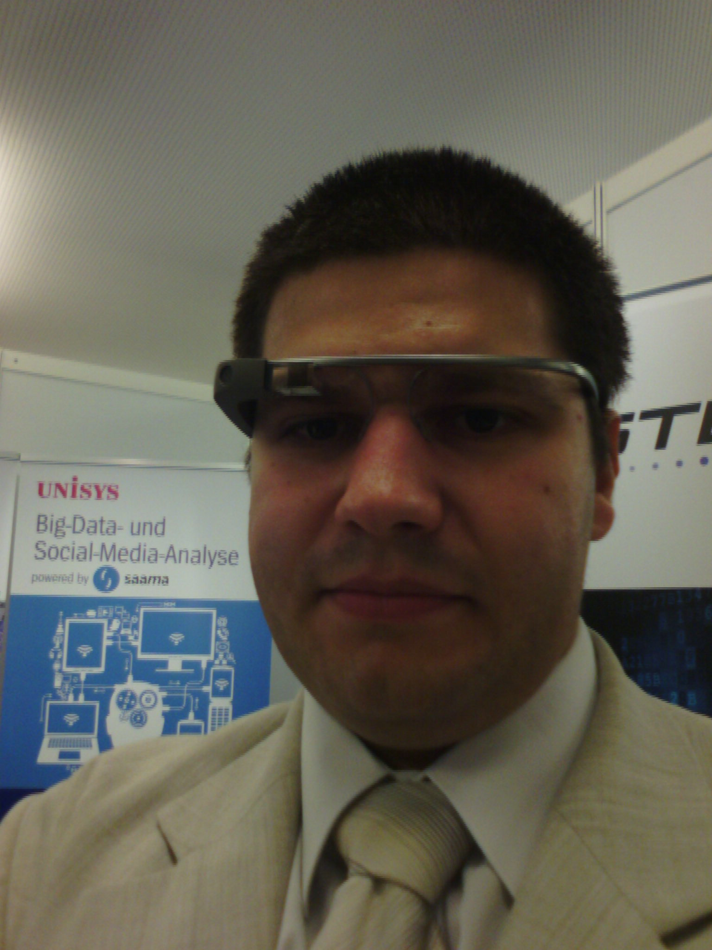  Picture 3- The author wearing a Google Glass. Picture is courtesy of Unisys

The most up-to-date augmented reality devices of the present are the smart glasses. These “eyeglass” displays were developed in 1997, but no one succeeded to put the idea to market until nowadays. The first type of a market-ready smart glass is currently under public test and the pattern is now owned by Google Inc. (Spitzer, 1997).

Use of augmented reality by authorities
First, we have to clarify that eyeglass systems are not the one and only device usable for the purpose of creating augmented reality. Smartphones, tabs, PDA-s, other Head-Mounted-Displays or Head-Up-Displays can be used as well. For example there are available solutions for firefighter or police helmets with augmented reality capability, first invented for training purposes (Bastian, 2001), later evolved to first-line assistance tools, like the C-THRU helmet designed by Omer Hacimeroglu, providing the ability of seeing through smoke with the use of augmented reality. With the help of this helmet, vital information is displayed for the firefighter supporting his or her decisions to find the best way to save the victims and extinguish the flames. Another great function of the helmet is that everything is recorded simultaneously, decreasing the time consuming paperwork and bureaucracy in relation of a deployment.

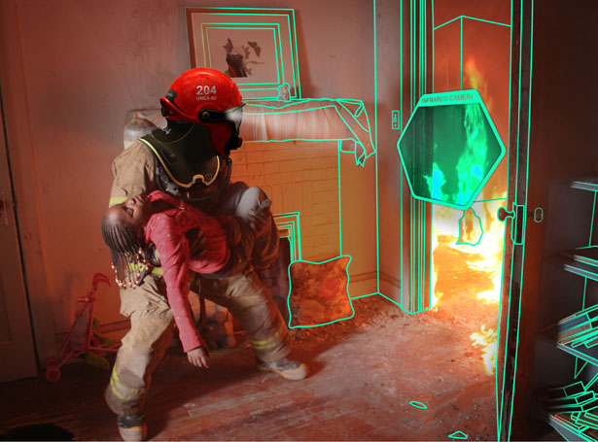
Picture 4- Depiction what a firefighter can see with C-THRU. Source: Omar Hacimeroglu, 2014

Moreover, vehicle windshields (Schofield, 2012) or any other transparent surface can be transformed to create augmented reality as well, with the use of a technology called microblind system on transparent surfaces (Lamontagne, 2005). On the picture below, the use of windshield displayed augmented reality is demonstrated in a patrol car for traffic policing purposes, as the built-in vehicle check system recognized a driver with expired registration and marked her car with an overlapping transparent virtual element in red and a hovering box with information on the driver.

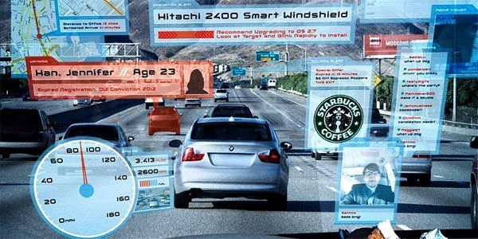
Picture 5- –Hitachi 2400 Smart Windshield in use. Source: Hitachi

Another important feature of augmented reality is the role as a new platform for collaboration and work organization. It allows tagging elements of the environment for another member of the team while assigning tasks to do with that object. Work-related information can be displayed for every team member or only for the members connected to the relevant task and all of this without drawing the attention of the worker from the environment. This can be vital in dangerous workplaces or emergency situations, where using an alternate communication system such as text message on handheld cell phone or walkie-talkie is a peril itself and much slower than just using voice commands for a context-sensitive software with augmented reality. Command chains can be simplified radically and emergency response time can be greatly reduced, while all aspects of cooperation will become simpler than ever. Such functions can be used not only in relation of preset working teams as well as between citizens and authorities.
Taking one more step, collaboration between humans and robots is greatly simplified by augmented reality, as the human “operator” can tag elements of the environment just as in human-human collaboration allowing a less robust environmental system for the robot, which spares resource and thus, energy (Billinghurst, 2007).
Needless to say, both of those solutions are already used in military, especially in the United States. On the picture below, a head-mounted display on an officer’s helmet is displaying the status of friendly forces around, tags a place as site of previous bomb (IED) attack, shows distance and shares a video seen by the UAV flying as forward recon sentry.

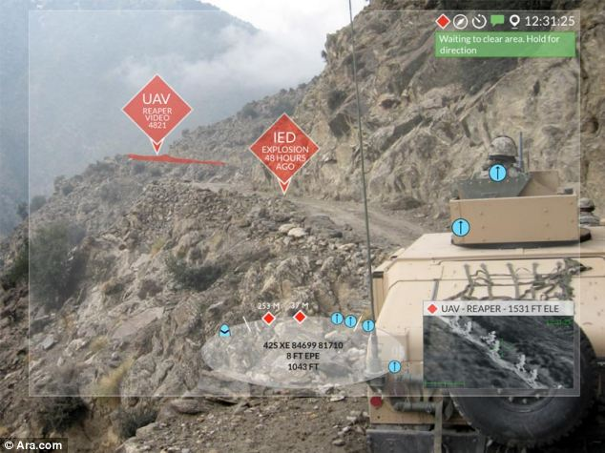
6. Picture - Military use of augmented reality. Source: Ara.com

Own augmented reality projects
Currently we run a project called ACCELERATE to develop an augmented reality based platform to enhance cooperation between citizens and the police.
During project preparation a survey made by one of my students, Police Warrant Officer Bálint Takács, among 94 active police patrols from different parts of the country showed that 59,6 per cent of police officers would welcome additional information on the patrol area, 61,7 per cent is in favor of using smart glasses to display results of database checks on persons and vehicles. Most importantly, 80,9 per cent would be happy to see augmented reality and eyeglass in support of processing cases on the spot (e.g. fines, petty offences, crime scene investigation) and for recording evidence. Finally, 86,2 per cent of them would like to use the device as a switchable body camera!
The project is expected to have direct impact in the following fields:
• Timely intervention with shortening police response time due to simultaneous information sharing.
• Early identification, better crime reporting, identification of risk, discovering unreported crime due to the augmented reality supported by a strong data mining and processing engine.
• Strengthen and accelerate communication between citizens and police forces with facilitating push and pull of information through social media networks and display this with augmented reality devices.
• Strengthened community policing principles will be reached by such efficient tools as smartphones and smartglasses for patrols, a specific police patrol application and speeding up administration (case processing) with the use of these.
• A new approach proactively targeting the needs and requirements of both citizens and policemen will be the “mobile police station”-concept as due to the enhanced equipment and sophisticated software platforms, citizens can get much more support from a single police patrol than ever before and patrols will be able to deliver almost full scale police services to the citizen instead of just sending him or her to the police station.

Conclusions
The features of augmented reality systems have the following useful functions in the supporting of decision-making:
- learning and preparation of decision makers (enhanced e-learning materials, gamified learning applications, cost-effective simulation possibilities);
- providing additional information in support of decision making when under time pressure (database queries, Big Data mining, results of sensors on phenomena beyond human perception etc.);
- enhanced collaboration during implementation (work organization, human-human and human-robot cooperation in a shared workspace with augmented reality);
- less administration after implementation and better protection from corruption (due to everything has to be recorded to provide augmented reality, this also acts as a live documentary system).
Those features are of vital importance in emergency response services, but can be also important in any case when the situation has to be solved at the current place and time. Mostly emergency response services and law enforcement bodies have such situations, but can arise at any branch of public administration where site inspections are usual. For authorities, I find the following branches of administration a suitable place for augmented reality experiments (in priority order):
- emergency response services
  - firefighters
  - medical ambulance
  - disaster management
  - police intervention
- law enforcement (in general)
  - patrols (uniformed police and/or gendarmerie)
  - investigators (police or other security agencies)
  - riot police (or gendarmerie)
- public administration
  - immigration office
  - social worker network
  - transport authorities
  - public health authority
  - construction authority (usually a local authority)

Please note that this list above is mainly created using the structure of the Hungarian State, number and responsibility area of authorities may be different, divided or overlapping in other countries.

Acknowledgements
I would like to thank the support of the entire ARES consortium (Fraunhofer IOSB, Eurecom, Saadian, Unisys, Bay Zoltan, Universitatea Babes-Bolyai, Budapest University of Technology and Economics, University of Zagreb, Academy of Criminology and Policing in Serbia, University of Kandahar, NetCoGame Gameful Living Research Center, Rinspeed AG, Valencia Local Police, Prosecutors Association in Serbia and last but not least the National University of Public Service in Hungary) for contribution in my research and participating in the project ACCELERATE. I would also like to thank Tom Flynn at Tom Flynn Consultants, Dávid Bálint Varga at Bay Zoltán and Tamás Kozik for the lot of support in the H2020 proposal writing, József Padányi for accepting the augmented reality experimental project, Elisabeth Sandor-Szalai for mentoring me, János Sallai, who organized my trip to Germany where I could test a Google Glass, to János Varga, for accepting my research plan into his department’s program and to József Németh for supporting my research from the side of our national police. Special thanks goes to the Hungarian Academy of Science, to the Scientific Council of the Hungarian National Police and for the Novell Inc. for all the given support. Finally, I would like to thank to all of the LEOs (Law Enforcement Officers) all around the world, near, far and very far, especially the ones who sacrificed their lives in protection of the innocents.

References
Bastian, M. S. et. al., (2001), Augmented reality-based firefighter training system and method. WO, Patent No: WO2003015057 A1.
Baum, L. F., (1901), The Master Key. 1st ed. US: Bowen-Merril Company.
Billinghurst, M. et. al., (2007), Augmented Reality for Human-Robot Collaboration. In: N. Sarkar, (Ed.). Human Robot Interaction. Shanghai: I-Tech Education and Publishing, pp. 65-94.
Fuchs, H. et. al., (1998), Augmented reality visualization for laparoscopic surgery. Lecture Notes in Computer Science, 1496(1), pp. 934-943.
Hansmann, U. et. al., (2003), Pervasive Computing: The Mobile World. 2nd ed. Germany: Springer.
Klepper, S., (2007), Augmented Reality - Display Systems, München: TU München.
Lamontagne, B. et. al., (2005), Microblinds and a method of fabrication thereof. US, Patent No: US20060196613 A1.
Morton, H. L., (1961), Sensorama Simulator. US, Patent No: US 3050870 A.
Schofield, K. e. a., (2012), Vehicular vision system. US, Patent No: US8599001 B2.
Spitzer, M. B., (1997), Eyeglass interface system. US, Patent No: US 6349001 B1.
Valimont, R. e. a., (2002), The effectiveness of augmented reality as a facilitator of information acquisition. US, IEEE, pp. 7C5-1, 7C5-9.

