Securing Medical Data Storage with Post-Quantum Cryptography

Stefan-Nikola & Youp Klijnman

Contents
Introduction 1
Explanation of the Chosen Algorithms 2
Ring-LWE 2
Number Theoretic Transform (NTT) 2
Relevance to Medical Data Storage 2
Results and Implementation 3
Implementation Overview 3
Evaluation Methodology 3
Experimental Results 3
Conclusion 3
Future work 4
References 4

Introduction
Modern hospitals increasingly depend on digital systems for patient monitoring, diagnostics, and long-term storage of medical records. These records include highly sensitive information such as demographic data, vital-sign logs, diagnostic reports, laboratory results, and long-term physiological signals like ECG recordings. Ensuring the confidentiality and integrity of this data is critical, not only for patient privacy but also for compliance with regulations such as the GDPR.
Currently most current hospital information systems rely on classical public-key cryptography (e.g., RSA or ECC) to protect their data. With the upcoming rise of quantum computing and the Q-day expected to arrive in about 10 years. This data will not be safe anymore; therefore, we will investigate Post-Quantum Cryptography (PQC). These schemes are believed to be secure in the era of the quantum computer.
This assignment focuses on evaluating lattice-based PQC for a realistic application scenario: secure storage of patient data in a hospital environment, inspired by the Maxima Medical Center. The main goal is to investigate whether Ring-Learning with Errors (Ring-LWE) based cryptography is suitable in terms of performance and memory efficiency, and whether optimization using the Number Theoretic Transform (NTT) significantly improves its practicality.
We will work out this assignment at the hand of the research question:
Is NTT-optimized Ring-LWE a suitable and efficient post-quantum cryptographic approach for securing stored medical data in a real hospital environment?
We also will focus on the computing time, because hospitals need to gain quick access to their data. Based on NTT information in the lectures and writing our proposal we will expect that PQC is a suitable way for a hospital like the Maxima Medical Center to store their data and that NTT will significantly improve the computing time and the efficiency of Ring-LWE.

Explanation of the Chosen Algorithms

Ring-LWE
Ring-LWE is a lattice-based cryptographic construction derived from the Learning With Errors (LWE) problem, which is believed to be hard for both classical and quantum computers (Regev, 2009). Instead of operating over general matrices, Ring-LWE works in polynomial rings of the form:
$$R_{q}=\frac{Z_{q\left[x\right]}}{\left(x^{n}+ 1\right)}$$

where ($n$) is typically a power of two and ($q$) is a modulus. Security relies on the difficulty of distinguishing noisy polynomial samples from uniformly random ones.
In a Ring-LWE–based encryption scheme, keys and ciphertexts are represented as polynomials. Encryption involves polynomial multiplication and addition with small error terms. Compared to standard LWE, Ring-LWE significantly reduces key sizes and improves efficiency due to its algebraic structure, making it attractive for practical implementations.

Number Theoretic Transform (NTT)
The most computationally heavy operation in Ring-LWE is polynomial multiplication. A naïve multiplication has quadratic complexity $O(n^2),$ which quickly becomes impractical for realistic parameter sizes.
The Number Theoretic Transform (NTT) is a variant of the Fast Fourier Transform (FFT) that operates over finite fields. It allows polynomial multiplication to be performed in ${O log}_{n}{n}$ time by transforming polynomials into the NTT domain, performing pointwise multiplication, and transforming the result back.
By using NTT, Ring-LWE implementations can achieve significant speed-ups, especially for larger polynomials. This optimization is used in many standardized PQC schemes, such as CRYSTALS-Kyber (Bos, 2021)

Relevance to Medical Data Storage
Hospital data ranges from small files (kilobytes) to large continuous recordings (megabytes). Encryption schemes must therefore support efficient handling of varying data sizes while minimizing latency and memory overhead. Ring-LWE provides strong security guarantees, while NTT improves performance enough to make frequent access to encrypted data feasible.

Results and Implementation

Implementation Overview
To evaluate the performance impact of NTT, we implemented two variants of Ring-LWE polynomial multiplication in Python: a baseline version using naïve polynomial multiplication and an optimized version using the Number Theoretic Transform. Rather than implementing a full production-ready encryption system, the focus was on benchmarking the core cryptographic operation that dominates Ring-LWE performance.

Evaluation Methodology
The implementation generates random polynomials representing Ring-LWE operands and measures computation time for both approaches under identical conditions. Multiple polynomial sizes were tested to reflect increasing security parameters and realistic post-quantum workloads. Each experiment was repeated several times to account for runtime variability.

Experimental Results
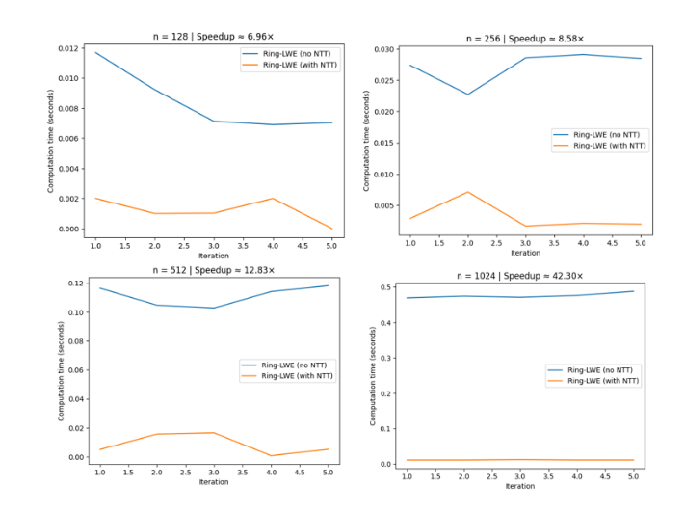
The results show that while the baseline implementation functions correctly, its runtime increases rapidly as the polynomial size grows. In contrast, the NTT-optimized implementation scales significantly better and consistently outperforms the naïve approach. For larger values of $n$, the measured speedup exceeds an order of magnitude, clearly demonstrating the importance of NTT optimization. Memory usage is comparable for both implementations, as NTT primarily affects computation rather than storage.
These findings confirm that NTT is essential for making Ring-LWE practical in performance-sensitive environments such as hospital data storage systems.

Conclusion
This project investigated the feasibility of Ring-LWE–based post-quantum cryptography for securing stored medical data in a hospital environment. While Ring-LWE provides strong security guarantees, a naïve implementation is not efficient enough for large-scale or time-sensitive applications
The introduction of the Number Theoretic Transform significantly improves performance without compromising security. This makes NTT-optimized Ring-LWE a realistic candidate for protecting sensitive medical records against future quantum attacks.
In a real hospital context, such as the Maxima Medical Center, adopting PQC early can help ensure long-term confidentiality of patient data, especially for records that must remain secure for decades. Our findings suggest that lattice-based schemes, when properly optimized, can meet both security and performance requirements of modern healthcare systems.

Future work
Future work could focus on further optimizing the performance of Ring-LWE–based cryptographic schemes. This includes the use of highly optimized and constant-time NTT libraries, as well as hardware acceleration through techniques such as SIMD instructions or dedicated cryptographic hardware. In addition, combining these optimizations with realistic simulated patient data could provide deeper insight into the practical performance of post-quantum cryptography in a hospital setting.
Another promising direction is the use of hybrid encryption schemes, in which post-quantum cryptographic algorithms are employed for key encapsulation, while symmetric encryption is used for encrypting large medical data files. Finally, integrating such optimized PQC schemes into real hospital information systems and evaluating their scalability, energy consumption, and operational impact would be valuable next steps toward real-world deployment.

References
- NIST IR 8413 (Withdrawn): Status Report on the Second Round of the NIST Post-Quantum Cryptography Standardization Process
- J. Bos et al., CRYSTALS-Kyber: Algorithm Specifications and Supporting Documentation, Round 3, NIST Post-Quantum Cryptography Project, 2021.
- O. Regev, On Lattices, Learning with Errors, Random Linear Codes, and Cryptography, Journal of the ACM, vol. 56, no. 6, 2009.

