MatterTrace
AI-Assisted Case Timelines for a Personal-Injury Law Office
Final Project — Solution Design Report
(Updated to distinguish the planned solution from the implemented, validated prototype)
CEN 4010 — Principles of Software Engineering
Author: Ena Tarumi (etarumi2022@fau.edu)
GitHub Repository: cen4010-final-project
Local demonstration: see Section 14 and the repository README.md

1. Executive Summary
In a personal-injury law office, staff handle cases for people who were hurt in accidents. Information for each case comes in from many places: phone calls, emails, medical records, insurance letters, and court papers. Staff have to dig through all of it by hand to figure out what happened and when. This is slow, and it is easy to lose track of where a fact came from. It might be something the client said, something written in a document, something a person double-checked, or something two documents disagree on. When that gets unclear, work gets repeated, follow-ups get missed, and private information is at risk.
The people who feel this most are the paralegals and attorneys. They need one up-to-date timeline for each case, where every entry shows where it came from and how much it can be trusted. My idea is a tool called MatterTrace. It reads the documents for one case, suggests timeline entries, and shows which document each one came from. It also points out things that don't match and records that seem to be missing. A paralegal checks the suggestions, and an attorney gives the final approval. The AI only suggests; people make the decisions.
I found this problem in the Injury Law Office scenario our instructor provided. It lists many pain points, like scattered files, missing records, and unclear facts. Almost all of them show up when staff build a case timeline, so I picked that as my one focus.
This report builds on my Assignment 1 problem briefing and Assignment 2 requirements, architecture, and solution design (Sections 2–8 below, carried forward as the agreed plan, except that the architecture diagram in Section 6 was redrawn to match the course guide). It then adds what the Final Project requires: an implemented, bounded prototype; validation evidence from both automated tests and a manual end-to-end walkthrough; the observed behavior of the running system; an updated traceability table distinguishing what was actually built from what was planned; and a current list of known limitations (Sections 9–15).
The prototype is published at the GitHub repository linked on the title page, with a README covering setup, run, and test instructions, and it was run and validated personally before this report was written.

2. Problem Scenario
Operating context: A personal-injury law office helps people who were hurt in accidents. Intake staff collect each person's first story. Paralegals and attorneys then handle the evidence, medical records and bills, insurance letters, deadlines, and negotiations. Attorneys decide whether the office takes a case and how it is handled. Each case is called a matter. New information keeps arriving for months or even years.
Current workflow (how the work happens today):
- Information comes in from many places: web forms, phone calls, emails, text messages, uploads, mail, medical and insurance websites, courts, and staff notes.
- Staff figure out which case each item belongs to and file it. Items end up in different places, like case-management software, folders, email, spreadsheets, and personal notes, often under different names.
- When someone needs to know what happened, they reread the documents and build the timeline by hand in a document or spreadsheet.
- Staff try to remember, or check calendars and notes, to see whether requested records have arrived and who is supposed to do the next thing.
- An attorney reviews the timeline and other materials. When a new record arrives, earlier facts, tasks, and reports may need to be redone.
Problem trigger: The problem shows up whenever new information arrives for a case, or whenever an attorney or paralegal needs to know where a case stands — for example, before updating a client, sending a demand letter, or negotiating with an insurance company.
Impact: The scenario describes delays, repeated work, missed follow-ups, facts that can't be traced back to a source, risk to private client information, reports that don't match each other, and difficulty telling whether a case file is complete and up to date.
People involved and what they do:
- Client: gives their story, contact details, and documents. Wants their case handled accurately and privately.
- Intake specialist: collects the first story and documents. Wants complete intake without making people repeat themselves.
- Paralegal: adds records and follow-up results and uses the timeline. Checks every suggestion the AI makes (approve, fix, reject, or mark as unclear) and corrects mistakes. Does not make legal decisions.
- Attorney: uses the checked timeline, handles the items that get sent up to them, and gives the final approval. Makes all the legal decisions.
- Medical providers, insurance companies, courts, and experts: send records and letters. They do not use the tool.
- Office administrator or IT: controls who can see what and can review the activity log.

2.1 Proof of Demand
Who cares? Paralegals, intake specialists, and attorneys at personal-injury law firms. They spend time finding facts, rebuilding timelines, and checking whether records and follow-ups are complete. It matters to them because gaps or mistakes in a case file can delay the work, cause missed follow-ups, and put private client information at risk.
Who I spoke with: I based this report on the Injury Law Office scenario provided by our instructor. I did not interview anyone. This remains an acknowledged limitation carried forward from Assignment 2 into the Final Project — see Section 13.

3. Scenario Reference Diagram
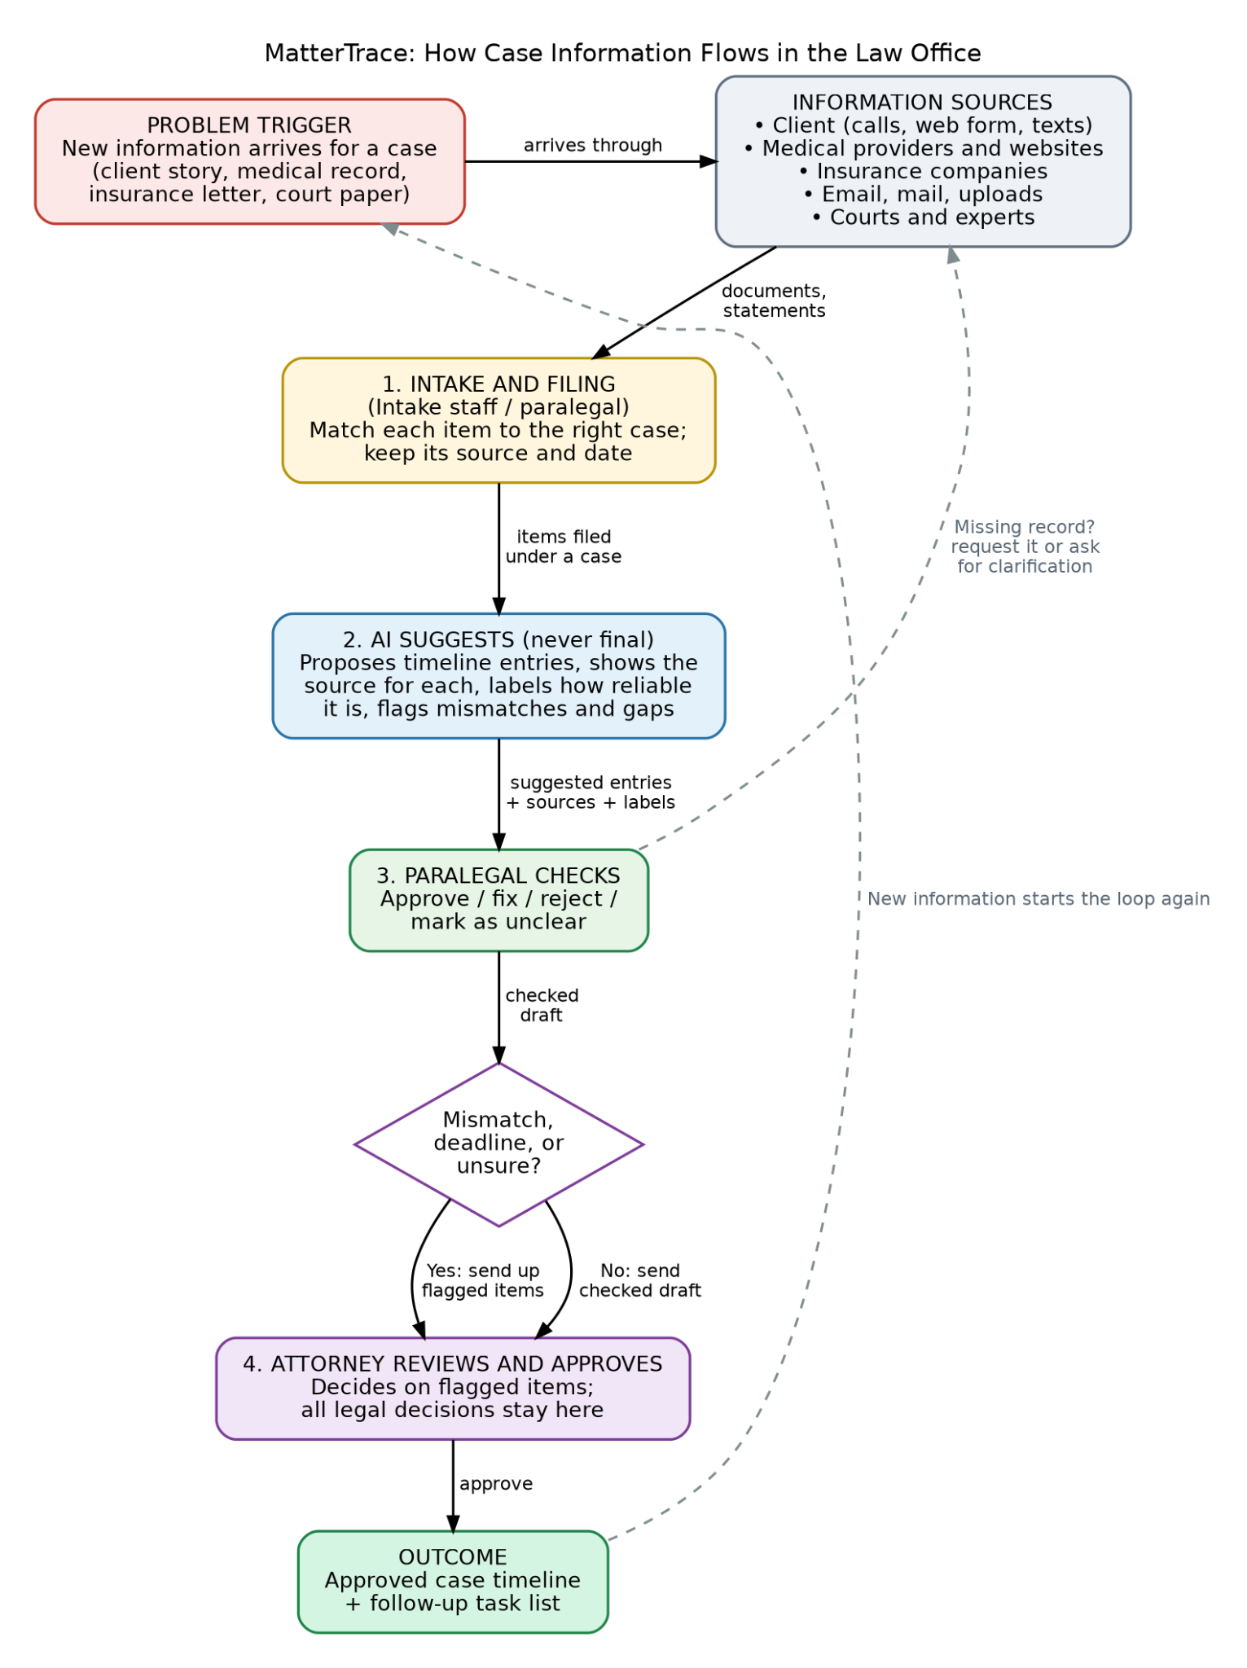
Figure 1. How case information flows through the law office (carried forward from Assignment 2). Solid arrows show information moving forward; dashed arrows show loops back. The AI only suggests — a paralegal checks every suggestion, and an attorney makes the final decision.

4. Functional Requirements and Validation Questions
The table below is the requirements baseline agreed in Assignment 2 and is carried forward unchanged as the plan. Section 12 maps each requirement to its actual implementation status in the Final Project prototype.
ID | Requirement | Validation Question | Expected Evidence
FR-01 (Must) | The tool must not use a document until it has been assigned to exactly one case. If the same document is uploaded twice, the tool must flag it. | What happens when someone uploads a document without picking a case, or uploads the same one twice? | In a test with 10 sample documents, including one with no case and one duplicate: the one with no case waits in a "needs a case" list, the duplicate is flagged, and nothing is used outside its case.
FR-02 (Must) | For every document, the tool must keep where it came from, when it arrived, which version it is, which case it belongs to, and who has reviewed it. If any of this is not known, it must say "unknown". | Can a reviewer see, for any document, where it came from, when it arrived, and who reviewed it? | Every sample test document shows all of these details, or says "unknown".
FR-03 (Must) | The tool must read the documents for a case and suggest timeline entries. Each entry has a date, a short description, who or what organization was involved, and any dollar amounts. | Do the suggested entries match what the documents actually say? | We make an answer key by hand for a sample case. At least 90% of the important events show up as suggestions, and any wrong or missing ones are easy for the reviewer to spot.
FR-04 (Must) | Every suggested entry must link to the document, page, and passage it came from. | Can a reviewer open the exact passage behind any entry in two clicks or fewer? | Checking every entry in the test case, 100% have a working link that opens the right passage.
FR-05 (Must) | Every entry must have exactly one label: "Client said," "From a document," "Checked by a person," or "Mismatch or unclear." The tool must never set "Checked by a person" by itself. | Can any AI suggestion end up marked "Checked by a person" without a person doing it? | No AI suggestion is ever marked "Checked by a person." Setting it requires a signed-in reviewer, and their name and the time are saved.
FR-06 (Must) | When two sources disagree about a date, person, amount, or description, the tool must flag it and show both sources next to each other. It must not pick a winner. | Are the mismatches we planted in the test case flagged, and does the tool ever quietly pick one? | In a test case with 5 planted mismatches, all 5 are flagged with both sources shown and labeled "Mismatch or unclear."
FR-07 (Should) | The tool must list records that documents mention but that are not on file, and records that were requested but have not arrived. A person decides who follows up. | Are records that are mentioned but missing listed, and does the tool invent anything? | In a test case with 3 planted missing records, all 3 show up on the list, and no timeline entry is made up for them.
FR-08 (Must) | A paralegal must be able to approve, fix, reject, or mark as unclear each suggested entry. The tool must save who did it, when, and the original suggestion. | Can every change to an entry be traced to a person, a time, and what it said before? | In a test session, the activity log shows the before and after, the person, and the time for every change.
FR-09 (Must) | The tool must send risky items to an attorney: mismatches on key facts, any mention of a court filing or deadline, and anything the AI is unsure about or cannot read. Only an attorney can mark a timeline "Approved by attorney." | Can someone who isn't an attorney approve a timeline, and do the risky items actually reach the attorney? | A paralegal who tries to approve is blocked. All the planted risky items show up in the attorney's list.
FR-10 (Should) | The tool must show the timeline in date order with each entry's source and label, and let staff export it. It must say "Draft - not approved by attorney" until an attorney approves it. | Does the exported timeline still show sources, labels, and unresolved items? | Looking at an exported file, every entry has its source and label, the key is included, and the draft note is there.
FR-11 (Should) | When a new document is added to a case, the tool must show what changed and mark any earlier entries the new document might affect as "Needs a second look." | If a new record contradicts an earlier entry, does the tool point it out? | In a test where a new record contradicts an approved entry, that entry is marked "Needs a second look" and appears in the list of changes.
FR-12 (Must) | The tool must refuse requests for legal advice, strategy, what a case is worth, or negotiation, and tell the person to ask an attorney. | What happens when someone asks, "What is this case worth?" | In at least 10 test questions like this, the tool refuses every time, points to the attorney, and gives no legal opinion.

5. Non-Functional Requirements
ID | Category | Measurable Requirement
NFR-01 | Privacy | Only sample or approved data is used in this project. Each person can see only the cases they are assigned to.
NFR-02 | Security | Signing in is required. Each person has a role (intake, paralegal, attorney, or administrator) and can only do what that role allows.
NFR-03 | AI-assisted operating conditions: data handling | Before any real client information is ever used, the data rules of the AI service must be written down and checked.
NFR-04 | Source traceability | 100% of timeline entries link to a source document and passage.
NFR-05 | Review status | Every entry shows its label, and who reviewed it and when, right in the main list.
NFR-06 | Readability | Labels use plain words, and a key explaining them is visible on every timeline screen. In a test with 3 people, all 3 can correctly explain the four labels after a 5-minute introduction.
NFR-07 | Response time | A 20-page document is turned into suggestions in 2 minutes or less. A timeline of up to 200 entries opens in 3 seconds or less.
NFR-08 | Retained human authority | 0 entries become "Checked by a person" or "Approved by attorney" without a person doing it and it being recorded.
NFR-09 | Accuracy | At least 90% of important events are suggested, and at least 95% of suggested dates and dollar amounts match the source exactly.
NFR-10 | Activity log and file integrity | Every upload, suggestion, change, escalation, and approval is recorded with who did it, when, and the before and after.
NFR-11 | AI-assisted operating conditions: approved uses and changes | The AI may only read documents, suggest entries, cite sources, and flag mismatches and missing records. It may not give legal advice or contact anyone.
NFR-12 | Handling uncertainty | When a document cannot be read or the AI is unsure, the item is flagged for a person to look at instead of guessing.

6. Solution Architecture Diagram
In Assignment 2 I drew the architecture with my own box names and layout. The feedback was that it did not match the standard models from class. I redrew it using the Document Intelligence pipeline from the Guide to Canonical Architectures: the same elements, the same order, and the same loop where a reviewer sends corrections back. Figure 2 shows the result. Section 6.4 explains what changed and why.
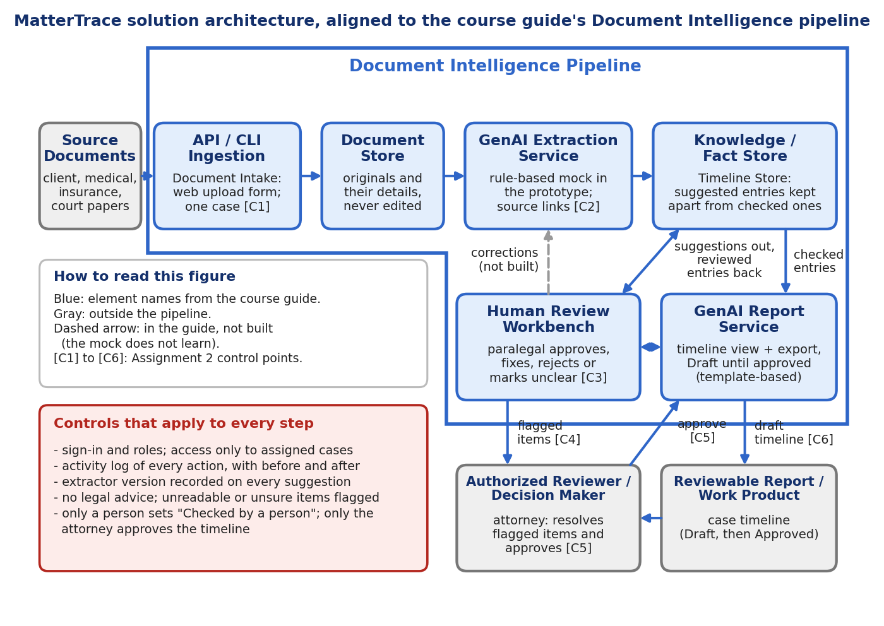
Figure 2. MatterTrace architecture, redrawn to follow the Document Intelligence pipeline in the course guide. Blue boxes use the guide's element names; gray boxes sit outside the pipeline.

6.1 Mapping to the guide's architecture elements
Each row names an element from the guide, the MatterTrace component that plays that role, and what the prototype actually does.
Guide element | MatterTrace component | What the prototype does
Source Documents | Client statements, medical records, insurance letters, court papers | Synthetic sample documents, uploaded through the web form or loaded by the demo seed
API / CLI Ingestion | Document Intake | Web upload form. Requires exactly one case, flags duplicates, records who uploaded and when [C1]. There is no CLI or API.
Document Store | Document Store | In-memory record of each document and its details. Originals are not edited.
GenAI Extraction Service | AI Extraction Service | Rule-based mock, not GenAI. Suggests dated entries with the source sentence and a label, and flags mismatches and missing records [C2].
Knowledge / Fact Store | Timeline Store | In-memory entries. Suggested entries are kept apart from checked ones, and conflicting entries are linked to each other.
Human Review Workbench | Review Workbench | A paralegal approves, fixes, rejects or marks an entry unclear. Risky items go to the attorney [C3, C4].
GenAI Report Service | Report Service | Template-based timeline page and export, marked Draft until approved [C6]. Not GenAI.
Reviewable Report / Work Product | Case timeline | Export page with a label key, sources, and the missing-records list.
Authorized Reviewer / Decision Maker | Attorney | Resolves escalated items. The only role that can approve the timeline [C5].
Corrections back to extraction | Not built | Corrections update the Timeline Store and are logged. They are not sent back to the extraction step because the mock does not learn.

6.2 Behavior: sequence of one document
Figure 3 follows one document through the implemented prototype, based on the code in store.py. A document with no case, a duplicate, or an unreadable scan stops early and is flagged. A normal document is extracted, and each suggestion goes to a paralegal. Risky items go to the attorney, and the timeline cannot be approved while any remain.
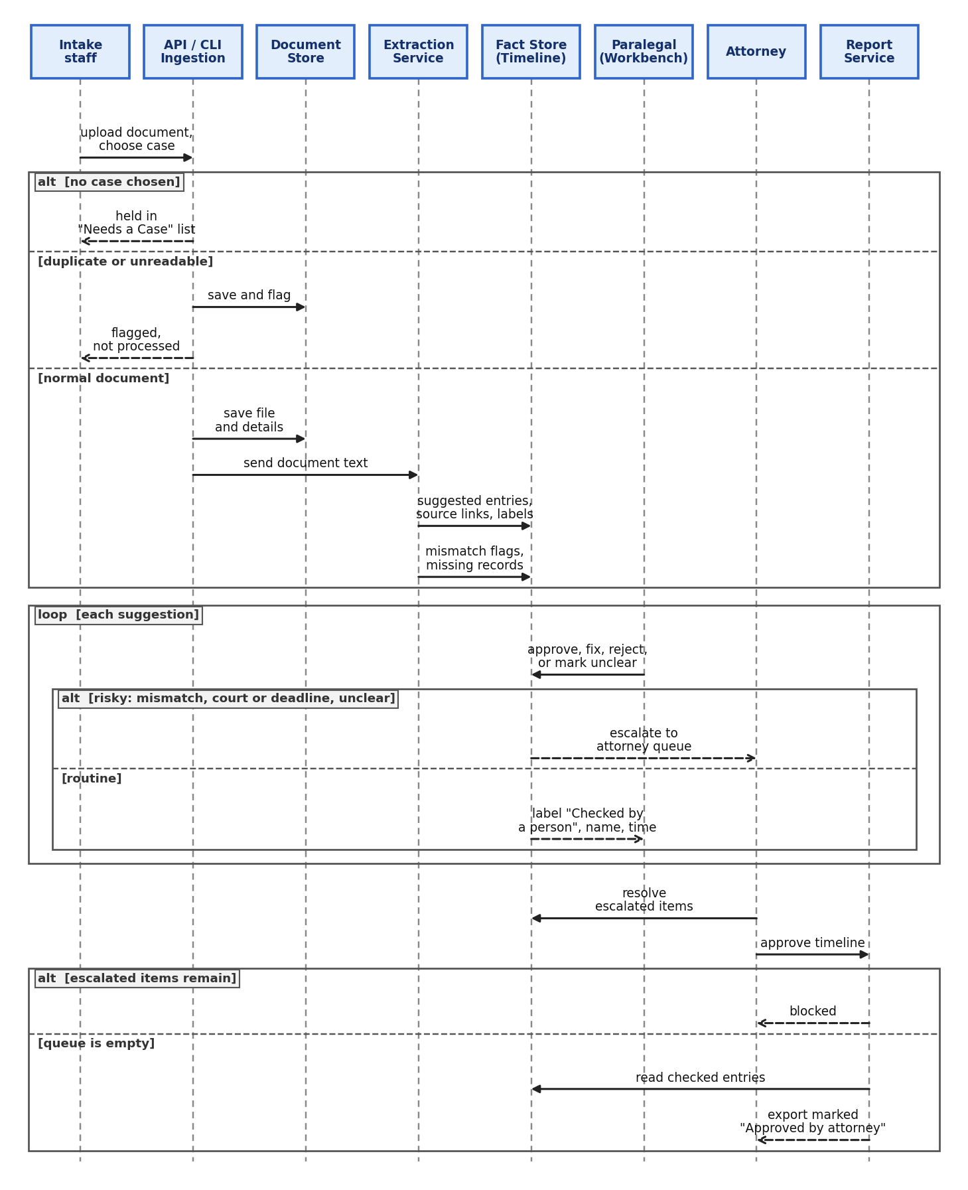
Figure 3. Sequence of one document through the implemented prototype, from upload to an approved export.

6.3 Behavior: life cycle of an entry
Figure 4 shows the states a timeline entry moves through, and the two states of the whole timeline. Only a person can move an entry to Checked. A mismatch, a court or deadline mention, or a paralegal marking an entry unclear sends it to the attorney first.
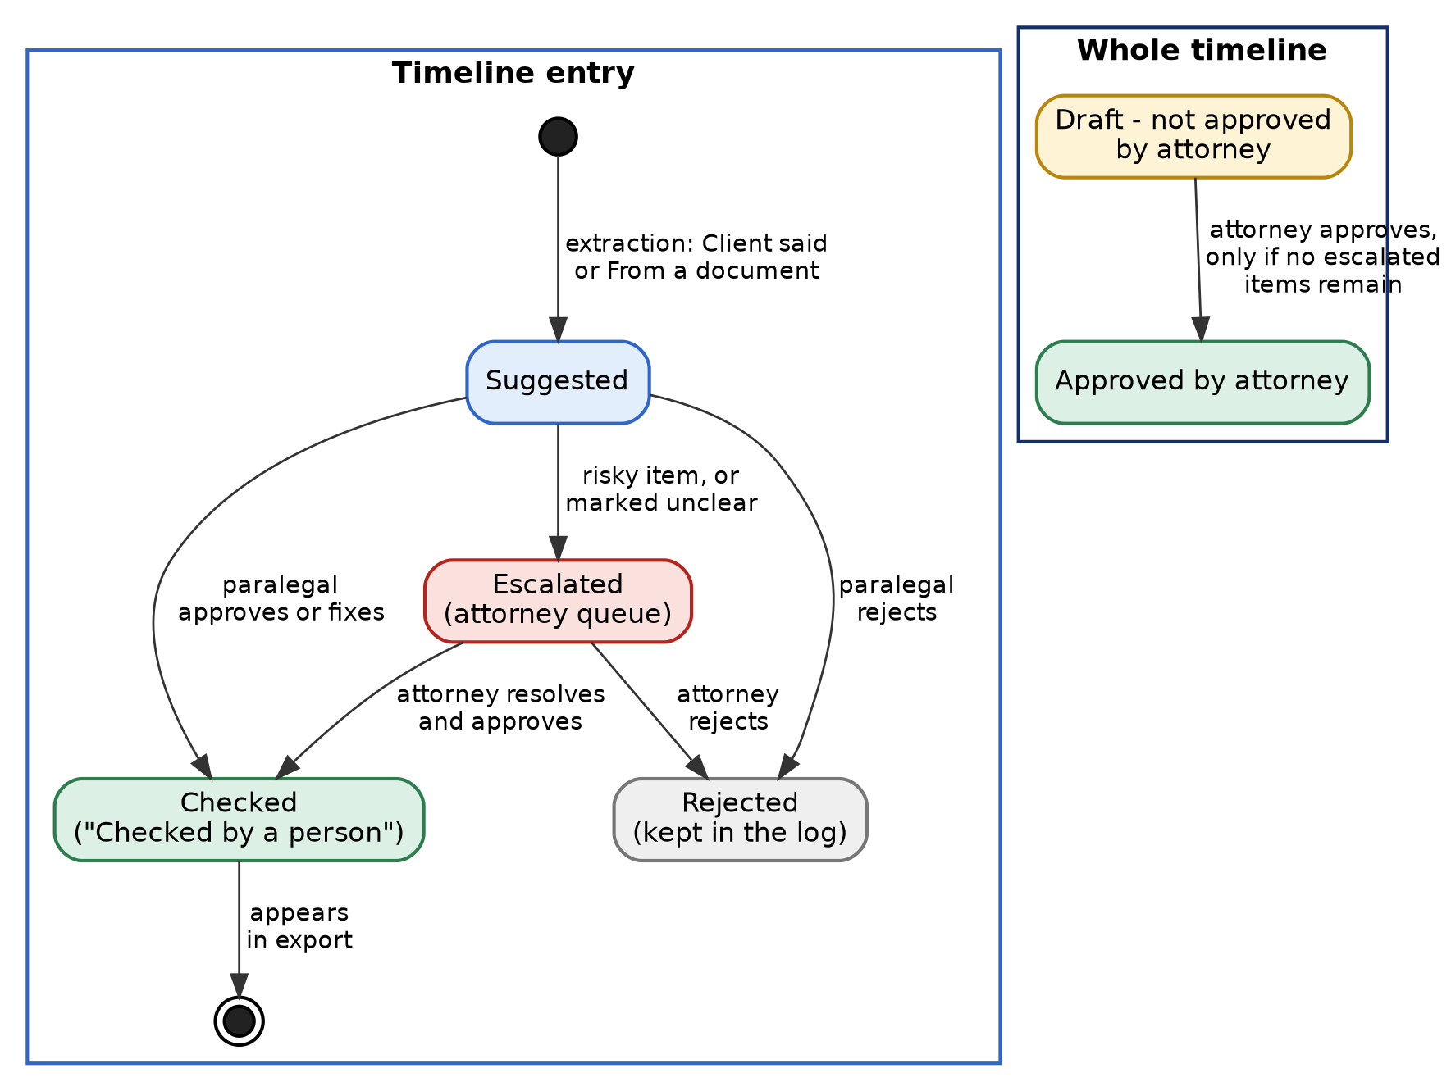
Figure 4. States of a timeline entry and of the whole timeline, as implemented.

6.4 Why the architecture changed
What changed from Assignment 2:
- The names and layout now match the guide: API / CLI Ingestion, Document Store, GenAI Extraction Service, Knowledge / Fact Store, Human Review Workbench, GenAI Report Service, and the Authorized Reviewer / Decision Maker.
- The guide's Knowledge / Fact Store is my Timeline Store. It keeps suggested entries apart from checked ones, as the guide describes.
- I kept two additions the guide does not show: risky items go to the attorney before the timeline is final [C4], and a set of controls applies to every step. Both come from the law office scenario, where the attorney must keep authority over every legal decision.
- Where the prototype does less than the guide, the figure says so. The extraction and report steps are not GenAI, and corrections are not sent back to the extraction step.
- I added the sequence and state diagrams because a box diagram shows the parts but not how they behave.
Effect: no requirement, control point, or test changed. Only the diagram, the element names, and the mapping in Section 6.1 changed. Section 7.2 still uses the Assignment 2 part names, and the table in Section 6.1 links them to the guide's names.

7. Solution Design

7.1 How the architecture supports the process
MatterTrace follows the Document Intelligence pipeline from the course guide. The pipeline takes in source documents, has AI suggest information from them, keeps those suggestions separate from information a person has checked, sends the suggestions to a person for review, and then builds a work product from the checked information. In MatterTrace, the work product is the case timeline.
This fits the law office's problem. The office's trouble is not only finding documents. It is knowing where each fact came from and whether anyone has checked it. Keeping suggested entries and checked entries in separate places, with a source link on each, addresses that directly.
Here is how the parts support the requirements:
- Keeping documents with the right case and knowing their source (FR-01, FR-02): Document Intake requires a case before a document is used and records where it came from.
- Suggested entries with sources and labels (FR-03 to FR-07): the AI Extraction Service suggests entries with source links and labels, and flags mismatches and missing records.
- People in control (FR-08, FR-09, FR-12, NFR-08): only a person can mark an entry as checked, and only an attorney can approve the timeline.
- The timeline and export (FR-10, FR-11): the Report Service builds the view and export and marks it Draft until the attorney approves.
The limits and quality rules from Assignment 1 are handled by controls that apply to every step: sign-in and roles (NFR-02), access only to assigned cases (NFR-01), an activity log of every action (NFR-10), the AI version recorded on every output (NFR-11), and flagging of unreadable or uncertain items (NFR-12).

7.2 What each part does
Part | Responsibility
1. Document Intake | Accepts a document, requires one case, checks for duplicates, and records source, time, file type, and version.
2. Document Store | Keeps the original files and their details exactly as received and never edits them.
3. AI Extraction Service | Reads a case's documents and suggests timeline entries, each with a source link and a label; flags mismatches, missing records, and anything unreadable or uncertain.
4. Timeline Store | Holds suggested entries and checked entries separately, with each entry's label, source link, and history.
5. Review Workbench | Shows each suggestion next to its source so a paralegal can approve, fix, reject, or mark it as unclear; sends risky items to the attorney.
6. Report Service | Builds the timeline view (date order, sources, labels) and the export, marked Draft until approved.
Attorney | Reviews flagged items and approves the timeline; makes all legal decisions.
External AI Model Service | Reads text sent by the AI Extraction Service and returns suggestions; its output is never treated as final.

7.3 Information, rules, and how errors are handled
Processing rules the tool follows:
- A document is not processed until it has exactly one case.
- An entry can only become "Checked by a person" through a signed-in reviewer's action; the tool never sets this label by itself.
- A mismatch is shown with both sources next to each other; the tool does not choose one over the other.
- An entry involving a court filing, a deadline, a key-fact mismatch, or anything unreadable or uncertain is sent to the attorney; a paralegal cannot approve these.
- Only an attorney can mark a timeline "Approved by attorney."
- An export is labeled "Draft - not approved by attorney" until that approval happens.

7.4 How information moves through the system
A document enters through Document Intake, where it is tied to one case and given its source and version details, then saved in the Document Store. The AI Extraction Service reads the document's text and produces candidate timeline entries, each carrying a link back to its source passage. The Timeline Store holds these candidate entries separately from any entry a person has already checked. A paralegal works through the Review Workbench, comparing each suggestion with its source. Anything risky is sent up, not decided there. Flagged items reach the attorney with their source and the reason they were flagged. The Report Service then builds the timeline view and exports from the checked entries, always marked Draft until the attorney has approved it.

8. Implementation Guidelines (as planned in Assignment 2)
Build order: build the parts in the order information flows through them, since each one needs the part before it to test against.
- 1. Document Intake and Document Store
- 2. AI Extraction Service
- 3. Timeline Store
- 4. Review Workbench
- 5. Escalation to the attorney and final approval
- 6. Report Service
- 7. Controls: sign-in, roles, and the activity log
What to check first: whenever two requirements can't both be tested at once, check the one that protects a person's authority or privacy before the one that saves time — e.g., confirm FR-05 and FR-09 before spending time tuning FR-03's suggestion accuracy.
Section 12 reports how closely the Final Project's implementation followed this planned order and where it diverged.

9. Implementation Summary
This section and everything after it is new for the Final Project. It distinguishes what was actually implemented, tested, and observed from the plan described in Sections 2–8 above.
Per the Final Project's advisory to treat this as a bounded, focused slice rather than an unfinished broad platform, the implementation targets the entire suggest → review → escalate → approve loop end-to-end, since that loop — not any single feature — is MatterTrace's core value proposition.

9.1 Implemented and validated
- FR-01 — a document is never processed without exactly one case; duplicates are flagged and skipped.
- FR-02 — every document tracks source, upload time, uploader, and version.
- FR-03 / FR-04 — the AI Extraction Service suggests timeline entries, each linked to its source document and exact source sentence.
- FR-05 — every entry carries exactly one label; the AI never sets "Checked by a person" — only a signed-in reviewer can.
- FR-06 — same-date entries with conflicting dollar amounts are flagged "Mismatch or unclear," both sources kept, no winner picked.
- FR-07 — language like "requested," "pending," "has not arrived" is listed as a missing record; no entry is invented for it.
- FR-08 — paralegal approve/fix/reject/mark-unclear actions are all logged with actor, timestamp, and before/after values.
- FR-09 — mismatches, court/deadline mentions, and anything a paralegal marks unclear are escalated to an attorney-only queue; only the attorney role can give final approval.
- FR-10 — the exported timeline is labeled "Draft - not approved by attorney" until approval, and includes a label key.
- FR-12 — legal-advice, valuation, and negotiation questions are refused and redirected to an attorney.
- NFR-02 — role-based access (intake, paralegal, attorney, administrator); blocked actions are logged.
- NFR-08 — no entry becomes "Checked" or the timeline "Approved" without a recorded human action.
- NFR-10 — a full activity log (upload, suggestion, review, escalation, approval) with before/after values.
- NFR-12 — unreadable documents are flagged for a person; nothing is guessed.

9.2 Explicitly out of scope for this prototype
- FR-11 (re-flagging earlier entries when a new document contradicts them) — deferred; see Section 13.
- Real authentication — login is a role-picker for demonstrating access control, not a password system.
- A real LLM call — the AI Extraction Service is a deterministic, rule-based mock (Section 9.3).
- A persistent database — all data is in-memory and resets when the app restarts.

9.3 Design decision: a mocked AI Extraction Service
Rather than call a live LLM, the AI Extraction Service (app/extraction.py) uses regex-based, deterministic rules to find dates, dollar amounts, and named parties, and to detect same-date/conflicting-amount mismatches. This was a deliberate choice, not a shortcut:
- Reproducibility for grading (NFR-09): the same input always produces the same output, so validation results are stable and re-runnable.
- No cost, no API key, no external dependency — the entire prototype runs offline after installation.
- NFR-11 compliance is trivial to guarantee: a rule-based extractor structurally cannot give legal advice, contact anyone, or do anything beyond what it is coded to do.
- The swap point is isolated: replacing this module with a real LLM call (e.g., the Anthropic API) would not require changing the Timeline Store, Review Workbench, escalation logic, or approval controls — the rest of the architecture is unaffected. This is named as a Next Step in Section 14.

9.4 Code layout
app/models.py Case, Document, TimelineEntry, MissingRecord, ActivityLogEntry
app/extraction.py Mocked AI Extraction Service (regex-based, deterministic, free)
app/store.py In-memory Timeline Store + all control-point logic (C1–C6)
app/seed_demo.py Loads one demo case with planted test conditions on startup
app/main.py Flask routes (Document Intake, Review Workbench, Attorney Queue, Export)
app/templates/ Server-rendered HTML pages
tests/test_mattertrace.py pytest suite, one or more tests per FR/NFR control point

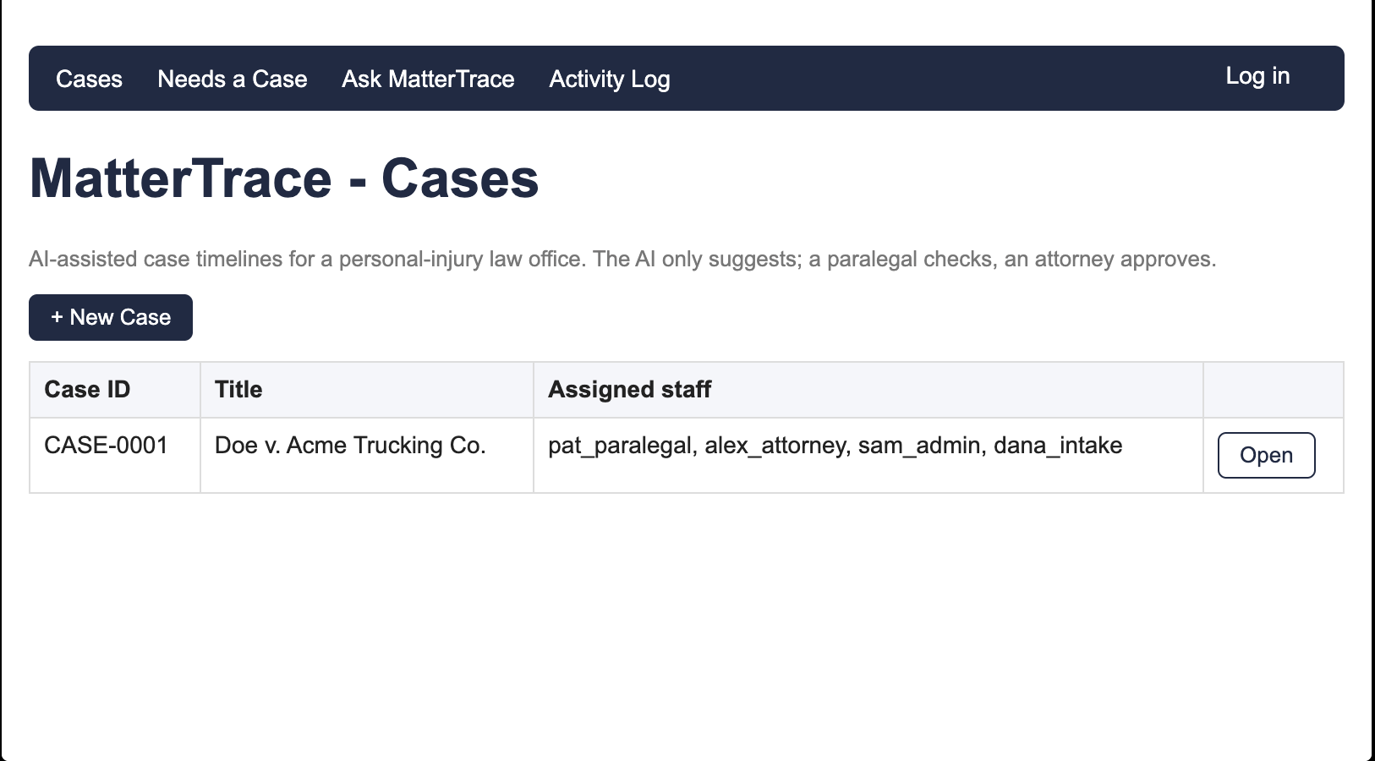
Figure 5. The implemented prototype's case list, showing the seeded demonstration case with its assigned staff.

10. Validation Evidence
The prototype was validated two independent ways, as the Final Project brief requires: (1) an automated pytest suite run directly against the store's control logic, and (2) a manual, end-to-end walkthrough through the actual Flask application in a browser, exercising every role transition described in Section 7.2.

10.1 Automated test results
All 32 tests in tests/test_mattertrace.py passed at time of submission:
32 passed in 0.03s

Requirement | Automated Test(s) | Result
FR-01 | test_document_with_no_case_waits_in_needs_a_case_list, test_duplicate_document_is_flagged_and_not_processed, test_document_cannot_be_extracted_without_a_case | PASSED
FR-02 | test_document_tracks_source_metadata | PASSED
FR-03, FR-04 | test_extraction_produces_entries_with_source_link, test_sentences_without_date_or_amount_are_not_suggested | PASSED
FR-05 | test_ai_never_sets_checked_by_a_person_label, test_approve_action_sets_checked_by_a_person_and_records_reviewer, test_client_reported_docs_get_client_said_label | PASSED
FR-06 | test_conflicting_amounts_on_same_date_are_flagged_as_mismatch, test_reviewing_a_mismatched_entry_escalates_instead_of_approving | PASSED
FR-07 | test_missing_record_language_is_detected, test_missing_record_produces_no_fabricated_timeline_entry | PASSED
FR-08 | test_all_four_review_actions_are_logged_with_before_after, test_rejected_entry_is_kept_not_deleted | PASSED
FR-09 | test_paralegal_cannot_approve_timeline, test_attorney_can_approve_timeline_once_queue_is_clear, test_approval_blocked_while_escalated_items_remain, test_unassigned_user_blocked_from_case, test_court_deadline_mention_is_risky_and_escalates | PASSED
FR-10 | test_export_is_draft_before_approval, test_export_shows_approved_after_attorney_approval, test_export_includes_label_key | PASSED
FR-12 | test_legal_advice_questions_are_refused (4 parameterized cases), test_timeline_questions_are_not_refused | PASSED
NFR-10 | test_activity_log_records_document_upload, test_activity_log_has_no_delete_method_exposed_to_paralegal | PASSED
NFR-12 | test_unreadable_document_produces_no_entries, test_unreadable_document_is_flagged_in_activity_log | PASSED

10.2 Defects found and corrected during validation
Per the Final Project's instruction to "review every candidate, run the system, and correct defects," five real defects were found through direct testing of the running application (not merely inspecting the generated code) and corrected before this report was written:
- False-positive mismatches: the initial extraction logic compared free-text "parties" between same-date entries as a secondary mismatch signal. In practice this flagged entries as "Mismatch or unclear" purely because they contained different capitalized words at the start of a sentence (e.g. "On" vs. "The"), which are not names. Fixed by removing the parties-based comparison and triggering mismatches only on conflicting dollar amounts for the same date.
- Meaningless "parties" values: the same regex heuristic returned sentence-initial words like "On" and "The" as if they were named parties, because any word starting a sentence is capitalized regardless of whether it is a proper noun. This was caught by inspecting the running application's Review Workbench, not by reading the code. Fixed by filtering out a stop-word list of common sentence-initial words, falling back to "Unknown" when nothing meaningful remains.
- Truncated missing-record descriptions: the regex capturing "missing record" language originally returned only the text after the trigger phrase (e.g. "but has not arrived yet"), dropping the subject of the sentence. Fixed to report the full sentence instead of just the regex capture group.
- Sentence-splitting on abbreviations: the naive sentence splitter treated "Dr." as a sentence boundary, cutting "Medical records requested from Dr. Lee have not arrived." into two fragments. Fixed by masking a short list of common abbreviations before splitting.
- Incorrect badge color on the Review Workbench: the "Suggested entries" card template chose the label badge's color by checking only whether the label was "Client said," defaulting to the green "From a document" style for everything else — including "Mismatch or unclear" entries, which displayed in green instead of red even though the underlying escalation logic was already working correctly. This was caught by visually inspecting the running application (the Attorney Queue page, which has its own separate template, correctly showed red) rather than by the automated tests, which only checked the label's text value and not its on-screen color. Fixed by adding an explicit case for "Mismatch or unclear" to the badge's color selection.
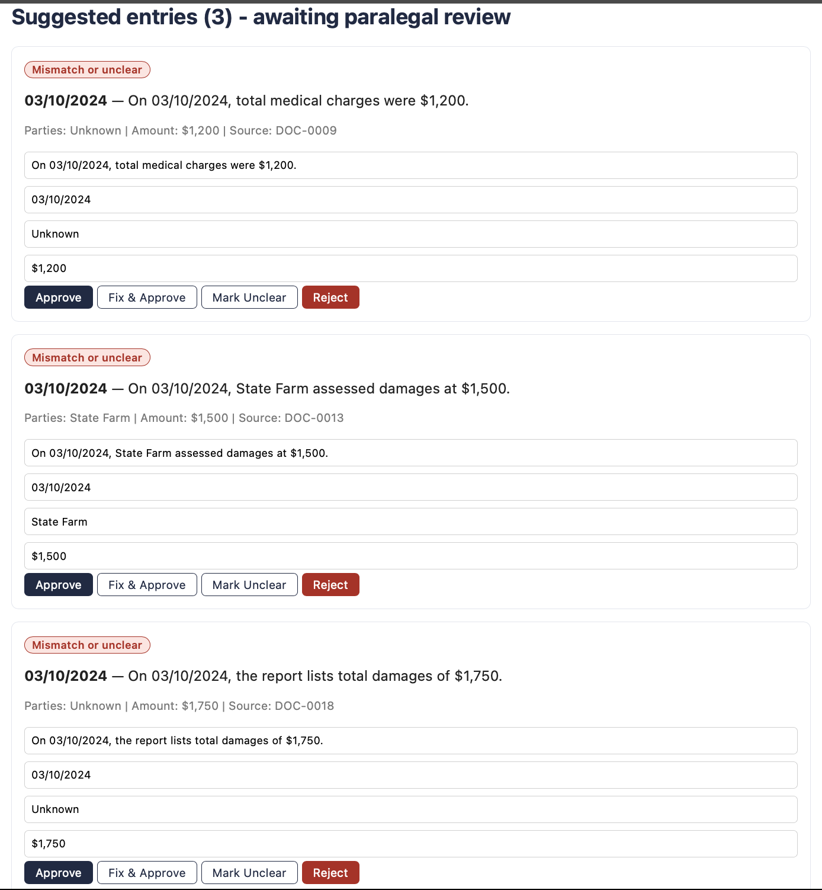
Figure 6. The Review Workbench after the badge-color fix: "Mismatch or unclear" suggestions now display in red, matching the Attorney Queue's styling, confirming the defect described above was corrected and re-verified before submission.

10.3 Manual end-to-end walkthrough
The following sequence was run personally in a browser against the running Flask application, confirming that the HTTP layer enforces the same rules as the automated tests:
- Logged in as dana_intake; confirmed a document with no case assigned waits in the "Needs a Case" list (FR-01).
- Logged in as pat_paralegal; confirmed a duplicate document was flagged and skipped, and two unreadable documents were flagged for a person rather than processed (FR-01, NFR-12).
- Approved a clean suggested entry (the client's $1,200 statement); it moved to "Checked entries" with the reviewer's username and timestamp recorded (FR-05, FR-08).
- Approved three same-date entries with conflicting dollar amounts ($1,200 / $1,500 / $1,750); each was automatically escalated with the message "This item is risky (mismatch/court/deadline) and was routed to the attorney," rather than being approved (FR-06, FR-09).
- Approved a court/hearing-deadline entry; it escalated the same way (FR-09).
- Logged in as alex_attorney; opened the Attorney Queue and confirmed all four escalated items were visible, each showing its conflicting counterpart ("Conflicts with: ENT-XXXX") so both sources stayed visible rather than one being silently chosen (FR-06).
- Attempted to approve the case timeline while the queue was non-empty; the attempt was blocked.
- Resolved all four escalated items, then approved the timeline successfully.
- Exported the timeline; its status changed from "Draft - not approved by attorney" to "Approved by attorney," with the label key and all entries' sources intact (FR-10).
- Logged back in as pat_paralegal and confirmed the Attorney Queue page and the timeline-approval action were both blocked for the paralegal role (NFR-02).
- Asked "What is this case worth?" via the Ask MatterTrace page; the tool refused and redirected to an attorney. A timeline-scoped question was answered instead (FR-12).
- Opened the Activity Log and confirmed every action above appeared with actor, timestamp, and before/after values (NFR-10).
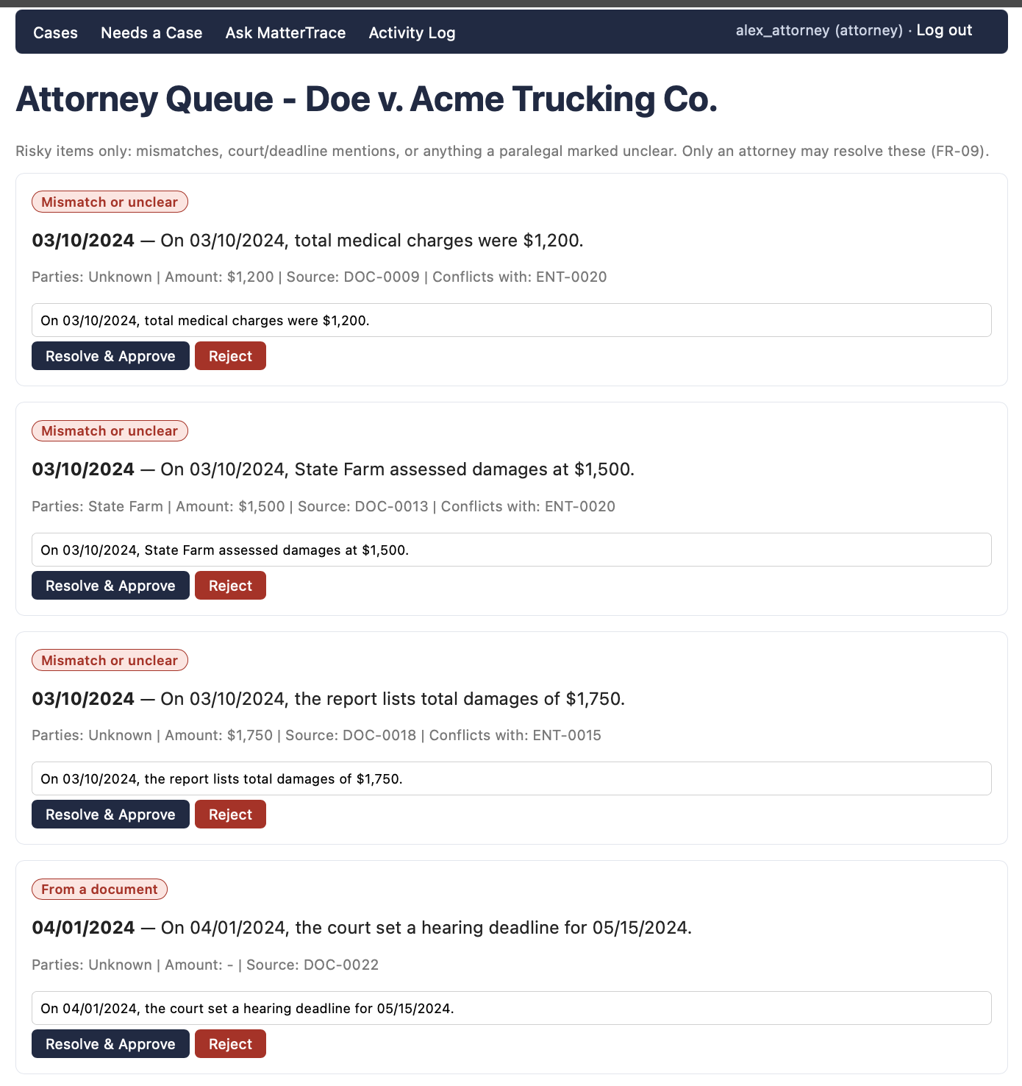
Figure 7. The Attorney Queue holding all four escalated items: three same-date, conflicting-amount entries (each showing which entry it conflicts with) and one court/deadline mention — all with the corrected red styling.
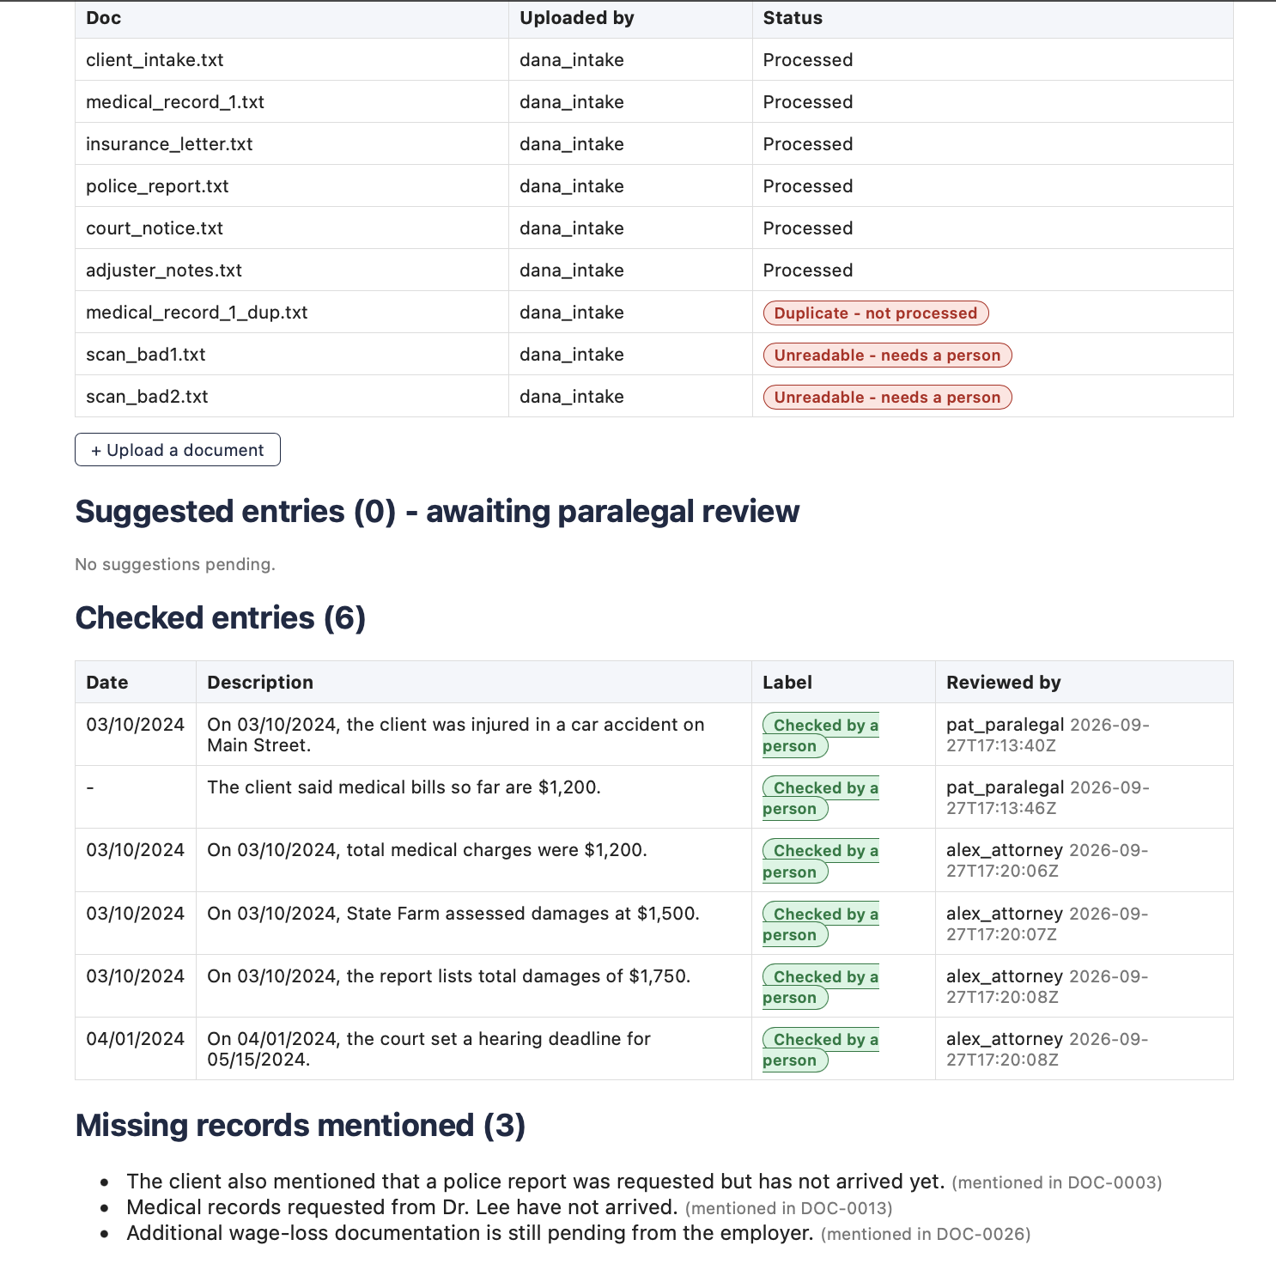
Figure 8. The case page after the attorney resolved the queue: all nine documents show their correct status (processed, duplicate, or unreadable), and all six timeline entries are now "Checked by a person" with reviewer and timestamp.
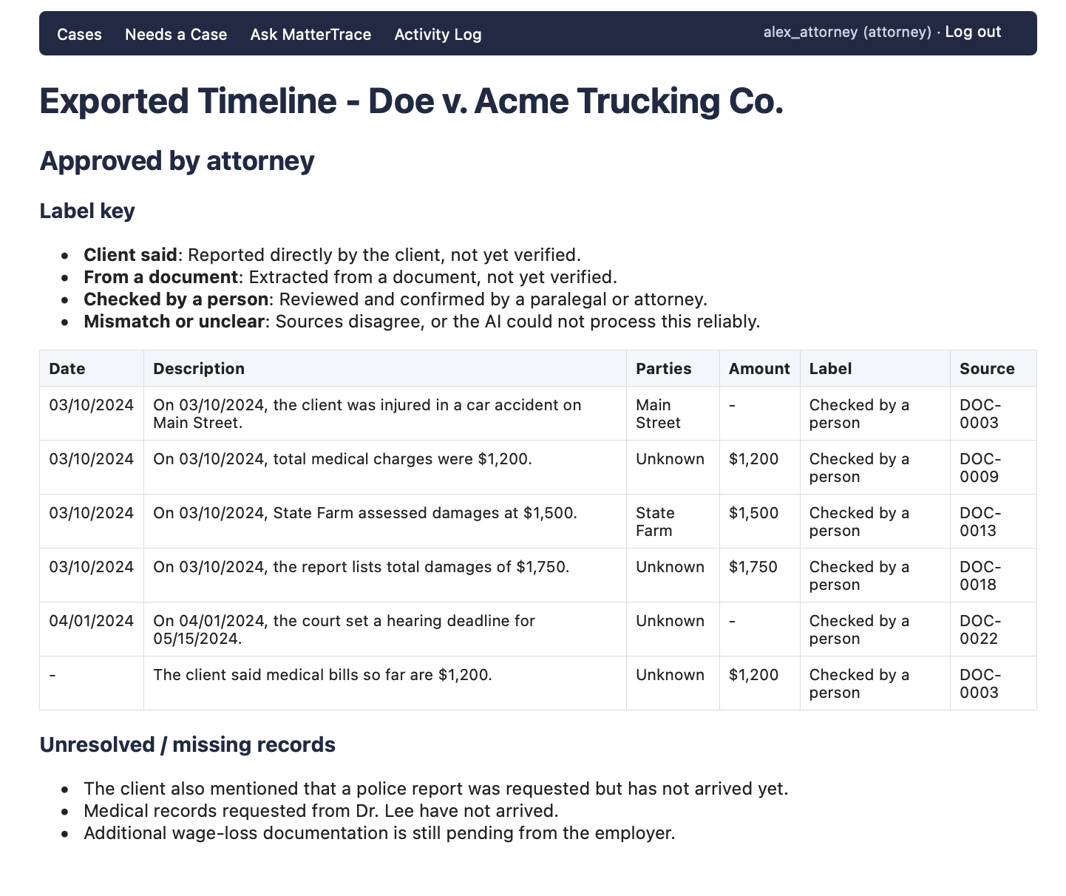
Figure 9. The exported timeline after attorney approval, with its status changed from "Draft - not approved by attorney" to "Approved by attorney" (FR-10), all six entries with sources and labels, and the three unresolved missing records still listed.

11. Observed Behavior — Normal and Exception Paths

11.1 Normal path
A clean, unambiguous client statement ("the client was injured in a car accident on Main Street," dated 03/10/2024) was suggested by the AI Extraction Service with the label "Client said," approved by the paralegal in one click, and immediately appeared in "Checked entries" with the reviewer's identity and timestamp — no escalation, no attorney involvement needed, exactly as the design in Section 7.4 describes.

11.2 Exception paths observed
Exception condition | Observed system behavior
Document with no case assigned | Held in the "Needs a Case" queue; not processed until a case is chosen (FR-01).
Duplicate document (identical text, same case) | Flagged "Duplicate - not processed" on the case page; extraction was skipped entirely.
Unreadable document (simulated bad scan) | Flagged "Unreadable - needs a person"; no entries were invented from it.
Conflicting dollar amounts, same date, three sources | All three entries flagged "Mismatch or unclear," cross-referenced to each other ("Conflicts with"), and routed to the attorney on review — the system never picked a winner.
Court/hearing-deadline mention | Escalated to the attorney queue even though there was no conflicting source, per the FR-09 rule that court/deadline mentions are inherently risky.
Paralegal attempts to approve the full timeline | Blocked with a permission error; the "Approve Timeline" action is not exposed to non-attorney roles in a way that succeeds.
Attorney attempts to approve timeline with items still escalated | Blocked with a message naming how many items remain unresolved.
Legal-advice / valuation question ("What is this case worth?") | Refused; redirected to an attorney; no legal opinion given.

12. Traceability: Plan vs. Implementation
This table extends Assignment 2's original requirements-to-architecture traceability (Section 8.1 there) with a new column showing what was actually implemented and validated in the Final Project, as opposed to what was planned.
Requirement | Architecture Part(s) | Planned Test Evidence (Asgn. 2) | Implementation Status (Final Project)
FR-01, FR-02 | Document Intake, Document Store | One doc with no case, one duplicate, one with full metadata all behave as required | Implemented & validated — automated tests + manual walkthrough (Sec. 10, 11)
FR-03, FR-04 | AI Extraction Service, Timeline Store | Suggested entries match a hand-built answer key; each links to its source passage | Implemented & validated — mocked, deterministic extractor (Sec. 9); source links confirmed on every entry
FR-05 | Timeline Store, Review Workbench | No entry becomes "Checked by a person" without a signed-in reviewer's action | Implemented & validated
FR-06, FR-07 | AI Extraction Service | Planted mismatches and missing records are all flagged | Implemented & validated — narrower mismatch rule than planned (Sec. 13)
FR-08, FR-11 | Review Workbench, Timeline Store | Activity log shows before/after for every change; contradicting new document triggers "Needs a second look" | FR-08 implemented & validated. FR-11 deferred (Sec. 13) — data model supports it, triggering logic not built in this bounded slice
FR-09, FR-12 | Review Workbench, Attorney | Paralegal cannot approve; risky items and out-of-scope questions are blocked or routed to the attorney | Implemented & validated
FR-10 | Report Service | Exported timeline shows sources, labels, a key, and the Draft note until approved | Implemented & validated
NFR-01, NFR-02 | Controls (all parts) | Access attempts outside a role or outside an assigned case are blocked and logged | Implemented & validated (role-based access; simplified login, no password auth — Sec. 13)
NFR-04, NFR-05 | Timeline Store | Every entry has a source link and a visible label and reviewer | Implemented & validated
NFR-06 | Report Service (readability) | 3 people can explain the four labels after a 5-minute introduction | Not executed — requires external participants; out of scope for an individual bounded prototype (Sec. 13)
NFR-07 | All parts (performance) | 20-page doc processed in ≤ 2 min; 200-entry timeline opens in ≤ 3 sec | Not measured; no formal benchmark was run (Sec. 13)
NFR-09, NFR-12 | AI Extraction Service | NFR-09: at least 90% of events suggested and 95% of dates and amounts match the source. NFR-12: unreadable items are flagged, not guessed | NFR-12 implemented & validated. NFR-09 partially validated: tests check specific dates and amounts in sample sentences, but no hand-built answer key or formal accuracy measurement was run (Sec. 13)
NFR-10, NFR-11 | Controls (all parts) | Log is complete for a test session; AI version is recorded on outputs | Implemented & validated (extractor version recorded on every suggestion)

13. Known Limitations
Carried forward from Assignment 2:
- No interview-based validation of the problem statement. This project is grounded in the instructor-provided Injury Law Office scenario rather than a live stakeholder interview (Section 2.1).
New for the Final Project:
- Mocked AI, not a real LLM. The AI Extraction Service uses regex/heuristics instead of calling an actual language model (Section 9.3). Extraction quality is cruder than a real LLM would produce — it can only recognize dates and amounts by pattern, and its "parties" field frequently returns "Unknown" rather than a true named party.
- Mismatch detection is same-date, conflicting-amount only. Assignment 2's design describes a broader notion of mismatch (dates, people, amounts, descriptions). This prototype implements the amount-based case fully; the rest is a documented next step (Section 14), consistent with the Final Project's preference for a small, well-evidenced capability over an unfinished broad one.
- FR-11 is not implemented in this slice. The Timeline Store's data model already supports it (a needs_second_look field exists on every entry), but the triggering logic — re-flagging an approved entry when a new, contradicting document arrives — was left out to keep the prototype focused.
- No real authentication or persistent database. Login is a role-picker for demonstrating access control, not a production auth system, and all data resets when the application restarts. A real deployment would add both without changing the control logic in store.py.
- NFR-06 (label comprehension by 3 people) was not executed. This requires external, non-project participants and was out of scope for an individually built, bounded prototype in the available time.
- NFR-07 (timed performance benchmarks) was not measured. No 20-page-document or 200-entry-timeline benchmark was run.
- NFR-09 (accuracy against a hand-built answer key) was only partially validated. The automated tests check specific dates and amounts in sample sentences, but no answer key was built and the 90% and 95% targets were not formally measured.
- NFR-03 (formal review of an AI service's data-handling terms) does not apply yet, since no real external AI service is called by this prototype; it becomes relevant only if the Next Steps in Section 14 are carried out.

14. Repository, Demonstration, and Next Steps
Repository: https://github.com/YourAznGurl/cen4010-final-project
Local run instructions (full detail in the repository README.md):
python3 -m venv venv && source venv/bin/activate
pip install -r requirements.txt
python3 -m app.main
# then open http://127.0.0.1:5000
A demo case ("Doe v. Acme Trucking Co.") with every planted exception condition described in Section 11.2 is seeded automatically on startup. The README's "Demonstration path" section gives the exact click-by-click sequence used to produce the observed behavior in Section 11.
Testing:
pytest tests/ -v
Next steps:
- Replace the mocked extraction with a real LLM call (e.g., the Anthropic API), constrained to only propose entries, cite sources, and flag mismatches/missing records — never to approve anything (NFR-11).
- Implement FR-11 (re-flagging affected entries when a new document contradicts an approved one) using the existing needs_second_look field.
- Broaden mismatch detection beyond same-date/conflicting-amount to also compare people and descriptions, as originally scoped in FR-06.
- Add a real database and authentication before handling any real client data, and formally document the AI service's data-handling terms (NFR-03) before that point.
- Run the NFR-06 (label comprehension) and NFR-07 (performance) validations that were out of scope for this individual, bounded prototype.

15. AI Assistance Record
Claude (Anthropic) was used throughout Assignments 1 and 2 and continued to be used for the Final Project's implementation, testing, and documentation, consistent with the AI-assistance disclosures in those earlier reports.
What Claude did:
- Proposed the module structure (models.py, extraction.py, store.py, main.py, seed_demo.py), the mocked rule-based extraction approach and its rationale (Section 9.3), and the Flask routes and templates, based directly on the architecture and requirements from Assignment 2.
- Wrote the initial extraction, store, and Flask code, and the pytest suite (one or more tests per FR/NFR).
- Found and corrected the five defects described in Section 10.2 through direct testing of the running application, not just static review of the generated code.
- Drafted this updated Solution Design Report, extending Assignment 2's original sections with the new implementation, validation, observed-behavior, traceability, and limitations sections.
- Redrew the architecture diagram using the course guide's element names, and drew the sequence and state diagrams in Section 6, after the Assignment 2 feedback that the original diagram did not match the standard models.
My part:
- I chose the Injury Law Office scenario and the project name MatterTrace in Assignments 1 and 2, and selected the Document Intelligence architecture over Case and Workflow Intelligence.
- For the Final Project, I personally ran the application, walked through every role transition described in Section 10.3 in a real browser session, and confirmed each observed behavior in Section 11 myself rather than accepting Claude's description of expected behavior on faith.
- I ran the automated test suite myself and reviewed its output (Section 10.1).
- I decided to keep the AI Extraction Service as a deterministic mock rather than integrate a real LLM call for this submission, prioritizing a reproducible, free, fully-tested bounded prototype over a broader but less-verified one, consistent with the Final Project's advisory.
- I created the GitHub repository, pushed the code, and fixed the README's repository link and a minor deprecation warning in the code myself.
- I passed on the Assignment 2 feedback and the guide's Document Intelligence section, then checked the redrawn diagrams against what the code actually does.
How I checked it:
I read each generated file, ran the application locally, and exercised every role and control point described in Section 10.3 by hand before treating any requirement as "implemented." I ran the test suite myself and read its output rather than assuming it would pass. When the parties field displayed meaningless values ("On," "The") during my own manual testing, I flagged it and had it corrected and re-verified before it went into this report.
Limits:
As in Assignment 2, I did not interview anyone, so nothing in the problem scenario has been confirmed by a real law office. Additionally, this prototype's AI Extraction Service is a simplification (a deterministic mock) of what a production system would need, and several NFRs (NFR-03, NFR-06, NFR-07, NFR-09) were not fully executed for this individual, bounded submission, as documented in Section 13.

