A.画出printPrimes（）方法的控制流图

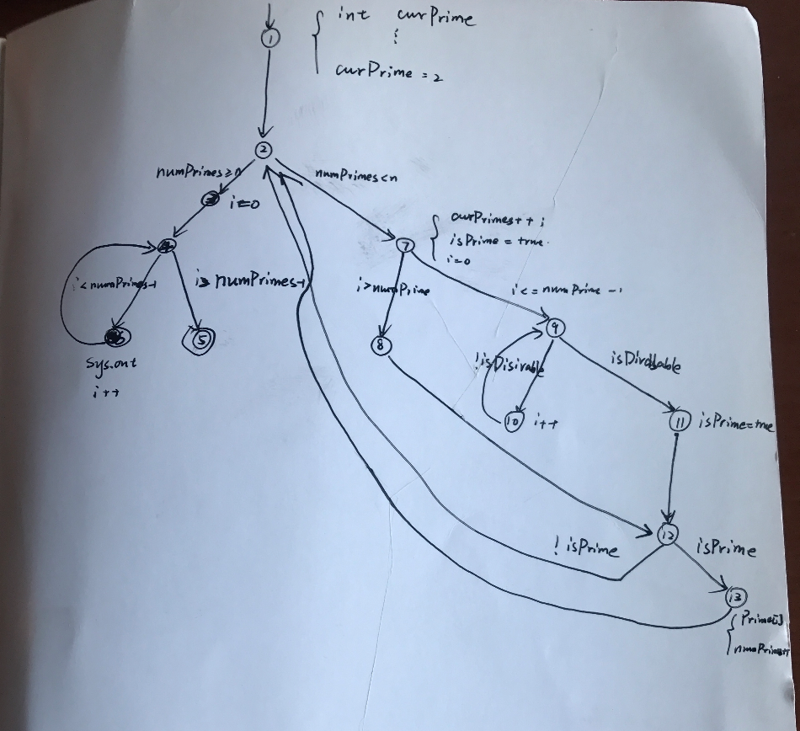

B.设计的故障：

令MAXPRIMES=4，会出现越界错误

C.测试用例：n = 1

D.节点覆盖：{1,2,3,4,5,6,7,8,9,10,11,12,13

边覆盖：{(1,2)(2,3)(3,4)(4,5)(4,6)(6,4)(2,7)(7,9)(7,8)(8,12)(9,10)(9,11)(10,9)(11,12)(12,2)(12,13)(13,2)}

主路径覆盖：

[1,2,3,4,5] [1,2,3,4,6] [4,6,4] [6,4,6] [6,4,5] [1,2,7,8,12,13] [1,2,7,9,11,12,13] [2,7,8,12,2] [2,7,8,12,13,2] [9,10,9] [10,9,10] [7,8,12,2,3,4,5] [7,8,12,2,4,6] [7,8,12,13,2,3,4,5] [7,8,12,13,,2,4,6] [7,9,11,12,2,3,4,5] [7,9,11,12,13,2,3,4,5]

[10,9,11,12,2,3,4,5] [10,9,11,12,2,3,4,6] [10,9,11,12,2,7,8] [10,9,11,12,13,2,7,8,12,13]

二．对主路径的测试：