Steven Miller

Slm115@case.edu

instructions

For PsychImmersion

Contents

1 Introduction 2

2 Initial Setup 2

2.1 Hardware-specific Setup 2

2.1.1 Non-VR 2

2.1.2 Oculus Rift 2

2.1.2 HTC Vive 5

2.2 General Setup 5

2.2.1 Controller Setup 5

# 1 Introduction

# 2 Initial Setup

In order to run the experiment, some initial setup is required prior to the first experiment. First follow the Hardware-specific Setup for the chosen platform, and then the general setup steps outlined later.

## 2.1 Hardware-specific Setup

Before we can get to the actual application, we need to set up for the specific hardware. The exact hardware setup will vary based on the chosen platform. The start of the hardware setup varies by platform.

### 2.1.1 Non-VR

Outline of steps:

1. Ensure you have a compatible system
2. (Optional) connect a secondary display

Detailed steps:

#### Ensure you have a compatible system

First, ensure that you have the proper system. You must have a Windows 10 PC. We do not currently support MacOS or Linux due to the way they handle Xbox controllers. In theory, Windows 7 or later should work, but it is untested and may cause issues; Windows 10 is strongly recommended. Ensure that your computer meets the minimum requirements (this is important to ensure a comparable experience to VR). The system should have either a dedicated graphics card, or at least a 6th-generation Intel Core i5 CPU (any mid to high range PC made in the past two years should be fine). You will also need a free USB port, or Bluetooth support for the controller.

#### (Optional) connect a secondary display

If desired, you may connect an additional monitor to the computer to allow for some researcher control during the experiment. Simply connect the secondary monitor to an available output on the device and turn it on. Then hold down the windows key and press ‘p’ and click “Extend” on the menu that appears. That is all the setup that is required, although you need to remember to enable the display once the application has started.

### 2.1.2 Oculus Rift

Outline of steps:

1. Ensure you have a compatible system
2. Unpack and set up the Rift
3. Set up the space
4. Enable Outside Apps

Detailed Steps:

#### Ensure you have a compatible system

First, ensure that you have the proper system. You must have a Windows 10 PC. We do not currently support MacOS or Linux due to the way they handle Xbox controllers. In theory, Windows 7 or later should work, but it is untested and may cause issues; Windows 10 is strongly recommended. Ensure that your computer meets the minimum requirements. At minimum, the computer should have an NVIDIA GTX 980 graphics card and a 5th generation Intel Core i5 CPU. Higher is better on both of those. Additionally, ensure that the system’s monitor is plugged into the GPU (green box in the image below) and not the motherboard (red box). See the image below for reference:

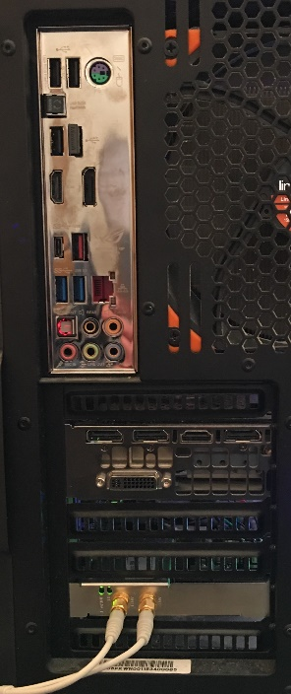

Don’t connect the display or headset HDMI here

Both the display and headset plug in here.

NOTE: This panel may be rotated or slightly different, but it will ALWAYS be detached from the one with USB ports (marked in red)

This port (HDMI) is for the headset, the display should use a different one in this area

NEVER USE THESE FOR ANYTHING

#### Unpack and set up the Rift

Next, go to <oculus.com/setup> and follow the steps. You will download an installer which will install an app called “Oculus” and will guide you through setting up the device. When connecting the USB cables, ensure that both the headset and sensor are plugged in to USB 3.0 ports. These look like normal USB ports labeled “3.0” or “S.S.”, and/or that are blue. An example is below:



Normal USB Ports

USB 3.0 Ports (note the blue plastic and “SS” label)

Another note at this stage is to select a good position for the sensor. Once the sensor is calibrated for the user, it cannot be moved. Think of the sensor as a small camera (the front is the side without a logo) and position it such that it will always be able to see the headset during the experiment. It will work better if it is in front of the user (looking at the front of the headset), but it should work from the back or sides as well. Ensure that the sensor can see the headset with the user both sitting and standing. Don’t forget that the top of the sensor can be tipped up or down to make it easier.

Be sure to follow the optional steps of setting up the Xbox Controller, as you will have to do this later anyway. We do not use the Oculus Remote during the experiment, although you may during setup if you want.

#### Set up the space

The subject will be seated for the duration of the experiment. It is essential that all calibration be done standing immediately in front of the chair and as close as possible to it. Additionally, to more closely match the VR space, the chair should NOT have arms, although, if you can’t find one without arms that’s ok. It doesn’t matter what direction the chair faces so long as calibration was done facing forward.

#### Enable Outside Apps

Before the experiment can be run, a setting must be changed in Oculus. First open Oculus. Click on the gear icon, then click on “Settings”, then click “General”, and ensure that “Unknown Sources” is turned on as shown below.

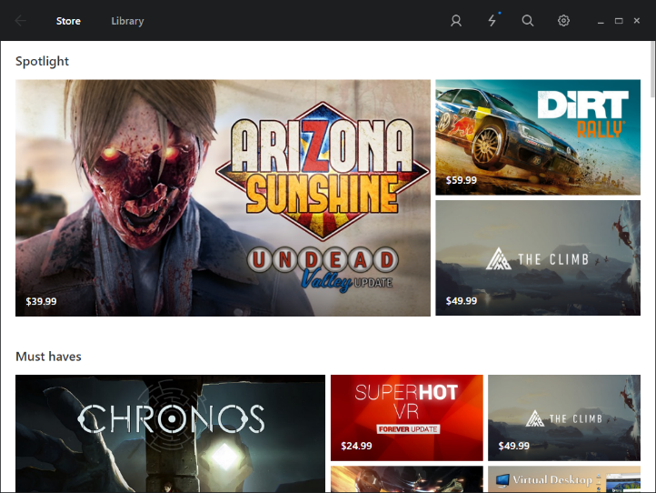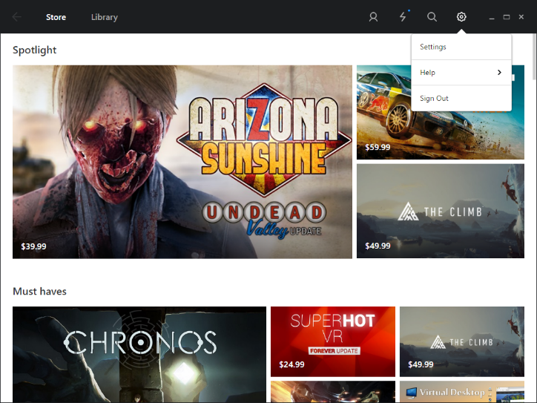

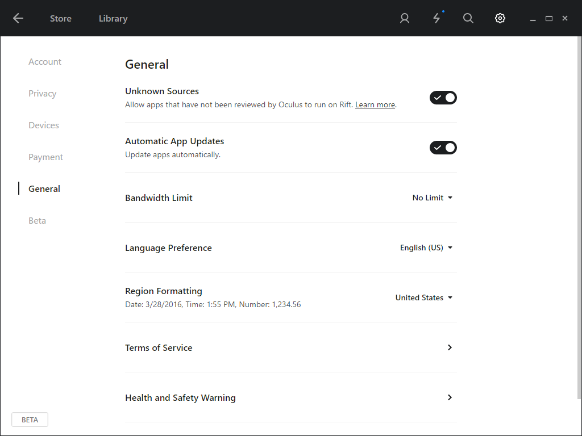

### 2.1.2 HTC Vive

The HTC Vive should already be setup for you. Ensure that the Vive is calibrated for “Standing Room Only” with the center and direction matching the Oculus’s setup. Follow the instructions in step 3 (Set up the space) from the Oculus instructions.

## 2.2 General Setup

There are a few things that need to be done regardless of what platform you are using.

### 2.2.1 Controller Setup

An Xbox One controller is required for the experiment. There are three ways to connect the controller depending on your hardware setup. If you are using Oculus, you already set up the Xbox Controller as part of the Rift setup process, and can skip this section.

First things first, we need to figure out how to connect the controller. If you have an Xbox Wireless Adapter for Windows (pictured below), you have the easiest setup process. 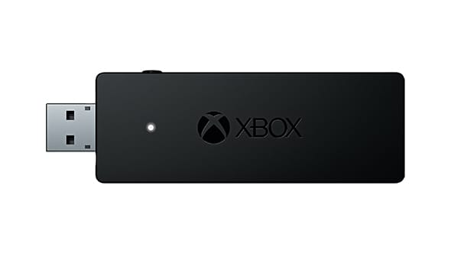

Simply plug the adapter in and wait for it to finish installing. Turn on the controller by pressing the Xbox Button (the big button with an X on it in the upper center) for a second, then hold down the SYNC button (the small round button next to the connector on the top of the controller) for a few seconds. Now, hold the button on the side of the adapter for a few seconds. The light on the controller should stop blinking and be solid. It is now connected to the computer. If this, for some reason, does not work, you can try the method outlined here <http://support.xbox.com/en-US/xbox-on-windows/accessories/connect-xbox-one-controller-to-pc>

If you have a white controller, you can also connect it over Bluetooth. Go to Settings -> Devices. If you are on the latest version of windows 10, you should then click Add a device and hit Bluetooth. Otherwise, click on the Bluetooth tab. Turn on the controller by pressing the Xbox Button (the big button with an X on it in the upper center) for a second, then hold down the SYNC button (the small round button next to the connector on the top of the controller) for a few seconds. After a few seconds, the controller should appear in the list of devices, when it does click on it and press “Pair”. If it does not appear in the list, try holding the SYNC button again. If you get stuck, see <http://support.xbox.com/en-US/xbox-on-windows/accessories/connect-xbox-one-controller-to-pc>.

The final, last resort, method is to connect wired. We avoid this method as it adds another cable tethering the user to the computer. Simply find any micro USB cable (typically used to charge Android phones), connect one end to port on the top of the controller, and the other to a free USB port on the computer. The controller will turn on, and after a few seconds to install, will be ready to go.