Luke Ambray

1/23/22

4562758

COP 4600

**Homework 2**

**Problem 1**

Installing Ubuntu via PowerShell

Familiarizing myself with the bash shell: running processes in the foreground and background, stopping and killing processes, and listing running processes

Installing GCC in order to compile and run C programs

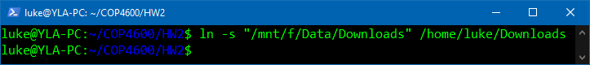

Creating symlinks in order to easily access files

Running the “hello_world” program

**Problem 2**

The operating system is a integral part of computing systems as it ensures the system functions properly and is easy to use. The first was the OS does this is through virtualization. The OS virtualizes the system’s resources, which includes the processor and memory. Virtualizing the CPU is important as it gives the illusion that the system has a large number of virtual CPUs, allowing for multiple processes to run simultaneously. Virtualizing memory is important as, since the CPU can now run multiple programs at once, every program needs memory allocated to it in order to run. By virtualizing memory, each process is able to access its own private virtual address space, which in turn helps prevent processes from using the same addresses as other processes. Another aspect of the system that the OS manages is concurrency. The OS is in charge of managing the thousands of processes that happen simultaneously and the problems that come with them. The last main objective of the OS is managing data persistence. Since system memory is volatile, the system needs a way to ensure not all data is lost whenever the system crashes or powers off. The OS alleviates this issue by managing the disk by way of a file system.

**Problem 3**

Figure 2.1

Figure 2.2

Figure 2.3

Figure 2.4

Figure 2.5a

Figure 2.5b

Figure 2.6