Got it. You want your existing content to be arranged in a developer-understandable website structure, not rewritten into new website copy.
Here’s the corrected format using YOUR ORIGINAL CONTENT, properly structured for the developer.

NEVA WEBSITE STRUCTURE DOCUMENT

Website Type
E-commerce skincare website

1. HOMEPAGE

HERO SECTION

Main Heading
Natural | Balanced | Conscious Skincare for men & women — inspired by nature and made for healthy, glowing skin.

CTA Button
- Shop Now

2. BESTSELLERS SECTION

Section Heading
Bestsellers

Subheading
Top-Rated by Customers

PRODUCT CARD STRUCTURE (FOR ALL PRODUCTS)
Each product card must contain:
- Product Image
- Product Name
- Short Tagline
- Key Benefits
- Price Section
- ⭐ Customer Rating
- Add to Cart Button
- WhatsApp Chat / Buy on WhatsApp Button

WhatsApp Button Redirect
Use this number:
+91 9998318359
Example:
“Hi NEVA team, I want to buy Neva Face Wash.”

PRODUCT 1

Neva Face wash (Deep cleansing formula)

Product Card Benefits
- Unclogs pores
- Fights acne
- Exfoliates gently
- Soothes inflammation
- Ideal for all skin type

Product Description
Say goodbye to breakouts with our deep cleansing Facewash.
Weight: 30 ML
Expertly formulated to target acne, blackheads, and clogged pores, this gentle yet powerful cleanser penetrates deep into the skin to remove excess oil, dirt, and dead skin cells. Enriched with Salicylic Acid (BHA), it helps reduce acne while promoting a clearer, healthier complexion. Designed for daily use on acne-prone skin, it leaves your face feeling fresh, clean, and balanced without over-drying.

Benefits Section
- Unclogs Pores: Salicylic acid penetrates deep to clear pores, reducing blackheads and whiteheads.
- Fights Acne: Helps prevent future breakouts by controlling excess oil and bacteria.
- Exfoliates Gently: Removes dead skin cells without irritation, promoting smoother, healthier skin.
- Soothes Inflammation: Reduces redness and swelling caused by acne.
- Ideal for all skin types: Balances oil production and purifies skin without over-drying.

Ideal For Section
- Oily and acne-prone skin that needs gentle yet effective cleansing.
- Individuals struggling with blackheads, whiteheads, and clogged pores.
- Skin prone to breakouts or excess oil production.
- Anyone looking for a daily facewash that exfoliates without over-drying.
- Those who want to calm redness and inflammation while promoting a clearer complexion.

How To Use Section
- Apply a small amount of the deep cleansing Facewash to damp skin.
- Gently massage in circular motions to help remove dirt, oil, and impurities, then rinse thoroughly with water.
- For best results, use twice daily—morning and evening.
- Follow with a lightweight moisturizer and SPF during the day to protect and hydrate your skin.

Ingredients Section
- Salicylic Acid – Exfoliates and unclogs pores to reduce breakouts.
- Niacinamide – Control acne-causing bacteria.
- Green Tea Extract – Rich in antioxidants, reduces redness and irritation.
- Lactic Acid – Gently exfoliates and promotes smooth skin.

Reviews Section
Developer should create:
- Scrollable review slider
- 5-star rating format
- Customer name + date + review text
(Add all provided reviews exactly as shared.)

Product CTA Buttons
- Add to Cart
- Buy on WhatsApp

PRODUCT 2

Intense Night Repair Cream

Product Description
Neva Intense night Cream works overnight to target dark spots, acne marks, and pigmentation while you sleep.
It is formulated to help even out skin tone and enhance your natural glow for a brighter, healthier-looking complexion.
Lightweight yet effective, it helps rejuvenate and restore your skin through the night. Suitable for both men and women, it fits perfectly into any night time skincare routine.

Benefits Section
- Reduces Dark Spots & Pigmentation: Helps fade stubborn spots and uneven patches.
- Fades Tanning: Brightens skin and restores clarity after sun exposure.
- Restores Skin Glow: Promotes a radiant, healthy-looking complexion overnight.
- Improves Texture & Tone: Smooths and evens skin while you sleep for softer, more balanced skin.

Ideal For Section
- Individuals with dark spots, acne marks, or pigmentation concerns.
- Those seeking an even skin tone, restored clarity, and a natural glow.
- Men and women looking for an effective overnight skincare solution.
- Anyone wanting to improve skin texture, tone, and overall radiance while they sleep.

How To Use Section
- Cleanse your face thoroughly with Neva deep cleansing facewash before bedtime.
- Take a desired amount of the Night Miracle Cream and apply evenly over your face and neck in a thin layer.
- Leave it overnight.
- Do not massage or rub.
- Next morning wash your face with gentle facewash.
- Use daily at night for best results.

Ingredients Section
- Alpha Arbutin: Brightens skin and helps reduce pigmentation for a more even tone.
- Peptides: Support skin repair, boost elasticity, and promote firmness.
- Multivitamins: Nourish and revitalize dull, tired skin for a healthy glow.
- Advanced Skin Actives: Target discoloration and improve overall skin tone and clarity.

Reviews Section
Developer should create:
- Review carousel/slider
- 5-star format
- Name + date + review
(Add all provided reviews exactly as shared.)

Product CTA Buttons
- Add to Cart
- Buy on WhatsApp

3. CONTACT SECTION

Heading
We love skincare talk

Content
Leave your email and never miss a glow-up! Hot deals, skincare secrets, and news you’ll actually want.

Contact Details
Email: services.neva@gmail.com
Phone: +91 9998318359

Additional Support Text
Still using chemicals?
Let’s upgrade your routine.
Your skin questions answered—reach us anytime at services.neva@gmail.com
Need help choosing? Call us now for instant guidance.

4. FOOTER SECTION
Footer should contain:
- About Us
- Privacy Policy
- Shipping Policy
- Return, Replacement & Refund Policy
- Contact Us

5. ABOUT US PAGE

Heading
Welcome to NEVA

Content
Founded in 2021, NEVA was created with a passion for delivering high-quality, effective skincare solutions. We are a progressive personal care brand offering 100% organic beauty and wellness products. Our formulations are certified, paraben-free, cruelty-free, and result-oriented.
We believe skincare is more than just a routine—it is a journey of self-love and well-being.

Join Us Section
Explore our range of products and become a part of the NEVA family. Follow us on social media for the latest updates, skincare tips, and exclusive offers.

6. POLICY PAGES
Developer should create separate pages for:
- Privacy Policy
- Shipping Policy
- Return, Replacement & Refund Policy
(Use exact content provided.)

7. IMPORTANT WEBSITE FEATURES
Developer must add:
- Add to Cart functionality
- Cart page
- WhatsApp chat integration
- Mobile responsive layout
- Floating WhatsApp icon
- Product review slider
- Secure checkout page
- Online payment only
- Email subscription form

REVIEWS SECTION (FACE WASH)

Developer Instructions
Create a horizontally scrollable review slider/carousel.
Each review card must contain:
- ⭐⭐⭐⭐⭐ Rating
- Review Heading
- Review Date
- Customer Review Text
- Customer Name

Review 1
⭐⭐⭐⭐⭐

Visible Reduction In Pimples & Blackheads
Date: 13 May 2026
“Maine kaafi face wash try kiye hain but isse jaisa result nahi mila. Chhote pimples aur blackheads visibly kam hue hain. Skin pehle se zyada smooth lagti hai.”
— Shibra Ansari

Review 2
⭐⭐⭐⭐⭐

Perfect Before Wedding Season
Date: 27 Dec 2025
“I started using this before my wedding skincare routine and I’m genuinely impressed. My skin looks clearer, less oily, and more healthy overall.”
— Vani Arora

Review 3
⭐⭐⭐⭐⭐

Lightweight & Non-Drying
Date: 7 Jan 2025
“Very lightweight and non-drying face wash. I noticed fewer pimples and less redness within a few days. Good product for daily use.”
— Rahul S.

Review 4
⭐⭐⭐⭐⭐

Balanced & Fresh Skin
Date: 13 Nov 2025
“Most acne face washes make my skin feel stretchy, but this one keeps it balanced. My face feels fresh and smoother after every wash.”
— Sachin Bansal

Review 5
⭐⭐⭐⭐⭐

Fresh Skin
Date: 18 Jan 2026
“Meri skin bahut oily thi aur baar-baar pimples ho jaate the. Is face wash ko use karne ke baad skin kaafi clean aur fresh lagti hai. Oil bhi control rehta hai.”
— Kirat K. Singh

Review 6
⭐⭐⭐⭐⭐

Best Face Wash For Acne-Prone Skin
Date: 17 Feb 2026
“This is honestly one of the best salicylic acid face washes I’ve tried. My small bumps and blackheads reduced a lot, and my skin texture looks smoother now.”
— Aanchal Mehta

Review 7
⭐⭐⭐⭐⭐

Helped Calm My Active Acne
Date: 22 Nov 2025
“2 weeks use karne ke baad meri active acne problem kaafi control hui hai. Skin clean lagti hai aur redness bhi pehle se kam hui hai.”
— Kritika Jain

Review 8
⭐⭐⭐⭐⭐

Finally Found Something That Works
Date: 19 Oct 2025
“Main honestly expectations ke bina use kar raha tha but results are surprising the. Pimples kam hue aur skin texture bhi improve hua.”
— Harish M. Rao

Review 9
⭐⭐⭐⭐⭐

Best For Humid Weather
Date: 19 Nov 2025
“Bhopal ki garmi aur humidity mein meri skin bahut oily ho jaati hai, but ye face wash skin ko fresh aur non-greasy rakhta hai.”
— Mansi Gupta

Review 10
⭐⭐⭐⭐⭐

Breakout Control That Actually Works
“I’ve been dealing with frequent breakouts for a long time, but after using this face wash, my skin feels much calmer. New pimples have reduced noticeably.”
— Priya Nair

Review 11
⭐⭐⭐⭐⭐

Great Oil Control
Date: 10 Oct 2025
“My T-zone used to get very oily, especially in the afternoon. This face wash helps control oil without making my skin feel tight or dry.”
— Kavya Mishra

Review 12
⭐⭐⭐⭐⭐

Reduces Acne Marks Slowly
Date: 2 Oct 2025
“It not only helped with pimples but also reduced my acne marks gradually. My skin looks more balanced now.”
— Adrija Bose

REVIEWS SECTION (INTENSE NIGHT REPAIR CREAM)

Developer Instructions
Create:
- Auto-scroll review slider
- Mobile responsive review cards
- 5-star design format

Review 1
⭐⭐⭐⭐⭐

Visible Glow in 3 Days
Date: 16 Nov 2025
“I started using this night cream daily and within 3 days my skin started looking more fresh and glowing. It feels soft in the morning and dark spots look lighter.”
— Ridhi Verma

Review 2
⭐⭐⭐⭐⭐

Perfect Night Skincare Routine
Date: 02 Dec 2025
“This cream has become part of my nightly routine. It absorbs quickly and I wake up with hydrated, healthy-looking skin every morning all thanks to my wife for recommending this cream.”
— Arjun Pal

Review 3
⭐⭐⭐⭐⭐

Reduced Pigmentation Noticeably
Date: 10 Feb 2026
“My pigmentation has reduced gradually and my skin looks more balanced. I can see a natural brightness coming back.”
— Armin Kaur

Review 4
⭐⭐⭐⭐⭐

Holy Grail For Me
Date: 20 Apr 2026
“I can actually see my skin renewing over time. It looks healthier, brighter, and more even-toned than before.”
— Asmita Pathak

Review 5
⭐⭐⭐⭐⭐

Skin Feels Brighter Every Morning
Date: 08 Jun 2026
“I’ve been using this night cream for a few weeks now and my skin looks visibly brighter in the morning. It feels soft and well-rested.”
— Meera Nair

Review 6
⭐⭐⭐⭐⭐

Noticeable Glow Boost
Date: 10 Jul 2026
“My skin has started looking more radiant and healthy. Friends even noticed the glow on my face.”
— Padmja Mohanty

Review 7
⭐⭐⭐⭐⭐

Fresh & Rested Skin Look
Date: 25 Jun 2026
“Every morning my skin looks fresh and well-rested. It has improved my overall skin texture a lot.”
— Ayra Zisan

Review 8
⭐⭐⭐⭐⭐

Skin Feels Treated, Not Just Moisturized
Date: 20 Jan 2026
“Skin ko proper treatment jaisa feel deta hai. Quality clearly high-end skincare jaisi lagti hai.”
— Ankita Singh

Review 9
⭐⭐⭐⭐⭐

Visible Difference in Product Quality
Date: 05 Nov 2025
“Bohot saare night creams use kiye hain, but iski quality clearly better hai. Skin pe irritation bilkul nahi hota.”
— K.M Laxmi
https://twaura.com/
Track your order-
Whatsapp
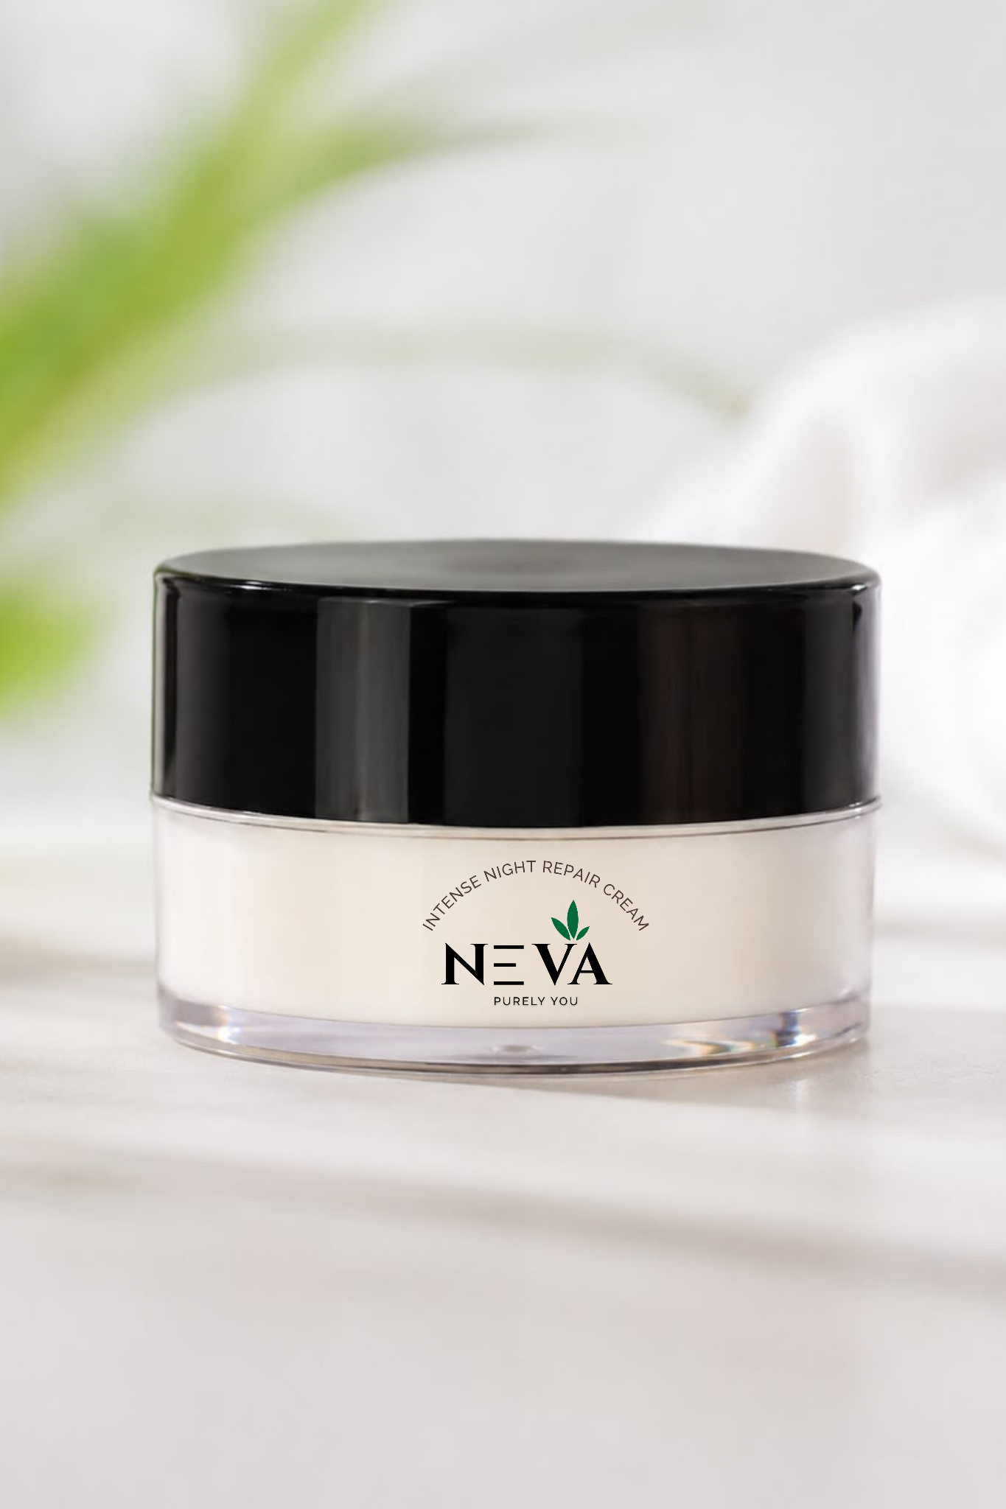
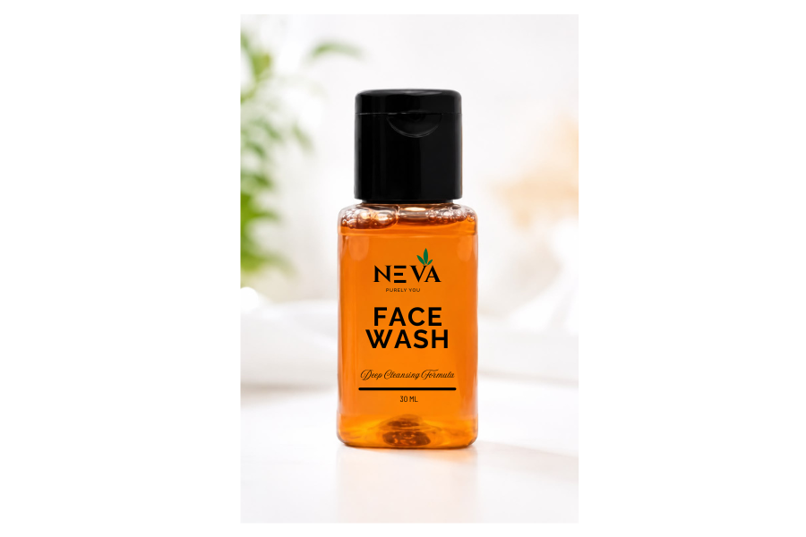
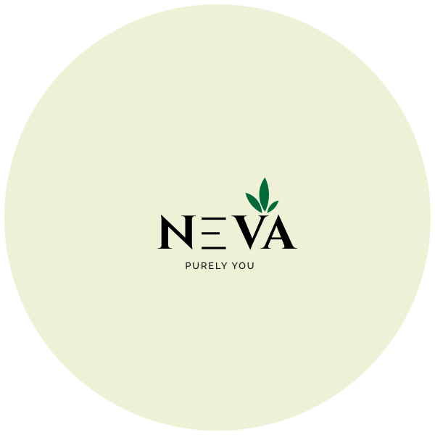

Brand color
Before/After
See the Transformation Journey
