Task 3.

create table, create index ad describe table.

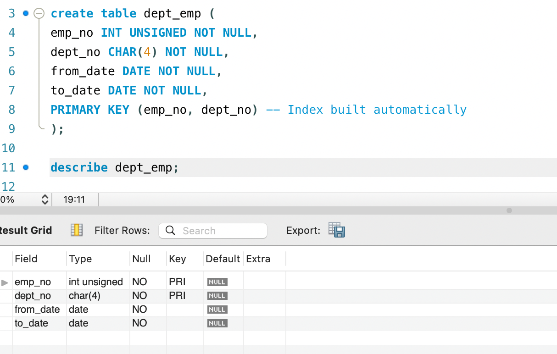

Show index from dept_emp;

