containers.py

some_rand(x, a, b): generate x different ints in [a,b)

self.subscription_pool: save all subscribe info [{“topic name”: [ broker names]}]

self.subscription_queue: subscription info that need to be flood [(topic, name), ]

Demo1:

0 ->1 ->2

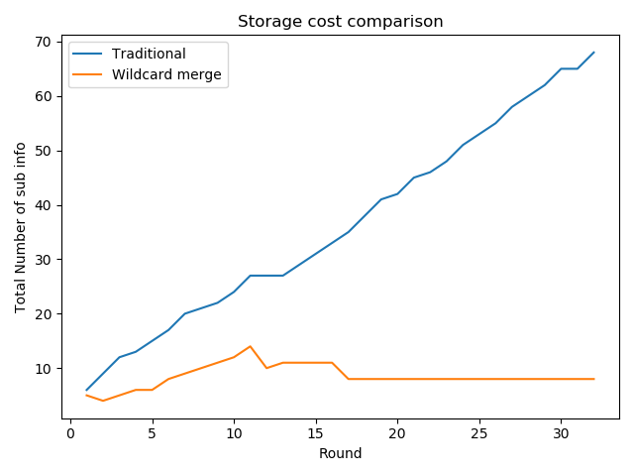

1 <- 0 -> 2 ->3,4:

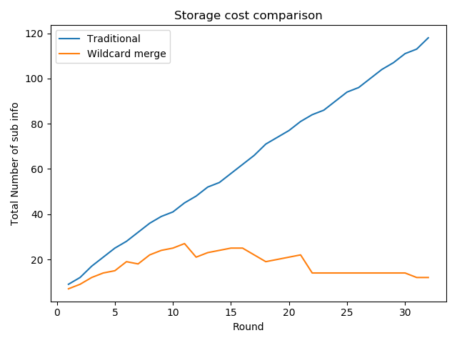

Demo2: SF, NSF, PF 下的系统中的占据带宽情况

Size：选取message最后两位

时间应该由workloop决定