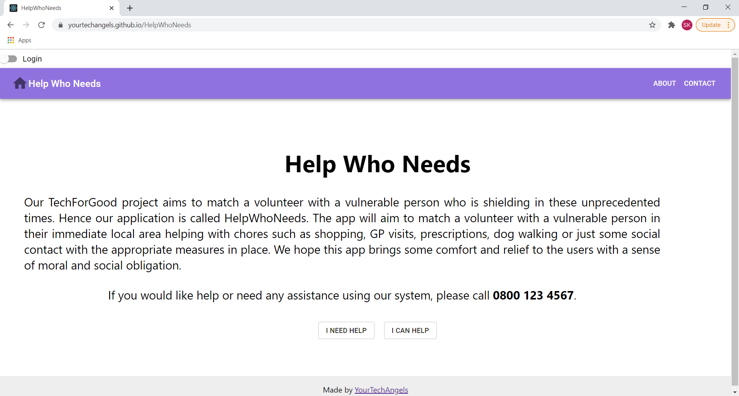

Components :

* Header (Across all our pages)
* Footer (Across all our pages)
* About
* Contact

No dynamic data

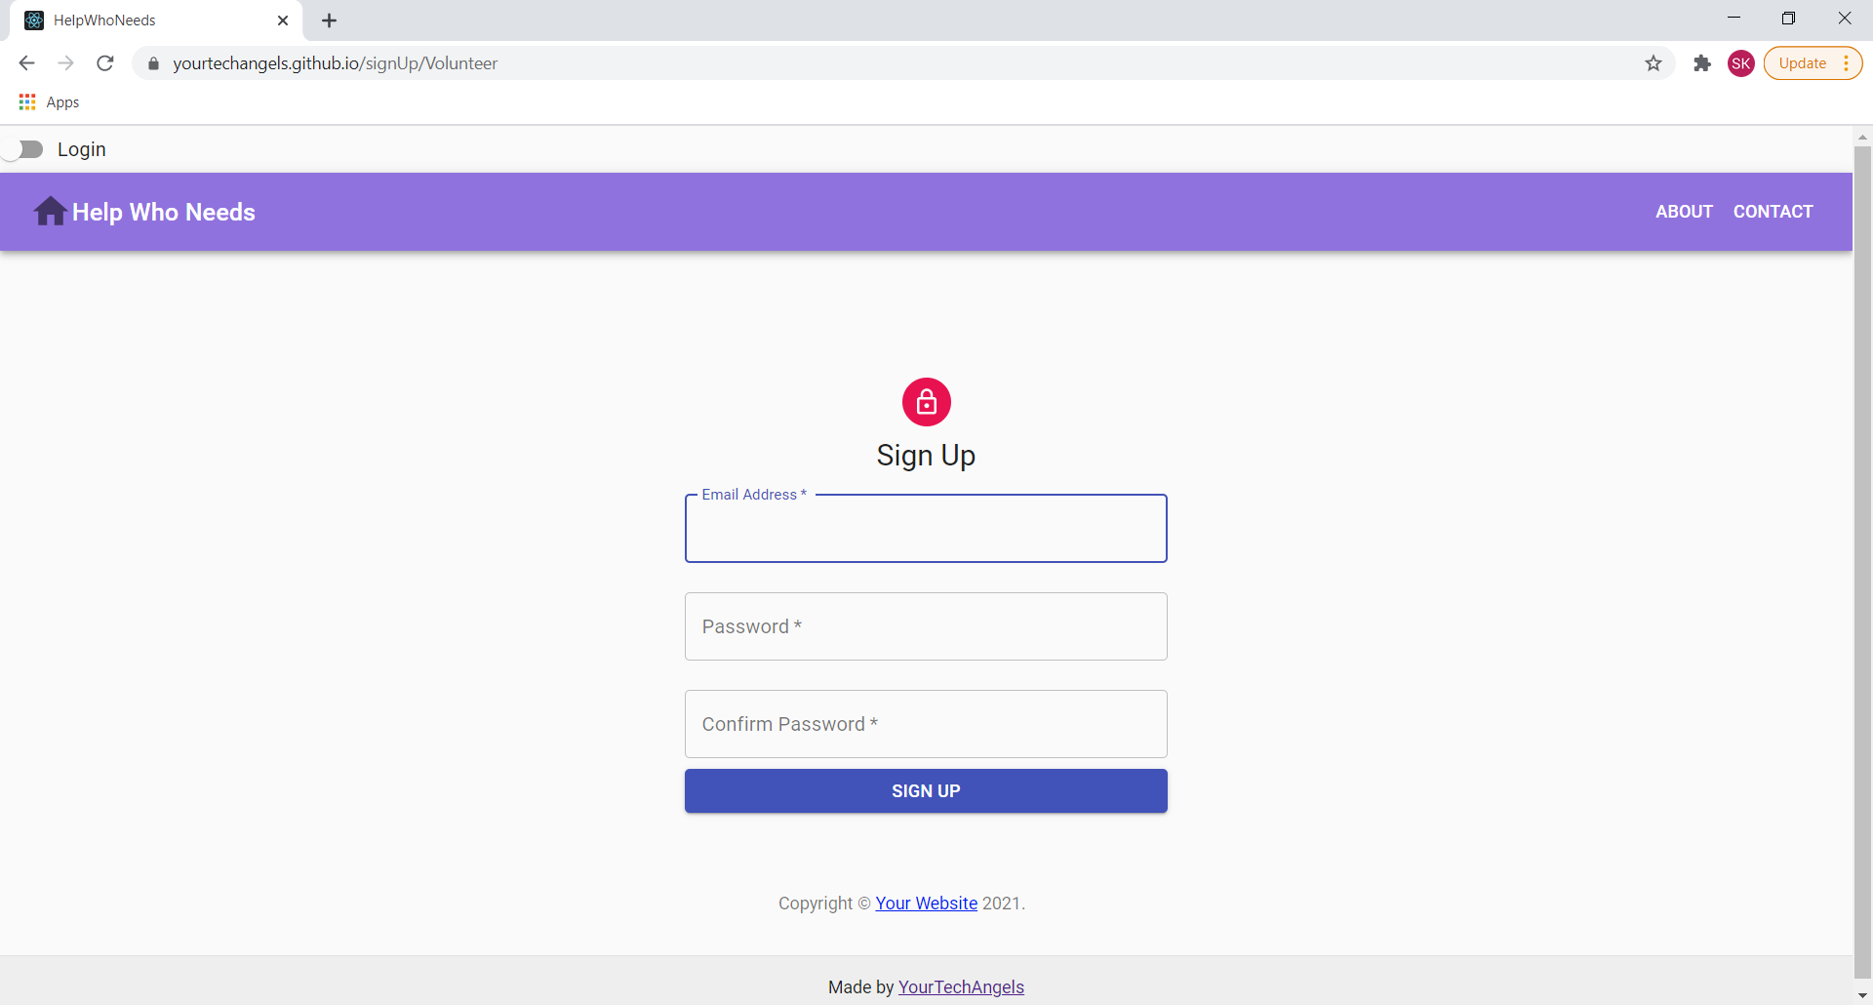

Component : Signup

No dynamic data

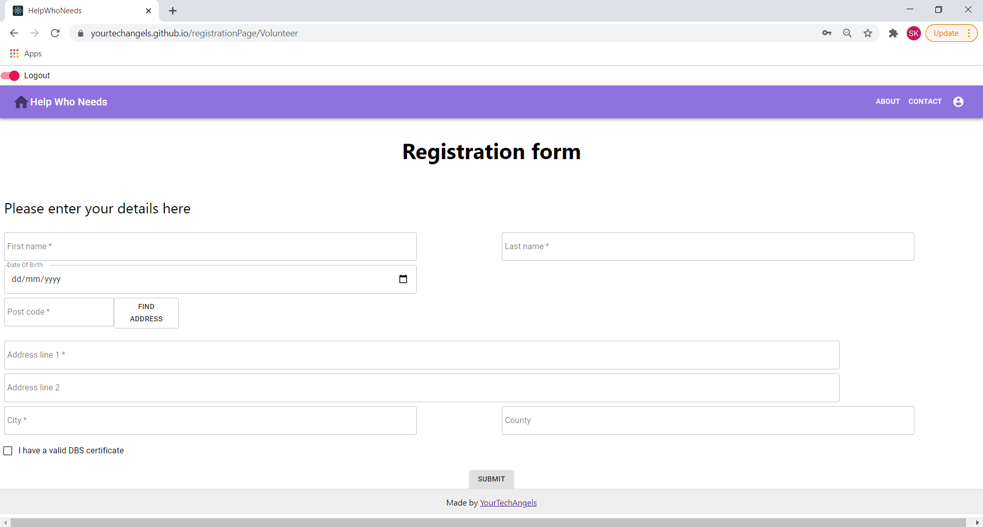

Component : Registration form

Dynamic data : Address fields (based on lookup)

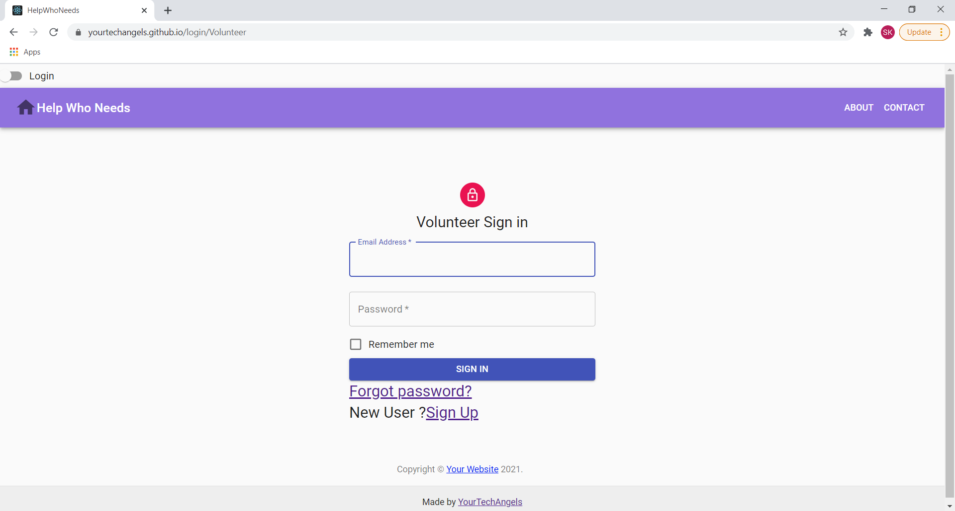

Components:

* Sign in form
* Forgot password link
* Sign Up link

No dynamic data

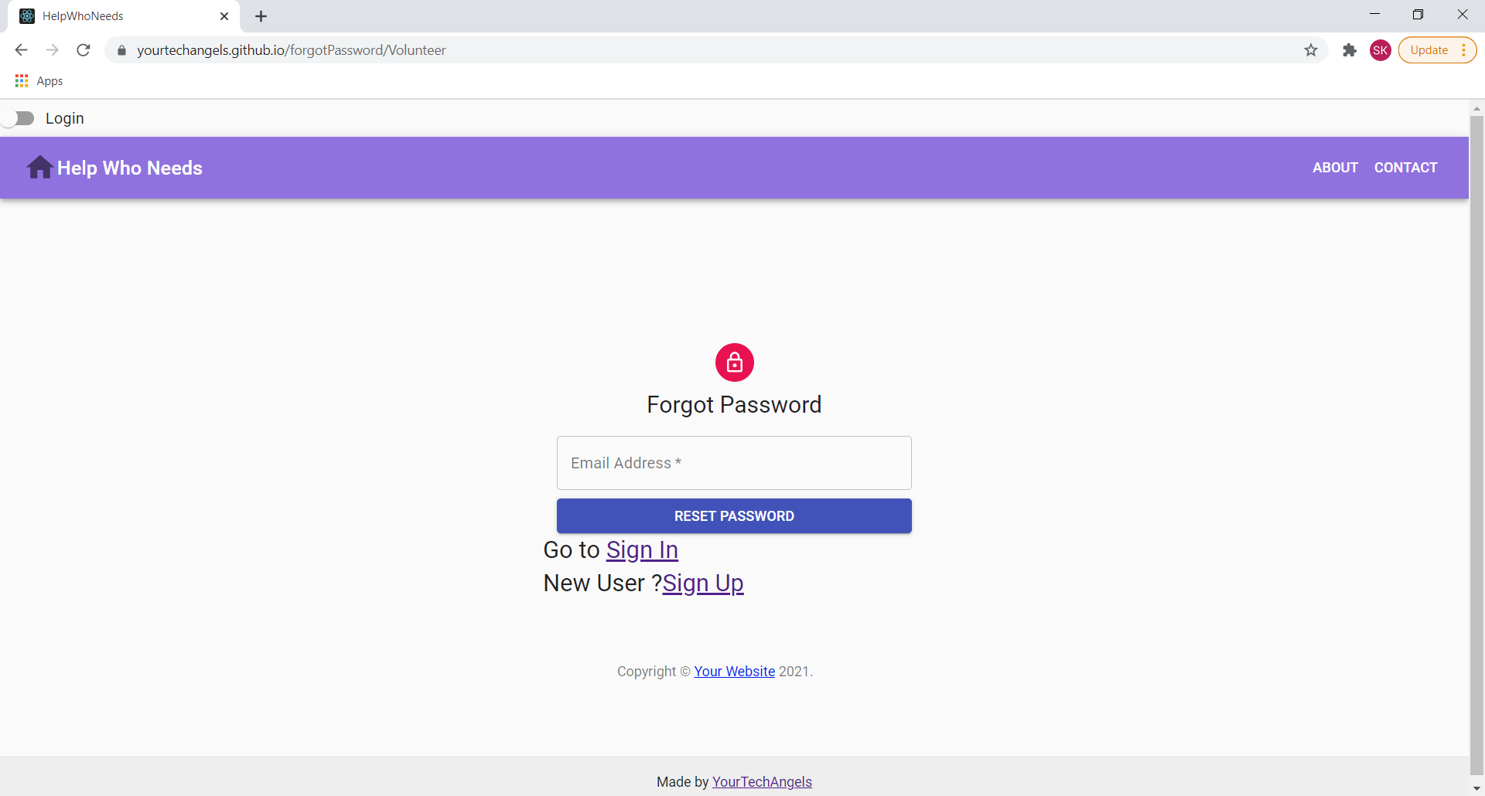

Components :

* Forgot password form
* Sign In link
* Sign Up link

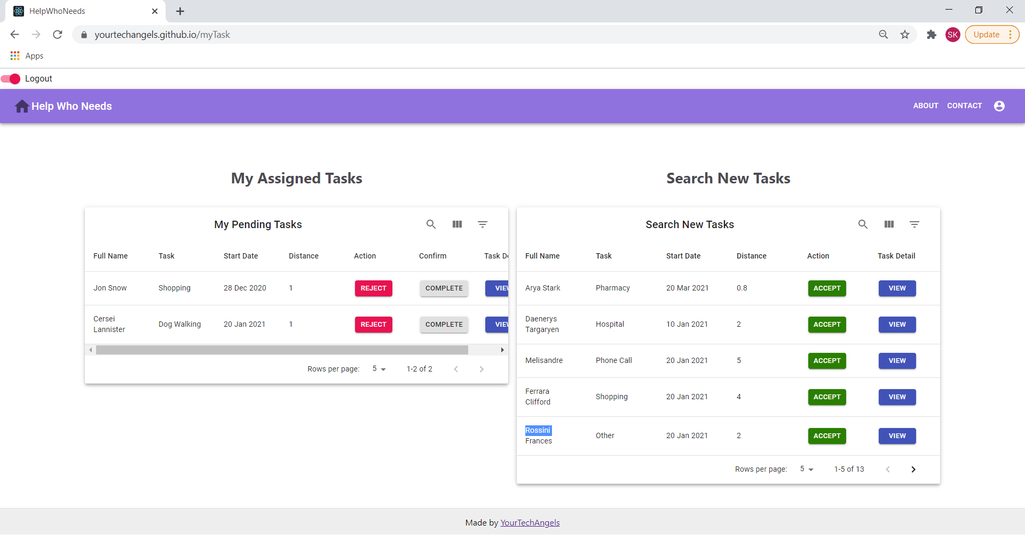

Components :

* My Assigned Tasks
* Search New Tasks
* VIEW -> Task details

Dynamic data :

* Data in My Assigned Tasks & Search New Tasks tables
* Number of per page

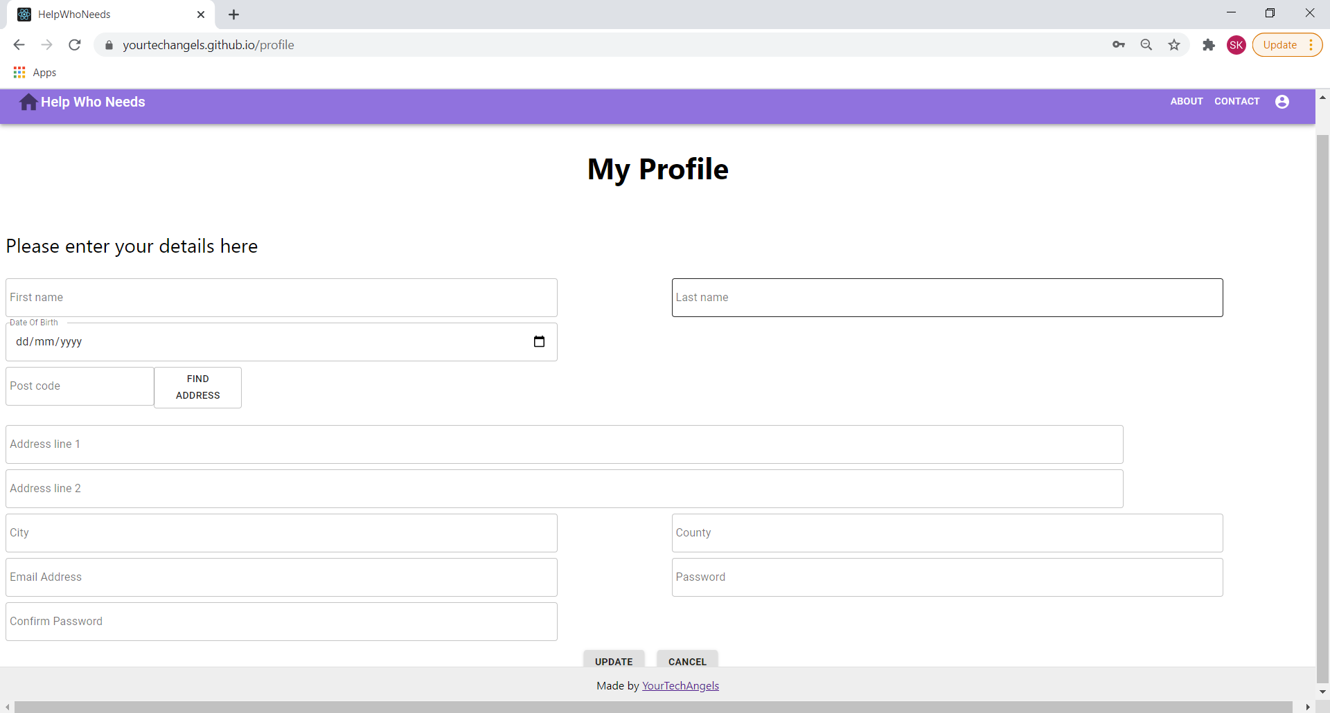

Components :

* My Profile form

Dynamic data : All the data fields

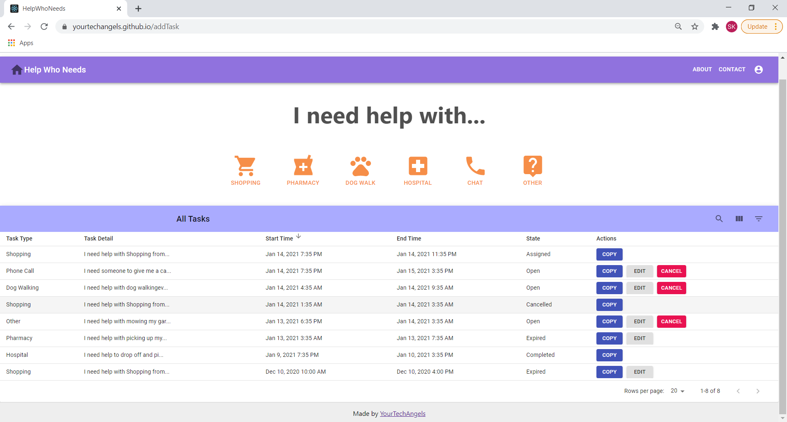

Components:

* Add Task panel(with task buttons eg : Shopping, Pharmacy etc.)
* All Tasks (the table)

Dynamic data :

* All Tasks table data (each row)
* Number of records per page

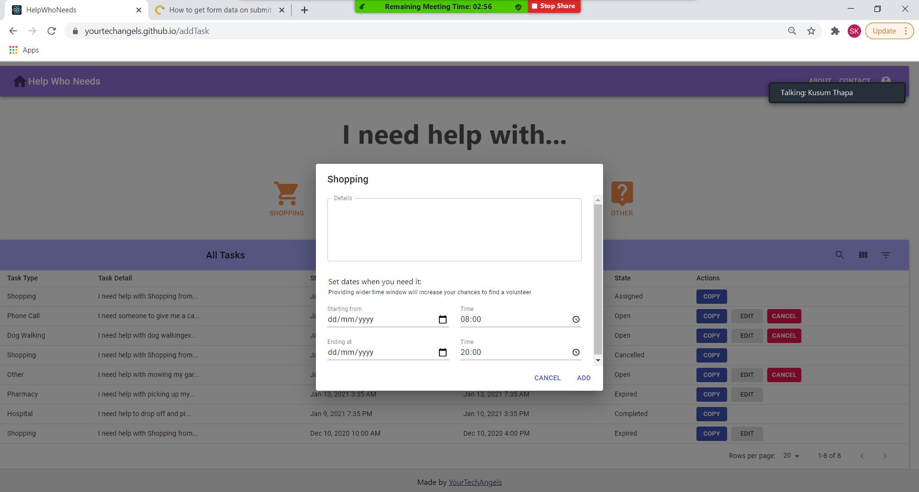

Components :

* New task form

Dynamic data : All fields