# Wireframe of “HelpWhoNeed” web application

**Goal – Match, pair and deploy**

1. Landing Page

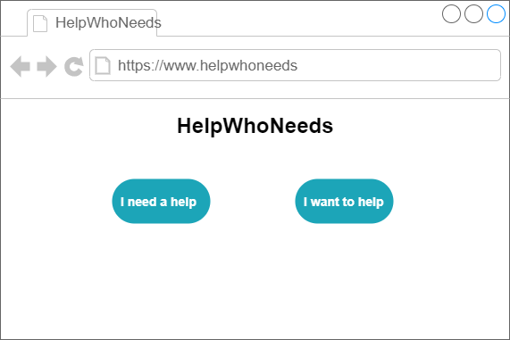

1. Login Page

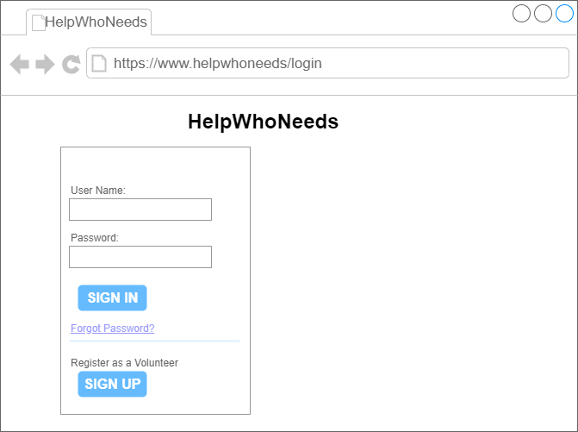

1. Registration Page

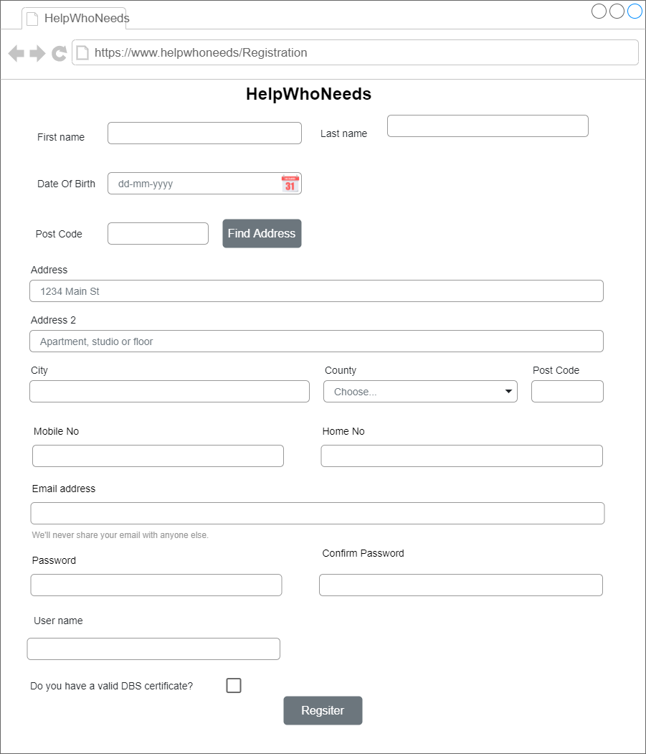

1. Request Task Page

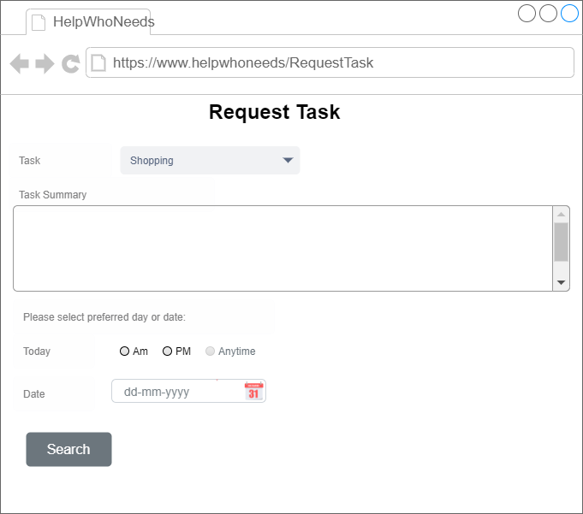

5)Request Result Task

