COMP6224 Foundations of Cyber Security 2022/23

Coursework on Cyber Attack Analysis and Password Cracking

**Student ID**: *replace this text with the 8 digits of your student ID*

# Part 1 – Cyber-Attack Analysis

## Task 1.1 – Kill Chain-based Analysis

[*Note that you may need to add further sections, depending on how many phases the attack went through*]

### Reconnaissance Phase

[*Describe what happened during the “reconnaissance” phase. What information did attackers gather? How? Max 100 words*]

### Weaponization Phase

[*Describe what happened during the “weaponization” phase. What cyber weapons have been used? How did attackers obtain them? Max 100 words*]

### Delivery Phase

[*Describe what happened during the “delivery” phase. How did the attackers deliver the cyber weapon(s) to the intended target? Max 100 words*]

### Exploitation Phase

[*Describe what happened during the “exploitation” phase. How have cyber weapons been activated? Max 100 words*]

### Installation Phase

[*Describe what happened during the “installation” phase. How did the attackers gain persistence inside the target? Max 100 words*]

### Command and Control Phase

[*Describe what happened during the “command and control” phase. How did the attackers establish a communication channel to control the cyber weapons installed inside the target? What kind of instructions did the attackers send? What types of information did the cyber weapons send back to the attackers? Max 100 words*]

### Actions on Objective Phase

[*Describe what happened during the “actions on objective” phase. What did the attacker do to achieve their goals? Max 100 words*]

## Task 1.2 – Cyber Actor Analysis

[*Most likely cyber actor profile (or combinations of cyber actor profiles)*]

**Cyber Actor Profile:** *replace this text with the type of cyber actor profile considered, or list of types if a combination of cyber actor profiles is considered*

### Attack Strategy

[*Discuss how the attack strategy used in this cyber-attack compares to the attack strategies commonly used by this cyber actor profile.* *Max 100 words*]

### Motivations

[*Discuss how the motivations of the attacker in this cyber-attack compares to the motivations that generally characterise this cyber actor profile.* *Max 100 words*]

# Part 2 – Password Cracking

## Task 2.1 - Dictionary-based cracking of passwords

[*Up to 3 dictionaries, up to 20 passwords overall; you will need to add further hash/password entries*]

**Dictionary #1**

Name of the file:

File source:

Command (also include a screenshot): john –wordlist=cain.txt CW_Hack_2023.txt

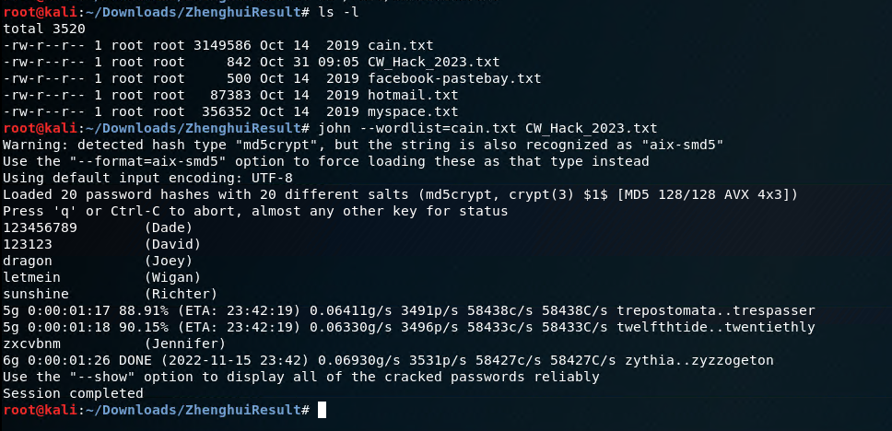

Cracked passwords

* hash #1
* password #1
* hash #2
* password #2

**Dictionary #2**

Name of the file:

File source:

Command (also include a screenshot):

Cracked passwords

* hash #1
* password #1
* hash #2
* password #2

**Dictionary #3**

Name of the file:

File source:

Command (also include a screenshot):

Cracked passwords

* hash #1
* password #1
* hash #2
* password #2

## Task 2.2 - Password cracking of Linux accounts

**Brute force**

Command (also include a screenshot):

Cracked passwords

* username #1
* password #1
* username #2
* password #2

**Dictionary**

Command (also include a screenshot):

Cracked passwords

* username #1
* password #1
* username #2
* password #2

**Result Comparison** [max 200 words]

…

## Task 2.3 - Password analysis

[*Up to 25 passwords, up to 4 weaknesses per password*]

**Password #1**

Password:

Weaknesses

* weakness #1 [max 50 words]
* weakness #2 [max 50 words]
* weakness #3 [max 50 words]
* weakness #4 [max 50 words]

**Password #2**

Password:

Weaknesses

* weakness #1 [max 50 words]
* weakness #2 [max 50 words]
* weakness #3 [max 50 words]
* weakness #4 [max 50 words]

**Password #3**

Password:

Weaknesses

* weakness #1 [max 50 words]
* weakness #2 [max 50 words]
* weakness #3 [max 50 words]
* weakness #4 [max 50 words]

**Password #4**

Password:

Weaknesses

* weakness #1 [max 50 words]
* weakness #2 [max 50 words]
* weakness #3 [max 50 words]
* weakness #4 [max 50 words]

**Password #5**

Password:

Weaknesses

* weakness #1 [max 50 words]
* weakness #2 [max 50 words]
* weakness #3 [max 50 words]
* weakness #4 [max 50 words]

**Password #6**

Password:

Weaknesses

* weakness #1 [max 50 words]
* weakness #2 [max 50 words]
* weakness #3 [max 50 words]
* weakness #4 [max 50 words]

**Password #7**

Password:

Weaknesses

* weakness #1 [max 50 words]
* weakness #2 [max 50 words]
* weakness #3 [max 50 words]
* weakness #4 [max 50 words]

**Password #8**

Password:

Weaknesses

* weakness #1 [max 50 words]
* weakness #2 [max 50 words]
* weakness #3 [max 50 words]
* weakness #4 [max 50 words]

**Password #9**

Password:

Weaknesses

* weakness #1 [max 50 words]
* weakness #2 [max 50 words]
* weakness #3 [max 50 words]
* weakness #4 [max 50 words]

**Password #10**

Password:

Weaknesses

* weakness #1 [max 50 words]
* weakness #2 [max 50 words]
* weakness #3 [max 50 words]
* weakness #4 [max 50 words]

**Password #11**

Password:

Weaknesses

* weakness #1 [max 50 words]
* weakness #2 [max 50 words]
* weakness #3 [max 50 words]
* weakness #4 [max 50 words]

**Password #12**

Password:

Weaknesses

* weakness #1 [max 50 words]
* weakness #2 [max 50 words]
* weakness #3 [max 50 words]
* weakness #4 [max 50 words]

**Password #13**

Password:

Weaknesses

* weakness #1 [max 50 words]
* weakness #2 [max 50 words]
* weakness #3 [max 50 words]
* weakness #4 [max 50 words]

**Password #14**

Password:

Weaknesses

* weakness #1 [max 50 words]
* weakness #2 [max 50 words]
* weakness #3 [max 50 words]
* weakness #4 [max 50 words]

**Password #15**

Password:

Weaknesses

* weakness #1 [max 50 words]
* weakness #2 [max 50 words]
* weakness #3 [max 50 words]
* weakness #4 [max 50 words]

**Password #16**

Password:

Weaknesses

* weakness #1 [max 50 words]
* weakness #2 [max 50 words]
* weakness #3 [max 50 words]
* weakness #4 [max 50 words]

**Password #17**

Password:

Weaknesses

* weakness #1 [max 50 words]
* weakness #2 [max 50 words]
* weakness #3 [max 50 words]
* weakness #4 [max 50 words]

**Password #18**

Password:

Weaknesses

* weakness #1 [max 50 words]
* weakness #2 [max 50 words]
* weakness #3 [max 50 words]
* weakness #4 [max 50 words]

**Password #19**

Password:

Weaknesses

* weakness #1 [max 50 words]
* weakness #2 [max 50 words]
* weakness #3 [max 50 words]
* weakness #4 [max 50 words]

**Password #20**

Password:

Weaknesses

* weakness #1 [max 50 words]
* weakness #2 [max 50 words]
* weakness #3 [max 50 words]
* weakness #4 [max 50 words]

**Password #21**

Password:

Weaknesses

* weakness #1 [max 50 words]
* weakness #2 [max 50 words]
* weakness #3 [max 50 words]
* weakness #4 [max 50 words]

**Password #22**

Password:

Weaknesses

* weakness #1 [max 50 words]
* weakness #2 [max 50 words]
* weakness #3 [max 50 words]
* weakness #4 [max 50 words]

**Password #23**

Password:

Weaknesses

* weakness #1 [max 50 words]
* weakness #2 [max 50 words]
* weakness #3 [max 50 words]
* weakness #4 [max 50 words]

**Password #24**

Password:

Weaknesses

* weakness #1 [max 50 words]
* weakness #2 [max 50 words]
* weakness #3 [max 50 words]
* weakness #4 [max 50 words]

**Password #25**

Password:

Weaknesses

* weakness #1 [max 50 words]
* weakness #2 [max 50 words]
* weakness #3 [max 50 words]
* weakness #4 [max 50 words]