Morsecode

1x button

1x schakelaar

2x lampje

1x buzzer

1x arduino bord

1x breadboard

1x micro USB

2x 100 ohm weerstand

6x kabels

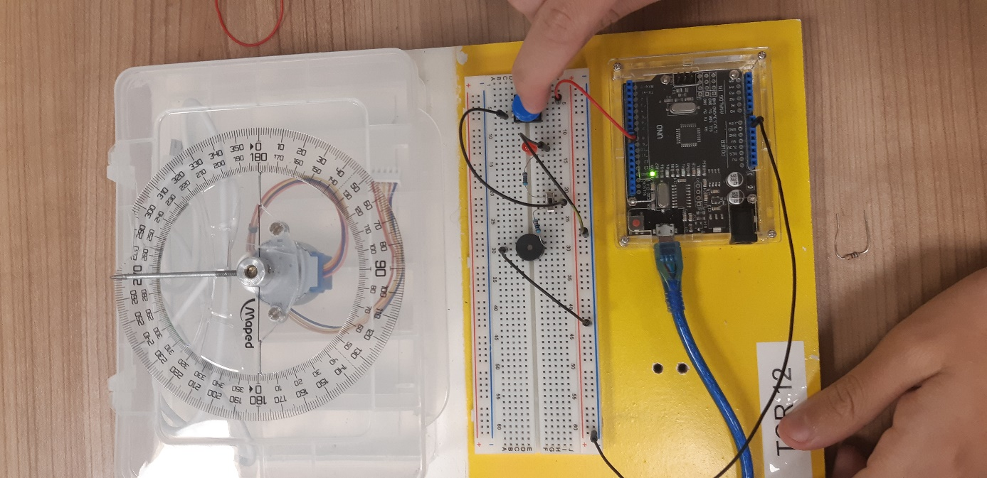

int pin = 9;

void setup() {

// put your setup code here, to run once:

pinMode (pin,OUTPUT);

}

void loop() {

// put your main code here, to run repeatedly:

tone(pin, 1000); //

}