**100% ASK**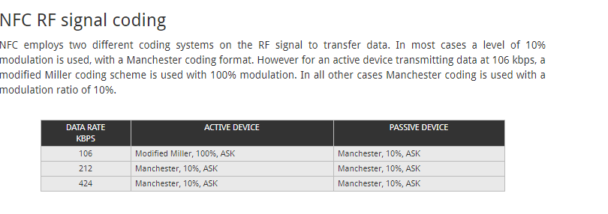

[**http://www.radio-electronics.com/info/wireless/nfc/near-field-communications-modulation-rf-signal-interface.php**](http://www.radio-electronics.com/info/wireless/nfc/near-field-communications-modulation-rf-signal-interface.php)