Question

1. Detail about the using of logging module in python

Answer:

A well-organized Python application is likely composed of many modules. Sometimes these modules are intended to be used by other programs. Still, unless you’re intentionally developing reusable modules inside your application, you’re likely using modules available from PyPI and modules that you write yourself specifically for your application.

PYPI: Python Index programming language.

Logging in Python is a way to record information about your Python scripts and keep track of events generated by the scripts as they take place.

Level

When it’s used

DEBUG

Detailed information, typically of interest only when diagnosing problems.

INFO

Confirmation that things are working as expected.

WARNING

An indication that something unexpected happened, or indicative of some problem in the near future (e.g. ‘disk space low’). The software is still working as expected.

ERROR

Due to a more serious problem, the software has not been able to perform some function.

CRITICAL

A serious error, indicating that the program itself may be unable to continue running.

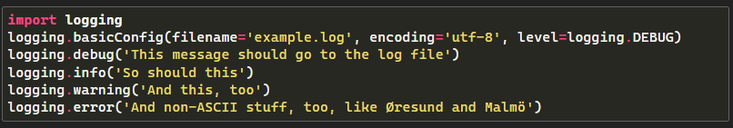

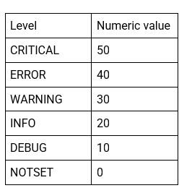

w