PROJECT TITLE:
Scientific Calculator with User Interface
GROUP MEMBERS:
Roll No: 03-134241-047 Name: Muhammad Yousaf Naeem
Roll No: 03-134241-002 Name: Abdullah Iqbal Aujla
Roll No: 03-134241-048 Name: Muzammil Altaf
──────────────────
SOURCE CODE:
.model small

org 100h

jmp start

msg: db 0dh,0ah,"CALCULATOR",0dh,0ah,0dh,0ah,"1-For addition",0dh,0ah,"2-For multiplication",0dh,0ah,"3-For subtraction",0dh,0ah,"4-For division",0dh,0ah,"5-For square",0dh,0ah,"6-For power",0dh,0ah,"$"
msgA: db 0dh,0ah,"Enter Your Operation (1 to 6): $"
msgB: db 0dh,0ah,"Enter First Number: $"
msgC: db 0dh,0ah,"Enter Second Number: $"
msgD: db 0dh,0ah,"PLEASE ENTER A VALID OPERATION $"
msgE: db 0dh,0ah,"Result", 0dh,0ah,"the sum is:","$"
msgF: db 0dh,0ah,"Result", 0dh,0ah,"the difference is: ","$"
msgG: db 0dh,0ah,"Result", 0dh,0ah," the quotient is:","$"
msgH: db 0dh,0ah,"Result", 0dh,0ah,"the answer is: " ,0dh,0ah,"$"
msgI: db 0dh,0ah,"Result", 0dh,0ah,"the answer is: ",0dh,0ah,"$"
msgJ: db 0dh,0ah,"Enter the Base ","$"
msgK: db 0dh,0ah,"Enter the Power","$"
msgM: db 0dh,0ah,"Enter The Number ","$"
msgL: db 0dh,0ah,"THANK YOU FOR USING MY CALCULATOR"

base db ?
pow db ?
nl1 db 0ah,0dh,"enter base:","$"
nl2 db 0ah,0dh," Result in power 3: ",0dh,0ah,"$"

.code
start:
mov ah, 9
mov dx, offset msg
int 21h

mov dx, offset msgA
int 21h
mov ah, 0
int 16h

cmp al, '1'
je addition
cmp al, '2'
je multiplication
cmp al, '3'
je subtraction
cmp al, '4'
je division
cmp al, '5'
je square
cmp al, '6'
je power

mov ah, 9
mov dx, offset msgD
int 21h

mov ah, 0
int 16h
jmp start

addition:
; Performing addition
mov ah, 9
mov dx, offset msgB
int 21h
mov cx, 0
call inputno
push dx
mov ah, 9
mov dx, offset msgC
int 21h
mov cx, 0
call inputno
pop bx
add dx, bx
push dx
mov ah, 9
mov dx, offset msgE
int 21h
pop dx
mov cx, 10000
call view
jmp exit

exit:
mov dx, offset msgL
mov ah, 9
int 21h
mov ah, 0
int 16h
ret

view:
mov ax, dx
mov dx, 0
div cx
call viewno
mov bx, dx
mov dx, 0
mov ax, cx
mov cx, 10
div cx
mov dx, bx
mov cx, ax
cmp ax, 0
jne view
ret

inputno:
mov ah, 0
int 16h
mov dx, 0
mov bx, 1
cmp al, 0dh
je formno
sub al, 30h
call viewno
mov ah, 0
push ax
inc cx
jmp inputno

formno:
pop ax
push dx
mul bx
pop dx
add dx, ax
mov ax, bx
mov bx, 10
push dx
mul bx
pop dx
mov bx, ax
dec cx
cmp cx, 0
jne formno
ret

viewno:
push ax
push dx
mov dx, ax
add dl, 30h
mov ah, 2
int 21h
pop dx
pop ax
ret

multiplication:
; Performing multiplication
mov ah, 9
mov dx, offset msgB
int 21h
mov cx, 0
call inputno
push dx
mov ah, 9
mov dx, offset msgC
int 21h
mov cx, 0
call inputno
pop bx
mov ax, dx
mul bx
mov dx, ax
push dx
mov ah, 9
mov dx, offset msgH
int 21h
pop dx
mov cx, 10000
call view
jmp exit

subtraction:
; Performing subtraction
mov ah, 9
mov dx, offset msgB
int 21h
mov cx, 0
call inputno
push dx
mov ah, 9
mov dx, offset msgC
int 21h
mov cx, 0
call inputno
pop bx
sub bx, dx
mov dx, bx
push dx
mov ah, 9
mov dx, offset msgF
int 21h
pop dx
mov cx, 10000
call view
jmp exit

division:
; Performing division
mov ah, 9
mov dx, offset msgB
int 21h
mov cx, 0
call inputno
push dx
mov ah, 9
mov dx, offset msgC
int 21h
mov cx, 0
call inputno
pop bx
mov ax, bx
mov cx, dx
mov dx, 0
div cx
mov dx, ax
push dx
mov ah, 9
mov dx, offset msgG
int 21h
pop dx
mov cx, 10000
call view
jmp exit

square:
; Performing square
mov ah, 9
mov dx, offset msgM
int 21h
mov cx, 0
call inputno
push dx
mov ah, 9
mov cx, 0
pop bx
mov ax, dx
mul bx
mov dx, ax
push dx
mov ah, 9
mov dx, offset msgI
int 21h
pop dx
mov cx, 10000
call view
jmp exit

power:
; Performing power
; Enter base
lea dx, nl1
mov ah, 9
mov dx, offset msgJ
int 21h
mov ah, 1
int 21h
sub al, 30h
mov bl, al
mov base, al

; Enter power
lea dx, nl2
mov ah, 9
mov dx, offset msgK
int 21h
mov ah, 1
int 21h
sub al, 30h
mov cl, al
dec cl
mov ax, 00
mov al, base

lbl1:
mul bl
loop lbl1
mov cl, 10
div cl
add ax, 3030h
mov dx, ax
mov ah, 02h
int 21h
mov dl, dh
int 21h
mov ah, 4ch
int 21h

end main

_______________________ OUTPUT SCREENSHOTS ___________________________
Figure 1: Main Menu 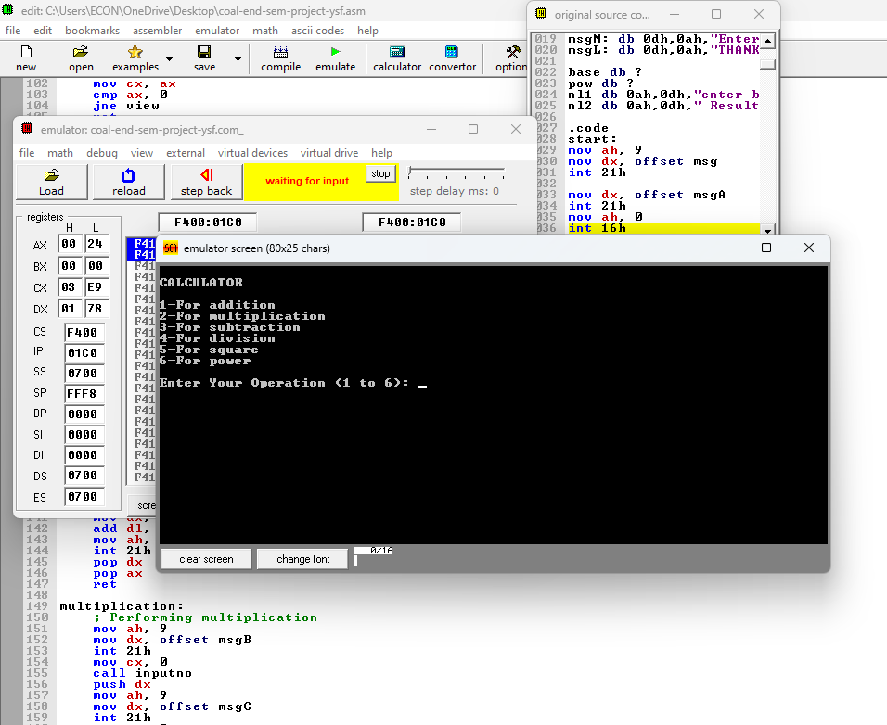
Figure 2: Addition:
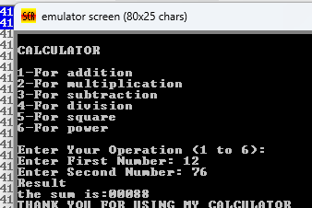
Figure 3: Multiplication
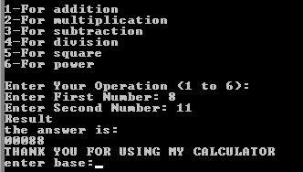
Figure 4: Subtraction
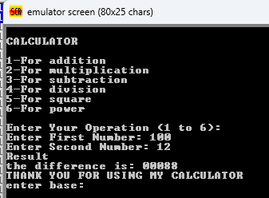
Figure 5: Division
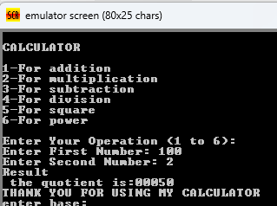
Figure 6: Square
