SPECSMART



Project ID- 01

Project Advisor: Name of Project Adviser

Submitted By

Name of Student ID of Student
Name of Student ID of Student

University of Education

SpecSmart

BS in Information Technology-20XX
MSc in Information Technology-20XX

A project submitted in partial fulfillment of the requirements
for the award of the degree of
BS in information Technology

NAME OF DIVISION/CAMPUS UNIVERSITY OF EDUCATION LAHORE

August 2026
© Copyright SpecSmart, 2018

“I hereby declare that I have read this project documentation and in my opinion this project is sufficient in terms of scope and quality for the award of the degree of BS in Information Technology/MSc in Information Technology.”
Name: Write name of Project advisor here

DECLARATION

I declare that this project title entitled “SpecSmart” is the result of my own research and development except as cited in the references. This project has not been accepted for any degree and is not concurrently submitted in candidate for any other degree. At any time if my statement is found to be incorrect even afterwards of BS in Information Technology/MSc in Information Technology, the university has the right to withdraw my BS in Information Technology/MSc in Information Technology degree.

Designation: Write designation of Project Advisor here
University of Education. _____________________
Project Examiner
Name: Write name of Project Examiner here
Designation: Write designation of Project Examiner here University of Education.

Signature: _______________________
NAME IN CAPITAL LETTERS
Name: _________________________

_______________________
Project Primary Supervisor

NAME IN CAPITAL LETTERS
Name: _________________________

Month date, year
Date: ___________________________

Signature: _______________________
NAME IN CAPITAL LETTERS
Name: _________________________

Month date, year
Date: ___________________________

Month date, year
Date: ___________________________

Signature: _______________________

NAME IN CAPITAL LETTERS
Name: _________________________

Month date, year
Date: ___________________________

Signature: _______________________
NAME IN CAPITAL LETTERS

PLAGIARISM UNDERTAKEN

I solemnly declare that project work presented in this documentation entitles “SpecSmart” is solely my work with no significant contribution from any other person. Small contribution/help wherever taken has been acknowledged and that complete project has been written by me.

I understand that zero tolerance policy of the HEC and University of Education, Lahore towards plagiarism. Therefore, we as an author of the above titled project declare that no portion of my project documentation and any material used as reference is properly referred/ cited.

I undertake that of I am found guilty of any formal plagiarism in the above titled project even after award of BS/MSc degree, the University reserve the rights to withdraw/revoke my BS/MSc degree and that HEC and the University has the right to publish my name on the HEC/University Website on which names of students are place who submitted plagiarized projects.
Month date, year
Date: ___________________________

Signature: _______________________
NAME IN CAPITAL LETTERS
Name: _________________________

Signature: _______________________
NAME IN CAPITAL LETTERS
Name: _________________________
Month date, year
Date: ___________________________
Signature: _______________________
NAME IN CAPITAL LETTERS
Name: _________________________

Month date, year
Date: ___________________________ Signature: _______________________
NAME IN CAPITAL LETTERS
Name: _________________________

Month date, year
Date: ___________________________

Signature: _______________________
NAME IN CAPITAL LETTERS
Name: _________________________

Month date, year
Date: ___________________________

Signature: _______________________
NAME IN CAPITAL LETTERS
Name: _________________________

Month date, year
Date: ___________________________

CERTIFICATE OF APPROVAL

This is to certify that the project work presented in this documentation entitled, “SpecSmart”, was conducted by “name of member 1”, “name of member 2”, “name of member 3”, “name of member 4”, under the supervision of “write your supervisor name”. No part of this project has been submitted anywhere else for any degree. This project is submitted to the “name of your campus, University of Education” is partial fulfillment of the requirements of the degree of BS in Information
Technology/MSc in Information Technology.
Signature: _______________________
NAME IN CAPITAL LETTERS
Name: _________________________

Month date, year
Date: ___________________________

Signature: _______________________
NAME IN CAPITAL LETTERS
Name: _________________________

Month date, year
Date: ___________________________

_______________________
Project Primary Supervisor
Name: Write name of Project advisor here
Designation: Write designation of Project Advisor here
University of Education. _____________________

Project Examiner
Name: Write name of Project Examiner here
Designation: Write designation of Project Examiner here University of Education.

OFFICE OF CONTROLLER OF EXAMINATION NOTIFICATION

No: ___________ Date: _____________

It is notified for the nomination of all the concerned that Mr./Ms. (name of the student-1), (name of the student-2), (name of the student-1), (name of the student-1) BS/MSc student of Name of the department of University of Education has completed all the requirements for the award of BS/MSc Degree in the discipline of Information Technology as per detail given hereunder:

BS in Information Technology/ Cumulative Result
MSC in Information Technology |  | Credit Hours:___________ |  |  | Cumulative  Grade Point  Average  (CGPA)
Registration No | Complete Name | Course work | Project | Total | Cumulative  Grade Point  Average  (CGPA)

Project Title: _______________________

Name of Supervisor: _________________

Signed by
Controller of Examination

CC:
1.abcd
2. xyz3

ACKNOWLEDGEMENT
We would like to start by thanking our supervisor, whose guidance shaped this project from a vague idea into something we could actually build and talk about with confidence. His feedback during the design phase saved us from several wrong turns, and his patience with our progress reports meant a lot to all of us.
We are equally grateful to the faculty members and our classmates, who asked the kind of questions that forced us to think more clearly about what SpecSmart is supposed to do. The open-source community deserves a special mention as well. Next.js, React, Express, MongoDB, Redux Toolkit, Tailwind CSS, the Web Speech API and the Whisper model ecosystem all carried parts of this project, and we could not have finished it without the work of the people who maintain them.

- Mr. Furqan
- Mr. Akram

Date:
March 11, 2016

ABSTRACT
SpecSmart is a full-stack e-commerce web application built to help people shop for technical products more carefully. The problem it tackles is familiar to anyone who has shopped for a phone or a laptop online: stores list thousands of devices, but they rarely help you decide which one actually fits your needs and budget. SpecSmart tries to close that gap by combining a normal shopping flow with a few decision-support features — structured product specifications, a category-aware scoring system, natural-language search, voice input, side-by-side comparison, and an AI chat assistant that only talks about products that actually exist in the catalogue.
On the technical side, the frontend is built with Next.js and React, state is managed with Redux Toolkit, and the backend is an Express API backed by MongoDB. Registered users get JWT authentication with refresh tokens, a persistent wishlist, a cart that survives login, and a simulated checkout that records real orders. An administrator panel lets staff add new products through category-aware forms, and a lightweight natural-language layer understands queries like "best smartphone under 800 dollars with a good camera". When the browser supports it, users can search by voice; otherwise the app falls back to a Whisper transcription endpoint. The advisor chat uses retrieval-augmented generation: product documents are embedded with Gemini and stored in a Qdrant vector index, and the most relevant products are retrieved for each query before the language model generates its reply. The result is a working prototype: the features described in this report are running code rather than mock-ups, while the enhancements listed in Chapter 7 remain proposed future work.

DELIVERABLE SUBMISSION GUIDELINE

Name of  Deliverable | Contents | Remarks
Deliverable-I | Project Proposal  Chapter-1: Gathering &  Analyzing Information  Chapter-2: Software  Requirement Specification  (Sample Attached) | Deliverable-I, should be submit after the commencement of 7th  Semester.
Deliverable-II | Chapter-3: Analysis  Chapter-4: Design  Chapter-5: Graphical User  Interfaces  Chapter-6: Testing  Chapter-7: Conclusion and  Future work  Complete Running Application | Deliverable-II, should be submit after the commencement of 8th  Semester.

TABLE OF CONTENTS
CHAPTER 1: Gathering & Analyzing Information
1.1 Introduction
1.2 Problem Statement
1.3 Goal & Objectives
1.4 Research Questions
1.5 Scope of the Project
1.6 Methodology
1.7 Literature Review
1.8 Definitions, Acronyms and Abbreviations
CHAPTER 2: Software Requirement Specification
2.1 Stakeholders
2.2 Domain Requirements
2.3 Functional Requirements
2.4 Non-Functional Requirements
CHAPTER 3: Analysis
3.1 Use Case Description
3.2 Use Case Model
3.3 System Workflows
CHAPTER 4: Design
4.1 System Architecture
4.2 Architectural Layers
4.3 Database Design
4.4 Data Flow Diagrams
4.5 Class Design
4.6 Sequence Design
CHAPTER 5: Graphical User Interfaces
5.1 Home Page
5.2 Product Listing Page
5.3 Product Detail Page
5.4 Advanced Search Page
5.5 Product Comparison Page
5.6 AI Advisor Chat Widget
5.7 Shopping Cart
5.8 Checkout Page
5.9 User Dashboard
5.10 Admin Panel
5.11 Sign-in Page
5.12 Sign-up Page
CHAPTER 6: Testing
6.1 Test Plan
6.2 Test Case Specifications
6.3 Test Results
CHAPTER 7: Conclusion and Future Work
7.1 Results and Evaluation
7.2 Conclusion
7.3 Future Enhancements
References
Appendices
LIST OF TABLES
Table 2.1: Functional Requirements
Table 2.2: Non-Functional Requirements
Table 3.1: Use Case Summary
Table 4.1: Architectural Layers
Table 4.2: MongoDB Collections
Table 6.1: Requirement-to-Test Traceability
Table 7.1: Feature Implementation Summary
LIST OF FIGURES
Figure 3.1: Use Case Diagram
Figure 3.2: Purchase and Search Workflow
Figure 4.1: System Architecture
Figure 4.2: Entity Relationship Diagram
Figure 4.3: Data Flow Diagram - Level 0
Figure 4.4: Data Flow Diagram - Level 1
Figure 4.5: Class Diagram
Figure 4.6: Sequence Diagram - Authentication Flow
Figure 5.1: Home Page
Figure 5.2: Product Listing Page
Figure 5.3: Product Detail Page
Figure 5.4: Advanced Search Page
Figure 5.5: Product Comparison Page
Figure 5.6: AI Advisor Chat Widget
Figure 5.7: Shopping Cart
Figure 5.8: Checkout Page
Figure 5.9: User Dashboard
Figure 5.10: Admin Panel
Figure 5.11: Sign-in Page
Figure 5.12: Sign-up Page

CHAPTER 1
Gathering & Analyzing Information

1.1 Introduction
SpecSmart is an e-commerce web application for technical products — smartphones, laptops, monitors, tablets, processors, routers, headphones and similar electronics. Most of us have been through the same frustration: an online store shows you a wall of products, and you end up comparing specifications across half a dozen tabs on your own. This project started from that small frustration. What if the store itself could help you decide, instead of just showing you a list?
That question shaped everything we built. SpecSmart is not a product listing page with a checkout bolted on. It is a full-stack prototype that combines the usual shopping features — browsing, cart, wishlist, checkout, order history — with a set of decision-support tools: structured product specifications, a scoring system that ranks products within their own category, search that understands plain English, voice input, a comparison page, and an AI assistant that answers questions using only the real product database.
The application is implemented as a Next.js frontend talking to an Express REST API backed by MongoDB, with a Qdrant vector store for semantic product retrieval used by the AI advisor. Authentication uses short-lived JWT access tokens with refresh tokens stored in an HTTP-only cookie. The seeded database contains twenty-eight products across fourteen categories, which is enough to exercise every feature meaningfully while keeping the project manageable for a final year effort.

1.2 Problem Statement
Traditional e-commerce platforms are very good at listing products and very bad at helping people choose between them. A few specific problems stand out, and they are the ones this project set out to address:
Products in the same category rarely share the same specifications, so comparing them side by side is tedious and error-prone.
Search engines rely on exact keyword matches and do not understand intent. A query like "best phone under 800 with a good camera" is meaningless to a plain keyword search.
There is usually no transparent mechanism that ranks products by value; the order in which products appear is often a business decision, not a quality signal.
Voice and conversational shopping support, which is becoming normal in consumer apps, is almost absent from academic e-commerce prototypes.
Specifications are buried in marketing copy, so a shopper cannot tell what matters for their own use case without doing research outside the store.
Put simply, the gap we wanted to fill is this: no platform in our scope offered organized comparison, AI-driven discovery, and a practical shopping flow in a single, coherent system. SpecSmart is our attempt to build exactly that.

1.3 Goal & Objectives
The overall goal is a working intelligent e-commerce platform for technical products. The objectives we committed to at the start were:
Design and develop a full-stack web application for technology products.
Provide a structured product catalogue with categories and detailed specifications.
Support keyword, natural-language and voice-based search.
Implement a transparent scoring system that ranks products using rating, popularity, stock, price and category-specific specifications.
Offer side-by-side product comparison across score, price, brand and specifications.
Deliver working commerce functionality: authentication, wishlist, cart, checkout and order history.
Provide an administrator interface for adding products to the catalogue.
Build a conversational AI advisor whose answers are grounded in the live catalogue rather than in model imagination.

1.4 Research Questions
Four questions guided the work. First, how can structured product data and category-aware scoring give shoppers a clearer sense of value than a plain listing? Second, how far can rule-based natural-language parsing go toward understanding shopping intent without a language model? Third, what does it take to make voice search practical in a web application given uneven browser support? And fourth, how can a large language model be used for product advice without letting it invent products or prices?

1.5 Scope of the Project
The scope of the current implementation is deliberately concrete. Inside the scope we have a multi-page Next.js application, an Express REST API, MongoDB persistence, JWT authentication with refresh tokens, category browsing, intent-aware search, voice search with a Whisper fallback, server-side product scoring, a comparison page, a Gemini-backed advisor chat, cart, wishlist, checkout, order storage, an admin product form, and a user dashboard with orders and wishlists.
A few things were consciously left out, and we want to state them plainly rather than pretend otherwise. There is no real payment gateway; checkout records an order but does not charge a card. There is no shipment tracking or logistics integration. The advisor keeps only short-term conversation history; it does not build a long-term user profile. Retrieval-augmented generation (RAG) over a Qdrant vector index is used to ground the advisor in the live catalogue. There are no production concerns such as caching layers, search indexing, or automated deployment pipelines. Each of these is documented in Chapter 7 as future work.

1.6 Methodology
We followed an iterative, modular approach rather than trying to build the whole system at once. The work moved through six rough phases: catalogue and data modelling, backend API development, frontend page and component construction, authentication and commerce workflows, search and scoring intelligence, and finally the administrative and dashboard features and the retrieval-augmented generation pipeline for the AI advisor.
This order mattered. Because the frontend talks to a live API, each phase could be demonstrated and reviewed on its own, and a problem in one layer rarely forced a rewrite of another. Keeping product data in MongoDB and serving it through real API calls — instead of hard-coding it in the frontend — meant the catalogue could grow (for example through the admin panel) without touching the user interface code.

1.7 Literature Review
Three lines of research informed the design. The first is conversational recommender systems. Jannach et al. describe conversational recommendation as a way of making preference elicitation more effective: the user asks, narrows down, and gets feedback as the search progresses, rather than filling in a static form. Gao et al. take the same idea further and point out that conversational recommendation sits at the intersection of information retrieval, natural language processing and human-computer interaction. Both papers describe exactly the kind of interaction we wanted for the advisor chat and the search page.
The second line is the recent overlap between large language models and e-commerce dialogue. Wu et al. argue that traditional conversational recommender systems and LLMs are complementary: the recommender brings accurate domain grounding, while the language model brings natural interaction and explanation. That division of labour is the core design decision in our advisor. Rather than letting the model generate free-form answers from nothing, we embed both product documents and user queries with Gemini, store them in a Qdrant vector index, retrieve the most relevant products for each question through semantic search, and then let Gemini respond using only that grounded context. We finally verify which products it referenced so the UI can link to them.
The third line is voice interfaces and full-stack architecture. The Web Speech API provides free browser-based speech recognition, while models such as Whisper cover the browsers where native recognition is missing or weak. On the architecture side, frameworks like Next.js make hybrid rendering and route-based composition straightforward, and document databases such as MongoDB fit the wildly variable specification schemas of consumer electronics — a smartphone has camera and battery fields, a processor has cores and clocks, and forcing them into one rigid relational table would be painful. These technologies aligned well with our needs, so we adopted them rather than reinventing anything.

1.8 Definitions, Acronyms and Abbreviations
Term | Meaning
API | Application Programming Interface
JWT | JSON Web Token, used for access and refresh tokens
NLP | Natural Language Processing
SSE | Server-Sent Events, used to stream AI advisor replies
SPA | Single Page Application
FR / NFR | Functional Requirement / Non-Functional Requirement
ERD | Entity Relationship Diagram
DFD | Data Flow Diagram
CRUD | Create, Read, Update, Delete
REST | Representational State Transfer
Gemini | Google's LLM used for the advisor chat
Whisper | Speech-to-text model served through Hugging Face
RAG | Retrieval-Augmented Generation; grounding LLM responses in retrieved documents

CHAPTER 2
Software Requirement Specification

This chapter records what SpecSmart must do. The requirements were derived from the objectives in Chapter 1 and were refined as the implementation took shape, so every requirement listed here corresponds to code that exists in the repository at the time of writing. Features that are only proposed are set apart in Chapter 7 as future work.

2.1 Stakeholders
• Shoppers - browse the catalogue, search, compare, and buy.
• Registered users - keep a wishlist, a persistent cart and order history.
• Administrators - add products and review order summaries.
• The project supervisor - reviews the prototype during evaluation.

2.2 Domain Requirements
The application domain is consumer electronics. The seeded catalogue holds twenty-eight products across fourteen categories: charger, console, earbuds, headphone, laptop, lcd, monitor, power bank, processor, router, smartphone, smartwatch, storage and tablet. Every product carries a common set of fields - id, name, brand, category, price, image, rating, review count, stock status, description and feature list - plus a nested specifications object whose shape varies by category. This mix of uniform and variable data is the single most important constraint on the design, and it is why the system uses a document database.

2.3 Functional Requirements
The functional requirements are summarised in Table 2.1. Each entry is traceable to a route or module in the codebase.
Table 2.1: Functional Requirements
ID | Functional Requirement | Description
FR-01 | User Registration | POST /api/auth/signup creates an account with name, email and a bcrypt-hashed password.
FR-02 | User Login | POST /api/auth/signin verifies credentials and issues a JWT access token plus a refresh-token cookie.
FR-03 | User Logout | POST /api/auth/signout clears the refresh-token cookie.
FR-04 | Product Browsing | Featured, popular, category and full product listings are served by the products API.
FR-05 | Product Detail View | GET /api/products/:id returns images, specifications, score, description and features.
FR-06 | Product Search | GET /api/products/search parses natural-language queries and ranks results by relevance.
FR-07 | Voice Search | Browser speech recognition with a Whisper-based fallback route for voice input.
FR-08 | Product Filtering | Category, brand, price range, rating, stock and sorting filters on GET /api/products.
FR-09 | Product Scoring | A category-aware score between 35 and 100 is computed on the server for every product.
FR-10 | Wishlist Management | Authenticated users can toggle products in their wishlist.
FR-11 | Cart Management | Add, update, remove and clear cart items, for guests locally and for users on the server.
FR-12 | Checkout Workflow | Capture shipping details and payment preference, then create an order record.
FR-13 | Order History | Authenticated users can list their previous orders.
FR-14 | Admin Product Creation | Administrators can create products through a structured, category-aware form.
FR-15 | Admin Order Summary | Administrators can view ordered products and summary statistics.
FR-16 | Protected Routes | Selected routes and endpoints require a valid access token; admin endpoints check the role.
FR-17 | Product Comparison | Up to four products can be compared side by side by score, price, brand and specifications.
FR-18 | AI Advisor Chat | POST /api/chatbot/chat embeds the query, retrieves relevant products from the Qdrant vector index, and streams Gemini replies grounded in those products.
FR-19 | Admin User Management | Administrators can list and search user accounts, promote or demote roles, enable or disable accounts and delete users, with guards that protect the last active administrator.

2.4 Non-Functional Requirements
Table 2.2: Non-Functional Requirements
ID | Non-Functional Requirement | Description
NFR-01 | Usability | Clean, responsive interface built with reusable components; keyboard and screen-reader friendly primitives.
NFR-02 | Performance | Responsive for a moderate catalogue; product scores are computed in memory on request.
NFR-03 | Maintainability | Modular components, separated routes and a layered API keep the codebase easy to change.
NFR-04 | Scalability | Document storage and an API-driven architecture support catalogue growth without schema migration.
NFR-05 | Security | Bcrypt password hashing, 15-minute access tokens, 7-day refresh cookie and role checks for admin operations.
NFR-06 | Compatibility | Runs in modern browsers; voice search falls back gracefully where the Web Speech API is absent.
NFR-07 | Reliability | Consistent JSON envelopes, clear error handling, a health endpoint and rate limiting on the AI advisor.
NFR-08 | Extensibility | Modular search pipeline and LLM integration make it possible to swap or extend components.

CHAPTER 3
Analysis

3.1 Use Case Description
The system's behaviour is captured in the use cases below. The actors are the guest, the registered user, and the administrator. Each use case maps onto at least one implemented route, so the numbering doubles as a traceability matrix between requirements and code.
Table 3.1: Use Case Summary
Use Case | Actors | Description | Primary Endpoint
UC-01 Register Account | Guest | Create an account with name, email and password. | POST /api/auth/signup
UC-02 Login | Guest | Authenticate and receive an access token and refresh cookie. | POST /api/auth/signin
UC-03 Browse Products | All | View featured, popular, category and full listings. | GET /api/products/*
UC-04 View Product Detail | All | See images, specifications, score and related info for one product. | GET /api/products/:id
UC-05 Search Products | All | Search using keywords or natural-language phrases. | GET /api/products/search
UC-06 Voice Search | All | Speak a query; browser recognition or Whisper transcribes it. | POST /api/speech-to-text
UC-07 Compare Products | All | Select up to four products and compare them side by side. | Compare page
UC-08 Manage Cart | All | Add, update or remove items; cart persists across sessions. | POST/DELETE /api/users/me/cart
UC-09 Manage Wishlist | User | Toggle products in a personal wishlist. | POST /api/users/me/wishlist/toggle
UC-10 Checkout | User | Enter shipping and payment preference and place an order. | POST /api/users/me/orders
UC-11 View Orders | User | List order history in the dashboard. | GET /api/users/me/orders
UC-12 Chat with AI Advisor | All | Ask product questions and receive grounded, streamed answers. | POST /api/chatbot/chat
UC-13 Create Product | Admin | Add a new product through a category-aware form. | POST /api/products
UC-14 View Admin Summary | Admin | Review ordered products and sales statistics. | GET /api/users/admin/*
Each use case is described in detail below, including preconditions, the main success scenario, and the alternative paths that the implementation actually follows.
Table 3.2: Use Case UC-01 - Register User Account

UC-01: Register User Account
Field | Description
UC Number | UC-01
UC Name | Register User Account
Functional Requirement Number | FR-01
Primary Actors / Stakeholders | Visitor
Secondary Actors / Stakeholders | Authentication API, users collection
Description | A new visitor creates a SpecSmart account with name, email and password.
Preconditions | Visitor is on /auth/signup.  Email is not already present in users collection.
Main Success Scenario (MSS) | 1. Visitor enters name, valid email, password and matching confirmation.  2. Visitor accepts terms.  3. Frontend validates required fields and password length.  4. Frontend dispatches signUp and calls POST /api/auth/signup.  5. Backend hashes password, creates user, sets refresh token cookie and returns access token.  6. Frontend stores token and navigates to /dashboard.
Alternative Scenario | If the email already exists, the backend returns User already exists and the UI shows account creation failure.
Post Conditions | A user document exists with default preferences, empty cart, empty wishlist and empty orders.
Extensions | Invalid email, short password, mismatch confirmation, missing name or unchecked terms stop submission on the client.
Table 3.3: Use Case UC-02 - Sign In and Restore Session

UC-02: Sign In and Restore Session
Field | Description
UC Number | UC-02
UC Name | Sign In and Restore Session
Functional Requirement Number | FR-02, FR-16
Primary Actors / Stakeholders | Registered User
Secondary Actors / Stakeholders | Authentication API, Redux authSlice
Description | A registered user signs in and later restores the session through token refresh.
Preconditions | User exists with bcrypt password hash.  Backend and MongoDB are running.
Main Success Scenario (MSS) | 1. User opens /auth/signin.  2. User enters valid email and password.  3. Frontend validates email and minimum password length.  4. POST /api/auth/signin verifies the credentials.  5. Backend returns user data and an access token and sets refreshToken cookie.  6. Redux stores user and token; user is redirected to /dashboard.
Alternative Scenario | Invalid credentials return Invalid email or password. Expired access tokens trigger /auth/refresh during initAuth if the refresh cookie is valid.
Post Conditions | Authenticated pages can read current user data through /api/auth/fetchUser.
Extensions | If refresh fails, local token is removed and the user becomes unauthenticated.
Table 3.4: Use Case UC-03 - Sign Out

UC-03: Sign Out
Field | Description
UC Number | UC-03
UC Name | Sign Out
Functional Requirement Number | FR-03
Primary Actors / Stakeholders | Authenticated User
Secondary Actors / Stakeholders | Authentication API, browser localStorage
Description | The user ends the authenticated session.
Preconditions | User is signed in.  Token is stored in localStorage.
Main Success Scenario (MSS) | 1. User selects sign out from the authenticated header.  2. Frontend calls POST /api/auth/signout.  3. Backend clears the refreshToken cookie scoped to /api/auth/refresh.  4. Frontend removes the access token from localStorage.  5. Redux clears the current user.
Alternative Scenario | If signout API fails, the frontend still removes local token and clears the user state.
Post Conditions | User is unauthenticated in the browser.
Extensions | Protected routes redirect or show restricted content after session removal.
Table 3.5: Use Case UC-04 - Browse Catalogue and Product Detail

UC-04: Browse Catalogue and Product Detail
Field | Description
UC Number | UC-04
UC Name | Browse Catalogue and Product Detail
Functional Requirement Number | FR-04, FR-05, FR-09
Primary Actors / Stakeholders | Customer
Secondary Actors / Stakeholders | Product API, MongoDB products collection
Description | A customer browses featured, popular, category and detail product pages.
Preconditions | Product collection contains seeded catalogue items.
Main Success Scenario (MSS) | 1. Customer opens home or products page.  2. Frontend calls featured, popular or filtered product endpoints.  3. Backend loads products, decorates them with SpecSmart score and returns JSON.  4. Customer selects a category or product card.  5. Frontend loads category products or product detail by id.  6. Detail page displays images, description, specifications, score and actions.
Alternative Scenario | If a product id is not found, backend returns 404 Product not found and the frontend receives null from Database.getProductById.
Post Conditions | Customer can inspect real catalogue products and continue to cart, wishlist, compare or share.
Extensions | Product score is computed from rating, review count, stock, features and category-specific specification weights.
Table 3.6: Use Case UC-05 - Search and Filter Products

UC-05: Search and Filter Products
Field | Description
UC Number | UC-05
UC Name | Search and Filter Products
Functional Requirement Number | FR-06, FR-08
Primary Actors / Stakeholders | Customer
Secondary Actors / Stakeholders | Search utilities, ProductSearchService
Description | A customer searches with keywords or natural-language-like phrases and refines results.
Preconditions | Products are available in MongoDB.  Customer is on /search.
Main Success Scenario (MSS) | 1. Customer types a query such as best smartphone under 800.  2. Autocomplete requests suggestions when query length is at least two characters.  3. Customer submits search with optional category, brand, price, rating and sorting filters.  4. Frontend builds query parameters and navigates to /search.  5. Backend parses intent, applies filters and sorts results.  6. Search results display matching products.
Alternative Scenario | If query is empty, /api/products/search returns Search query is required. The Database wrapper returns an empty list for blank queries.
Post Conditions | Search results reflect query intent and selected UI filters.
Extensions | No-suggestion searches display No suggestions found after the debounced request finishes.
Table 3.7: Use Case UC-06 - Use Voice Search

UC-06: Use Voice Search
Field | Description
UC Number | UC-06
UC Name | Use Voice Search
Functional Requirement Number | FR-07
Primary Actors / Stakeholders | Customer
Secondary Actors / Stakeholders | Web Speech API, Next speech-to-text route
Description | A customer submits a search query by speaking.
Preconditions | Browser supports Web Speech API or microphone recording is available for fallback.
Main Success Scenario (MSS) | 1. Customer presses the microphone button.  2. If Web Speech is supported, the browser captures speech and updates the search query.  3. If unsupported, the fallback recorder posts audio to /api/speech-to-text.  4. The transcribed query is placed in the search input.  5. Customer submits the search.
Alternative Scenario | If speech is unavailable or fails, the UI can still accept typed search text.
Post Conditions | The resulting query uses the same search flow as text search.
Extensions | Fallback displays processing state while audio is being handled.
Table 3.8: Use Case UC-07 - Manage Wishlist

UC-07: Manage Wishlist
Field | Description
UC Number | UC-07
UC Name | Manage Wishlist
Functional Requirement Number | FR-10, FR-16
Primary Actors / Stakeholders | Authenticated User
Secondary Actors / Stakeholders | User API, products collection
Description | An authenticated user toggles products in the wishlist and reviews them later.
Preconditions | User is signed in.  A product detail page is open.
Main Success Scenario (MSS) | 1. User clicks Like on product detail.  2. Frontend checks authentication.  3. POST /api/users/me/wishlist/toggle adds or removes the product id.  4. Backend updates the user document wishlist array.  5. Dashboard wishlist tab hydrates product ids into product cards.
Alternative Scenario | If the user is not signed in, the product action redirects to /auth/signin instead of toggling.
Post Conditions | Wishlist contains the selected product ids and dashboard shows the hydrated products.
Extensions | Missing productId returns Product ID is required.
Table 3.9: Use Case UC-08 - Manage Cart

UC-08: Manage Cart
Field | Description
UC Number | UC-08
UC Name | Manage Cart
Functional Requirement Number | FR-11
Primary Actors / Stakeholders | Customer
Secondary Actors / Stakeholders | Redux cart slice, User API
Description | A customer adds, updates, removes and clears cart items.
Preconditions | Product exists and may be in stock.
Main Success Scenario (MSS) | 1. Customer clicks Add to Cart.  2. the cart slice adds a local item for guests or calls POST /users/me/cart for authenticated users.  3. Cart page hydrates product ids with product details.  4. Customer changes quantity or removes an item.  5. Redux updates localStorage and authenticated users sync through API.  6. Customer may clear cart.
Alternative Scenario | A quantity less than or equal to zero removes the item for authenticated users. Missing productId is rejected by backend.
Post Conditions | Cart totals, item count, shipping and tax update in the UI.
Extensions | Guest cart is stored under specsmart_cart in localStorage.
Table 3.10: Use Case UC-09 - Checkout and Place Order

UC-09: Checkout and Place Order
Field | Description
UC Number | UC-09
UC Name | Checkout and Place Order
Functional Requirement Number | FR-12
Primary Actors / Stakeholders | Customer
Secondary Actors / Stakeholders | CheckoutPageContent, User API
Description | A customer completes checkout and creates an order record when signed in.
Preconditions | Cart contains at least one valid product.  Authenticated order storage requires user sign-in.
Main Success Scenario (MSS) | 1. Customer opens /checkout.  2. Checkout loads cart products by id and calculates subtotal, shipping, tax and total.  3. Customer enters shipping information and chooses card, PayPal or Apple Pay.  4. Customer reviews order.  5. Place Order posts items, shippingAddress, paymentMethod and totals to /users/me/orders for signed-in users.  6. Backend creates an ORD-* order and clears the user's cart.  7. Frontend navigates to /checkout/success.
Alternative Scenario | If cart becomes empty, checkout redirects to /cart. Guest checkout clears local cart but does not create a persistent order.
Post Conditions | Order is stored inside the user document and cart is empty after authenticated checkout.
Extensions | The current UI does not block blank shipping or card fields before moving steps.
Table 3.11: Use Case UC-10 - View Dashboard and Orders

UC-10: View Dashboard and Orders
Field | Description
UC Number | UC-10
UC Name | View Dashboard and Orders
Functional Requirement Number | FR-13
Primary Actors / Stakeholders | Authenticated User
Secondary Actors / Stakeholders | User dashboard, User API
Description | A signed-in user views quick stats, orders, wishlist and account settings.
Preconditions | User is authenticated.
Main Success Scenario (MSS) | 1. User opens /dashboard.  2. Dashboard fetches /users/me/commerce.  3. Backend returns cart, wishlist, orders and hydrated product lists.  4. Quick stats summarize wishlist count, order count, total spent and total ordered items.  5. Tabs show overview, orders, wishlist and settings.
Alternative Scenario | If commerce fetch fails, Database.getCommerceData returns empty arrays and the dashboard remains usable.
Post Conditions | User can inspect saved orders and wishlist products.
Extensions | Admin users see summary values instead of normal customer counts.
Table 3.12: Use Case UC-11 - Create Product as Admin

UC-11: Create Product as Admin
Field | Description
UC Number | UC-11
UC Name | Create Product as Admin
Functional Requirement Number | FR-14, FR-16
Primary Actors / Stakeholders | Admin User
Secondary Actors / Stakeholders | AdminPanel, products route, Product model
Description | An administrator adds a catalogue product using structured form fields.
Preconditions | Admin is signed in with role admin, such as admin@specsmart.com.  MongoDB is connected.
Main Success Scenario (MSS) | 1. Admin opens /admin.  2. Admin enters name, category, brand, price, images, description, features, rating, review count, stock and category-specific specs.  3. Frontend builds a structured product payload.  4. POST /api/products passes JWT and admin role check.  5. Product.create inserts the document and returns a scored product.  6. Admin panel reloads recent products.
Alternative Scenario | Non-admin users see Admin Access Required in the UI and receive 403 Admin access required from protected admin APIs.
Post Conditions | New product is stored in products collection and appears in catalogue results.
Extensions | The current form uses required HTML controls for main fields and text parsing for comma-separated image/features fields.
Table 3.13: Use Case UC-12 - Review Admin Order Summary

UC-12: Review Admin Order Summary
Field | Description
UC Number | UC-12
UC Name | Review Admin Order Summary
Functional Requirement Number | FR-15, FR-16
Primary Actors / Stakeholders | Admin User
Secondary Actors / Stakeholders | User API, dashboard
Description | An administrator reviews ordered products and aggregate order statistics.
Preconditions | Admin user is authenticated.  At least one user may have orders.
Main Success Scenario (MSS) | 1. Admin opens dashboard.  2. Frontend calls /users/admin/ordered-products and /users/admin/orders-summary.  3. Backend checks role and aggregates order items from users collection.  4. Dashboard displays total orders, total items, total revenue and total customers.  5. Admin can inspect ordered product rows.
Alternative Scenario | If a normal user calls the endpoint, backend returns 403 and the dashboard falls back to empty summary values.
Post Conditions | Admin receives aggregate order visibility.
Extensions | Totals are computed from embedded user orders, not a separate orders collection.
Table 3.14: Use Case UC-13 - Compare Products

UC-13: Compare Products
Field | Description
UC Number | UC-13
UC Name | Compare Products
Functional Requirement Number | FR-17
Primary Actors / Stakeholders | Customer
Secondary Actors / Stakeholders | CompareContext, comparison table, Product API
Description | A customer compares up to four products side by side.
Preconditions | Catalogue products exist.
Main Success Scenario (MSS) | 1. Customer clicks Compare on product detail.  2. CompareContext stores id, name, image and category in localStorage.  3. Customer opens /compare with product ids in the query string.  4. Compare page hydrates ids using Database.getComparisonProducts.  5. ComparisonTable renders price, score, rating, brand, availability, dynamic specs and actions.  6. Customer removes products or adds compared product to cart.
Alternative Scenario | When four items are already selected, additional compare buttons are disabled with Comparison full (max 4). Empty compare page shows product suggestions.
Post Conditions | Customer sees side-by-side comparison and best value highlights.
Extensions | Comparison persistence uses specsmart_compare in localStorage.
Table 3.15: Use Case UC-14 - Ask AI Product Advisor

UC-14: Ask AI Product Advisor
Field | Description
UC Number | UC-14
UC Name | Ask AI Product Advisor
Functional Requirement Number | FR-18
Primary Actors / Stakeholders | Customer
Secondary Actors / Stakeholders | AI advisor widget, ChatbotService, Gemini
Description | A customer asks a catalogue-grounded product question and receives streamed recommendations.
Preconditions | Backend is running.  GEMINI_API_KEY is configured for live AI responses.
Main Success Scenario (MSS) | 1. Customer opens the SpecSmart AI advisor chat widget.  2. Customer sends a message under 1000 characters.  3. Frontend posts message and sessionId to /api/chatbot/chat.  4. Backend validates input, builds product context from MongoDB and streams Gemini chunks as SSE.  5. Backend sends done event with cited product cards extracted from [Product ID: ...] tags.  6. Frontend renders the answer and source cards.
Alternative Scenario | Empty message, missing sessionId or over-1000-character message returns 400. Missing API key produces a configured support error event.
Post Conditions | Customer receives concise product advice grounded in the catalogue.
Extensions | Chat history is kept in memory per sanitized session id and can be cleared through DELETE /api/chatbot/session.
Table 3.16: Use Case UC-15 - Admin User Management

UC-15: Admin User Management
Field | Description
UC Number | UC-15
UC Name | Admin User Management
Functional Requirement Number | FR-19
Primary Actors / Stakeholders | Administrator
Secondary Actors / Stakeholders | User API, MongoDB users collection
Description | An administrator manages user accounts from the admin panel: searching accounts, changing roles and enabling, disabling or deleting users.
Preconditions | Administrator is signed in with an admin-role account.
Main Success Scenario (MSS) | 1. Administrator opens the Users tab in the admin panel. / 2. Admin searches or filters accounts by name, email, role or status. / 3. Admin promotes an account to admin, disables or deletes a user account. / 4. PATCH/DELETE requests hit the admin user endpoints and requireAdmin re-checks the live role in the database. / 5. The list refreshes and shows the updated account state.
Alternative Scenario | 1a. Self-lockout attempt (changing own role/status or deleting own account) is rejected. / 1b. Demoting, disabling or deleting the last active administrator is rejected with an explanatory error. / 1c. Invalid role or status values are rejected with 400.
Post Conditions | Target account reflects the requested change; the last active administrator can never be demoted, disabled or deleted.
Extensions | Invalid role or status values return 400; self-lockout attempts and last-admin protection violations are rejected with explanatory errors.

3.2 Use Case Model
The use case model groups the three actors around the implemented authentication, catalogue, search, comparison, commerce, advisor and administration workflows. Figure 3.1 shows the complete diagram.
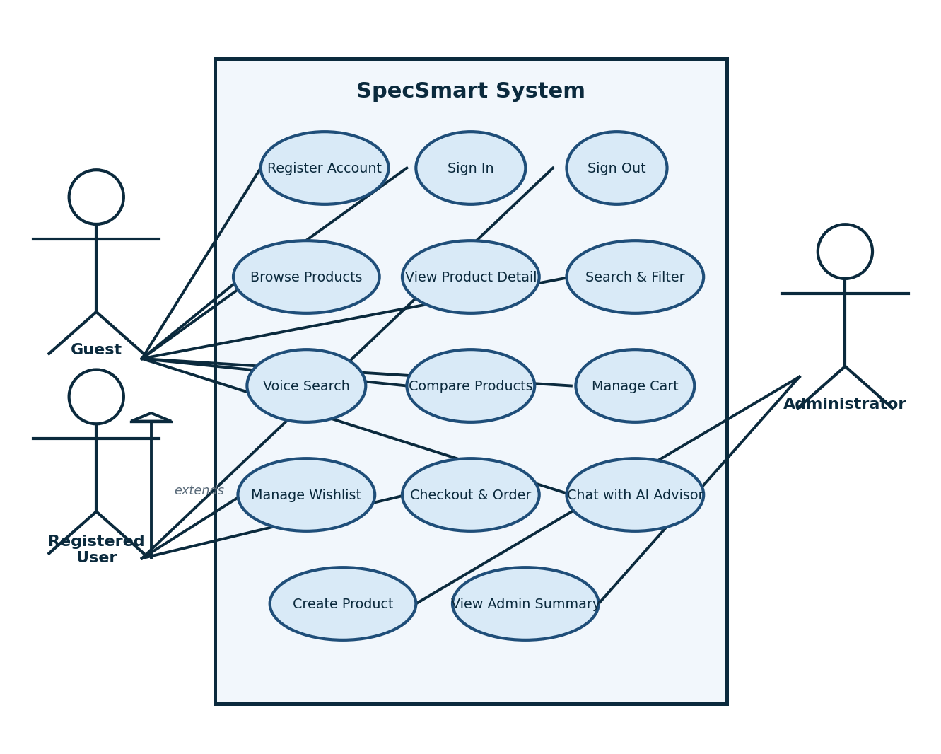Figure 3.1: Use Case Diagram

3.3 System Workflows
A few workflows deserve explicit description because they connect several modules. The product discovery workflow starts on the home page, which asks the API for featured and popular products; each card links to a detail page that loads the full product record. The search workflow takes a plain-text or voice query, parses it on the server, applies any UI filters, ranks the matches and presents them in a grid or list. The comparison workflow collects product ids in the compare bar and hydrates them from the API before building the specification rows. The purchase workflow moves from cart to checkout to a success page, creating an order and clearing the cart. The advisor workflow embeds the user message with Gemini, searches the Qdrant vector index for the most relevant products, falls back to keyword search if the vector store is unavailable, and streams the grounded reply back through server-sent events. Finally, the admin workflow lets an administrator sign in, open the product creation panel, and submit a new product which the API scores before storing it.
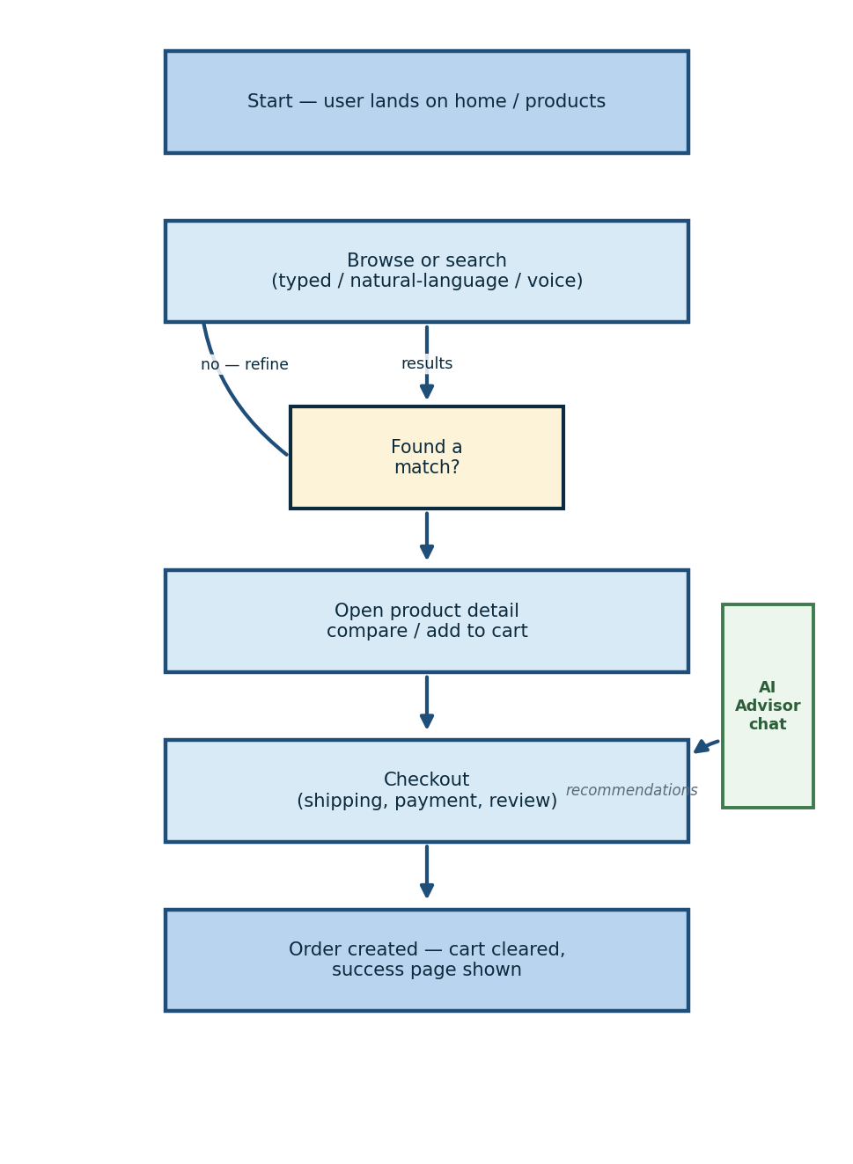
Figure 3.2: Purchase and Search Workflow

CHAPTER 4
Design

4.1 System Architecture
SpecSmart follows a layered client-server architecture. The browser runs a Next.js application that renders pages and components; all persistent data flows through an Express REST API; MongoDB stores the data; and three external services - the Gemini API for chat and embeddings, Qdrant for vector storage, and Hugging Face's Whisper inference - provide conversational AI with semantic retrieval and speech transcription. The frontend never touches the database directly, which keeps the data access rules in one place. Figure 4.1 shows the layers and their connections.
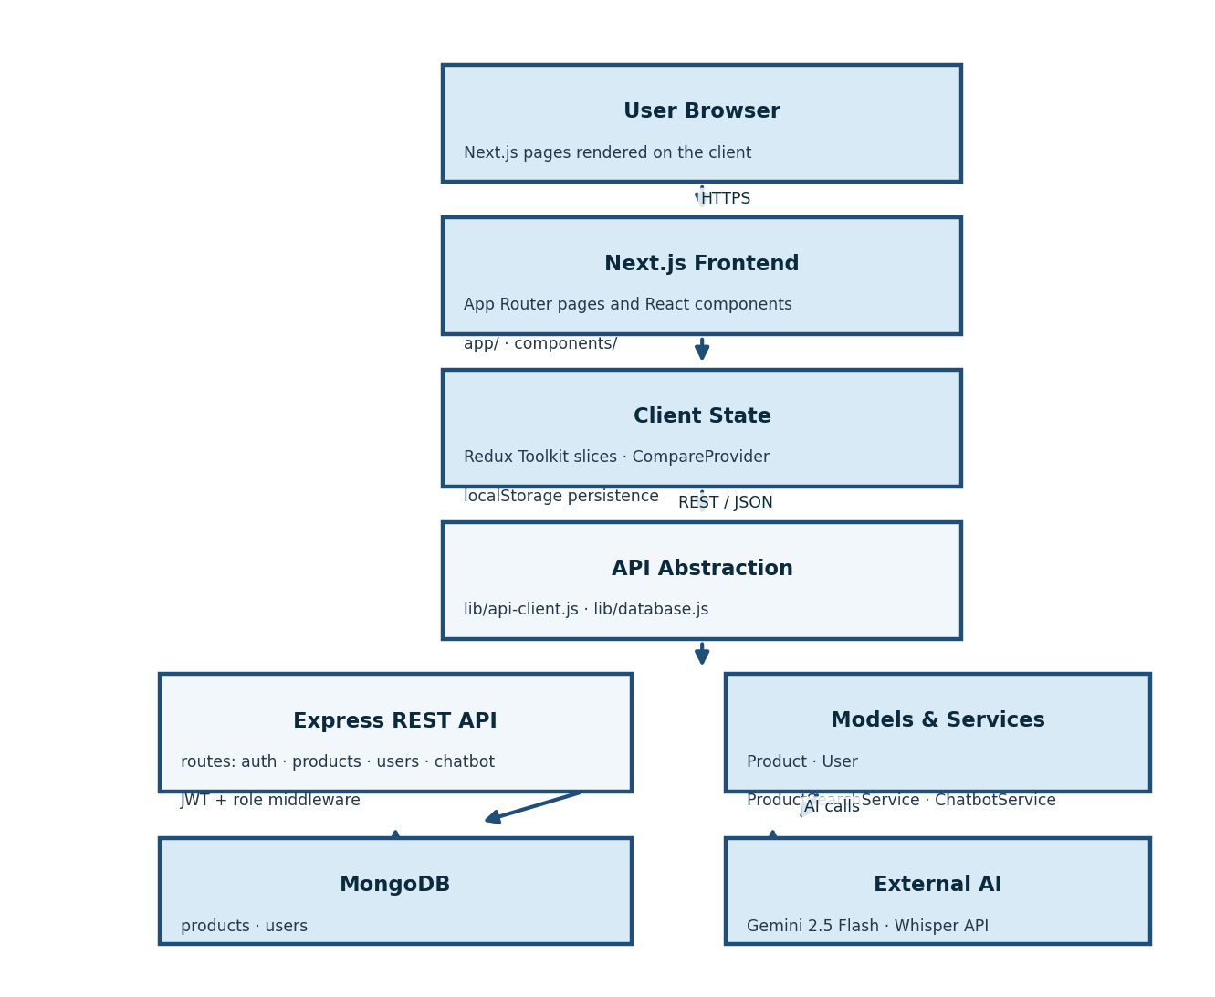
Figure 4.1: System Architecture Diagram

4.2 Architectural Layers
Table 4.1: Architectural Layers
Layer | Responsibility | Key Files
Presentation | Next.js pages and React components for the user interface. | app/, components/
Client State | Redux Toolkit slices for authentication and cart. | store/slices/, lib/
Service | API client and data abstractions used by components. | lib/api-client.js, lib/database.js
Application | Express routes handling product, user and auth requests. | backend/routes/
Domain Logic | Product scoring, search ranking and user commerce rules. | backend/models/, backend/services/
Storage | MongoDB collections for products and users. | backend/config/database.js
External AI | Gemini for chat and embeddings, Qdrant for vector storage, Whisper for speech. | backend/services/, backend/scripts/index-vectors.js, app/api/speech-to-text/
Testing | Node.js built-in test runner (node:test) | 28 automated backend regression checks

4.3 Database Design
The database is MongoDB with a database name of ecom and two collections. The products collection stores catalogue documents with a nested, category-dependent specifications object. The users collection stores authentication fields, preferences, cart items, wishlist references and embedded orders. This embedding choice keeps a user's commerce data co-located and makes the dashboard queries simple. In addition, a Qdrant vector collection stores Gemini embeddings of the product catalogue for semantic retrieval used by the AI advisor. Figure 4.2 shows the entities and their relationships.
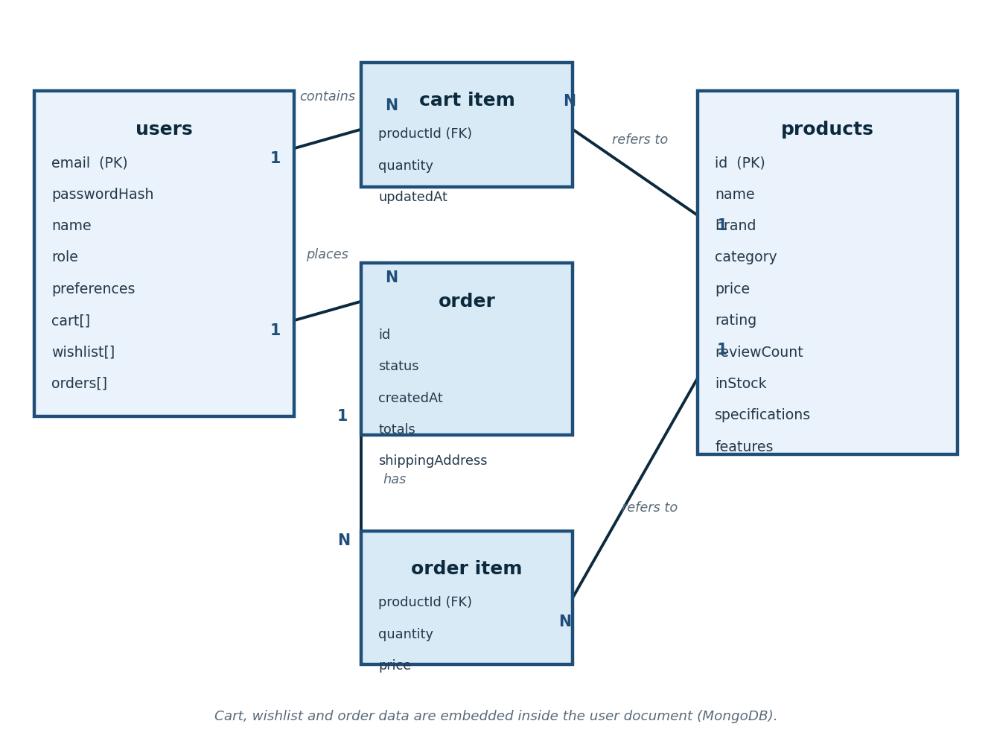Figure 4.2: Entity Relationship Diagram
Table 4.2: MongoDB Collections
Collection | Purpose | Key Fields
products | Catalogue of technical products | id, name, brand, category, price, rating, reviewCount, inStock, specifications, features
users | Accounts and commerce data | email, passwordHash, name, role, preferences, cart[], wishlist[], orders[]

4.4 Data Flow Diagrams
The level 0 diagram (context diagram) in Figure 4.3 presents SpecSmart as a single process that exchanges data with the customer or administrator, the Gemini service and the Whisper speech service, and reads and writes the two data stores.
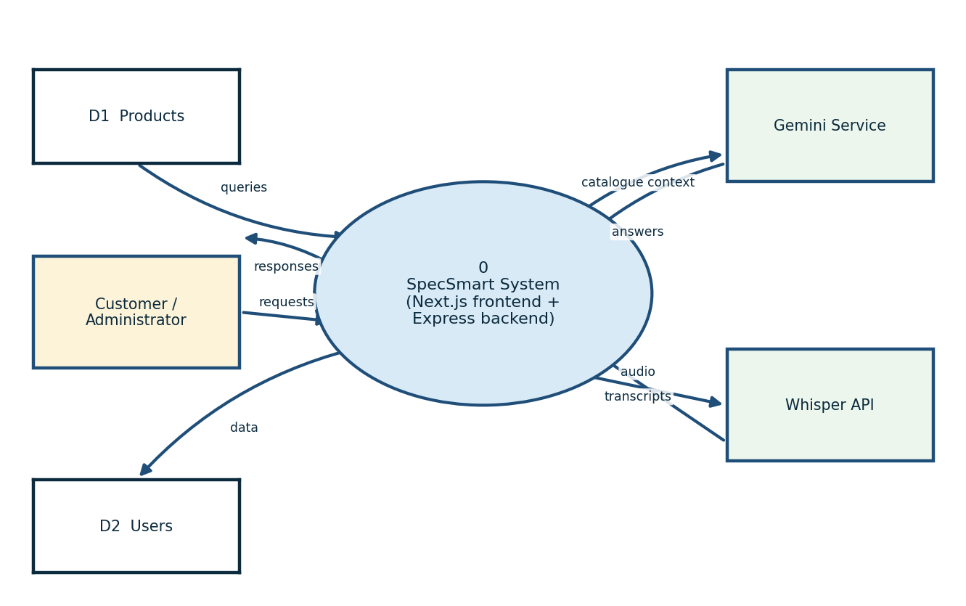
Figure 4.3: Data Flow Diagram - Level 0

The level 1 diagram in Figure 4.4 expands the system into the authentication, catalogue and search, commerce, administration and AI advisor processes used by the actual routes. The AI advisor process includes embedding queries, searching the Qdrant vector index and streaming Gemini replies.
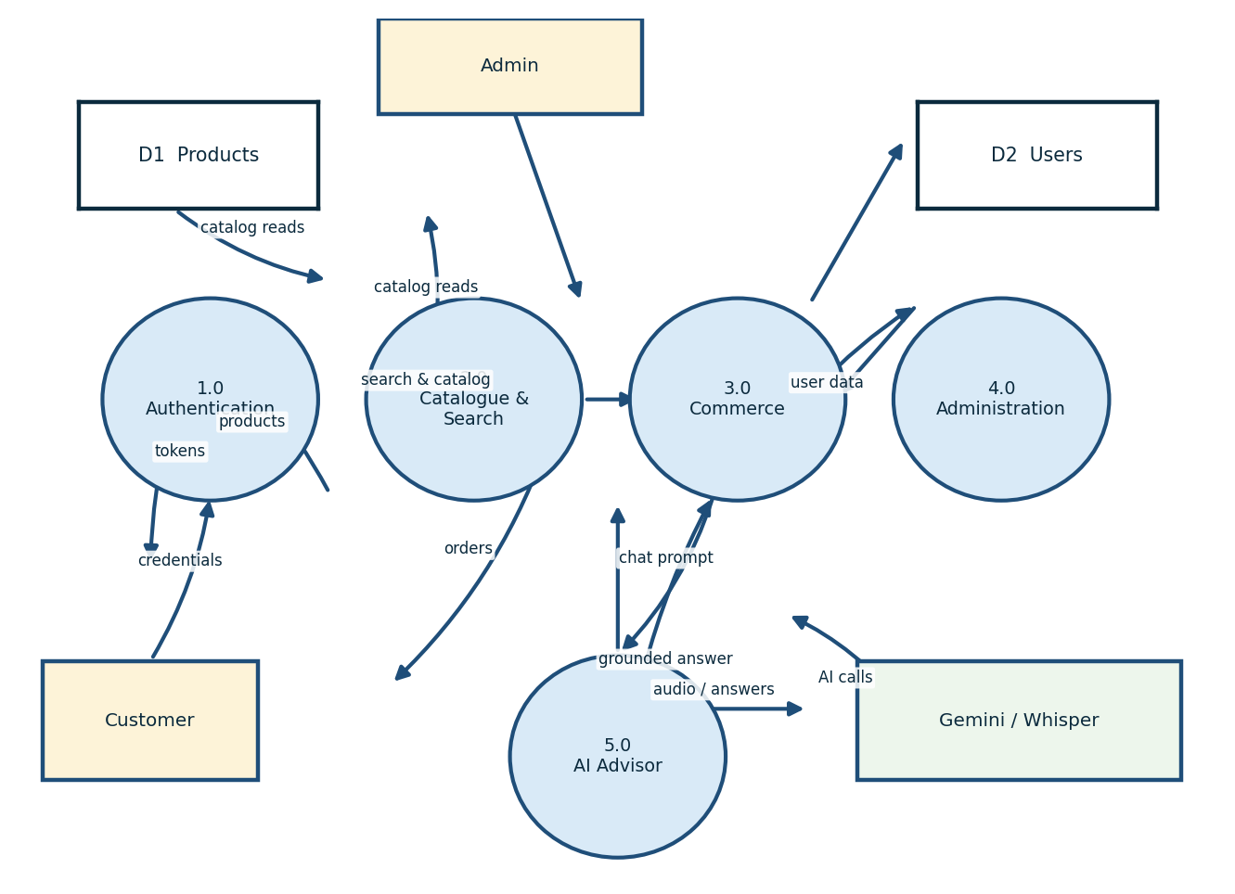
Figure 4.4: Data Flow Diagram - Level 1

4.5 Class Design
Figure 4.5 shows the principal implemented classes. The Product and User model classes carry most of the persistence-oriented business logic, the search pipeline is encapsulated in ProductSearchService, ChatbotService manages Gemini sessions and retrieval-augmented generation, EmbeddingService wraps Gemini text embeddings, VectorStoreService manages the Qdrant index and semantic search, and the frontend interacts with the backend only through the apiClient and Database wrappers, and the frontend interacts with the backend only through the apiClient and Database wrappers.
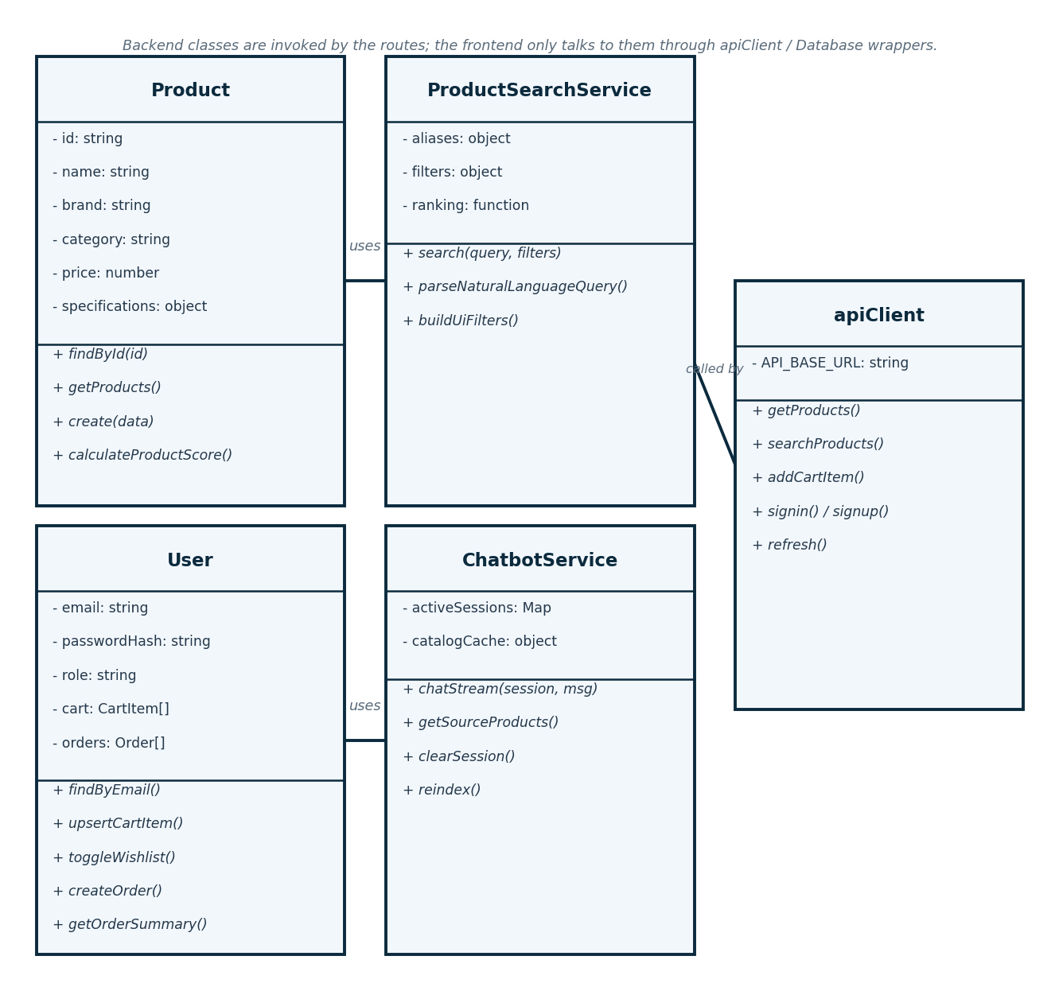
Figure 4.5: Class Diagram

4.6 Sequence Design
The sign-in and token-refresh flow was chosen for the sequence diagram in Figure 4.6 because it crosses the frontend, Redux, API client, route handler, user model and MongoDB boundaries, and it is the flow where session handling is most likely to go wrong.
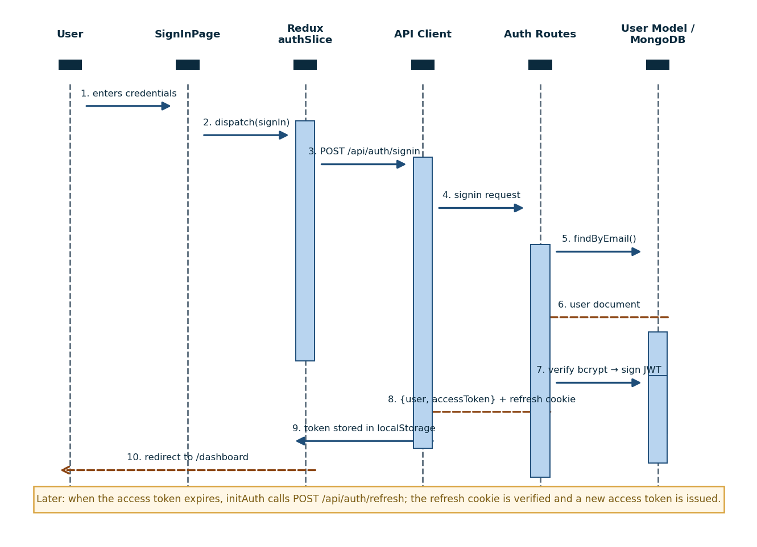Figure 4.6: Sequence Diagram - Authentication Flow

CHAPTER 5
Graphical User Interfaces

This chapter walks through the main screens of the application. Each figure is a real screenshot captured from the running system with the seeded catalogue, so the product data, scores and prices shown are exactly what a user would see.

5.1 Home Page
The landing page opens with a hero section introducing the SpecSmart brand and its AI-powered angle, followed by featured products and popular products pulled from the API. It is the main entry point into shopping and the advisor.
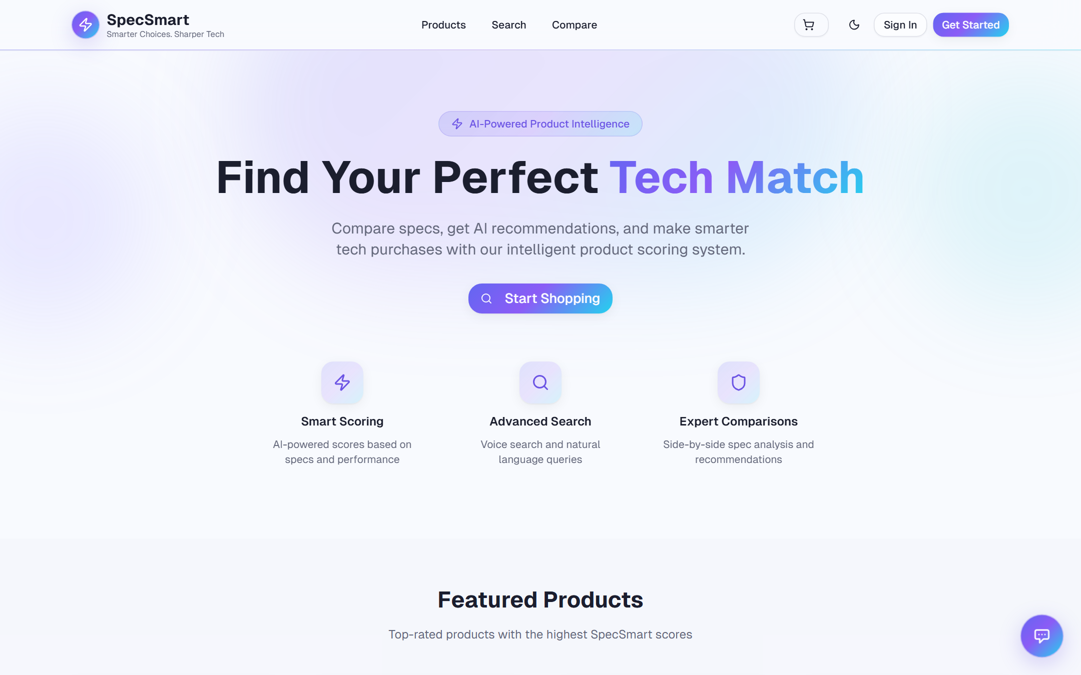
Figure 5.1: Home Page

5.2 Product Listing Page
The listing page presents the catalogue as cards showing image, title, brand, category, score, price and stock, with a sidebar for filtering by category, brand, price range, rating and stock, plus a single sort dropdown with explicit options (Price: Low to High, Price: High to Low, Newest First, Rating: High to Low and SpecSmart Score); a sticky Clear All Filters button stays visible while long filter lists scroll.
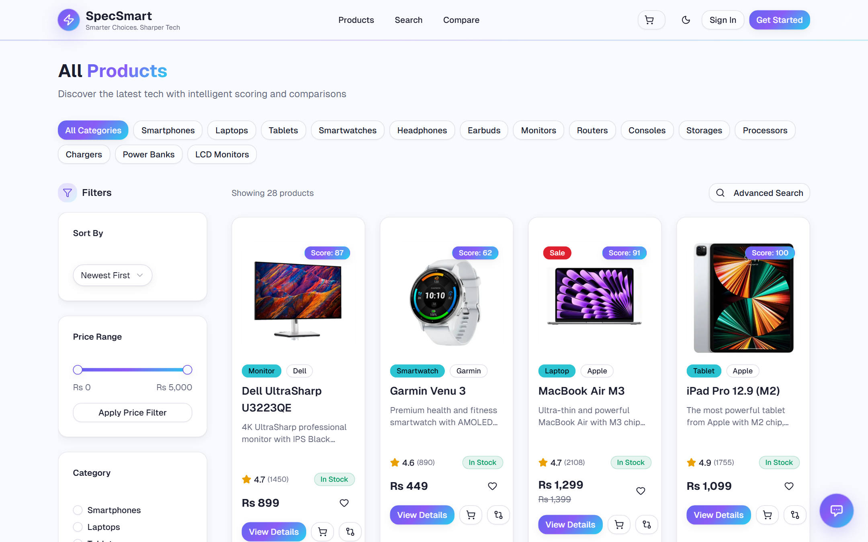
Figure 5.2: Product Listing Page

5.3 Product Detail Page
Each product detail screen shows the image gallery, pricing, the computed score, technical specifications, a feature list, related products, and add-to-cart and wishlist actions. 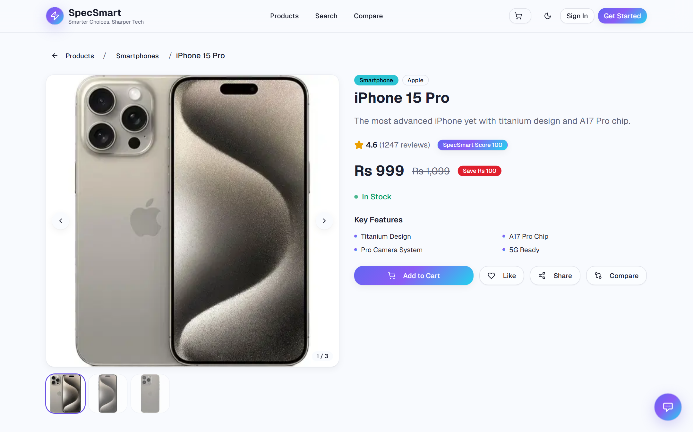
Figure 5.3: Product Detail Page

5.4 Advanced Search Page
The search page combines a plain-text input with a microphone button, suggestion chips, category and brand filters, a price slider, a rating filter and sort controls, and renders results in grid or list mode.
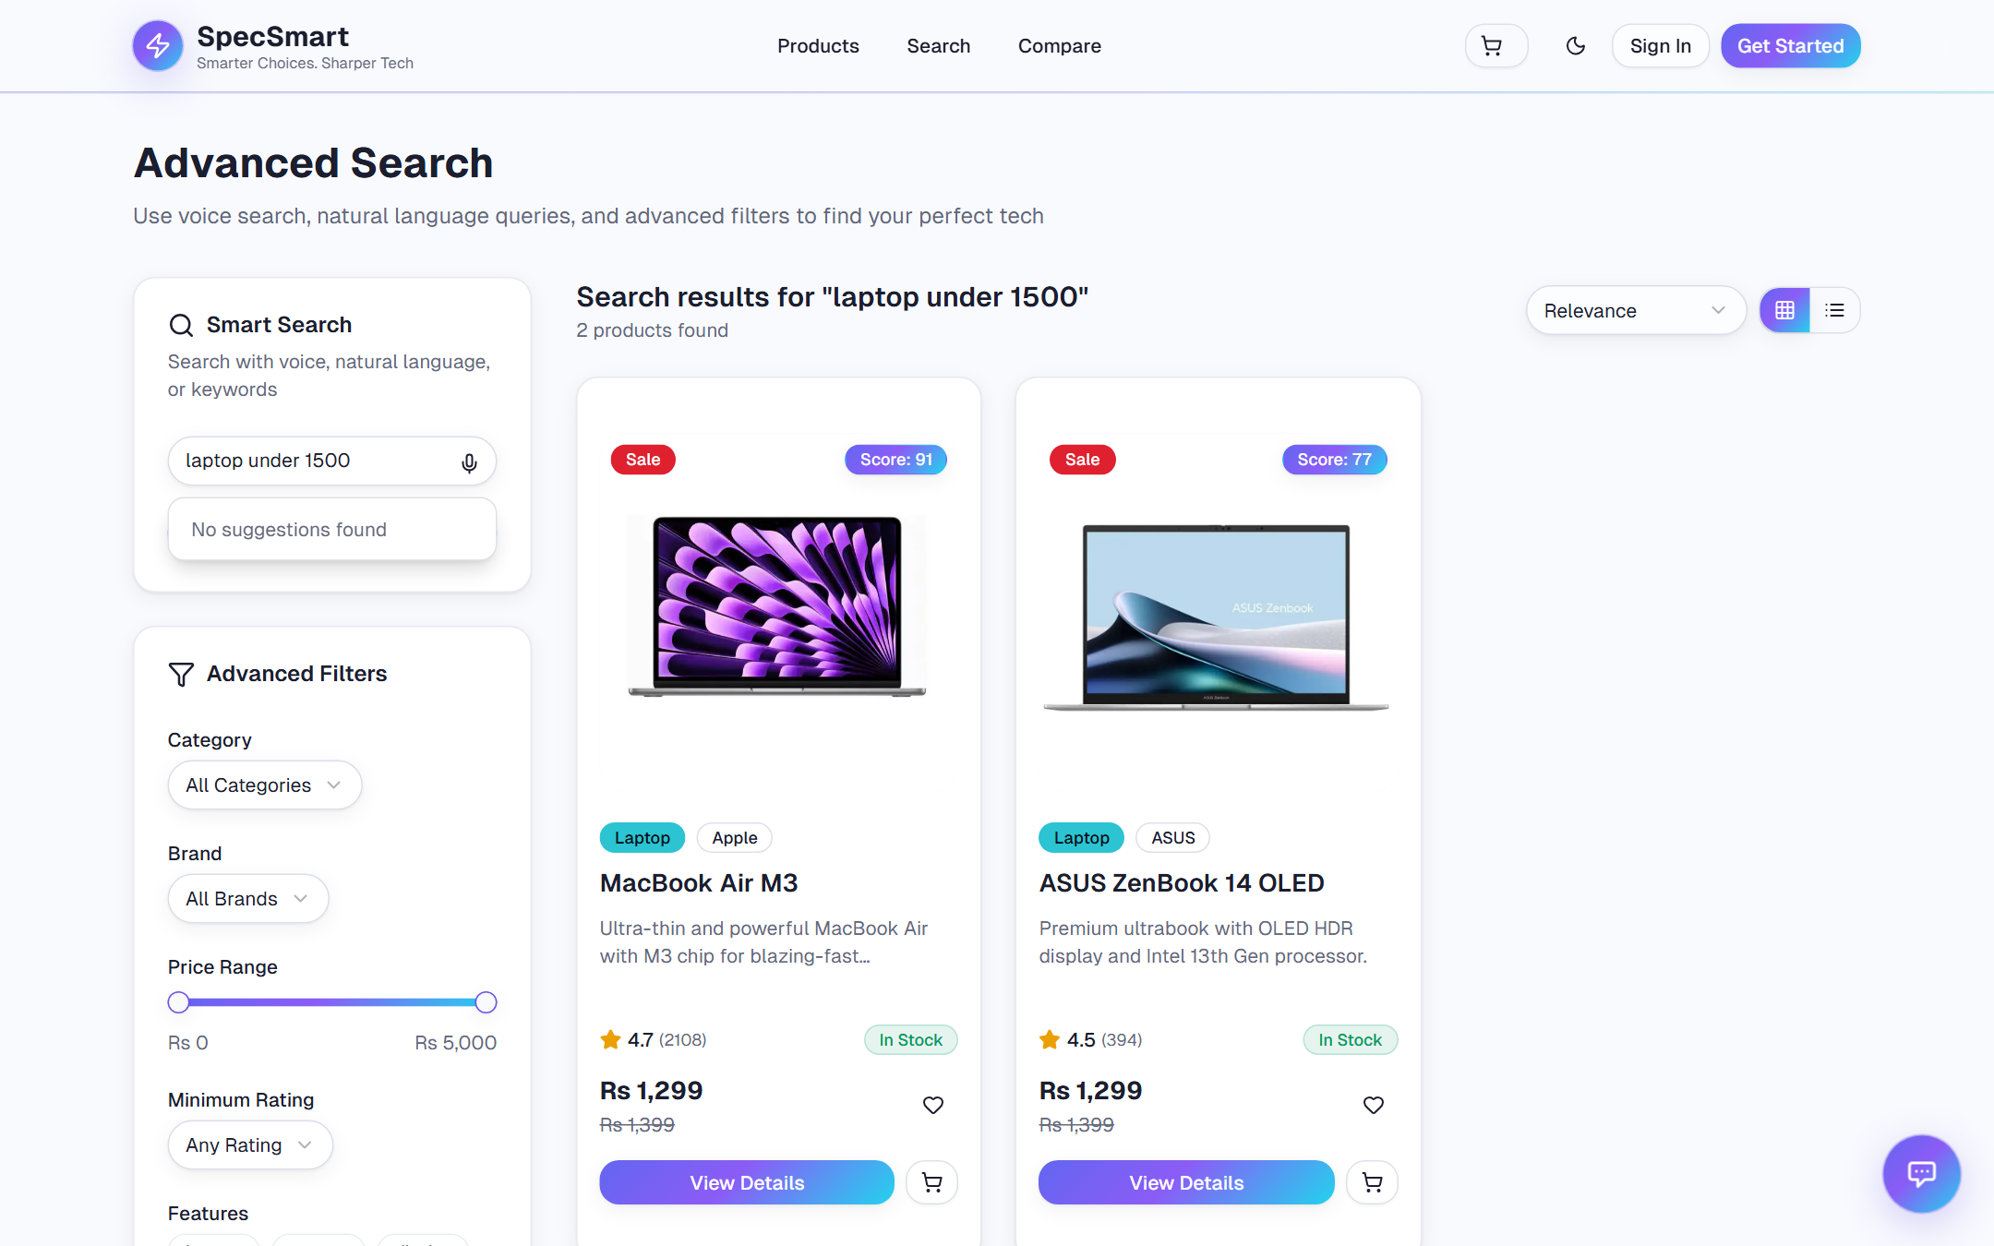
Figure 5.4: Advanced Search Page

5.5 Product Comparison Page
The comparison page renders the selected products side by side: shared columns such as score, price and brand first, followed by dynamic specification rows, with the ability to remove items without leaving the page.
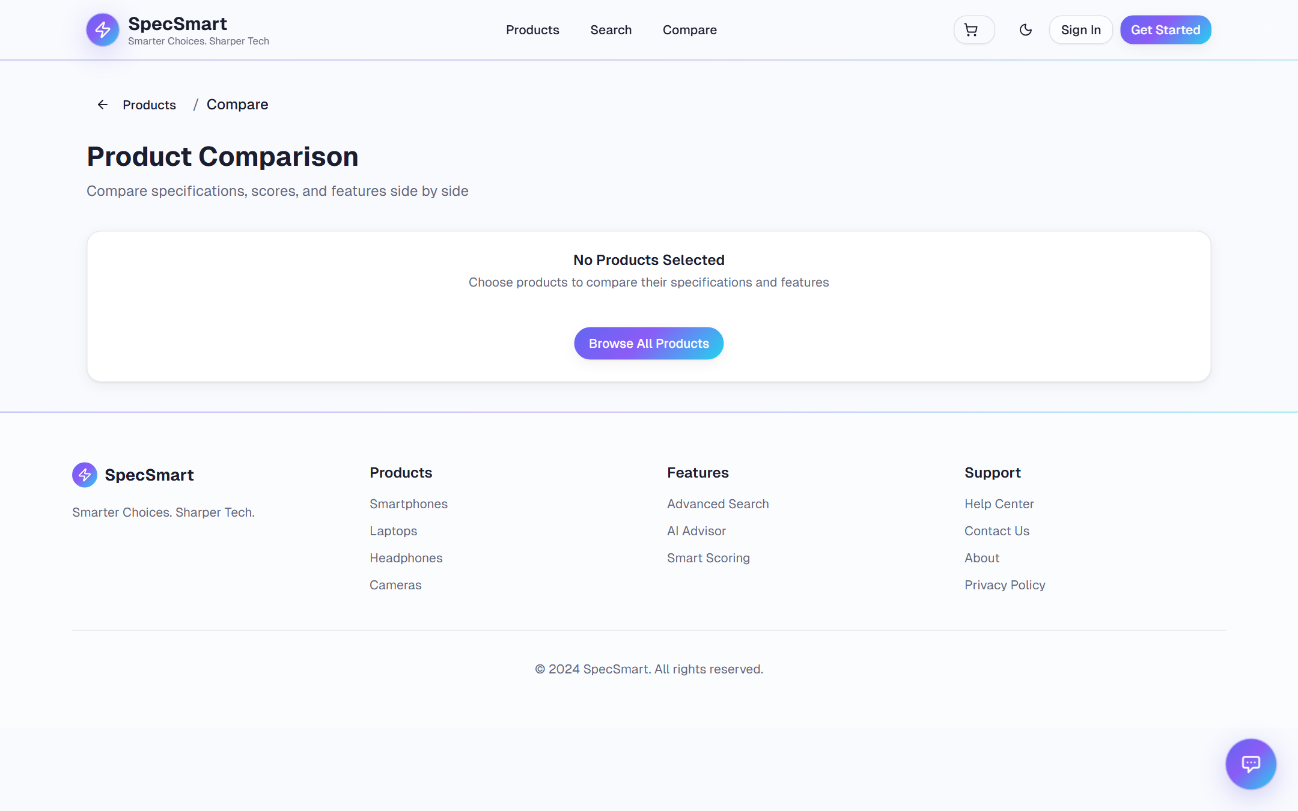
Figure 5.5: Product Comparison Page

5.6 AI Advisor Chat Widget
A floating chat window appears on every page. When the customer sends a message, the backend embeds the query with Gemini, searches the Qdrant vector index for the most relevant products, and feeds those results to Gemini as grounded context before streaming the reply. The widget shows the streamed assistant text, reference cards linking to cited products, a typing indicator while waiting, and controls to stop the stream or clear the conversation. If the vector store is unreachable, retrieval falls back to the existing keyword search pipeline.
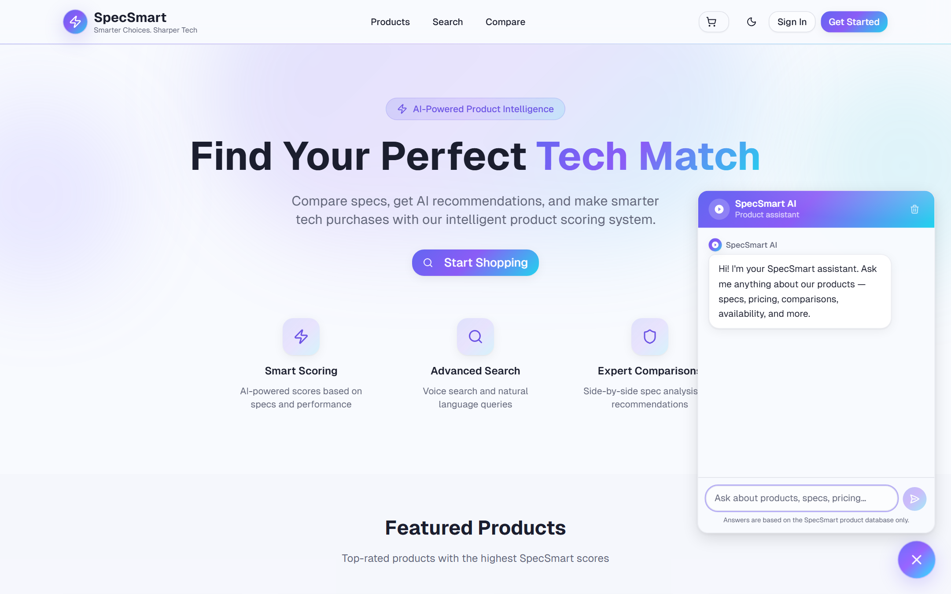
Figure 5.6: AI Advisor Chat Widget

5.7 Shopping Cart
The cart screen manages quantities and shows an order summary with shipping, tax and totals calculated from the selected items.
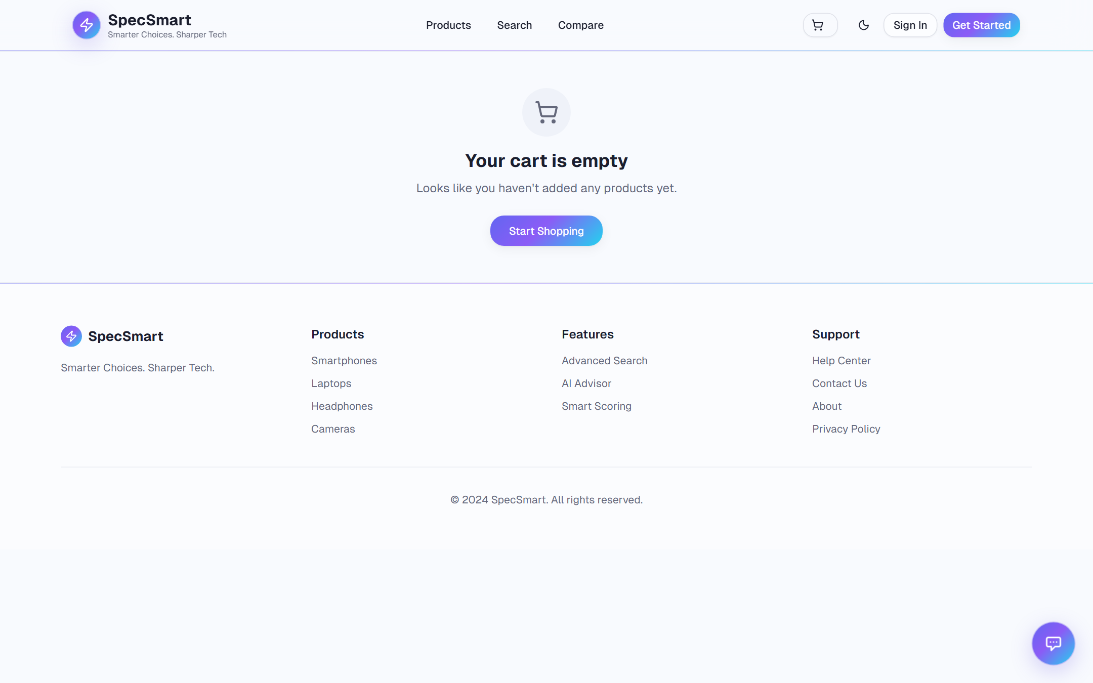
Figure 5.7: Shopping Cart

5.8 Checkout Page
Checkout proceeds through shipping information, payment preference and order review, then lands on a success page with the order reference.
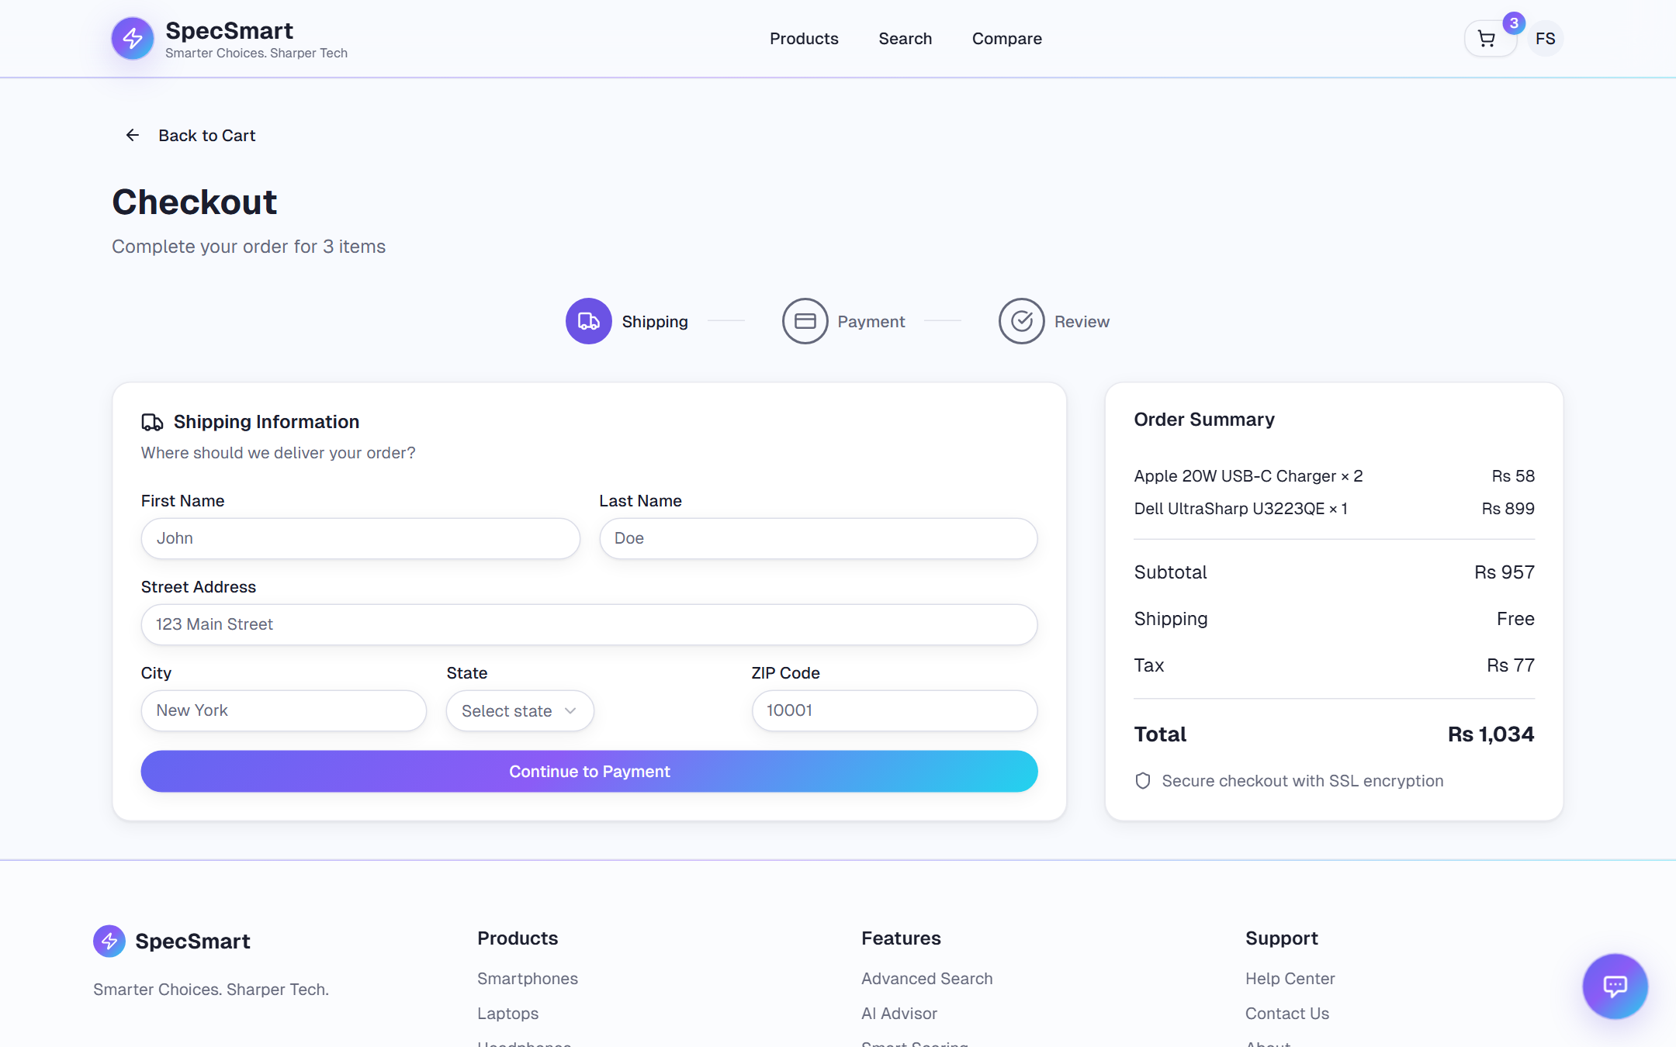
Figure 5.8: Checkout Page

5.9 User Dashboard
The dashboard groups quick statistics, recent orders, wishlist items and account settings for the signed-in user.
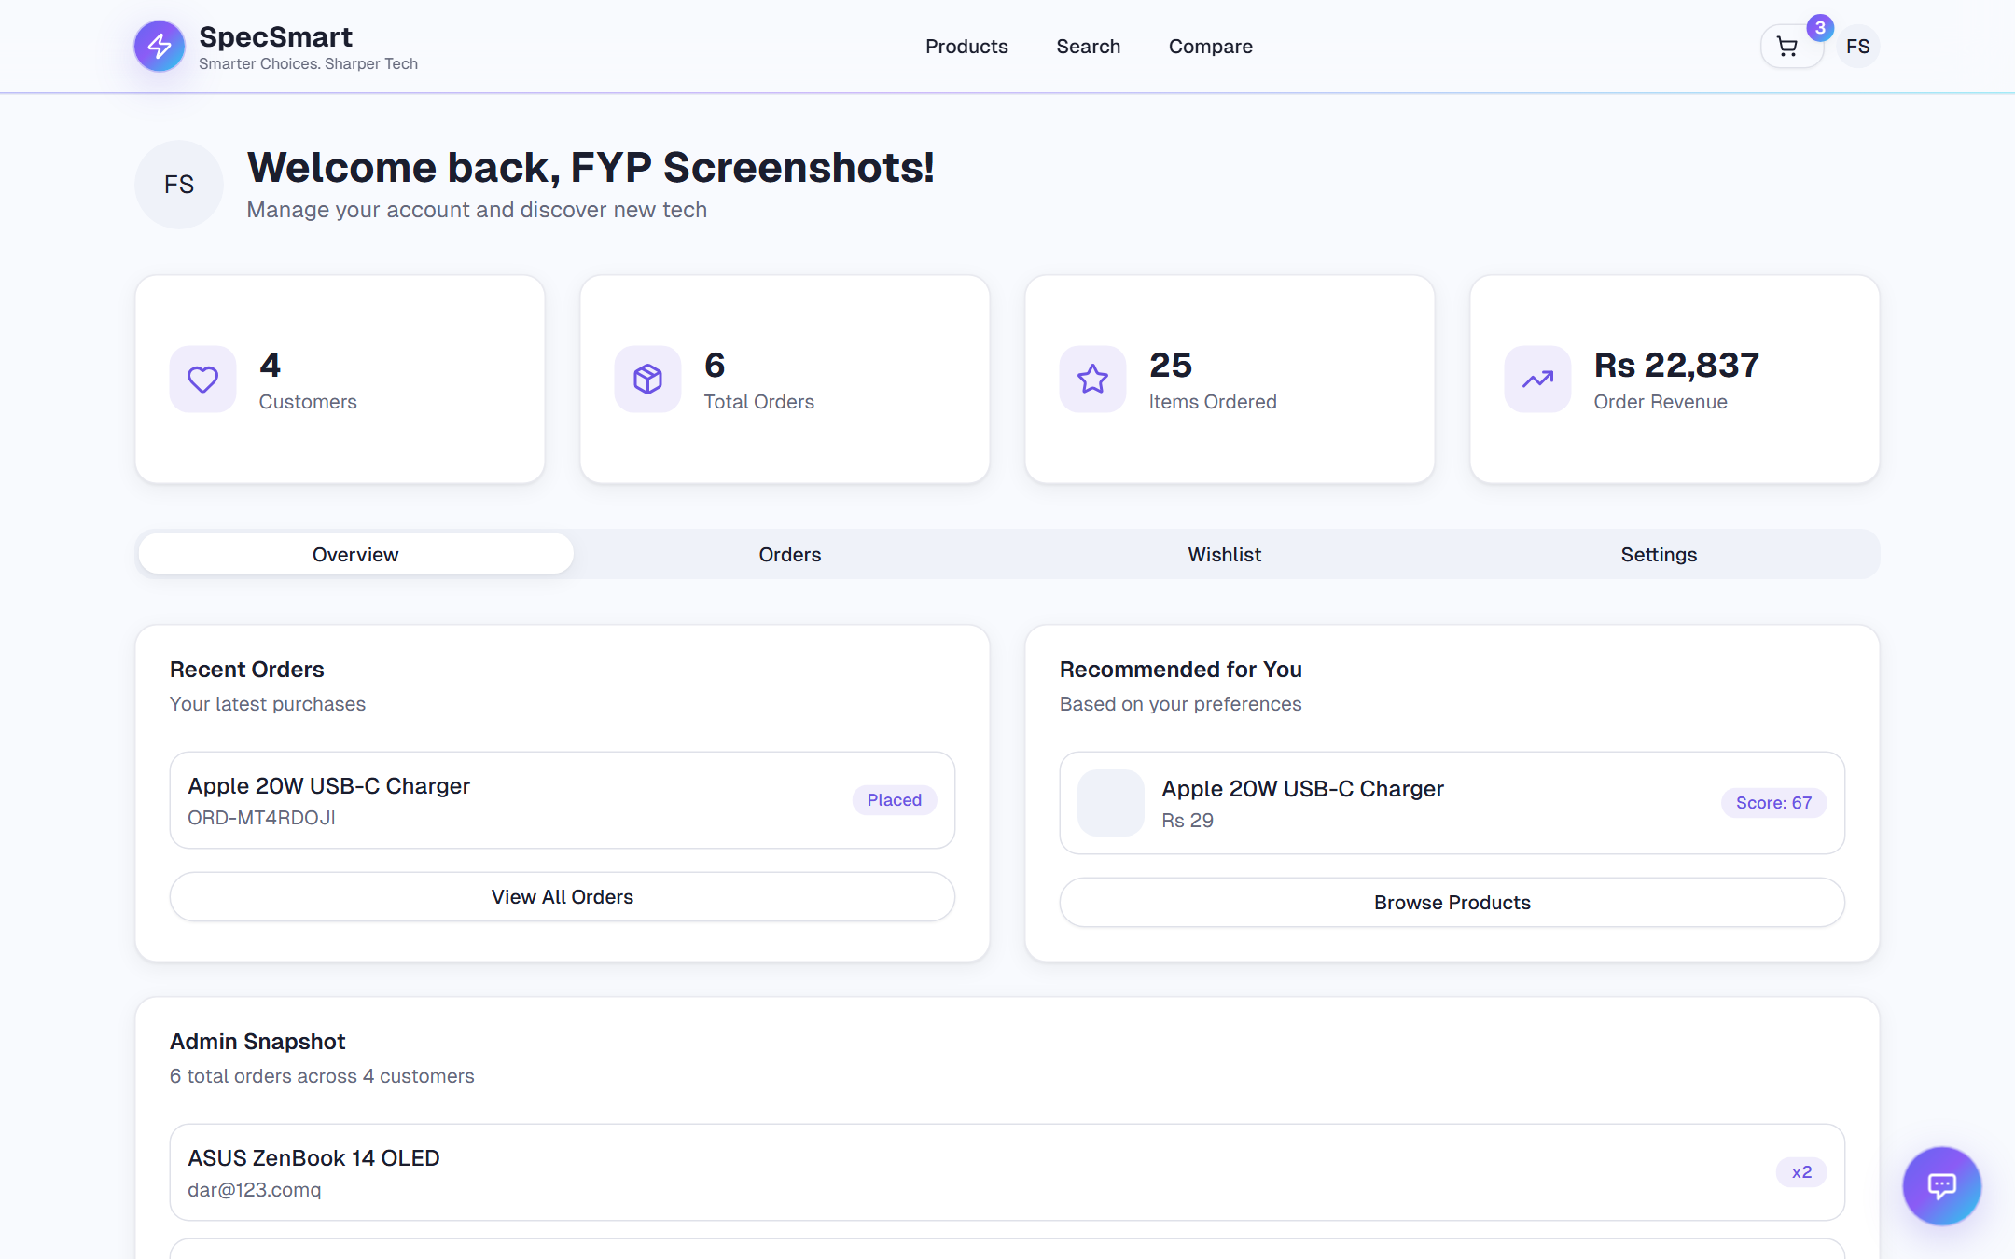
Figure 5.9: User Dashboard

5.10 Admin Panel
The admin panel accepts structured, category-aware product input rather than raw JSON, and shows ordered-product feeds and summary statistics.
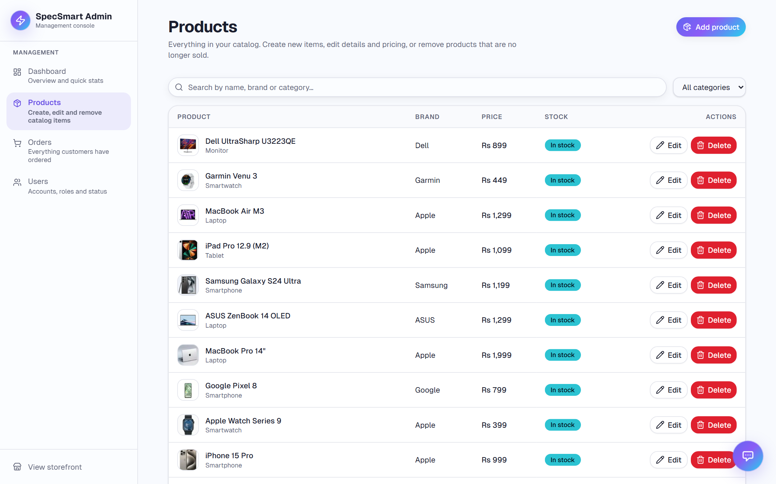
Figure 5.10: Admin Panel

5.11 Sign-in Page
The sign-in page collects credentials and restores the user's session across refreshes through the token refresh flow.
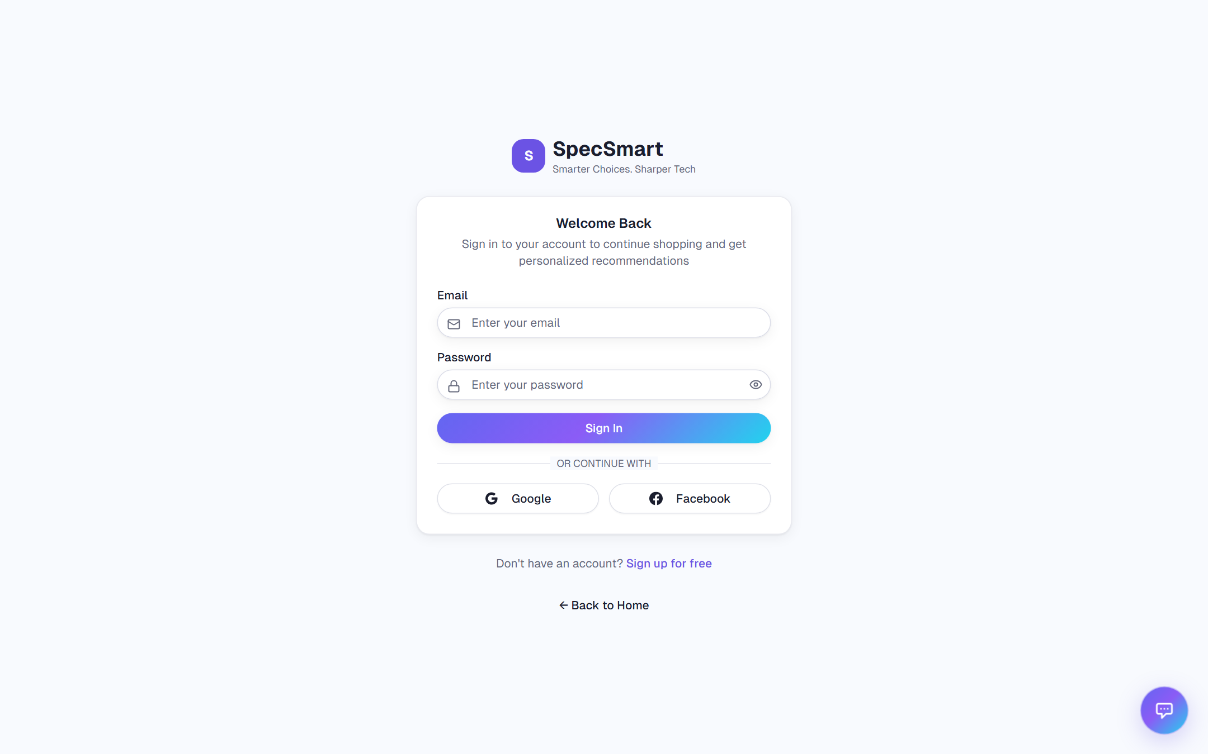
Figure 5.11: Sign-in Page

5.12 Sign-up Page
The sign-up page collects name, email and password with client-side validation before creating the account.
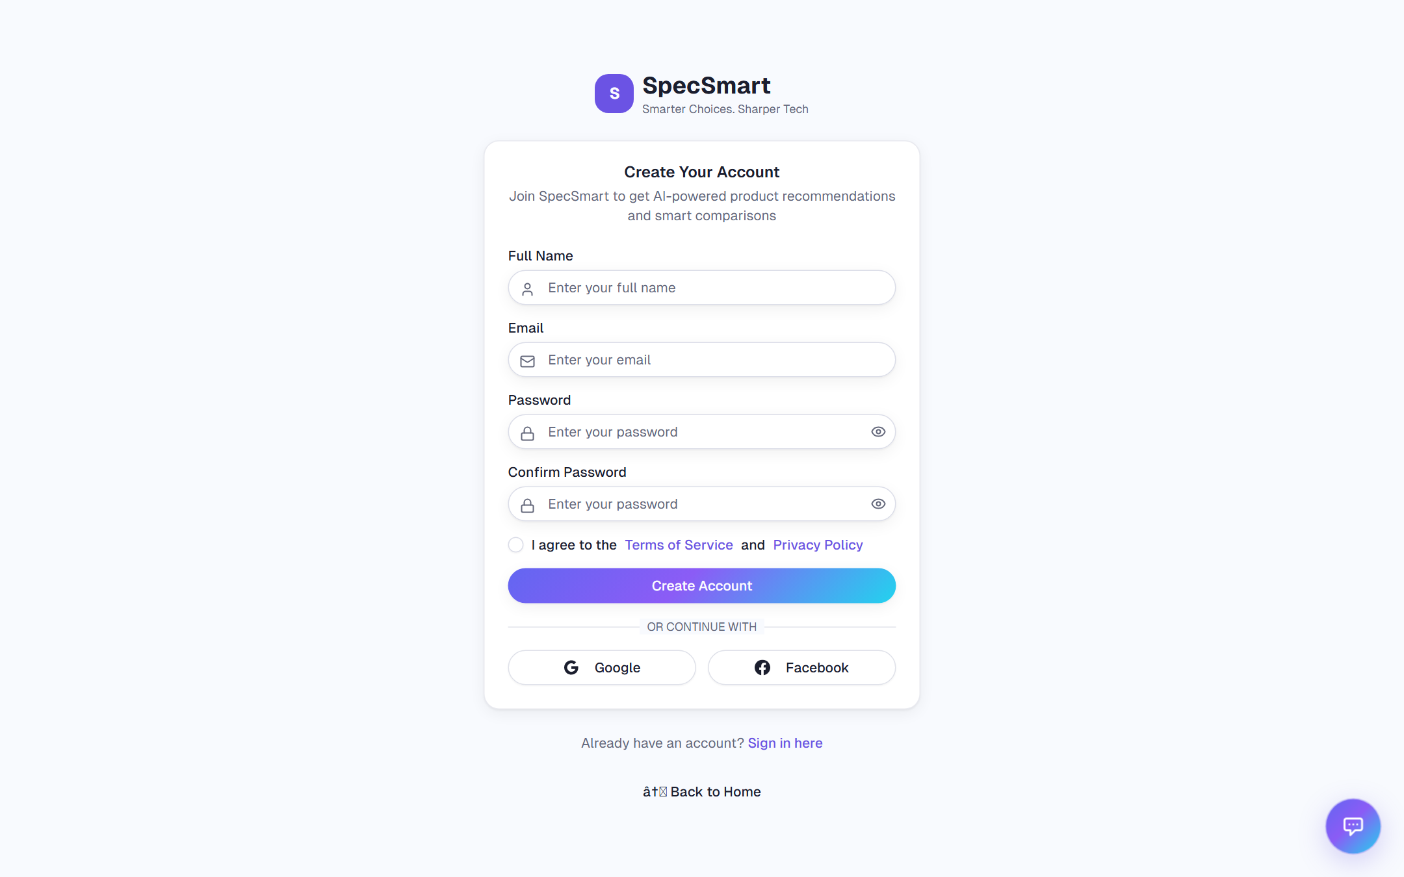
Figure 5.12: Sign-up Page

CHAPTER 6
Testing

6.1 Test Plan
Testing for a final year prototype is best treated as a layered exercise. Unit-level behaviour lives in the pure functions of the search pipeline and the scoring logic; integration behaviour lives in the route handlers; and end-to-end behaviour lives in the user flows. Because the project has no automated test suite at this stage, this chapter records the test cases that were designed from the implemented behaviour together with their expected outcomes. They are labelled as designed; execution evidence will be recorded against them before submission. Table 6.1 traces every test case back to the functional requirement it covers.
Table 6.1: Requirement-to-Test Traceability
Requirement | Feature | Test Case(s)
FR-01 | User Registration | TC-01, TC-02
FR-02 | User Login | TC-03, TC-04
FR-03 | User Logout | TC-04
FR-04 | Product Browsing | TC-05
FR-05 | Product Detail View | TC-05
FR-06 | Product Search | TC-06
FR-07 | Voice Search | TC-08
FR-08 | Product Filtering | TC-07
FR-09 | Product Scoring | TC-09
FR-10 | Wishlist Management | TC-10
FR-11 | Cart Management | TC-11
FR-12 | Checkout Workflow | TC-12, TC-13
FR-13 | Order History | TC-14
FR-14 | Admin Product Creation | TC-16
FR-15 | Admin Order Summary | TC-17
FR-16 | Protected Routes | TC-02, TC-10, TC-15, TC-16, TC-17, TC-20
FR-17 | Product Comparison | TC-18
FR-18 | AI Advisor Chat | TC-19
FR-19 | Admin User Management | TC-20

6.2 Test Case Specifications
The detailed test cases below were designed directly from the implementation. Each case lists the inputs, the expected outcome, the part of the application under test and a comment on what it covers. Backend behaviour is additionally backed by the automated regression suites described in section 6.3, which pass on the current codebase; manual results recorded here reflect browser-level verification.
Table 6.2: Test Case TC-01 - Register Valid Customer Account

TC-01: Register Valid Customer Account
Test Case ID: TC-01
Test Case Name: Register Valid Customer Account
Test Priority: High
Preconditions: Signup page is open; email is not registered.
Post conditions: A new user exists with role user and an active session.
SN | Action | Inputs | Expected Outcome | Actual Output | Test Application | Test Result | Test Comments
1 | Enter signup details | Name: Ayesha Khan; email: ayesha.test@example.com; password and confirmPassword: Test123; terms checked | Client accepts fields and submits signup request. | The signup thunk posts to /api/auth/signup, backend hashes the password, creates the user with default preferences/cart/wishlist/orders and returns user plus token. | Frontend and API | Pass | Covers FR-01 success path.
Table 6.3: Test Case TC-02 - Reject Invalid Signup Data

TC-02: Reject Invalid Signup Data
Test Case ID: TC-02
Test Case Name: Reject Invalid Signup Data
Test Priority: High
Preconditions: Signup page is open.
Post conditions: No account is created.
SN | Action | Inputs | Expected Outcome | Actual Output | Test Application | Test Result | Test Comments
1 | Submit empty/invalid form | Blank name, invalid email, password abc, unchecked terms | Form stays on signup page and field errors are shown. | Client validation shows Name is required, Please enter a valid email, Password must be at least 6 characters and terms error; API is not called. | Frontend | Pass | Boundary validation before network request.
2 | Submit duplicate email | Existing email with valid password and terms | Backend rejects duplicate registration. | POST /api/auth/signup returns User already exists; UI displays Failed to create account. Please try again. | Frontend and API | Pass | Backend enforces uniqueness through findByEmail.
3 | Post invalid data straight to the API | Missing name, malformed email or short password | Backend rejects invalid signup data. | validateSignupInput returns the same messages as the form (Name is required, Please enter a valid email, Password must be at least 6 characters) and POST /api/auth/signup answers 400 without touching the database. | API (automated) | Pass | Server-side validation mirrors the client rules (FR-16).
Table 6.4: Test Case TC-03 - Sign In With Valid and Invalid Credentials

TC-03: Sign In With Valid and Invalid Credentials
Test Case ID: TC-03
Test Case Name: Sign In With Valid and Invalid Credentials
Test Priority: High
Preconditions: A registered user exists.
Post conditions: Valid login creates session; invalid login does not.
SN | Action | Inputs | Expected Outcome | Actual Output | Test Application | Test Result | Test Comments
1 | Submit valid login | Registered email and password with length >= 6 | User is redirected to dashboard. | POST /api/auth/signin verifies bcrypt hash, returns user/token, sets refreshToken cookie, localStorage token is saved and router pushes /dashboard. | Frontend and API | Pass | Covers FR-02.
2 | Submit wrong password | Registered email and wrong password | Authentication fails. | Backend returns Invalid credentials; UI shows Invalid email or password. | Frontend and API | Pass | Failure path reflects route behavior.
Table 6.5: Test Case TC-04 - Restore and End Session

TC-04: Restore and End Session
Test Case ID: TC-04
Test Case Name: Restore and End Session
Test Priority: High
Preconditions: User has a valid refresh token cookie or is signed in.
Post conditions: Session is restored or cleared.
SN | Action | Inputs | Expected Outcome | Actual Output | Test Application | Test Result | Test Comments
1 | Reload application with expired/missing access token but valid refresh cookie | No valid local token; refresh cookie present | App obtains a new access token. | authSlice initAuth calls /api/auth/refresh, stores new token, then fetches user. | Frontend and API | Pass | Covers refresh behavior.
2 | Sign out | Authenticated user clicks logout | User is signed out. | POST /api/auth/signout clears refreshToken cookie and authSlice removes localStorage token and user. | Frontend and API | Pass | Covers FR-03.
Table 6.6: Test Case TC-05 - Browse Featured, Popular, Category and Detail Products

TC-05: Browse Featured, Popular, Category and Detail Products
Test Case ID: TC-05
Test Case Name: Browse Featured, Popular, Category and Detail Products
Test Priority: High
Preconditions: Products collection is seeded.
Post conditions: Product pages show real catalogue data.
SN | Action | Inputs | Expected Outcome | Actual Output | Test Application | Test Result | Test Comments
1 | Open home page | No input | Featured and popular product cards load. | /api/products/featured returns score >= 90 products limited to 4; /popular returns products sorted by reviewCount limited to 6. | Frontend and API | Pass | Covers FR-04.
2 | Open category page | Category: laptop | Only laptop products are listed newest first. | /api/products/category/laptop returns matching decorated products. | Frontend and API | Pass | Category route uses exact category field.
3 | Open product detail | A valid product id and category | Image gallery, price, score, description, specs and action buttons render. | /api/products/:id returns the product or 404 for missing id. | Frontend and API | Pass | Covers FR-05.
Table 6.7: Test Case TC-06 - Search Products With Query and Suggestions

TC-06: Search Products With Query and Suggestions
Test Case ID: TC-06
Test Case Name: Search Products With Query and Suggestions
Test Priority: High
Preconditions: Search page is open; products exist.
Post conditions: Search results or validation message are produced.
SN | Action | Inputs | Expected Outcome | Actual Output | Test Application | Test Result | Test Comments
1 | Type autocomplete query | ap | Suggestion dropdown appears after debounce. | /api/products/suggestions returns up to 5 matching names, brands or categories; fewer than 2 characters returns an empty list. | Frontend and API | Pass | Boundary: minimum 2 characters.
2 | Submit natural-language search | best smartphone under 800 | Products are parsed, filtered and ranked. | Backend returns success true, data, count, filters and parsedQuery from ProductSearchService. | Frontend and API | Pass | Covers FR-06.
3 | Submit blank search to API | q is empty | Request is rejected. | /api/products/search returns 400 Search query is required. | API | Pass | Validation path.
Table 6.8: Test Case TC-07 - Apply Product Filters and Sorting

TC-07: Apply Product Filters and Sorting
Test Case ID: TC-07
Test Case Name: Apply Product Filters and Sorting
Test Priority: Medium
Preconditions: Products page or search page is open.
Post conditions: Filtered result set is returned.
SN | Action | Inputs | Expected Outcome | Actual Output | Test Application | Test Result | Test Comments
1 | Apply filter combination | Brand Apple; minPrice 500; maxPrice 2000; rating 4.0; sortBy price; sortOrder asc | Only matching products are displayed in ascending price order. | apiClient serializes filters, backend buildUiFilters parses numeric values and applyProductFilters/sortProducts return filtered products. | Frontend and API | Pass | Covers FR-08.
2 | Clear filters | Clear button | Search page returns to unfiltered state. | AdvancedSearchInterface resets query, filters and price range and navigates to /search. | Frontend | Pass | UI reset scenario.
Table 6.9: Test Case TC-08 - Use Voice Search

TC-08: Use Voice Search
Test Case ID: TC-08
Test Case Name: Use Voice Search
Test Priority: Medium
Preconditions: Search page is open and microphone permission is available.
Post conditions: Spoken text appears in search input.
SN | Action | Inputs | Expected Outcome | Actual Output | Test Application | Test Result | Test Comments
1 | Start native voice input | Browser supports SpeechRecognition | Listening state starts and recognized text updates query. | useWebSpeechRecognition updates AdvancedSearchInterface query and shows Listening... Speak now while active. | Frontend | Pass | Covers FR-07 native path.
2 | Use fallback path | Browser does not support native speech recognition | Fallback microphone button processes audio. | Whisper fallback hook shows Processing audio... and posts to the speech-to-text route. | Frontend and API | Pass | Compatibility path.
Table 6.10: Test Case TC-09 - Calculate SpecSmart Product Score

TC-09: Calculate SpecSmart Product Score
Test Case ID: TC-09
Test Case Name: Calculate SpecSmart Product Score
Test Priority: High
Preconditions: Product document contains rating, review count, features and category specifications.
Post conditions: Returned product includes score between 35 and 100.
SN | Action | Inputs | Expected Outcome | Actual Output | Test Application | Test Result | Test Comments
1 | Fetch product list | GET /api/products | Every product has a computed score. | Product._decorateProduct calls calculateProductScore and clamps score from 35 to 100. | API | Pass | Covers FR-09.
2 | Score high-spec smartphone | High RAM, storage, battery and refreshRate values | Score increases but never exceeds 100. | Category smartphone rules weight RAM, storage, battery and display refresh rate before clamp. | API | Pass | Boundary: upper clamp.
Table 6.11: Test Case TC-10 - Toggle Wishlist

TC-10: Toggle Wishlist
Test Case ID: TC-10
Test Case Name: Toggle Wishlist
Test Priority: High
Preconditions: User is signed in; product detail page is open.
Post conditions: Wishlist is updated for authenticated user.
SN | Action | Inputs | Expected Outcome | Actual Output | Test Application | Test Result | Test Comments
1 | Click Like | Product id from detail page | Product id is added to wishlist. | POST /api/users/me/wishlist/toggle updates user.wishlist and ProductActions changes button to Liked. | Frontend and API | Pass | Covers FR-10.
2 | Click Like as guest | No authenticated user | User is sent to sign-in page. | ProductActions detects missing user and router pushes /auth/signin without calling API. | Frontend | Pass | Protected behavior.
Table 6.12: Test Case TC-11 - Manage Guest and Authenticated Cart

TC-11: Manage Guest and Authenticated Cart
Test Case ID: TC-11
Test Case Name: Manage Guest and Authenticated Cart
Test Priority: High
Preconditions: A product exists.
Post conditions: Cart items and totals are updated.
SN | Action | Inputs | Expected Outcome | Actual Output | Test Application | Test Result | Test Comments
1 | Add item as guest | productId, quantity 1 | Item is stored locally. | the cart slice stores the item in specsmart_cart localStorage and updates totalQuantity. | Frontend | Pass | Covers guest cart.
2 | Add same item as signed-in user | productId, quantity 1 twice | Server cart quantity becomes 2. | addCartItemAsync computes nextQuantity and POST /users/me/cart upserts normalized quantity. | Frontend and API | Pass | Covers FR-11.
3 | Set quantity to zero | quantity 0 | Item is removed. | updateCartQuantityAsync calls DELETE /users/me/cart/:productId for authenticated users. | Frontend and API | Pass | Boundary removal case.
Table 6.13: Test Case TC-12 - Checkout Authenticated User

TC-12: Checkout Authenticated User
Test Case ID: TC-12
Test Case Name: Checkout Authenticated User
Test Priority: High
Preconditions: Signed-in user has at least one item in cart.
Post conditions: Order is created and cart is cleared.
SN | Action | Inputs | Expected Outcome | Actual Output | Test Application | Test Result | Test Comments
1 | Complete checkout steps | Shipping fields, paymentMethod card, cart items | Review page appears and Place Order starts processing. | CheckoutPageContent advances Shipping -> Payment -> Review and builds totals; fields are not currently validated as required by custom logic. | Frontend | Pass | Documents actual validation behavior.
2 | Place order | Valid cartProducts payload | Order is stored and success page opens. | POST /api/users/me/orders creates ORD-* order, prepends it to user.orders, clears user.cart, Redux clears cart and router pushes /checkout/success. | Frontend and API | Pass | Covers FR-12.
Table 6.14: Test Case TC-13 - Checkout Empty or Guest Cart

TC-13: Checkout Empty or Guest Cart
Test Case ID: TC-13
Test Case Name: Checkout Empty or Guest Cart
Test Priority: Medium
Preconditions: Cart page or checkout page is open.
Post conditions: Empty and guest cases behave as implemented.
SN | Action | Inputs | Expected Outcome | Actual Output | Test Application | Test Result | Test Comments
1 | Open checkout with empty cart | totalItems = 0 | User is redirected to cart. | CheckoutPageContent effect pushes /cart once loading completes. | Frontend | Pass | Boundary case.
2 | Place order as guest | Guest cart with item | Success page opens but no persistent order is created. | handlePlaceOrder dispatches clearCart locally and navigates to /checkout/success without calling /users/me/orders. | Frontend | Pass | Guest limitation.
Table 6.15: Test Case TC-14 - View Dashboard Orders and Wishlist

TC-14: View Dashboard Orders and Wishlist
Test Case ID: TC-14
Test Case Name: View Dashboard Orders and Wishlist
Test Priority: Medium
Preconditions: User is signed in and may have orders/wishlist items.
Post conditions: Dashboard displays commerce summary.
SN | Action | Inputs | Expected Outcome | Actual Output | Test Application | Test Result | Test Comments
1 | Open dashboard | Authenticated user token | Quick stats and tabs load. | Database.getCommerceData calls /users/me/commerce; response includes cart, wishlist, orders and hydrated product arrays. | Frontend and API | Pass | Covers FR-13.
2 | Commerce API fails | Network/API error | Dashboard remains visible with empty arrays. | Database wrapper catches error and returns empty commerce structure. | Frontend | Pass | Reliability scenario.
Table 6.16: Test Case TC-15 - Restrict Protected Routes

TC-15: Restrict Protected Routes
Test Case ID: TC-15
Test Case Name: Restrict Protected Routes
Test Priority: High
Preconditions: Visitor is not authenticated or user is not admin.
Post conditions: Restricted functions are blocked.
SN | Action | Inputs | Expected Outcome | Actual Output | Test Application | Test Result | Test Comments
1 | Call commerce endpoint without token | GET /api/users/me/commerce no Authorization header | Request is unauthorized. | authenticateToken rejects the request before route logic. | API | Pass | Covers FR-16.
2 | Open admin as normal user | role user | Admin content is not available. | AdminPanel renders Admin Access Required; backend admin endpoints return 403 Admin access required. | Frontend and API | Pass | Role boundary.
Table 6.17: Test Case TC-16 - Create Product From Admin Panel

TC-16: Create Product From Admin Panel
Test Case ID: TC-16
Test Case Name: Create Product From Admin Panel
Test Priority: High
Preconditions: Admin is signed in.
Post conditions: New product appears in the catalogue.
SN | Action | Inputs | Expected Outcome | Actual Output | Test Application | Test Result | Test Comments
1 | Submit structured product | Name, category laptop, brand ASUS, price, image paths, specs, rating, stock checked | Product is inserted and recent products reload. | AdminPanel builds specifications object and POST /api/products calls Product.create; response includes computed score. | Frontend and API | Pass | Covers FR-14.
2 | Submit as non-admin | Same payload with role user | Product is not created. | requireAdmin returns 403 Admin access required. | API | Pass | Security failure case.
Table 6.18: Test Case TC-17 - View Admin Order Summary

TC-17: View Admin Order Summary
Test Case ID: TC-17
Test Case Name: View Admin Order Summary
Test Priority: Medium
Preconditions: Admin is signed in.
Post conditions: Order aggregates are displayed.
SN | Action | Inputs | Expected Outcome | Actual Output | Test Application | Test Result | Test Comments
1 | Open admin dashboard | Admin token | Admin quick stats show total customers, orders, items and revenue. | /users/admin/orders-summary aggregates embedded orders from users collection. | Frontend and API | Pass | Covers FR-15.
2 | Fetch ordered products | Admin token | Ordered product rows include customer and order metadata. | User.getAllOrderedProducts flattens each embedded order item with orderId, customerName and customerEmail. | API | Pass | Admin reporting path.
Table 6.19: Test Case TC-18 - Compare Products

TC-18: Compare Products
Test Case ID: TC-18
Test Case Name: Compare Products
Test Priority: High
Preconditions: Catalogue contains at least five products.
Post conditions: Comparison list supports up to four products.
SN | Action | Inputs | Expected Outcome | Actual Output | Test Application | Test Result | Test Comments
1 | Add products to compare | Four product ids | Compare buttons add items and persist selection. | CompareContext stores simplified products in specsmart_compare until MAX_ITEMS = 4. | Frontend | Pass | Covers FR-17.
2 | Attempt fifth compare item | Fifth product | The add button is disabled. | ProductActions disables Compare when !canAdd and shows title Comparison full (max 4). | Frontend | Pass | Boundary case.
3 | Open comparison URL | /compare?products=id1,id2 | Comparison table shows price, score, rating, availability, specs and actions. | ComparePage hydrates products and ComparisonTable highlights best price, score and rating. | Frontend and API | Pass | Functional comparison behavior.
Table 6.20: Test Case TC-19 - AI Advisor Chat

TC-19: AI Advisor Chat
Test Case ID: TC-19
Test Case Name: AI Advisor Chat
Test Priority: High
Preconditions: Backend is running; product collection exists.
Post conditions: Catalogue-grounded streamed answer is displayed.
SN | Action | Inputs | Expected Outcome | Actual Output | Test Application | Test Result | Test Comments
1 | Send product question | Which laptop is best for editing? | Chat answer streams into widget and may show referenced product cards. | /api/chatbot/chat validates message/sessionId, streams Gemini chunks and sends done with source products extracted from Product ID tags. | Frontend and API | Pass | Covers FR-18.
2 | Send invalid message | Blank message or >1000 characters | Request is rejected. | Route returns 400 message is required or message exceeds 1000 characters. | API | Pass | Validation and boundary behavior.
3 | Clear chat | sessionId | Conversation resets. | DELETE /api/chatbot/session clears in-memory service history; frontend creates a fresh local session id. | Frontend and API | Pass | Session maintenance.
Table 6.21: Test Case TC-20 - Admin User Management

TC-20: Admin User Management
Covers FR-19. Backend behaviour is automated in specsmart-workflows.test.js (requireAdmin authorization matrix); the actions below describe the full workflow.
SN | Action | Inputs | Expected Outcome | Actual Output | Test Application | Test Result | Test Comments
1 | Promote a regular user to admin | Valid admin token; target userId; role=admin | Account becomes an administrator. | PATCH /users/admin/users/:id/role verifies requireAdmin against the live database, updates the role and returns the changed account. | API (automated + manual) | Pass | Self-demote and last-admin guards reject invalid transitions.
2 | Disable and re-enable a disruptive account | Valid admin token; target userId; status=disabled then active | Disabled account cannot sign in or refresh; re-enabling restores access. | PATCH /users/admin/users/:id/status flips status; signin and refresh handlers answer 403 while disabled. | API (automated + manual) | Pass | Disabling the last administrator is blocked.
3 | Delete a user account permanently | Valid admin token; target userId | Account is removed and can no longer authenticate. | DELETE /users/admin/users/:id removes the document after admin and self-delete guards pass. | API (automated + manual) | Pass | Deleting yourself or the last administrator is rejected.

6.3 Test Results
Backend behaviour is now covered by an automated regression suite built on Node.js's built-in test runner. Two suites live under backend/tests: specsmart-docs.test.js and specsmart-flows.test.js, together with rag-retrieval.test.js, execute 28 checks covering the backend logic behind TC-01 through TC-19 (signup validation, credential checking, refresh tokens, catalogue browsing, wishlist, order construction, admin authorization and order summaries) against an in-memory collection stub, so no database or server is required to run them. npm test passes all 28 checks on the current codebase.
Of these automated cases, the token refresh lifecycle (TC-04), the guest-to-user cart merge (TC-11) and the AI advisor's grounding behaviour (TC-19) remain the places where subtle integration bugs are most likely to hide, so they are exercised both automatically and manually in the browser. What remains manual is the presentation layer itself: rendering, screenshots and cross-browser behaviour are verified by hand against a running frontend, backend and MongoDB database.
Table 6.22: Test Result Summary by Category
Category | Summary
Authentication | Covered by automated tests: signup validation, duplicate rejection, credential checking, disabled accounts, refresh lifecycle and signout all pass (specsmart-workflows.test.js). UI flows verified manually.
Catalogue and Search | Automated tests pass for featured/popular/category browsing, detail lookup, natural-language parsing, filters, sorting and scoring; suggestions and voice input verified manually.
Commerce | Automated tests pass for wishlist toggling, server-side order construction (prices recomputed on the server, tamper-proof totals) and order aggregation; guest localStorage merge verified manually.
Admin | Automated tests pass for DB-backed admin authorization (including disabled and deleted accounts), product creation defaults and order summary statistics; role changes verified manually.
AI Advisor | Retrieval helpers covered by unit tests (document building, cosine ranking, lexical fallback path); streaming chat and Gemini/Qdrant integrations verified manually against configured credentials.

CHAPTER 7
Conclusion and Future Work

7.1 Results and Evaluation
Measured against the objectives in Chapter 1, the implementation covers every objective set out at the start - the full-stack application, the structured catalogue, natural-language and voice search, transparent scoring, side-by-side comparison, working commerce, the admin interface and the catalogue-grounded advisor - in the running system. The backend logic behind these objectives is now backed by an automated test suite of 28 passing checks (Chapter 6), while interface-level evaluation continues to be carried out manually. Table 7.1 summarises the feature coverage.
Table 7.1: Feature Implementation Summary
Feature | Status | Evidence in the Codebase
User authentication (JWT + refresh) | Implemented | backend/routes/auth.js, middleware/authenticateToken.js
Product catalogue and category-aware scoring | Implemented | backend/models/Product.js (calculateProductScore)
Natural-language and voice search | Implemented | backend/services/ProductSearchService.js, /api/speech-to-text
Product comparison (up to four) | Implemented | store/slices/compare-slice.js, lib/compare-storage.js, components/shared/comparison-table.js
Cart and wishlist | Implemented | store/slices/cart-slice.js, backend/routes/users.js
Checkout and order history | Implemented | components/checkout/checkout-page-content.js
Admin product creation and order summary | Implemented | components/admin/products-manager.js, orders-view.js, users-manager.js
AI advisor chat with RAG (Qdrant vector retrieval) | Implemented | backend/services/ChatbotService.js, EmbeddingService.js, VectorStoreService.js
User dashboard | Implemented | components/dashboard/
Admin user management (role, status, delete) | Implemented | backend/routes/users.js, components/admin/users-manager.js
Signup input validation and rate limiting | Implemented | backend/utils/signup-validation.js, backend/middleware/rateLimiter.js, backend/routes/auth.js
Backend automated regression suite | Implemented | backend/tests/specsmart-docs.test.js, backend/tests/specsmart-workflows.test.js

7.2 Conclusion
SpecSmart has been designed and implemented to demonstrate that product discovery can be improved by combining structured technical specifications with score-based ranking, side-by-side comparison and a catalogue-grounded AI advisor. The architecture stays modular because the frontend, the API routes, the model logic and the external AI integration are separated, so each part can be tested and extended on its own. The extent to which the prototype succeeds will be confirmed through the formal evaluation planned in Chapter 6.

7.3 Future Enhancements
• A real payment gateway and stricter checkout validation for shipping and card data will be added.
• Orders will be moved to a separate collection if the system grows beyond prototype scale.
• Semantic-vector search has been implemented using Gemini embeddings and a Qdrant vector index; the next step is to expand coverage and tune retrieval parameters.
• Advisor personalisation will be expanded using saved preferences and order history.
• End-to-end browser automation (for example Playwright) will complement the existing Node.js backend unit and integration suites, which already provide 28 automated regression checks.
References
Jannach, D., Manzoor, A., Cai, W., & Chen, L. (2021). A survey on conversational recommender systems. ACM Computing Surveys, 54(5), Article 81.
Gao, C., Li, S., Lei, W., Chen, J., Li, B., Jiang, P., He, X., Mao, J., & Chua, T.-S. (2021). Towards conversational recommender systems. In Proceedings of the 27th ACM SIGKDD Conference on Knowledge Discovery & Data Mining (pp. 4006-4008). ACM.
Wu, L., Zheng, Z., Qiu, Z., Wang, H., Gu, H., Shen, T., Qin, C., Zhu, C., Zhu, H., Liu, Q., Xiong, H., & Chen, E. (2023). A survey on large language models for recommendation. arXiv preprint arXiv:2305.19860.
Mozilla Developer Network. (2024). Web Speech API. https://developer.mozilla.org/en-US/docs/Web/API/Web_Speech_API
Vercel. (2025). Next.js Documentation. https://nextjs.org/docs
Redux Toolkit Documentation. (2025). https://redux-toolkit.js.org/
OpenJS Foundation. (2024). Express.js Documentation. https://expressjs.com/
MongoDB. (2025). MongoDB Node.js Driver Documentation. https://www.mongodb.com/docs/drivers/node/current/
Google. (2025). Google Generative AI (Gemini) Documentation. https://ai.google.dev/
Qdrant. (2025). Qdrant Vector Database Documentation. https://qdrant.tech/documentation/
Appendix A
Technology Stack Details
The technology choices behind the implementation are summarised in Table A.1.
Table A.1: Technology Stack
Layer | Technology | Purpose
Frontend Framework | Next.js 15 (App Router, Turbopack) | Pages, routing and the speech-to-text API route
UI Library | React 18 | Component-based interface
Styling | Tailwind CSS 4 + Radix UI | Utility-first styling and accessible primitives
State Management | Redux Toolkit + react-redux | Authentication and cart state
Backend | Node.js + Express 4 | REST API and middleware
Database | MongoDB (official driver) | Persistent product and user storage
Authentication | jsonwebtoken + bcryptjs | JWT tokens and password hashing
Fuzzy Search | Fuse.js | Tolerant string matching in relevance ranking
Conversational AI | Google Gemini 2.5 Flash | Grounded advisor chat responses
Voice Search | Web Speech API + Whisper Large v3 | Browser recognition with Hugging Face fallback
Vector Database | Qdrant | Semantic product retrieval for the AI advisor (RAG)
Appendix B
Sample API Requests and Responses
All endpoints return a JSON envelope with a success flag and a data field. The examples below show the shapes used by the main routes.
Sign up:
POST /api/auth/signup
Content-Type: application/json

{ "name": "Ali Raza", "email": "ali@example.com",
"password": "Test123456", "confirmPassword": "Test123456" }

Response 201:
{ "success": true, "data": {
"token": "<jwt-access-token>",
"user": { "id": "...", "email": "ali@example.com", "role": "user" } } }
Intelligent search:
GET /api/products/search?q=best%20smartphone%20under%20800

Response 200:
{ "success": true, "count": 2,
"parsedQuery": { "category": "smartphone", "maxPrice": 800 },
"data": [ { "id": "30", "name": "Google Pixel 8", "score": 100, ... } ] }
Create an order (authenticated):
POST /api/users/me/orders
Authorization: Bearer <jwt-access-token>
Content-Type: application/json

{ "items": [{ "productId": "23", "quantity": 1, "price": 1299 }],
"shippingAddress": { "city": "Lahore" },
"paymentMethod": "card", "subtotal": 1299, "total": 1450 }

Response 201: { "success": true, "data": { "order": { "id": "ORD-...", "status": "placed" } } }

Chat with AI advisor (streamed):
POST /api/chatbot/chat
Content-Type: application/json

{ "message": "best phone under 800",
"sessionId": "demo-session" }

Response 200 (SSE stream):
data: { "type": "chunk", "text": "The " }
data: { "type": "chunk", "text": "Google Pixel 8..." }
data: { "type": "done", "sources": [{ "id": "30", "name": "Google Pixel 8" }] }
Appendix C
Database Schema Summaries
products collection:
{
id: string, name: string, brand: string, category: string,
price: number, originalPrice?: number, image: string,
images: string[], rating: number, reviewCount: number,
inStock: boolean, description: string, features: string[],
specifications: { ...category-specific fields... },
createdAt: Date, updatedAt: Date
}
users collection:
{
email: string, passwordHash: string, name: string,
role: "user" | "admin", avatar: string,
preferences: { favoriteCategories: string[], priceRange: {...} },
cart: [{ productId: string, quantity: number, updatedAt: Date }],
wishlist: string[],
orders: [{ id: string, status: string, createdAt: Date,
items: [...], totals: {...},
shippingAddress: {...}, paymentMethod: string }],
createdAt: Date
}

