11.15实验总结

测例一、
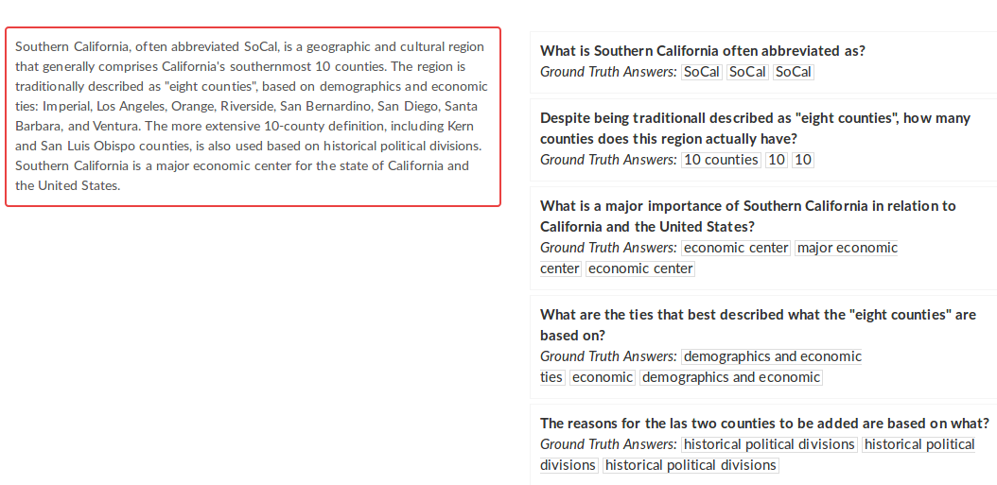
已将文档翻译为z3可用的一阶逻辑语言。
z3可以回答的问题是图中的第一道题，因为第一道题有明确的abbrevlated as词汇。
第二道题需要计数，暂时还没掌握z3的计数功能。
其余三道问题均需要自然语言分析才能进行回答。

翻译结果：
;;declare-sort 声明一个类型，这个翻译工作是根据文本中出现的词语的属性
(declare-sort region)
(declare-sort abbrName)
(declare-sort reason)
(declare-sort country)

;;declare-const 声明一个常量，这个翻译工作是根据文本中出现的名词
(declare-const _10counties region)
(declare-const California region)
(declare-const SouthernCalifornia region)
(assert (not (= SouthernCalifornia _10counties)))
(assert (not (= _10counties California)))
(assert (not (= California SouthernCalifornia)))

;;声明常量
(declare-const _10-counties abbrName)
(declare-const eightcounties abbrName)
(declare-const SoCal abbrName)
(assert (not (= SoCal _10-counties)))
(assert (not (= _10-counties eightcounties)))
(assert (not (= eightcounties SoCal)))

(declare-const demographicsAndEconomicTies reason)
(declare-const historicalPoliticalDivisions reason)
(assert (not (= demographicsAndEconomicTies historicalPoliticalDivisions)))

(declare-const UnitedStates country)

;;声明谓词，形容词为一元谓词，及物动词为二元谓词
(declare-fun abbr(region abbrName) Bool)
(declare-fun geographic (region) Bool)
(declare-fun cultural (region) Bool)
(declare-fun comprise (region region) Bool)
(declare-fun describedAS (region abbrName) Bool)
(declare-fun basedON (abbrName reason) Bool)
(declare-fun majorEconomicCenter_CR (country region) Bool)
(declare-fun majorEconomicCenter_RR (region region) Bool)

;;翻译事实
(assert (forall ((x region) (y abbrName)) (and (=> (and (= x SouthernCalifornia) (= y SoCal)) (abbr x y)) (=> (or (not (= x SouthernCalifornia)) (not (= y SoCal))) (not (abbr x y))))))

(assert (forall ((x region) (y region)) (and (=> (= x SouthernCalifornia) (= y _10counties) (comprise x y)) (=> (or (not (= x SouthernCalifornia)) (not (= y _10counties))) (not (comprise x y))))))

(assert (forall ((x region) (y abbrName)) (and (=> (and (= x SouthernCalifornia) (= y eightcounties)) (describedAS x y)) (=> (or (not (= x SouthernCalifornia)) (not (= y eightcounties))) (not (describedAS x y))))))

(assert (forall ((x abbrName) (y reason)) (and (=> (and (= x eightcounties) (= y demographicsAndEconomicTies)) (basedON x y)) (=> (or (not (= x eightcounties)) (not (= y demographicsAndEconomicTies))) (not (basedON x y))))))

(assert (forall ((x region) (y region)) (and (=> (and (= x California) (= y SouthernCalifornia)) (majorEconomicCenter_RR x y)) (=> (or (not (= x California)) (not (= y SouthernCalifornia))) (not (majorEconomicCenter_RR x y))))))

(assert (forall ((x country) (y region)) (and (=> (and (= x UnitedStates) (= y SouthernCalifornia)) (majorEconomicCenter_CR x y)) (=> (or (not (= x UnitedStates)) (not (= y SouthernCalifornia))) (not (majorEconomicCenter_CR x y))))))

;;往下为问题的解析
(assert (exists ((x region) (y region)) (and (= y SouthernCalifornia) (majorEconomicCenter_RR x y))))
(assert (exists ((x region) (y abbrName)) (and (= y SoCal) (abbr x y))))
(check-sat)
(get-model)

实验结果：对于第一个问题，Southern California缩写是什么？在实验结果中答案用y!0代替，我们可以看到y!0的值为abbrName!val!0，往下看可以知道abbrName!val!0的值为SoCal，即正确答案。

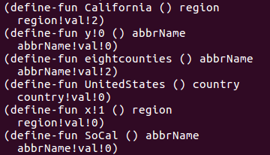

实验总结：其实今天上午的时候，就已经掌握了这个事实以及问题的解析方法，只不过下午的时候由于编写的数据太多，括号太多而在连接词处写少了一个括号导致实验数据出错，而我却误以为是公式出错，所以在这个点上花费了较长时间。

11.16工作安排以及疑问
- 继续学习掌握z3的语法，并尝试将更复杂的问题交给z3去解决。
- 研究如何将需要自然语言分析的问题转化为z3可推理的问题，如例一中的后面三个问题。

