包含问题内容的文件的格式：
第一行为问题的陈述句描述，
第二行为问题的背景知识，
第三行为问题的问句。
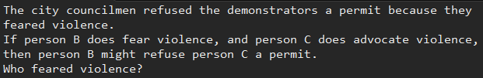

对自然语言文本解析的结果的格式：
Example——解析的句子的文本内容。
Tokens——句子中的单词
Lemmatized tokens——句子中的单词的标准化形式
POS tags——单词的词性，WP表示疑问词，VBD表示动词，NN表示名词
Dependency children——单词间的依赖关系，nsubj表示动词的主语，dobj表示动词的直接宾语。
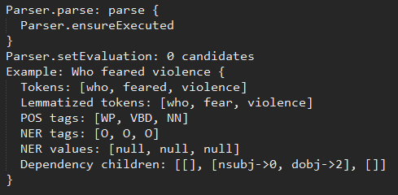

声明关系和声明常量的内容：
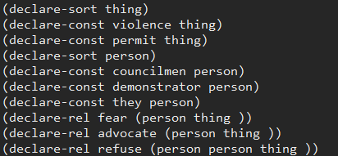

实体不相等的内容：
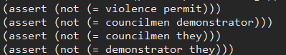

实体取值范围的内容：

Knowledge解析结果：
Parser.parse: parse {
Parser.ensureExecuted
}
Parser.setEvaluation: 0 candidates
Example: If person B does fear violence, and person C does advocate violence, then person B might refuse person C a permit. {
Tokens: [if, person, b, does, fear, violence, ,, and, person, c, does, advocate, violence, ,, then, person, b, might, refuse, person, c, a, permit, .]
Lemmatized tokens: [if, person, b, do, fear, violence, ,, and, person, c, do, advocate, violence, ,, then, person, b, might, refuse, person, c, a, permit, .]
POS tags: [IN, NN, NN, VBD-AUX, VB, NN, ,, CC, NN, NN, VBD-AUX, VB, NN, ,, RB, NN, NN, VBD-AUX, VB, NN, NN, DT, NN, .]
NER tags: [O, O, O, O, O, O, O, O, O, O, O, O, O, O, O, O, O, O, O, O, O, O, O, O]
NER values: [null, null, null, null, null, null, null, null, null, null, null, null, null, null, null, null, null, null, null, null, null, null, null, null]
Dependency children: [[], [], [compound->1], [], [mark->0, nsubj->2, aux->3, dobj->5, punct->6, cc->7, conj:and->11], [], [], [], [], [compound->8], [], [nsubj->9, aux->10, dobj->12], [], [], [], [], [compound->15, advmod->14], [], [nsubj->16, aux->17, advcl->4, iobj->20, dobj->22, punct->23, advcl->11, punct->13], [], [compound->19], [], [det->21], []]
}

可能遇到的困难：
- sempre对动词的依赖关系的解析
0 1 2 3 4 5 6 7 8 9 10
The city councilmen refused the demonstrators a permit because they feared violence .
Dependency children: [[], [], [det->0, compound->1], [nsubj->2, dobj->5, advcl->10, punct->12], [], [det->4], [], [det->6], [], [], [dep->7, mark->8, nsubj->9, dobj->11], [], []]

The city councilmen refused the demonstrators a permit, because they feared violence.
Dependency children: [[], [], [det->0, compound->1], [nsubj->2, xcomp->7, punct->8, advcl->11, punct->13], [], [det->4], [], [nsubj->5, det->6], [], [], [], [mark->9, nsubj->10, dobj->12], [], []]

The city councilmen refuse the demonstrators a permit because they fear violence.
Dependency children: [[], [], [det->0, compound->1], [nsubj->2, xcomp->7, advcl->10, punct->12], [], [det->4], [], [nsubj->5, det->6], [], [], [mark->8, nsubj->9, dobj->11], [], []]

- sempre对名词的复合关系的解析
Frank felt crushed when his longtime rival Bill revealed that he was the winner of the competition.
POS tags: [NNP, VBD, JJ, WRB, PRP$, NN, JJ, NN, VBD, IN, PRP, VBD-AUX, DT, NN, IN, DT, NN, .]
Dependency children: [[], [nsubj->0, punct->17, dobj->2], [acl:relcl->8], [], [], [], [], [nmod:poss->4, compound->5, amod->6], [advmod->3, nsubj->7, ccomp->13], [], [], [], [], [nmod:of->16, mark->9, nsubj->10, cop->11, det->12], [], [], [det->15, case->14], []]
}
如何知道Frank跟Bill是rival呢？

