AXSOS Academy

2021

Blessing

By:

Hani Kiwan

Tasneem Arafat

Yousef Nour

Dopamine Team

Contents

Abstract 1

Requirements 1

Login/Registration Page: 2

Home Page: 2

Donation Page: 2

Organizations Page: 3

List of Donations Page: 3

User Profile Page: 3

Wireframe 4

ERD diagram: 5

**Figures**

Figure 1: Blessing Wireframe 4

Figure 2: Blessing ERD Diagram 5

# Abstract

Blessing is a website for the community. It allows people to help those among us who are less fortunate by connecting users with charity.

Through our website people will be able to donate tangibles like food, clothes and other stuff. Also they will be able to see the list of charitable organizations in the country.

As for the charities they will be able to view list of donations in their city and accept donations.

# Requirements

We have three roles in our website:

* Administration
* Donor
* Organization

Admin: can see all website pages and can create a user for the Organizations.

## Login/Registration Page:

* Anyone can register as a donor
* Registered users can log in

## Home Page:

1. When the user writes the root route for our website, he will be directed to the home page.
2. The home page contains a slider with images and two buttons:

* Donate
* See all Charities

1. There is a navbar that contains buttons to navigate the user to different destinations in the website.

* Login/Registration page or logout
* Organizations page
* Search bar
* Donation Page
* Home page

1. A Footer that has a glimpse about us and our contact info.

## Donation Page:

1. A donation form that has:

* Donor contact information
* Type of Donation
* Description
* Date of donation

1. Submit button
2. If the user is not logged in he will not be able to submit the donation and will be redirected to the login page.
3. If the user is logged in and submitted a donation an alert will pop up that the donation is sent.
4. There is a navbar that contains buttons to navigate the user to different destinations in the website.

- Login/Registration page or logout

- Organizations page

- Search bar

- Donation Page

- Home page

1. A Footer that has a glimpse about us and our contact info.

## Organizations Page:

1. There will be a list of all organizations and there information in this page.
2. The user will be able to filter the organizations by city.
3. The user will be able to search for an organization by name.
4. There is a navbar that contains buttons to navigate the user to different destinations in the website.

* Login/Registration page or logout
* Organizations page
* Search bar
* Donation Page
* Home page

1. A Footer that has a glimpse about us and our contact info.

## List of Donations Page:

1. This is the main and the only page for the organizations, where they will be able to see all the donations in their area.
2. The organization can accept donation from the list.
3. Once the donation is accepted an Email will be sent to the donor.
4. There is a navbar that contains a logout button.
5. A Footer that has a glimpse about us and our contact info.
6. Donors can’t see this page it’s only available for organizations.

## User Profile Page:

1. In this page the user will be able to update his contact info.
2. There is a navbar that contains a logout button.
3. A Footer that has a glimpse about us and our contact info.

# Wireframe

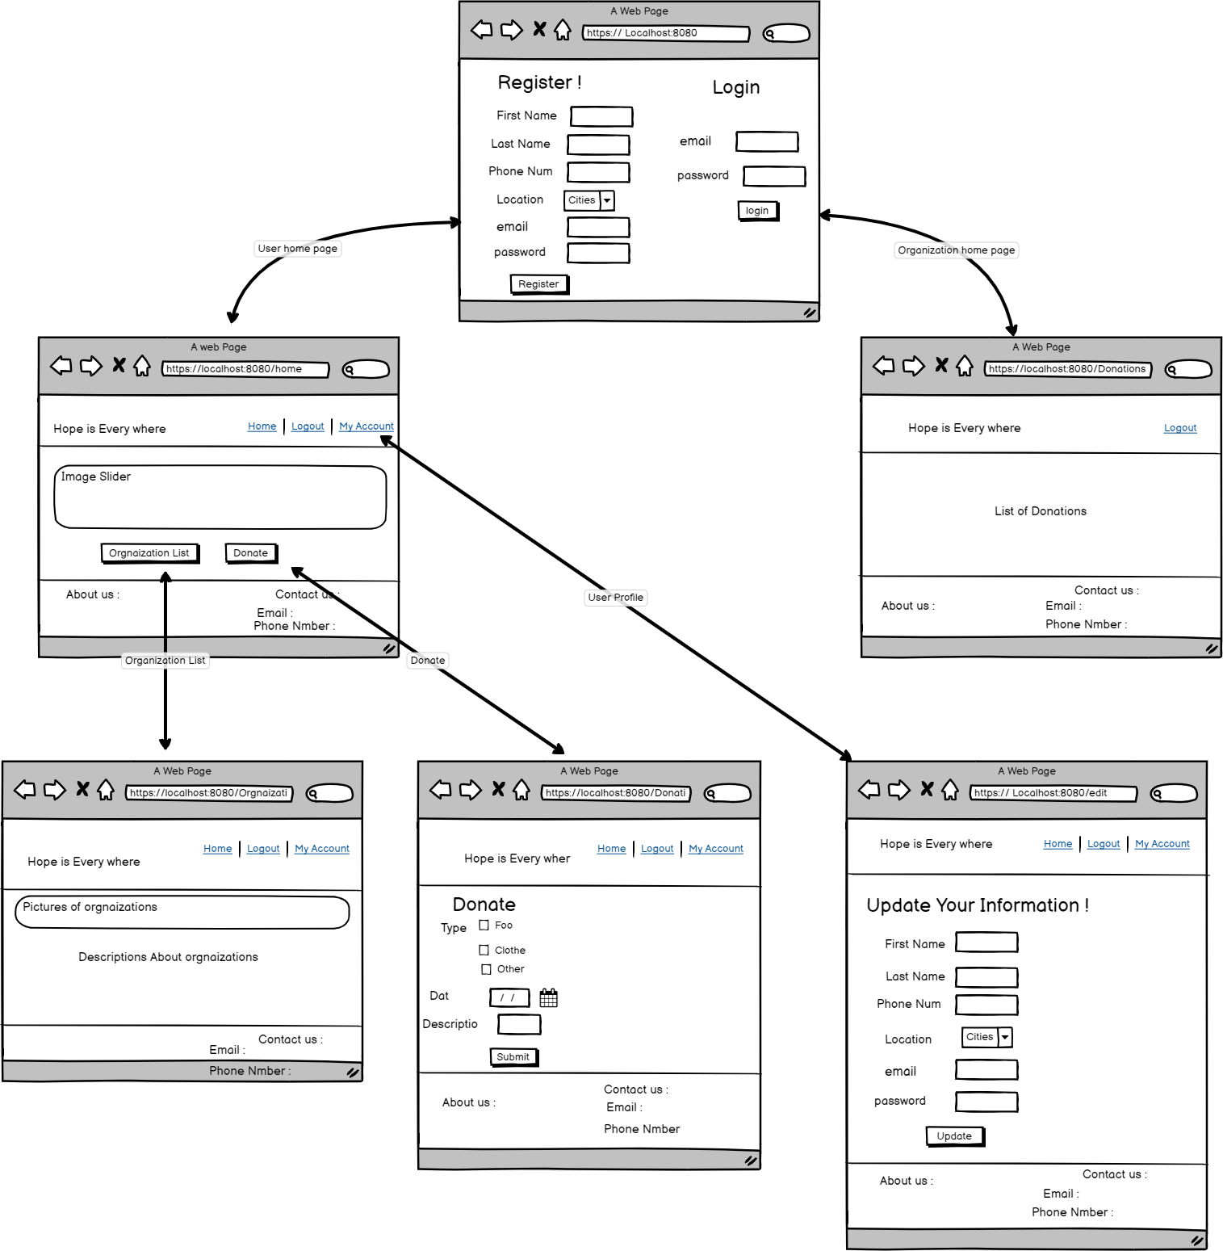

Figure : Blessing Wireframe

# ERD diagram:

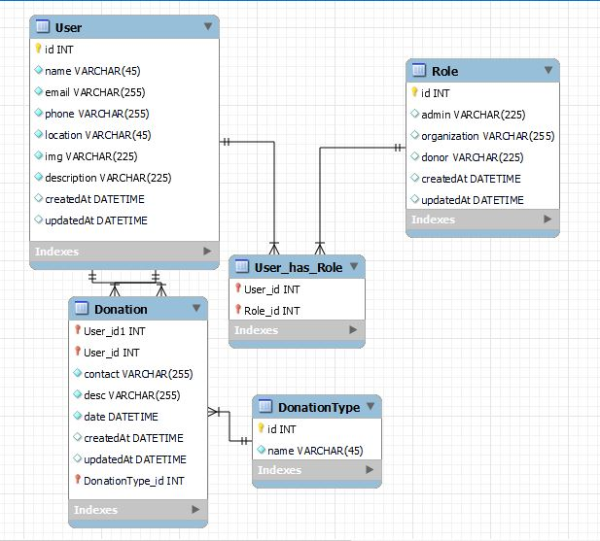

Figure : Blessing ERD Diagram