// Yousef Zoumot

// main.cpp

// Coen70HW5.1 Chapter 11 Problem 1

//

// Created by Yousef Zoumot on 2/21/16.

// Copyright (c) 2016 Yousef Zoumot. All rights reserved.

//

#include <iostream>

#include <vector>

#include <utility>

using namespace std;

class Heap{

vector<pair<int, int>> data;

int count;

int order;

public:

Heap();

void push(int);

int pop();

int top(){return data[0].first;};

int size(){return count;};

bool isEmpty(){return count==0;};

int lc(int k){return (2*k)+1;};

int rc(int k){return (2*k)+2;};

int p(int k){return (k-1)/2;};

void printValues();

};

Heap:: Heap(){

vector<pair<int, int>> data(100);

count=0;

order=0;

}

void Heap:: push(int input){

if(count==0){

data.push_back(pair<int, int> (input, order));

count++;

order++;

return;

}

int k=count;

pair<int, int> tmp;

data.push_back(pair<int, int> (input, order));

tmp = data[k];

while(k>0 && data[ p(k) ].first < input){

data[k]=data[ p(k) ];

k= p(k);

}

data[k]= tmp;

count++;

order++;

}

int Heap:: pop(){

int i, x, child, max, xo;

max=data[0].first;

x=data[count-1].first;

xo=data[count-1].second;

i=0;

while(lc(i) < count-1){

child= lc(i);

if(rc(i) < count && data[lc(i)] < data[rc(i)])

child=rc(i);

if(data[lc(i)].first == data[rc(i)].first){

if(data[lc(i)].second < data[rc(i)].second)

child=lc(i);

else

child=rc(i);

}

if(x < data[child].first ){

data[i]=data[child];

i=child;

}else

break;

}

data[i].first=x;

data[i].second=xo;

count--;

return max;

}

void Heap:: printValues(){

for(int i=0; i<count; i++)

cout<<data[i].first<<" "<<data[i].second<< "\n";

cout<<"\n";

}

int main(int argc, const char * argv[]) {

// insert code here...

Heap h1;

h1.push(1);

h1.push(2);

h1.push(3);

h1.push(4);

h1.push(4);

h1.push(5);

//cout<<h1.isEmpty();

h1.printValues();

h1.pop();

h1.printValues();

h1.pop();

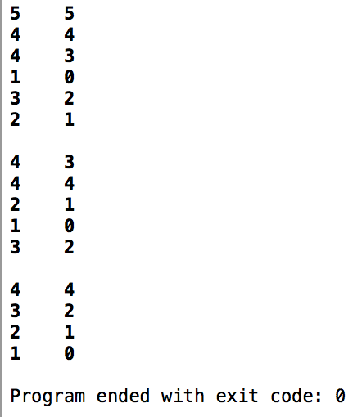 h1.printValues();

return 0;

}

// Yousef Zoumot

// main.cpp

// Coen70HW5.2 Chapter 11 Problem 5

//

// Created by Yousef Zoumot on 2/21/16.

// Copyright (c) 2016 Yousef Zoumot. All rights reserved.

//

#include <iostream>

#include <vector>

#include <utility>

using namespace std;

class Heap{

vector<pair<int, int>> data;

int count;

int order;

public:

Heap();

void push(int);

int pop();

int top(){return data[0].first;};

int size(){return count;};

bool isEmpty(){return count==0;};

int lc(int k){return (2*k)+1;};

int rc(int k){return (2*k)+2;};

int p(int k){return (k-1)/2;};

void printValues();

};

Heap:: Heap(){

vector<pair<int, int>> data(100);

count=0;

order=0;

}

void Heap:: push(int input){

if(count==0){

data.push_back(pair<int, int> (input, order));

count++;

order++;

return;

}

int k=count;

pair<int, int> tmp;

data.push_back(pair<int, int> (input, order));

tmp = data[k];

while(k>0 && data[ p(k) ].first > input){

data[k]=data[ p(k) ];

k= p(k);

}

data[k]= tmp;

count++;

order++;

}

int Heap:: pop(){

int i, x, child, max, xo;

max=data[0].first;

x=data[count-1].first;

xo=data[count-1].second;

i=0;

while(lc(i) < count-1){

child= lc(i);

if(rc(i) < count && data[lc(i)] > data[rc(i)])

child=rc(i);

if(data[lc(i)].first == data[rc(i)].first){

if(data[lc(i)].second < data[rc(i)].second)

child=lc(i);

else

child=rc(i);

}

if(x > data[child].first ){

data[i]=data[child];

i=child;

}else

break;

}

data[i].first=x;

data[i].second=xo;

count--;

return max;

}

void Heap:: printValues(){

for(int i=0; i<count; i++)

cout<<data[i].first<<" "<<data[i].second<< "\n";

cout<<"\n";

}

int main(int argc, const char * argv[]) {

// insert code here...

Heap h1;

h1.push(5);

h1.push(4);

h1.push(3);

h1.push(2);

h1.push(1);

//cout<<h1.isEmpty();

h1.printValues();

h1.pop();

h1.printValues();

h1.pop();

h1.printValues();

return 0;

