Screen one (HDMI 5" 800x480 Display Backpack) :

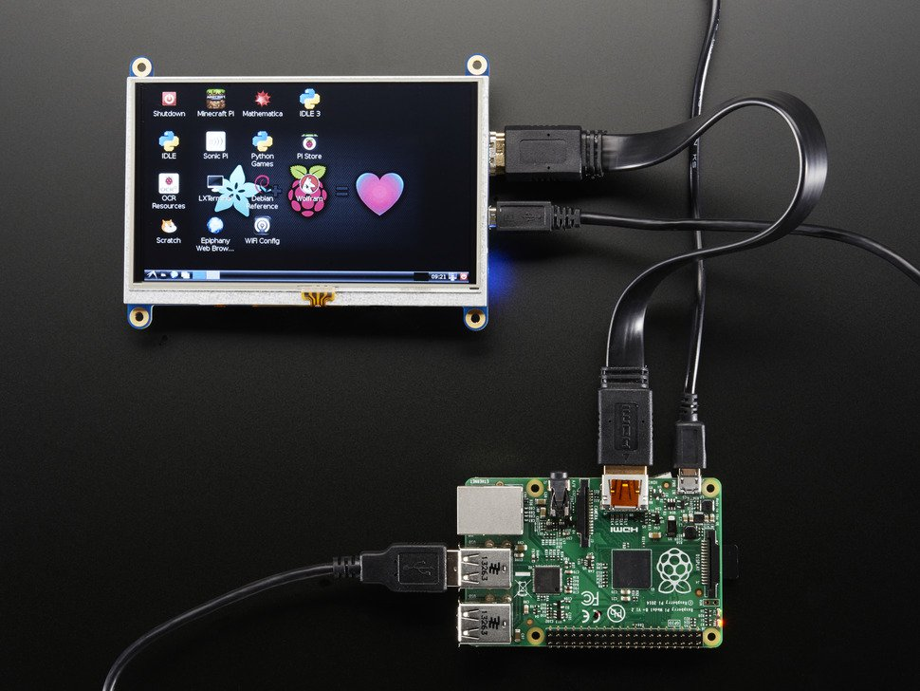

Screen two (HDMI 7" 800x480 Display Backpack) :

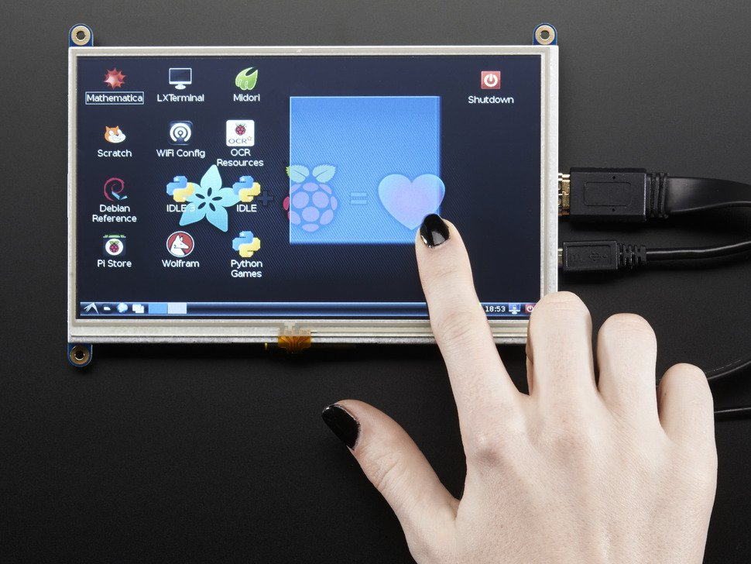

Screen three (HDMI 4 Pi - 10.1" Display 1280x800)

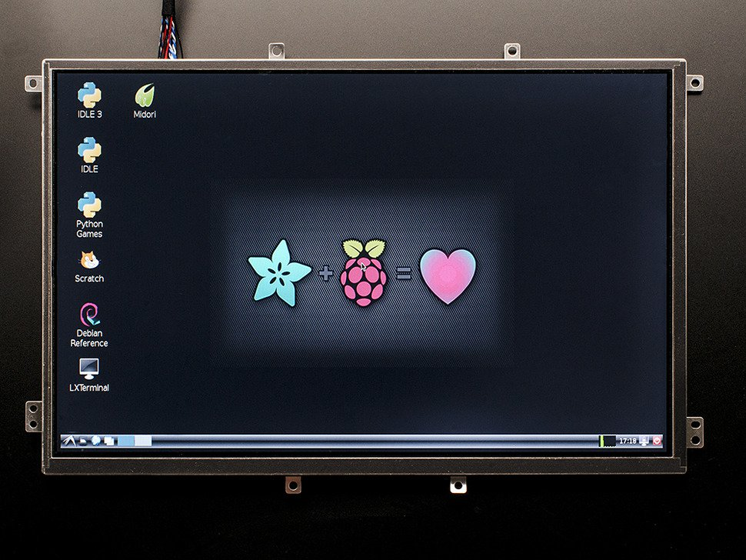

All the screens above have the same aspects, bit differ in size.

They also come in different versions: touchscreen and without-touch

The only difference between touch and non-touch is a chip that is added to enable the touch mode.

They also work with any microcontroller given the microcontroller has an hdmi ouput.

Pretty much all the screens on the market look the same

Bigger =^= expensive

Touchscreen== expensive

So for prices look at github.