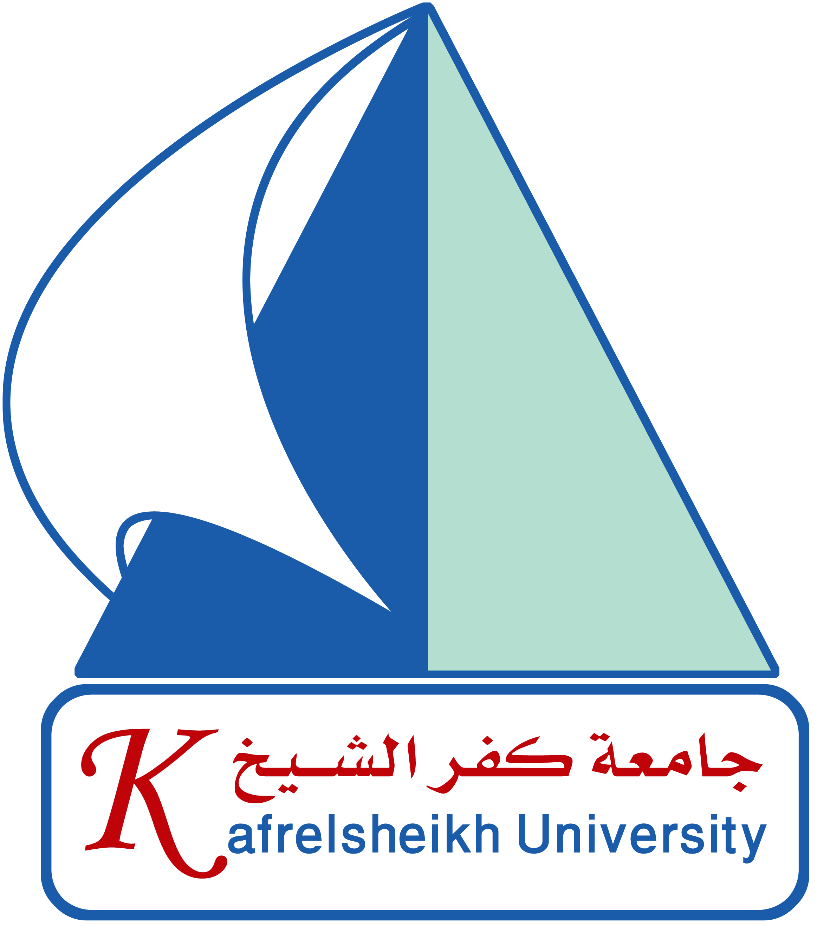 | 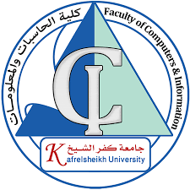
Kafr El-Sheikh University
Faculty of Computers and Information
Computer Science Department
Graduation Project Book
2025 / 2026


CareerCompass
AI-Powered Career Guidance and Job Recommendation Platform

Submitted by:
Yousef Altohamy Ahmed Altohamy | Ahmed Mohamed Ahmed Abdelaziz
Mohamed Ali Ahmed Mohamed | Mohamed Ibrahim Ahmed Mohamed
Ahmed Khamis Mohamed Younes | Ahmed Sobhy Mohamed Ali

Supervised by:
Dr. Amena Mahmoud

