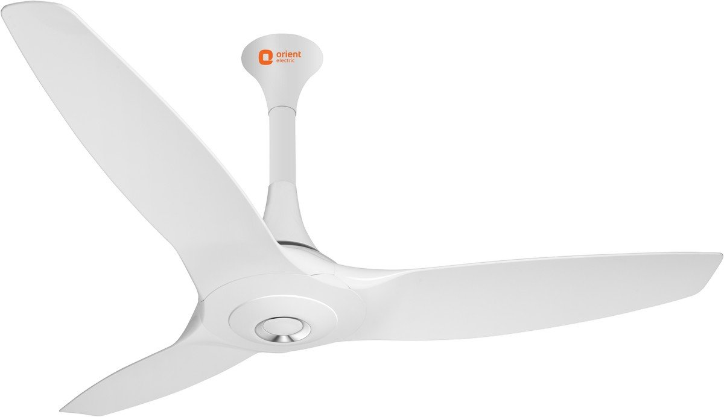

## Product description

Color Name:**White**

The all new Orient Aeroquiet ceiling fan promises highest ever air flow (in the category) with heavenly silence. First in the Orient electric’s aero series range of fans, it sets new standards in the segment with its inimitable design and outstanding performance. It features advanced aerodynamic profiled blade design which ensures maximum air throw while ensuring silent operation. Orient Aeroquiet has 100 percent rust-free blade made of high-grade glass filled compounded ABS which provides strength to the blades. It comes with the sturdiest 18-pole heavy motor with double ball bearing for smooth and silent operation.When it comes to styling, this fan is a sheer winner with its curvaceous silhouette and high gloss premium PU finish. It has an integrated design of top and bottom canopy with spindle cover and a stainless steel decorative rim on the top which adds to the premiumness. Contact_us on: [ 1800-103-7574 ] for any service related complaint.