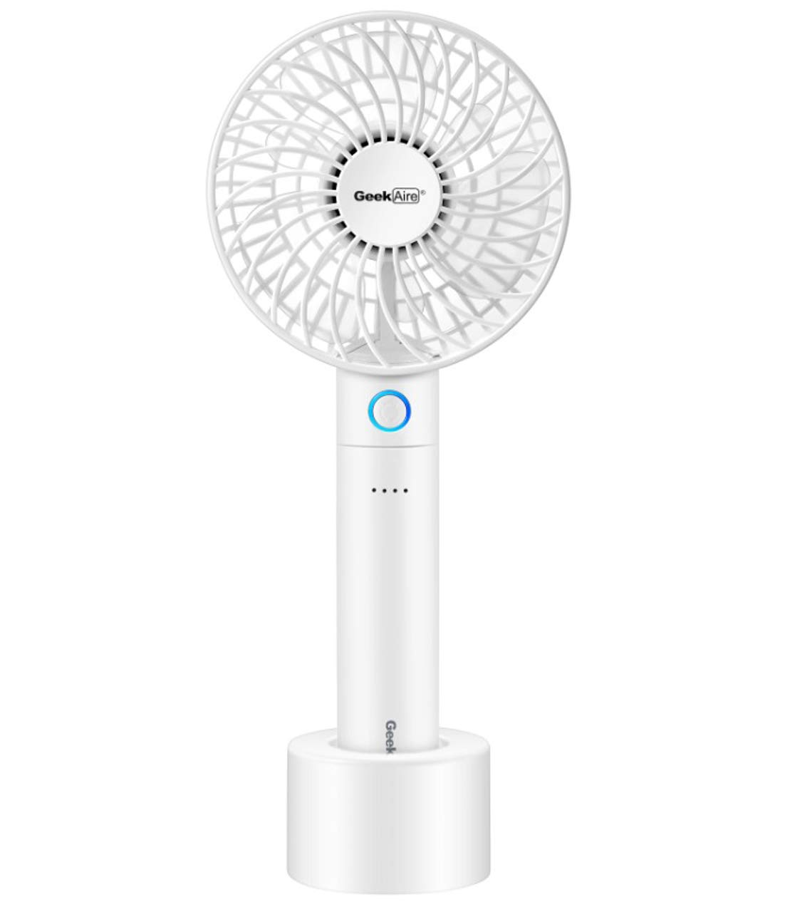

**Product description**

Size:**4 Inch**  |  Color Name:**White**

**A Cool Solution For Your Life**

Geek Aire GF2 series is new generation mini handheld portable fan. It is rechargeable with a 2600 mAh lithium-ion battery, which can also be detached as a separated power bank for convenience. The light-weight sleek handheld design allows you to carry around in office, home and travel. It is built with brushless DC motor for outstanding air performance and durable quality. It also comes with a charging dock to stand the fan where you would like to use.

* Patented 6-blade design to deliver impressive air performance. The 2600mAh li-ion battery ensures long duration time of up to 9 hours
* Intuitive LED indicator on both fan speed button and power gauge. Easy to read and observe.
* The battery compartment can be detached as a separated power bank to charge other digital devices
* Powered by a durable brushless DC motor, the fan has amazing air performance compared to other regular portable fans
* The fan also comes with a charging dock for convenient use. You can stand the fan up where you need.