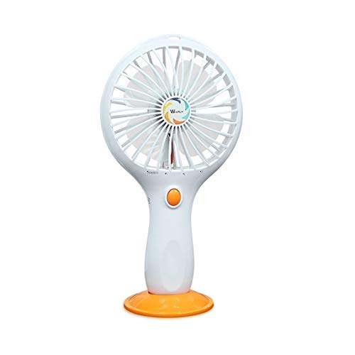

**Product description**

1.Foldable height: 17.5cm/6.89inch  
Total height: 30cm/11.8inch  
; Fan diameter: 9cm/3.54inch.   
2.removable handle design. You could put down the fan's handle when you walk. When you need reading or working,you could fold the handle up and put the fan on the desk. Description:  
Small size make the mini fan very easy to be carried.   
You could put them in your bag or take it in your hand directly.   
600mA rechargeable battery could be used 1-1.5 hours after fully charge.   
There are 2 levels wind velocity.   
The using time depends on the different wind speed.  
There is a USB port on the handle. You could charge the battery with computer, mobile power, very convenience.  
  
Item specifics:  
Brand: Kidsdream  
Output power: max 4W  
Input current: 0.5-1A  
Working time: 1-1.5 hours  
Charging time: approx 2 hours  
Net weight: approx.196g(include the battery)  
Speed adjustment: 2 speeds adjustable  
  
Package list:  
1 x Fan  
1 x Battery  
1 x Charging Cable