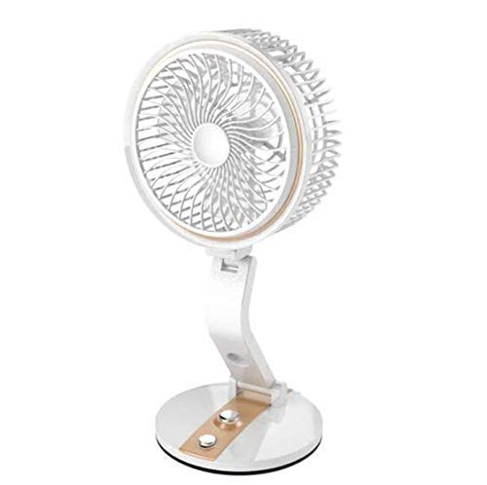

**Product description**

2 in 1 7" Inch Leaf Table Fan Works in AC and DC when Power Fails, Can Be Charged Using Solar Panel Boards also