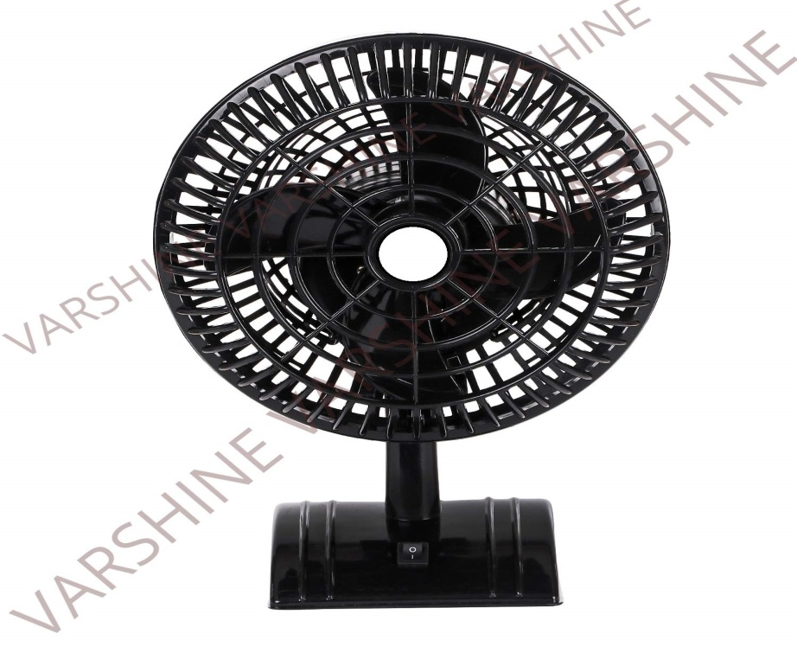

**Product description**

This fan comes equipped with a powerful motor for higher air delivery. This high speed fan is fitted with aerodynamically designed pp blades. This fan’s great features and good looks makes it a great buy. Feature 1 : seek and stylish feature 2 : powerful motor for higher air delivery, specially designed for indian conditions. Feature 3 : aerodynamically designed pp blades