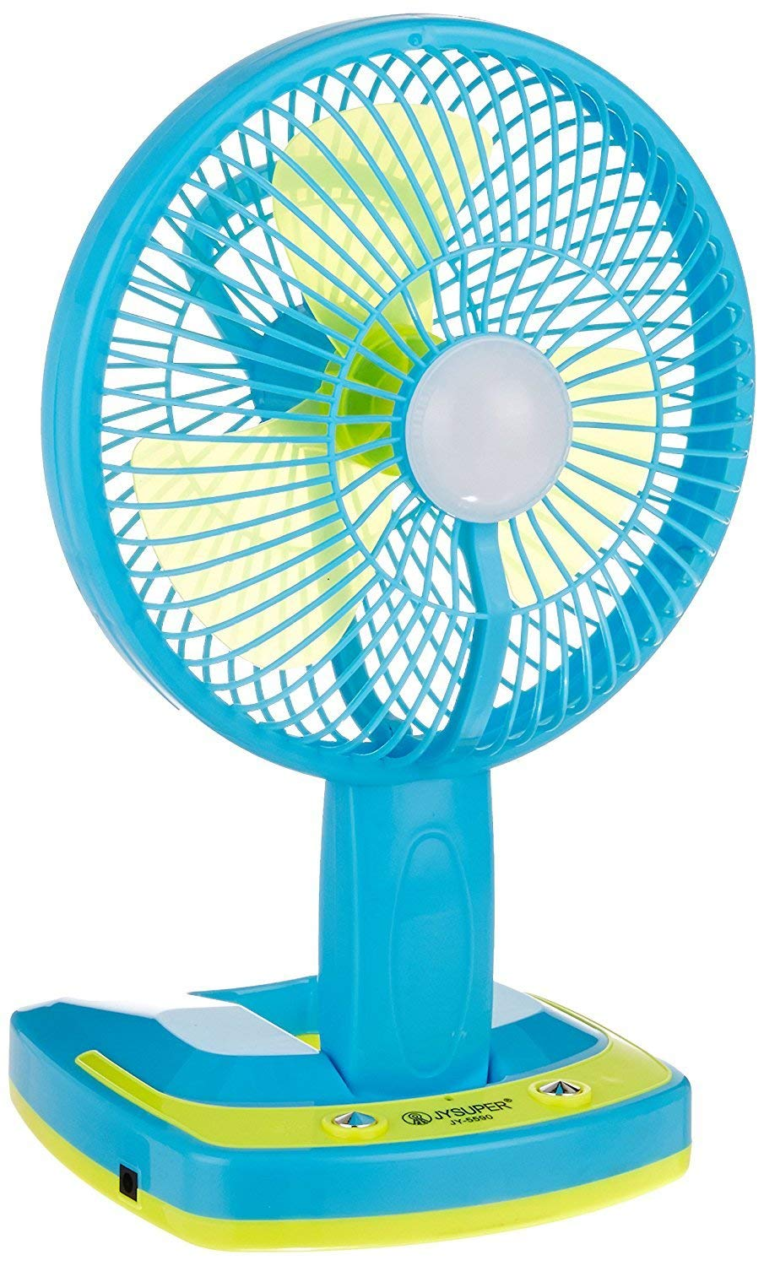

**Product description**

**Product details of REBORN 5590 Portable LED Light with Mini Fan**

Product brief Info:

1. Fan used only had a longer life up to 8 hrs.

2. As well LED light can be used for 8 hrs.

3. LED Light and Fan at the same time can be used up to 4 hrs.

4. Rechargeable - charging time is 8 - 12 hrs

.

1 pcs strong light LED make the lamp more brighter,

Province with electricity, full featured, user friendly, green environment-friendly new products

Rechargeable

led lamps can be used 8 hours or so,

Fan use up to 8 hours or more,

LED lights and fan at the same time about the use of up to 4 hours