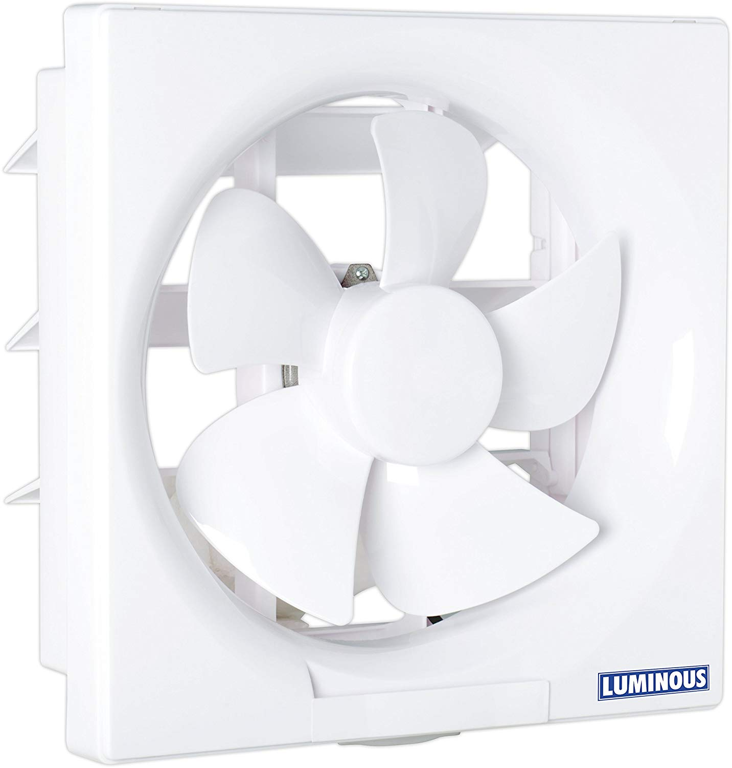

## Product description

Stylish design that matches spaces such as kitchen and keeps your home