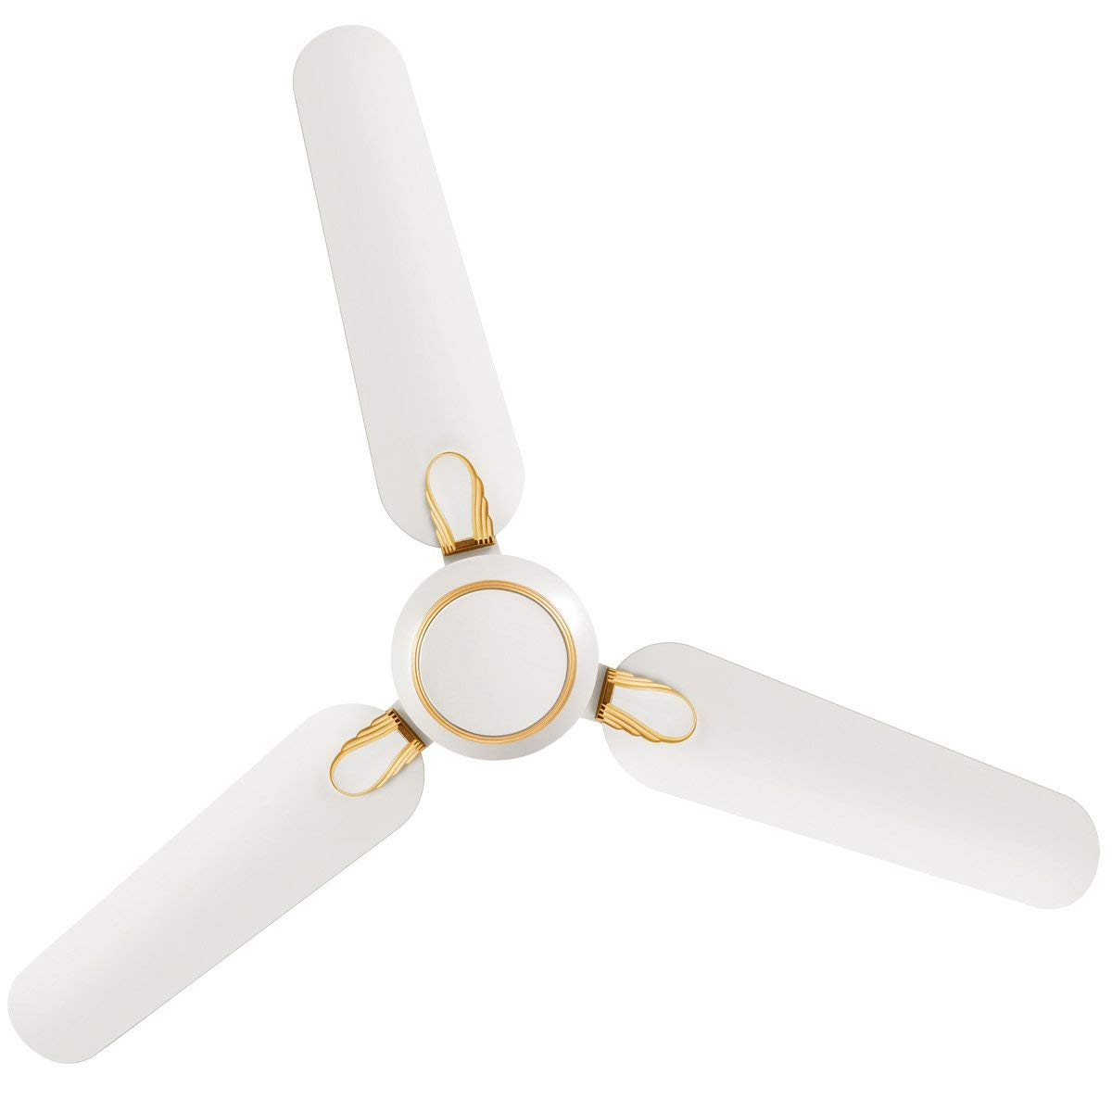

**Product description**

Luminous Dhoom High Speed Ceiling Fan bring the best of style, attractive design and performance to your home and office. It is designed to work even under low voltage conditions and maximize air circulation. It comes with high speed and aerodynamic blades. It adds life to your living and work spaces even as it freshen and cool every corner. Luminous fan is designed for higher air delivery and lower temperature rise. It is styled for different space and room keeping in mind the unique requirements of each space, different genres of interiors like modern, heritage, antique etc. It enhances different colour schemes of the space in which fan is installed. Luminous fan is crafted with high quality raw materials. Motor body and blades use the best quality of aluminium for non corrosive longer life. Motor windings are with pure electrolytic grade copper windings wire. Stators/rotors use hi-perm steel sheets for lower watts loss.