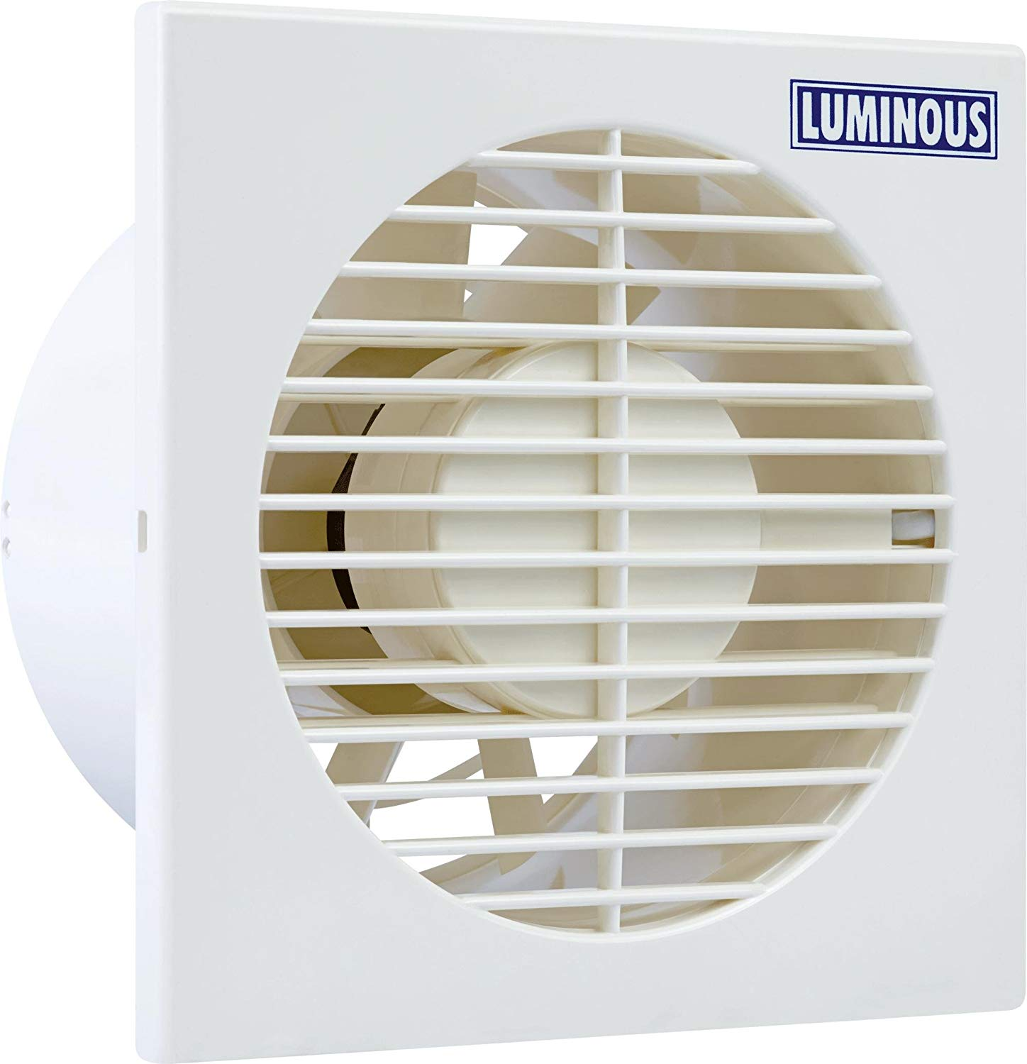

## Product description

The Luminous Exhaust Fan - Vento Axial 150 mm Single Colour 10 Inch Exhaust Fan is the ideal fan for your kitchen. Keep your kitchen clean and free from smoke while cooking with this exhaust fan. It comes in 10 inch size and has 720 m3/min air displacement.Â With 5 blades, it effectively removes smoke and other unwanted odour with its 2000 RPM Speed and consumes only 22 watts of power. Made of high quality material, the exhaust fan has stylish design. The compact exhaust fan enhances the beauty of your kitchen interiors, thanks to its classy white colour.