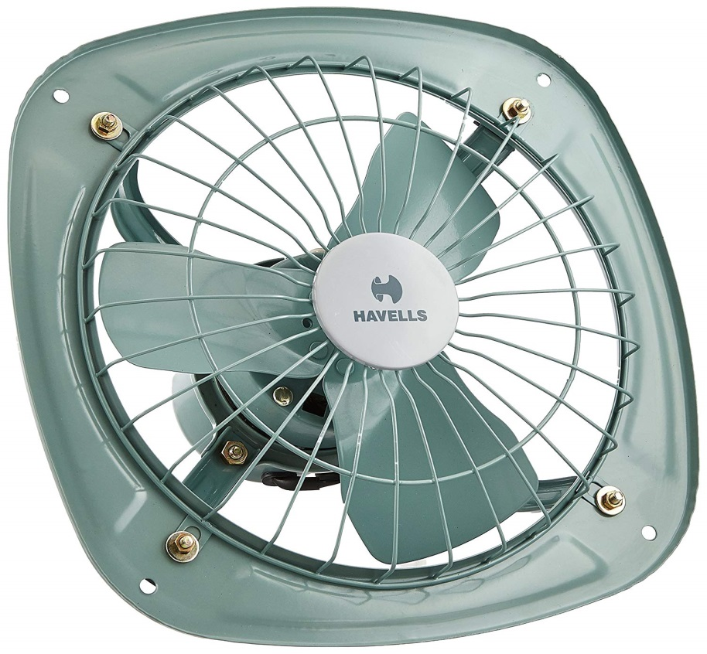

**Product description**

Regulates Fresh Air in Your Home. The Havells Ventilair exhaust fan draws out odour from your home to let you breathe easy. It features a high-quality metal body and blades that provide optimum performance. Plus, with three sharp blades this exhaust fan distributes air uniformly. You can conveniently install this exhaust fan in your kitchen, bathroom or toilet to keep unpleasant odours at bay. It will also keep your home smelling clean when you have unexpected guests at home. Consuming a mere 40W of power, this Havells exhaust fan is easy on your electricity bill too. Produces Less Noise During Operation. The Havells DSP exhaust fan is an excellent addition to your home. Unlike the other noisy exhaust fans, this one boasts a sound level of 40 to 50 db that will not disturb you and your family. So, you comfortably install one wherever required in your home. With a sweep distance of 230mm and working speed of 1350rpm, this fan provides optimum air flow. Moreover, this exhaust fan features a minimum air delivery speed of 700 cubic metre per minute to quickly eliminate the odour from the room. Brand: Havells Collection: Ventilair DSP, Material: Metal Blades: Three Power Source: Electric Rated Power Input: 40W Sweep Distance: 230mm Rated Speed: 1350rpm Minimum Air Delivery: 700 cubic metre per minute