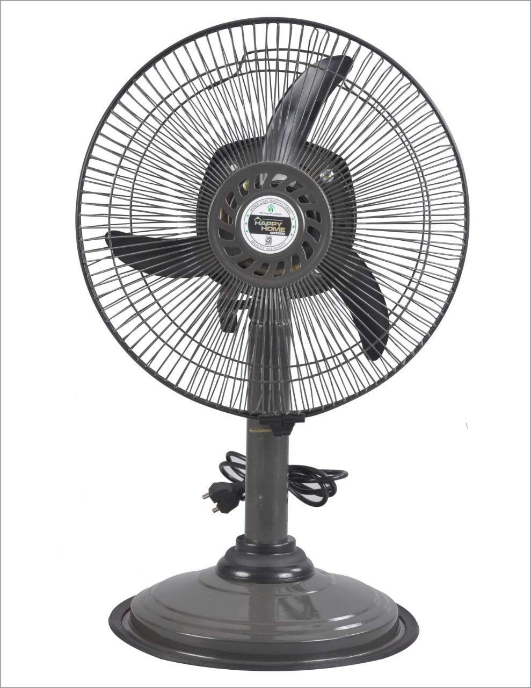

## Product description

Let the cool air fill your room once you have placed these smart and efficient pedestal fans. With compact and sleek looks, the breeze coming from these pedestal fans is sure to reach every corner of your room. Oozing out cool air, these pedestal fans are worth every penny